Water Availability and Use Science Program
Groundwater Availability Assessments
Cover Page

Project Title: Coastal Lowlands Aquifer System (CLAS) Groundwater Availability Study
Project Chief: Brian Clark and Linzy Foster
Key Project Personnel: Jeremy White, John Lovelace, Natalie Houston, Mark Kasmarek, Pierre Sargent
Lead Fiscal Contact: Linzy Foster
Project Summary: The Coastal Lowlands Aquifer System (CLAS) study will assess groundwater availability for the aquifers proximal to the Gulf of Mexico from the Texas-Mexico border through the panhandle of Florida. This assessment will be centered on the development of a regional-scale numerical model which will be coupled with uncertainty analysis to quantify the status of groundwater availability and temporal and spatial trends of availability within the CLAS. Quantities of interest (such as drawdown, land-surface subsidence, and groundwater storage) will be calculated within an uncertainty framework for potential future predictive scenarios based on anthropogenic and climatic changes to hydrologic components of the system. The current groundwater monitoring network will be assessed by applying data worth analyses to the numerical model. This project will culminate with useful tools, publications, and presentations summarizing estimates, captured within an uncertainty framework, of past, current and future groundwater availability and sustainability of the CLAS.

Regional Groundwater Availability Project

Statement of Project Goals
The Coastal Lowlands Aquifer System (CLAS) study will assess groundwater availability for the aquifers proximal to the Gulf of Mexico from the Mexico border through the panhandle of Florida (fig 1). This study complements other regional aquifer studies through the Water Availability and Use Science Program designed to develop a national assessment of groundwater availability in USGS Principal Aquifers as part of a National Water Census.
General project goals include:
- Rigorous analysis of the water budget of major aquifer system components
- Determination of current estimates and historic trends in groundwater use, storage, recharge, and discharge
- Construction of a groundwater model to assimilate all sources of aquifer system knowledge, and provide a tool for future projections of groundwater availability
- Development of regional, stochastic estimates of primary aquifer properties
- Evaluation of the existing regional groundwater monitoring network
The CLAS study provides a unique opportunity to not only unify parts of previously developed Regional Aquifer System Analysis (RASA) studies (Martin and Whiteman, 1990; Renken, 1996; Grubb, 1998) but also as a continuation of spatial extent through the inclusion of the Mississippi River Valley alluvial aquifer south of that simulated in the Mississippi Embayment Regional Aquifer Study (MERAS, Clark and others, 2011) and the recently enacted Mississippi Alluvial Plain (MAP) study (fig 1).

Background
The CLAS encompasses an area of about 140,000 square miles (mi²) (Grubb, 1998) that extends along the Gulf Coast from the Rio Grande Valley in south Texas, through Louisiana, Mississippi, and Alabama, to the western part of the Florida panhandle (Renken, 1998) and gulfward to the edge of the Continental Shelf. The system consists of Miocene, Pliocene, and Pleistocene deposits (fig. 2) overlying the upper-most massive clay of the Vicksburg Group or the Jackson and Vicksburg Groups where they are undifferentiated (Grubb, 1984). The system consists primarily of unconsolidated to poorly consolidated, discontinuous beds of sand, silt, and clay, with minor amounts of lignite and limestone deposited in continental, transitional, and marine environments. The system dips and thickens as a wedge towards the coast (fig. 3) and extends offshore to the edge of the continental shelf, but generally contains only saltwater (chloride concentrations greater than 250 mg/L) in offshore areas (Martin and Whiteman, 1999). The system also dips and thickens towards the Mississippi River alluvial valley and includes fluvial and deltaic deposits from the river in southeastern Louisiana. The aquifer system outcrops at land surface throughout much of its extent, although towards the coast, it is generally overlain by surficial confining clay. In some areas, the aquifer system is interrupted by down-to-basin normal faults that are common along the gulf coast (Murray, 1961). The depth of occurrence and displacement along these faults is highly variable and in many areas the faults seem to have little if any affect on groundwater flow. However, the offset of the Baton Rouge-Tepetate fault ranges from a few feet near the surface to almost 400 ft at a depth of 2,500 ft, displacing sands and forming a leaky barrier to flow in the Baton Rouge area. North of the fault, the aquifer system contains primarily freshwater, but south of the fault, many of the aquifers contain saltwater (Griffith, 2003).

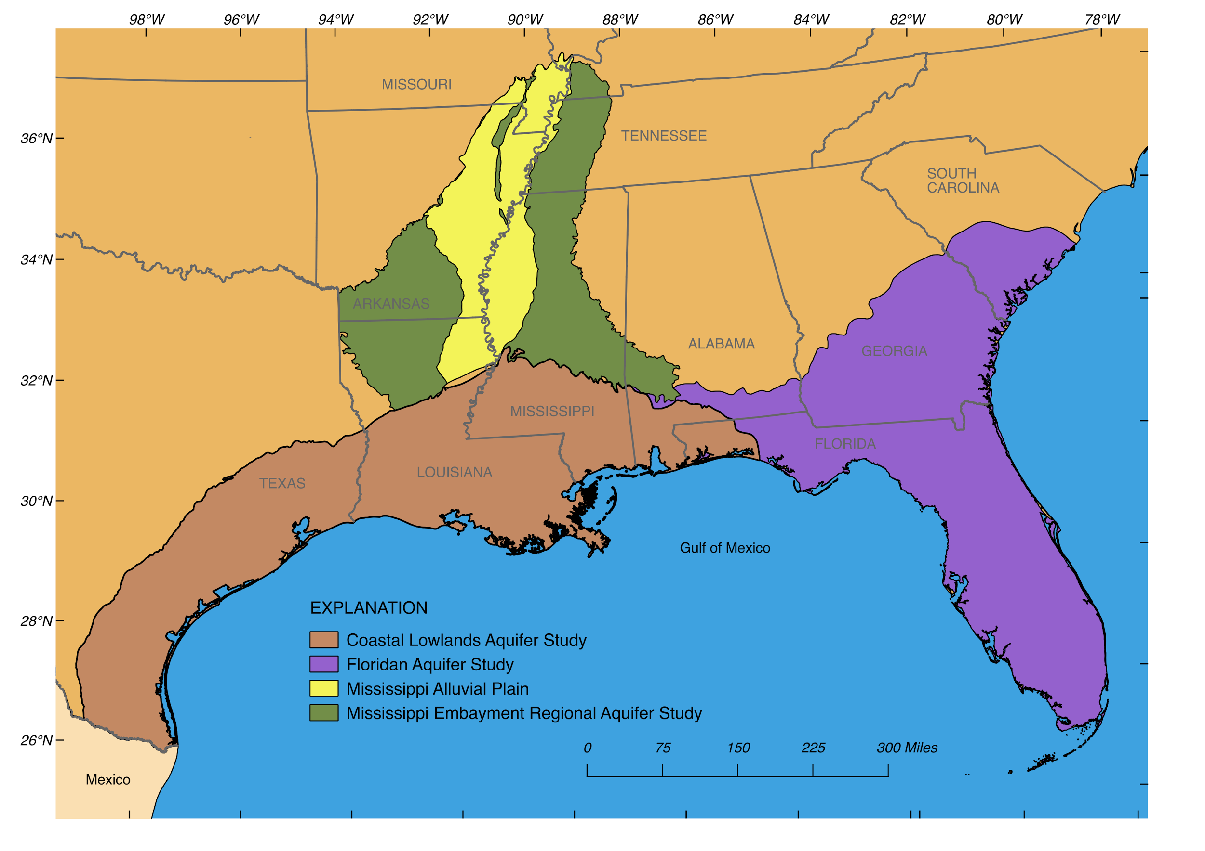
Figure 1. Map of the extent of the CLAS proposed for study, and spatial relation to existing groundwater availability studies.

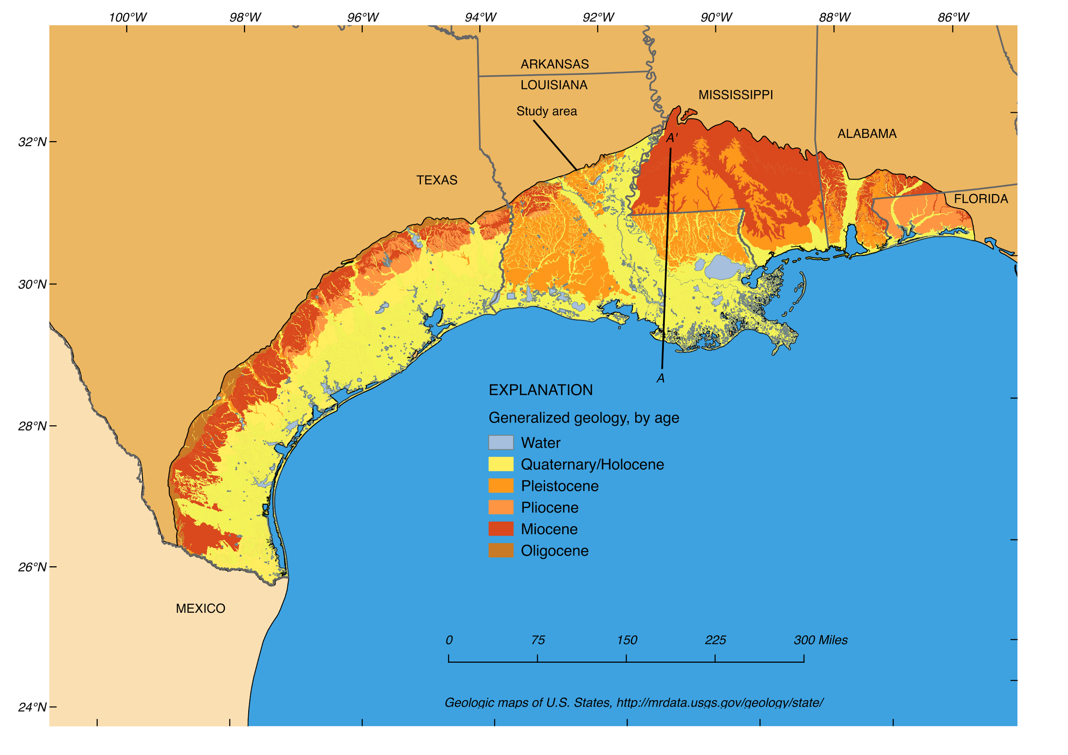
Figure 2. Generalized geology, by age, of the CLAS area and cross-section location of figure 3.
In Mississippi, the aquifer system comprises surficial terrace deposits, the Citronelle Formation, and the Miocene and Oligocene aquifer systems. The aquifer system also comprises the sand and gravel aquifer of Alabama and Texas, which is sometimes referred to as the Miocene-Pliocene, Citronelle, or Citronelle-Pliocene aquifer in those states (Miller, 1990).
Water withdrawals from the aquifer system for cities and agricultural use began in the late 1800s. Withdrawals by industry increased rapidly during the 1940s as petrochemical plants began locating in port cities along the Gulf coast. In 2000, about 2,370 Mgal/d (million gallons per day) were withdrawn from the entire CLAS. The withdrawals were for public supplies (43 percent), irrigation (39 percent), and self-supplied industries (18 percent). Most of the withdrawals were in Louisiana (43 percent) and Texas (41 percent) (Maupin and Barber, 2005). A large portion of the agricultural withdrawals were for rice and crawfish production in farmed areas between Houston, TX and Lafayette, LA. Major industrial complexes withdrawing large amounts of water from the aquifer system are located in Houston, Lake Charles, and Baton Rouge. In addition, about 112 Mgal/d were withdrawn from the aquifer system in 2005 by private (household) well owners for self-supplied domestic uses (Maupin and Arnold, 2010). Heavy withdrawals from the aquifer system in some areas have resulted in water-level declines, saltwater encroachment, compaction, and land subsidence.

Texas
In Texas and southwestern Louisiana, the CLAS comprises, from deepest to shallowest, the Catahoula, Jasper, Evangeline, and Chicot aquifers or aquifer systems, (Ryder, 1996; Renken, 1998). In southeastern Louisiana, the CLAS comprises the Jasper, Evangeline, and Chicot equivalent aquifer systems and the Catahoula aquifer, which are collectively referred to as the Southern Hills aquifer system, and the New Orleans aquifer system (Renken, 1998; Griffith, 2003). In the Northern Gulf Coast Groundwater Availability Model (GAM) (also referred to as the Houston Area Groundwater Model) (Kasmarek and Robinson, 2004; and Kasmarek, 2012), the altitude of the base of the Chicot aquifer in the study area ranges from more than 1,500 ft below Datum southeast of the coast to more than 420 ft above Datum in the outcrop area and varies locally because of numerous salt domes in the study area. The altitude of the top of the Chicot aquifer in the study area (Kasmarek and Robinson, 2004) approximates the land-surface altitude and ranges from the North American Vertical Datum of 1988 at the coast to as much as 445 ft above datum at its updip limit. The altitude of the base of the Chicot aquifer was constructed from hydrogeologic digital data of Strom and others (2003a). The original cumulative clay thickness of the Chicot aquifer was subtracted from aquifer thickness to construct cumulative sand thickness. The updip limit of the Evangeline aquifer is an undulating boundary approximately parallel to the coast and extending as far north as Lavaca, Fayette, Austin, Washington, Grimes, Montgomery, Walker, San Jacinto, Polk, Tyler, Jasper, and Newton Counties, TX. The downdip limit of freshwater is approximately coincident with the coast (Kasmarek and Robinson, 2004).
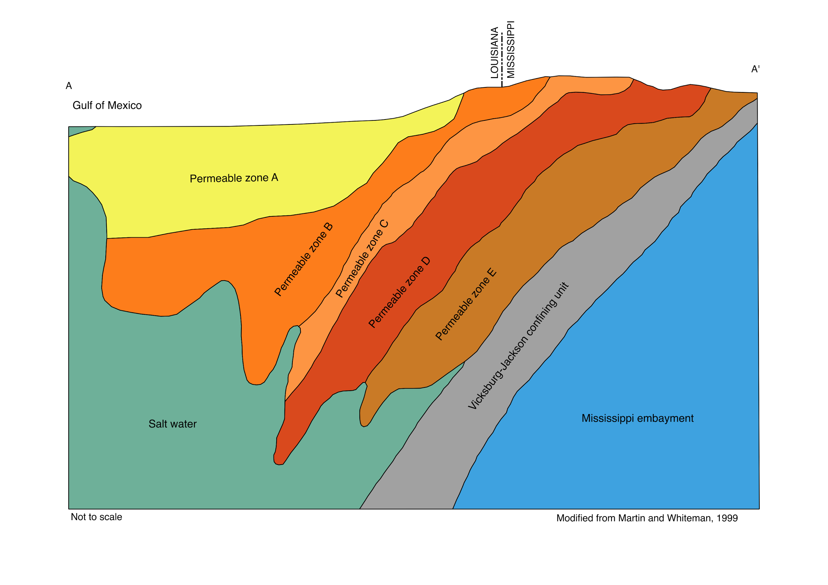
Figure 3. Generalized hydrogeologic section showing zonation of the CLAS (see figure 2 for location of section).
In the Houston-Galveston region of Texas, water-table conditions generally exist in the updip outcrop area of the Chicot aquifer and the outcrop areas of the Evangeline and Jasper aquifers and Burkeville confining unit. The water table is assumed to be a subdued replica of the topography (Williams and Williamson, 1989). In outcrops of the Chicot and Evangeline aquifers in parts of Harris and Montgomery Counties, a seismic refraction investigation indicated that the water table ranges from about 10 to 30 ft below land surface (Noble and others, 1996). Long-term hydrographs of water levels in wells screened in the water table of the Chicot and Evangeline aquifers indicate that the water levels were not influenced by increased groundwater withdrawal in the area and have remained fairly stable even during the 1950–57 drought (Kasmarek and Robinson, 2004, fig. 28). The water-use data of Kasmarek (2012) for the Chicot, Evangeline, and Jasper aquifers documents that total groundwater withdrawals increased from an estimated 41 Mgal/d in 1891 to about 1,130 Mgal/d in 1976, peaked at about 1,135 Mgal/d in 1980, and varied during the next 20 years but generally trended downward to about 895 Mgal/d in 2000. Subsequently, groundwater withdrawals varied from 799 Mgal/d in 2001 to 869 Mgal/d in 2009 (Kasmarek, 2012). For Harris, Galveston, and Fort Bend Counties in 2015, groundwater withdrawals totaled 284.8 Mgal/d.
The USGS annually has measured water levels in over 700 wells and constructed maps of potentiometric surfaces of the Chicot and Evangeline aquifers in the greater Houston area since 1977 (Gabrysch, 1979) and of the Jasper aquifer since 2000.
Land-surface subsidence in the Houston-Galveston region of Texas, has occurred primarily as a result of groundwater withdrawals from wells designed for municipal supply, commercial and industrial use, and irrigation purposes and secondarily as a result of hydrocarbon extraction. Groundwater withdrawals depressurized and dewatered the Chicot and Evangeline aquifers, thereby causing compaction of the aquifer sediments, mostly in the fine-grained silt and clay layers. This compaction process causes the land-surface elevation to differentially decline or subside. By 1979, as much as 10 ft of subsidence had occurred in isolated areas in the Houston-Galveston region, and approximately 3,200 mi² of the 11,000-mi² geographic area had subsided more than 1 ft (Coplin and Galloway, 1999). In a subsequent USGS subsidence report, documented data indicates as much as 13 ft of subsidence had occurred in isolated areas in southeast Harris County (Kasmarek and others, 2009).

Louisiana
Heavy pumping for irrigation and aquaculture in southwestern Louisiana has caused groundwater declines and created a broad cone of depression that extends over much of the region. In 2010, about 1,240 Mgal/d was withdrawn from the CLAS in Louisiana. Of that water, about 67 percent was used for irrigation and aquaculture in southwestern and northeastern Louisiana. About 12 percent was used for public supplies and 20 percent was used for industry and power generation (Sargent, 2011). Withdrawals from the aquifer system have caused concerns about drawdown and saltwater encroachment across a broad area of southwestern Louisiana. In addition, concentrated public-supply and industrial withdrawals in the Lake Charles area have created a deep cone of depression. Altered groundwater flow patterns in these areas have created conditions favorable for lateral encroachment of saltwater inland from coastal areas as well as upconing of saltwater from deeper salty aquifers (Lovelace and others, 2004). In 1982, the Sabine River Diversion Canal was completed and began supplying surface water from the Sabine River to several industries and one public supplier near Lake Charles. The subsequent reduction in groundwater withdrawals at these facilities resulted in a sharp rise in water levels in the aquifers beneath that area, but concentrations of chloride are still increasing in some wells, indicating that encroachment has continued to occur (Nyman, 1984; Lovelace, 1999). Nyman and others (1990) described the geohydrology and simulated flow in the Chicot aquifer in southwestern Louisiana.
In the Baton Rouge area, public supply and industrial withdrawals have lowered water levels and caused saltwater to encroach northward across the Baton Rouge Fault, which is a leaky barrier separating freshwater in aquifers north of the fault from saltwater in the aquifers south of the fault. A study conducted during 2004-05 found that saltwater encroachment across the fault was occurring in 7 of the 10 aquifers beneath the Baton Rouge area (Lovelace, 2007). A groundwater flow and saltwater transport model of the Baton Rouge area aquifers is currently being systematically calibrated to simulate past, current, and possible future conditions in each of the 10 aquifers (Heywood and others, 2014 and 2015). Subsidence also is a concern in the Baton Rouge area where groundwater withdrawals resulted in an estimated 1.3 ft of subsidence between 1935 and 1976. Since 1976, induced subsidence rates in the Baton Rouge area have probably averaged less than 0.014 ft per year (Whiteman, 1980). In the Lake Pontchartrain basin and along the Louisiana coast, however, subsidence rates as high as 0.4 inches per year have been documented and there is widespread concern about the sustainability of coastal wetlands due to the combined impacts of subsidence and sea-level rise (Yuill and others, 2009). The primary cause of the subsidence in these areas is probably faulting (Dokka, 2006), but some local subsidence, particularly in the New Orleans area, could be the result of groundwater withdrawals (Kazmann and Heath, 1968).
Pumping from aquifers in the New Orleans area also has altered predevelopment flow patterns and caused saltwater encroachment into freshwater areas. Although the city primarily relies on the Mississippi River for freshwater supplies, aquifers beneath the city have been evaluated for potential use as alternate sources of water during periods of surface-water-quality degradation (Dial and Sumner, 1989). Although the recent rate of pumpage from New Orleans area aquifers is less than half of what it was at its peak in 1969, groundwater flow continues to be radially towards pumping centers and chloride concentrations continue to rise at wells along the freshwater-saltwater interface (Dial and Sumner, 1989; Prakken, 2009).

Alabama
The CLAS is an important source of water in south Alabama. Counties underlain by the Coastal Lowland Aquifer System utilize more than 125 Mgal/d in groundwater for domestic, industrial, and irrigation water supplies. Two of the counties, Baldwin and Mobile are among the highest groundwater users in Alabama for public-water supply, self-supplied domestic, industrial, and irrigation (Maupin and others, 2014). The heavy groundwater use in Mobile and Baldwin Counties have resulted in lowered groundwater levels and increased problems with saltwater encroachment (Chandler and others, 1985, Murgulet and Tick, 2008, and Gillett and others, 2000). Nutrients in groundwater, especially in Baldwin County have also become an important issue. Heavy agricultural activities, other potential nitrate sources, and porous soils have resulted in high nitrate concentrations in the coastal aquifers in Baldwin County. Spatially extensive nitrate concentrations exceeding regulatory limits were present within the CLAS in southern Baldwin County, with maximum concentrations in excess of 100 mg/L (Murgulet and Tick, 2009). The high nitrate concentrations affect not only the suitability of the water for a drinking water supply, but also affect water-quality in the bays and estuaries. Nutrient rich submarine groundwater discharge has been linked to harmful algal blooms (Su and others, 2013). The bays, estuaries, and northern Gulf of Mexico along the Alabama coast have high occurrences of potentially harmful algae and high nutrient inputs from surface water and from the submarine groundwater discharge (Liefer and others, 2009).
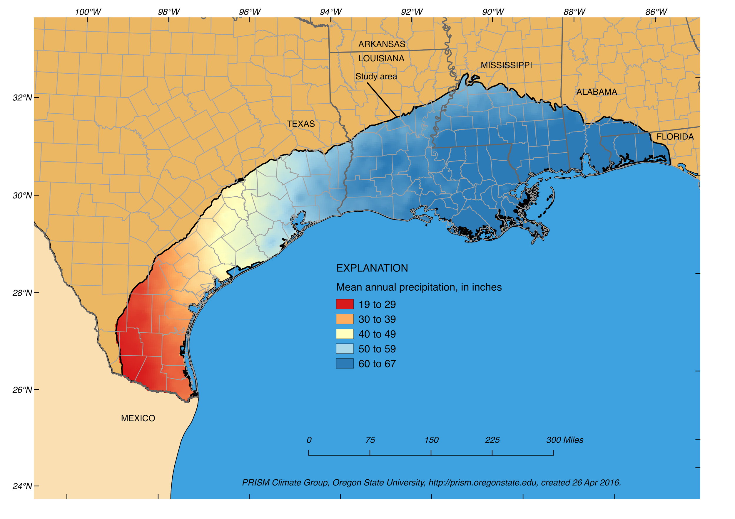
Figure 4. Mean annual precipitation across the study area (1901 to 2013).

Objectives
The overall goal of this study is to assess groundwater availability in the CLAS. To achieve the overall goal and provide a tool for future uses, the objectives of the proposed investigation are to:
- Assess the groundwater availability (status and trends) of the CLAS
- Systematically and rigorously estimate water budget components for the groundwater flow system
- Forecast system response to changes in anthropogenic and climatic stresses
- Develop and refine regional estimates of primary aquifer properties
- Develop a groundwater model to provide a tool for the evaluation of groundwater availability and future local uses within the study area
- Utilize the model for the evaluation of existing groundwater monitoring networks
The assessment of groundwater availability for the CLAS requires the evaluation of the hydrologic response to climatic and anthropogenic stresses on the system. The approach to meeting these objectives includes 1) synthesis of local-scale groundwater-flow model information (framework, water use, targets, etc.) into a regional context, 2) incorporate subsidence into MODFLOW6, and 3) utilize uncertainty quantification throughout the model development process to better guide resource expenditure.

Scope
Spatially, the project area covers parts of five states; Texas, Louisiana, Mississippi, Alabama, and Florida (fig. 1). The rectangular model grid will cover almost 340,000 mi², while the active part to be simulated will cover approximately 140,000 mi² extending offshore where needed to allow for adequate flow boundary conditions. Vertically the study area encompasses a minimum of five units, subdivided into permeable zones defined by areas of intense pumping and similar water levels (Martin and Whiteman, 1999).
The project is designed to span five years. The first year will be focused on data compilation for framework development, water use, and history-matching criteria and beginning construction of initial model datasets, including both the history-matching (calibration) model datasets and the forecast/scenario model datasets. The second year will be focused on updating the conceptual model, completion of initial model datasets, development of the prior uncertainty distributions for the model parameters, and preliminary uncertainty analysis and refinement/construction of more complex model datasets. The third and fourth years will be focused on application of non-linear uncertainty analysis with the more complex model input datasets, initial evaluation of groundwater availability and the monitoring network, and publication of results. The fifth year will be used to focus the modeling analysis on the topic of groundwater availability in regards to status and trends and future projections, as well as completing publication of the remaining products (professional paper and fact sheet).

Approach

Task 1 - Hydrostratigraphic Framework
We will make extensive use of the large number of recent, local to subregional scale modeling analyses completed in the CLAS region to avoid duplication and to include many local and subregional stakeholders (fig. 5). We will use the existing gulf coast regional aquifer system analysis (GCRASA) data to reconstruct the framework (hydrostratigraphy and aquifer properties) at a regional scale, only refining the framework in areas where more recent work has identified substantial differences with the GCRASA framework. If needed, hydrostratigraphic units will be refined locally through inclusion of data from subregional and local models, with the overarching goal to reduce expenditure of resources for minimal gain with respect to the goals of the project. We anticipate that some interpretation of borehole data may be necessary to fill gaps. The penultimate goal of this task is to develop the datasets needed to construct a hydrostratigraphic framework for a given spatial discretization in the first year of the project.

Task 2 - Conceptual model development and model input dataset construction
During the first two years of the project, the team will develop an updated conceptual model of the CLAS, which will lead to initial estimates of major water budget components such as recharge, surface water groundwater exchange, and coastal discharge. The conceptual modeling process will also include development of initial model input datasets. These datasets will be derived from a variety of sources, including remotely sensed datasets and outputs from other models, such as the soil water balance (SWB) (Westenbroek and others, 2010) and baseflow separation techniques, such as those (available in the groundwater toolbox; Barlow and others, 2014). These independent estimates of important water budget components will not only provide important, early insights into the groundwater available within the CLAS, but will also be used in construction of the model datasets and history matching.

The CLAS has been well-studied at the local to semi-regional scale. Given the number and coverage of previous investigations, we are proposing to use formal geostatistical analysis to develop hydraulic property distributions. Geostatistical modeling, including rigorous variogram modeling, will provide initial property distributions that honor available data (from the previous studies), such as point measurements of hydraulic conductivity and storage, and also interpolate between points in a minimum error variance sense. This property of geostatistics is important so that the starting point for the model inference process is centered in the Prior of Bayes equation.
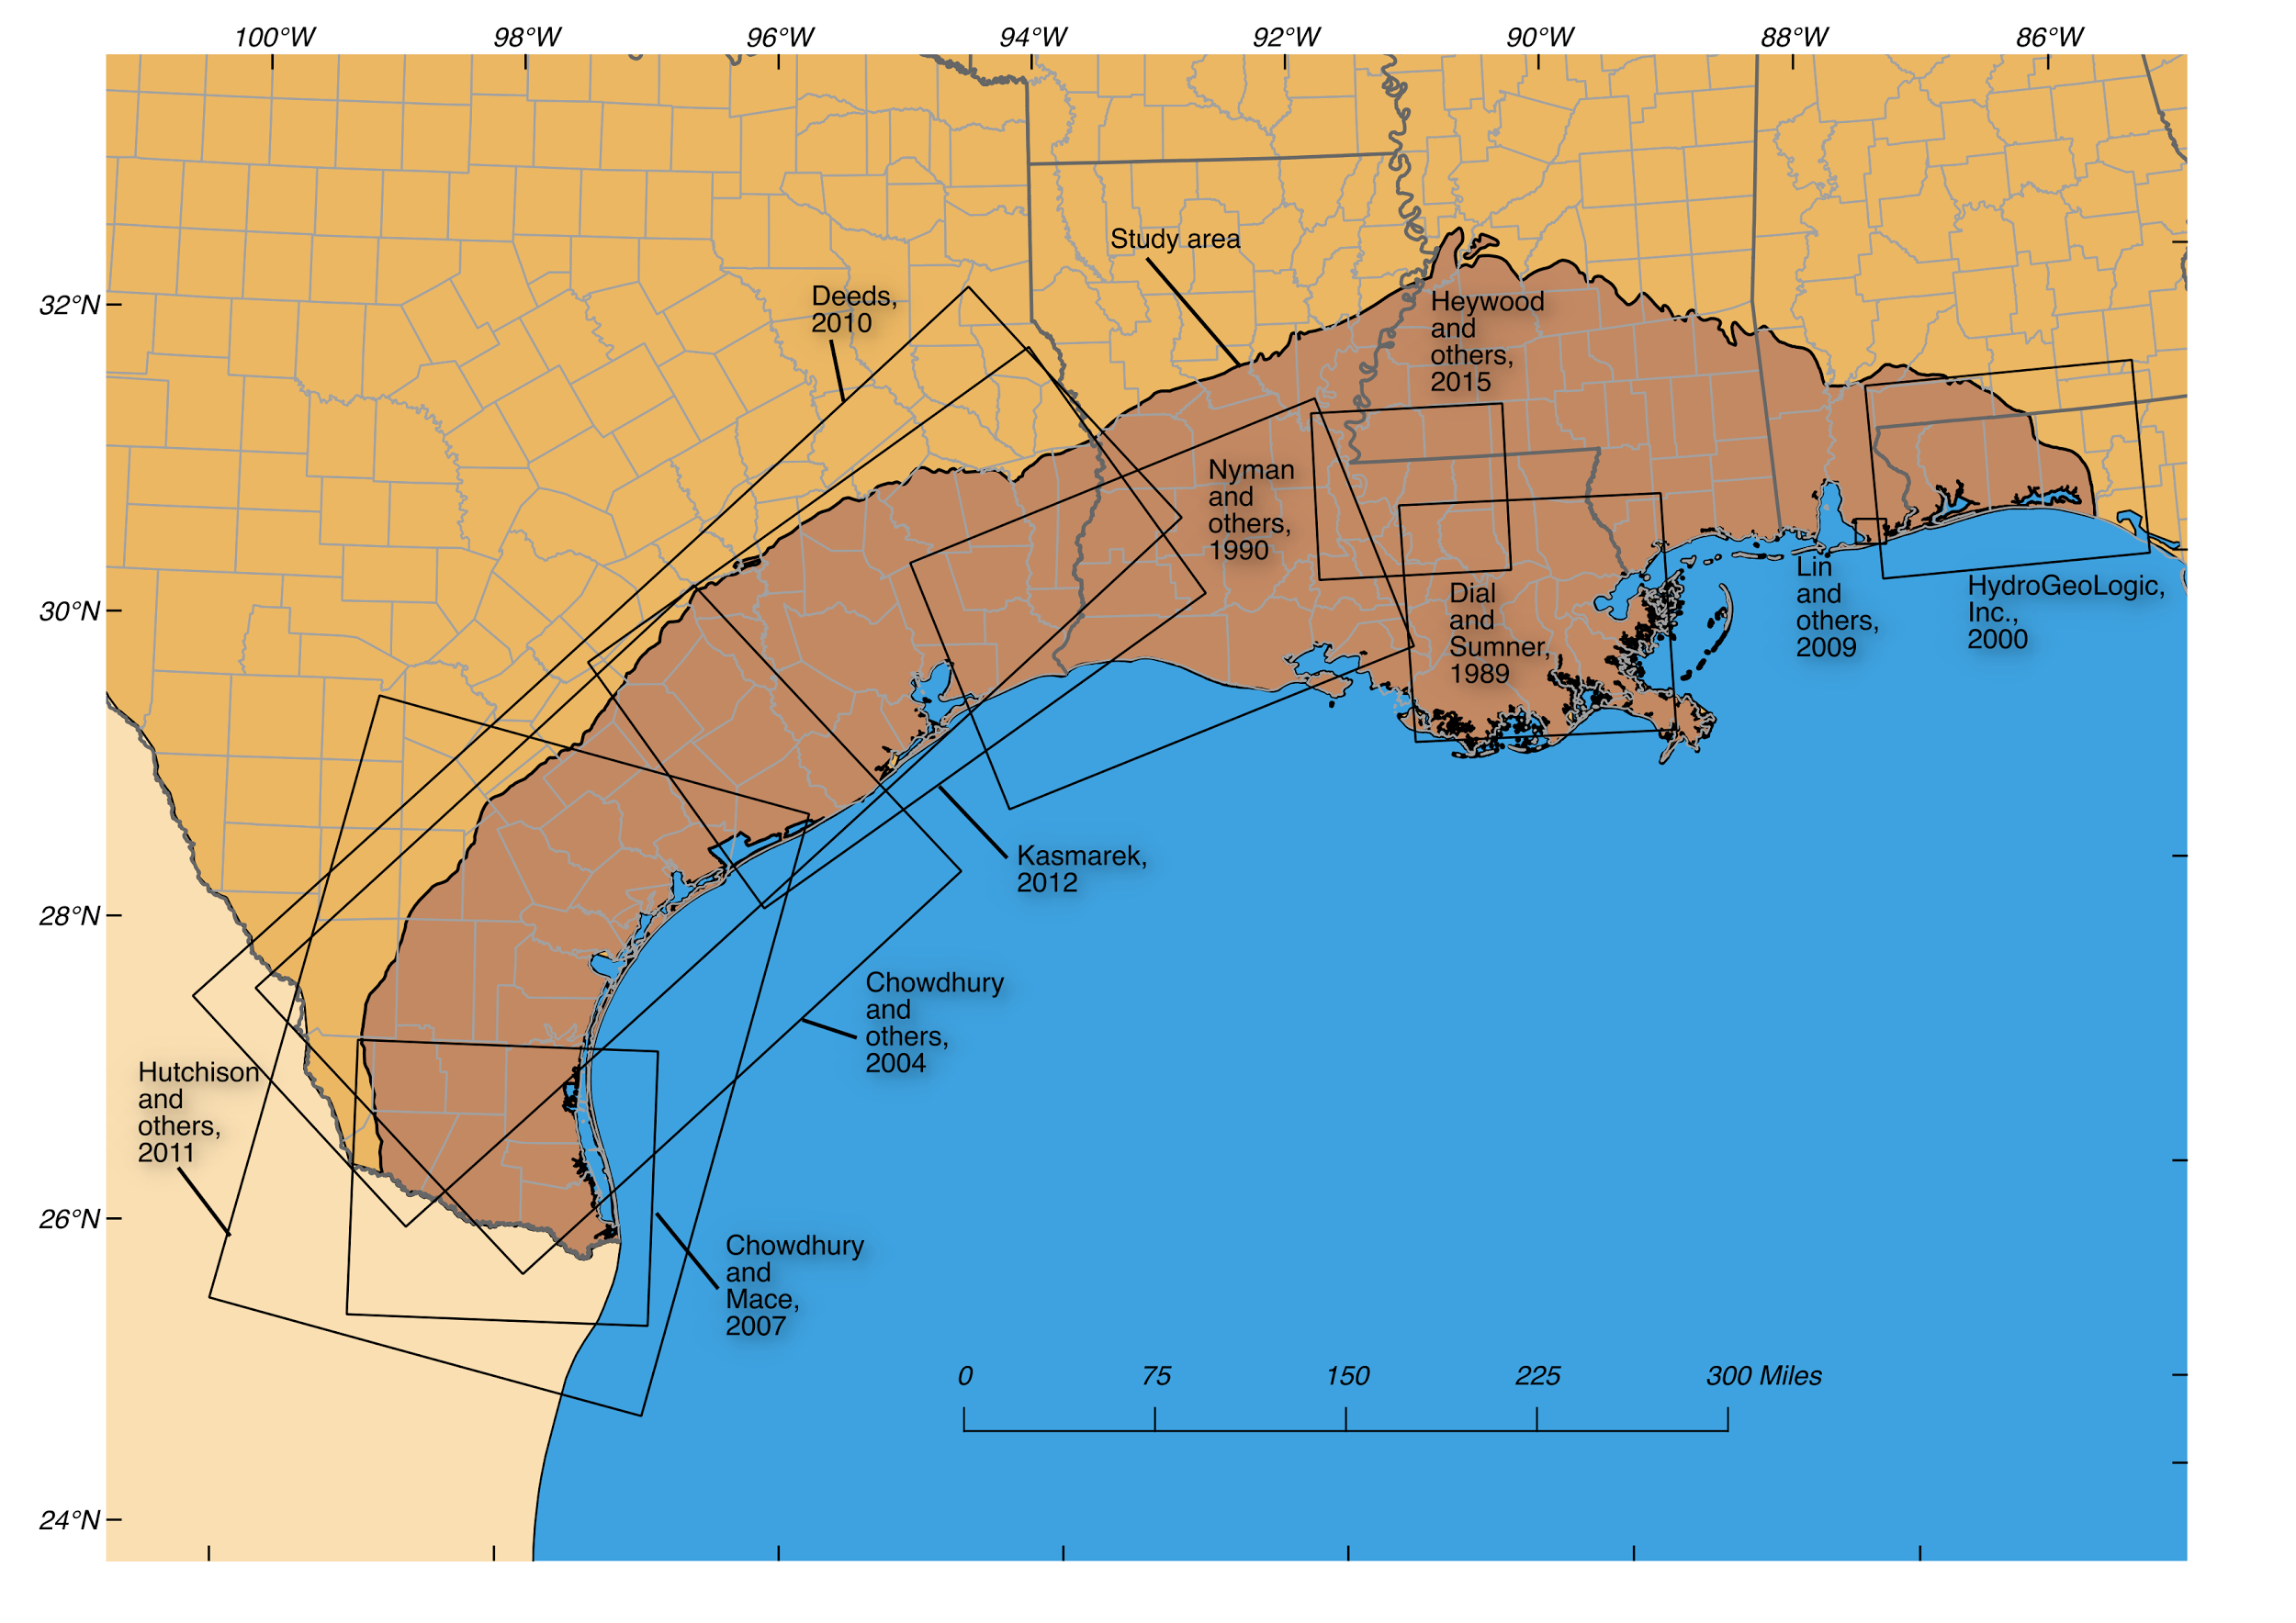
Figure 5. Previous model boundaries within the Coastal Lowlands aquifer study (excludes GCRASA).

Water use compilation/extrapolation
Similar to the hydrostratigraphic framework, the water-use dataset compiled for the CLAS groundwater availability will be largely derived from recently completed, subregional and local scale studies (fig. 5). However, when necessary, the water-use dataset will be extended and/or revised to meet the goals of the CLAS analysis. Specifically, historic groundwater withdrawal data will be compiled/estimated for the Coastal Lowlands aquifer from 1890 to 2015 for municipal, irrigation, industrial, mining, livestock, aquaculture, and power-generation uses. The basic, anticipated workflow process for developing the water use dataset is described below.

Existing groundwater models

Water use data from several existing groundwater models will be used to build the water use data from the CLAS groundwater availability analysis. For the GCRASA study, The CLAS was separated into two regional studies: Texas and all States east of Texas.

Martin and Whiteman (1999) developed a groundwater flow model for the CLAS in Alabama, Florida, Louisiana, and Mississippi. The researchers divided the aquifer system into five permeable zones defined by age of the deposits which along with an upper boundary formed six-model layers. Correlation between previously defined aquifers and the five permeable zones are defined in the report. Results of the model showed that the systems natural-flow has been altered by groundwater development in the study area.

Ryder and Ardis (2002) developed a variable-density groundwater-flow model for the CLAS and Coastal Uplands aquifer system combined in Texas. The model contained 14 layers, five of which represent the CLAS and are defined as permeable zones similar to the groundwater-flow model developed in the Coastal Lowlands east of Texas. Although the report was not published until 2002, the model calibration period ended in 1982.

Groundwater withdrawal data from existing groundwater-flow models will be acquired and synthesized (fig. 5). Three groundwater-flow models were developed in Texas between 2004 and 2014 by 1) the U.S. Geological Survey (Kasmarek, 2012) for the northern portion, 2) Waterstone Environmental Hydrology and Engineering, Inc and Intera Inc. for the central portion, which was later recalibrated by the Texas Water Development Board (TWDB) (Chowdhury and others, 2004), and 3) the TWDB (Chowdhury and Mace, 2007) for the southern portion. The Gulf Coast Aquifer System as defined by the TWDB is composed of the Chicot and Evangeline aquifers, the Burkeville confining unit where it exists, and the Jasper aquifer. These models cover the spatial and vertical extent of most of the units that comprise the Coastal Lowlands aquifer in Texas. The three groundwater flow models are as follows:
- Gulf Coast Aquifer System (Northern portion) Groundwater Availability Model (GAM) http://www.twdb.texas.gov/groundwater/models/gam/glfc_n/glfc_n.asp
- Gulf Coast Aquifer System (Central portion) GAM http://www.twdb.texas.gov/groundwater/models/gam/glfc_c/glfc_c.asp
- Gulf Coast Aquifer System (Southern portion) GAM http://www.twdb.texas.gov/groundwater/models/gam/glfc_s/glfc_s.asp

The TWDB also completed a groundwater flow model for what they term Groundwater Management Area 16 (Hutchison and others, 2011) which includes the underlying Yegua-Jackson aquifer. In addition, the TWDB is also currently developing a groundwater flow model for Groundwater Management Areas 15 and 16 combined. This model essentially covers the central and southern GAM model areas and is expected to be completed in 2016.

A separate groundwater flow model was done by Intera, Inc. in 2008 (Deeds and others, 2008), for the Yegua-Jackson aquifer. The URL to the report and data is as follows: http://www.twdb.texas.gov/groundwater/models/gam/ygjk/ygjk.asp

Historical withdrawal data compiled for groundwater flow models of aquifers in southwestern Louisiana (Nyman and others, 1990), in the Baton Rouge area of southeastern Louisiana (Heywood and others, 2015), and in the New Orleans area of southeastern Louisiana (Dial and Sumner, 1989) also will be acquired and synthesized.

Historical water-use data for areas not represented by one of the above listed groundwater-flow models will be acquired and synthesized from the Gulf Coast Plain Regional Aquifer System Analysis (RASA) model (Grubb, 1988) or the CLAS in parts of the Alabama, Florida, Louisiana, and Mississippi groundwater flow model (Martin and Whitman, 1990; 1999). Data from a variable-density SEAWAT model for Baldwin County, Alabama (Lin and others, 2008) will also be incorporated. A model was also developed for the Northwest Florida Water Management District by HydrogeoLogic, Inc. (2000) simulating the Sand and Gravel aquifer (which correlates to the CLAS) as model layer 1.

Gap Filling
Gaps in the groundwater withdrawal data for the simulation period will be filled as follows: Site-specific data will be used for categories where facility or entity-level data exist and can be disaggregated to a well (point-source). Not all States meter or report site-specific withdrawals for rural domestic use, irrigation, livestock, and aquaculture and withdrawals for these uses are often estimated based on county-level acreage or populations. Groundwater withdrawals for these uses will be estimated either by disaggregating county-level data to a model cell or by estimation using a geospatial feature class of irrigated acres, crop type, and water application rate per crop. Due to the differences in the way each State collects and compiles their water-use data, historic groundwater withdrawals will likely be compiled by USGS water-use specialists in each state (Texas, Louisiana, Mississippi, Alabama, and Florida) for this effort . Groundwater withdrawals for domestic use are generally a small part of total water-use. It is currently unknown how statistically significant domestic water-use will be at the scale of this model. Backcasting techniques will be applied to estimate groundwater withdrawals back to 1890 for the extent of the Coastal Lowlands Aquifer

Forecast water-use scenarios
Forecast period water-use scenarios will be developed to simulate the expected spatial and temporal distribution of water use going forward in time. These water-use datasets provide a critical input into the analysis of projected, future groundwater availability. We anticipate building these forecast water-use datasets from population projection information. Given the nature of projected population-change forecasts, these datasets will contain substantial uncertainty. Therefore, uncertainty in the future water-use scenarios will be included in the final groundwater availability analysis.

Compilation of groundwater levels and land-surface subsidence
During the conceptual model development phase of the project, available groundwater-level data and land-surface subsidence data will also be compiled and catalogued. These historic data will be used for model history matching during the uncertainty analysis phase of the project.

Water-level data
Water-level data stored in NWIS for selected wells screened in Coastal Lowlands aquifers will be used to create the base of the groundwater water-level observation dataset. This includes the 700+ wells measured each year in the greater Houston area.
The NWIS water-level data will be supplemented with similar available data from state and local agencies and stakeholders. The TWDB Groundwater Database (GWDB) contains water level data which can used to supplement NWIS as well as independently maintained data from local groundwater conservation districts (GCDs) in Texas. Other state agencies with water-level data include the Geological Survey of Alabama, the Mississippi Department of Environmental Quality, and the Florida Department of Environmental Protection.

Land surface subsidence data
In the Houston-Galveston region, since 1973, long-term cumulative compaction data have been collected at 13 borehole extensometer sites documenting compaction rates and the resulting change in land-surface elevations. Since 1977, water-level data from wells have been annually collected and used to depict water-level altitudes and changes (Kasmarek and others, 2015). These data have been used to calibrate and verify 11 groundwater flow models with the three most recent USGS models simultaneously simulating not just head, but also subsidence (Kasmarek, 2012). Subsidence data collected at other locations, such as in Baton Rouge, will be compiled as available.

Surface-water groundwater interaction data
As appropriate, depending on the scale of the data, we will use any available measures of surface-water groundwater interaction, as this type of information provides important constraints on our understanding of available groundwater within the CLAS system. We anticipate several sources of this type of data, including previous model efforts, gain-loss studies, as well as baseflow separation techniques.

Development of MODFLOW6 input datasets
The proposed Coastal Lowlands modeling analysis encompasses approximately 99,000 square miles, which means that a relatively coarse resolution model must be used to achieve a manageable computational burden. However, many stakeholders are interested in higher-resolution, local-scale model outputs. To remedy this conflict, we will use MODFLOW6, a new version of MODFLOW that supports multiscale modeling.

In a multiscale modeling framework, models of two or more resolutions/discretizations are developed simultaneously for the domain. These multiple models are then used in concert to reduce computational burden while also yielding higher resolution model results where needed. In the proposed model analysis, we will build a coarse-scale model of the entire CLAS. This coarse-scale model will capture system dynamics at a regional scale. In concert with the development of the coarse-scale model, we are proposing to build at least one fine-scale model, focusing on Houston, Texas, contingent upon cooperator funding.

Undoubtedly, stakeholders within other regions of the coarse model domain will also have interest in a higher-resolution model of their area. To serve this anticipated need, we will develop tools to automate the construction of higher-resolution models within the domain of the coarse model. These tools will make use of a “feature class” concept where all relevant model construction datasets can be constructed programmatically from base point and line feature class datasets and related time-series data. For example, the information needed to construct a pumpage dataset includes location information (x,y,z) and time-series information for each pumping well. If tools are developed to programmatically build the model dataset from these base sources of information, then a model dataset for pumpage can be built for any arbitrary domain within the bounds of the CLAS.

The primary benefit of using MODFLOW6 with a multiscale modeling approach is that the paired models can be used simultaneously, where the coarse model provides distal boundary conditions for the fine-scale models, or any of the models can be run independently, depending of the desired use of the model(s).

During this task, we will build both the history-matching period model input datasets, as well as the forecast period model input datasets. Construction of all these datasets at this early stage in the CLAS project will afford many opportunities for in-depth, critical analyses related to groundwater availability in the CLAS region.

Addition of a subsidence process to MODFLOW6
While MODFLOW6 supports sophisticated multiscale modeling, it does not currently simulate subsidence processes, which are an important consideration for the CLAS. As such, we are proposing, as part of this effort, to build a subsidence process simulator into MODFLOW6. This task will be completed concurrent to the conceptual modeling phase of the project. The project team has had discussions with Office of Groundwater personal and a tentative plan for this enhancement to MODFLOW6 has been designed.

Development of Prior uncertainty estimates
In addition to the initial model dataset construction, the conceptual modeling phase of the project will include development of uncertainty estimates for CLAS model input datasets, including hydraulic properties and boundary conditions. These initial estimates of uncertainty, referred to as the Prior uncertainty, form a critical part of the modeling-based inference process, described in detail below. The Prior uncertainty estimates will be defined as part of geostatistical modeling process as well as by literature review and expert elicitation.

Task 3 - Conditioning of numerical model and predictions under uncertainty
Sophisticated modeling analyses, such as those proposed herein, are performed to increase the understanding of the aquifer system as a whole, but also, and usually more importantly, modeling analyses such as these are undertaken to increase our understanding of specific model outputs, referred to herein as quantities of interest (QOIs). These QOIs are difficult or impossible to directly observe, so we rely on the model to help us learn about these important quantities. To use the Coastal Lowlands model as a tool for learning about QOIs, we will employee an uncertainty quantification (UQ) framework, since UQ addresses the concept of learning as a process of decreasing QOI uncertainty through data assimilation. The importance of UQ is stressed in the Strategic directions for U.S. Geological Survey water science, 2012–2022—Observing, understanding, predicting, and delivering water science to the Nation by Evenson and others (2012):

“Strategic Action 16.—Develop and apply improved methods to estimate uncertainty in model simulations, and routinely assess and communicate model uncertainty to end users. Anticipation of potential future conflicts over water resources requires improved predictions of future water demands. These predictions require understanding of the relations between future demands and population, land use, and climate change, as well as improved understanding of the social-science factors influencing water use. Improved water-use data and complementary water-use science (Committee on USGS Water Resources Research, 2002) would allow the USGS to more accurately and effectively predict future water availability under different scenarios and provide needed information on which to base sound decisions.”

Even with the recognized importance of UQ, many modeling analyses are still completed without it. In fact many sophisticated modeling analyses spend so much effort on the construction of complex model input datasets, no time or resources are left to evaluate the value of said datasets in the context of the purpose for the model analysis: to reduce QOI uncertainty. That is, the majority of project budget and time are invested in dataset construction, leaving little time and/or resources to perform the critical analyses related to the QOIs. We will use two strategies to overcome this common problem. First, as previously discussed, we will build both the history-matching and forecast model datasets simultaneously so that we can monitor how the model reproduces the past while also monitoring what the model is forecasting for the QOIs. The other strategy that we will use to ensure a robust and in-depth modeling analysis of the QOIs is we will put the model into a UQ framework early in the model dataset construction process, when only rough estimates of model datasets are available. This will allow us to gain an understanding of the model performance at an early stage in the analysis so that we will have time to address model errors.

By starting with both the history-matching and forecast model in a UQ framework, we will be able to monitor the importance of increasingly complex datasets by comparing how changing the model datasets affects both the history-matching process as well as the QOIs. For example, water-use datasets typically consume a lot of resources, but follow the rule of diminishing returns, where minimal effort is needed to get a large portion of water-use information compiled into a form for use in the model. Rather than wait until the final, complete water use data set is available, we will instead perform a preliminary uncertainty analysis using the “rough” water-use dataset immediately, at an early stage in the project. If we have already completed a preliminary uncertainty analysis, then we will be able to quantify how using a more complete, but more costly, water-use datasets effects the uncertainty measures for the QOIs. We anticipate that this information will provide guidance for many other modeling analyses completed by the USGS.

Additionally, starting with the model in a UQ framework will allow several “iterations” of model analysis to be completed, where each iteration can be analyzed for model input errors or other problems that may need to be corrected.

Purpose-driven modeling and model forecasts
The goal of this modeling analysis is to improve the understanding of historic, current and future groundwater availability in the CLAS region. In general, the proposed analyses will focus on quantifying groundwater availability spatially and temporally, as it relates to the following water budget components:
- recharge
- coastal discharge
- surface-water gains and losses
- anthropogenic uses

The modeling analysis will focus on estimating, in a stochastic sense, water-budget components and potential subsidence under different climate and water-use scenarios. First, a baseline, current-conditions, forecast-period simulation will be completed using long-term average climate conditions and water use. Then, the following scenarios will be used to quantify the response of the CLAS to different combinations of climate change and water usage:
- long-term, low-intensity drought with current and increased water usage
- short-term, high-intensity drought with current and increased water usage
Note that the increased water usage datasets will be derived from population projections for the CLAS region.

To further focus and drive the CLAS modeling analysis as it relates to groundwater availability and potential subsidence, we are defining the following specific quantities of interest (QOIs):
- Volumetric groundwater storage changes at key locations within the CLAS region
- Water-level and drawdown at key locations within the CLAS region
- Surface-water groundwater interactions for major surface water basins within the CLAS region
- Coastal discharge for sensitive coastal areas within the CLAS region
- Maximum potential land surface subsidence at key locations within the CLAS region
Each of these QOIs will be evaluated as both absolute values from each of the proposed scenarios, as well as differences in model outputs compared to the baseline scenario.

Traditional model analyses proceed from model dataset construction to the process of “calibration”, where the model inputs are adjusted to reproduce past observations of system state, such as water levels, fluxes, concentrations, etc. Herein, we refer to “calibration” as history-matching, to clarify the process and to draw a distinction between how we are proposing to use the Coastal Lowlands model and how traditional modeling analyses are completed.

In contrast to traditional modeling analyses, we are proposing an UQ framework for the Coastal Lowlands modeling analysis. We anticipate using a recently-developed USGS tool, PEST++ (Welter and others, 2015), as the UQ framework. Within this framework, we will formally and rigorously define the uncertainty in the model inputs during the construction of the model input datasets. The existing, or “Prior” uncertainty is a stochastic description of the model inputs, including both hydraulic properties and boundary conditions, based on the current state of knowledge about the CLAS. For example, during construction of the model input datasets, we will use geostatistics to develop spatially-interpolated distributions of hydraulic conductivity. As previously discussed, the geostatistical analysis will also yield an interpolation variance distribution. This variance distribution describes the Prior uncertainty of hydraulic conductivity.

Within the UQ framework, the purpose of history-matching is to transfer information from past observations of system state to the model inputs, a process known as conditioning. During conditioning, the uncertainty in the model inputs is decreased by “learning” about the model inputs; the process of “learning” through history matching results in a new stochastic description of the model inputs known as the “Posterior”. The Posterior represents the combination of our understanding of the model inputs plus the information contained in the past observations of system state. We anticipate using the PEST++ engine for history matching, since it includes several sophisticated algorithms to reduce the computation demand for the history-matching problem.

Armed with the Prior uncertainty in the model inputs, and the results of an initial conditioning effort, we can use the forecast model to estimate the Prior and Posterior uncertainty of the QOIs, in essence, the uncertainty that exists in the QOIs before and after conditioning. An early understanding of the Prior and Posterior uncertainty in the QOIs will provide critical information to guide the remainder of the project, with respect to which observations are most important to reducing QOI uncertainties and which model inputs are contributing most to QOI uncertainty. A relatively low-cost estimate of QOI Prior and Posterior uncertainty can be estimated through the use of first-order, second-moment analysis (FOSM) (Kunstmann and others, 2002), also known as Bayes-linear estimation (Goldstein and Wooff, 2007). We anticipate using a recently-developed USGS tool, pyEMU (White and others, submitted) , for this analysis.

FOSM-based uncertainty estimates are focused on estimating the expectation and variance of the parameter and QOI Posterior distribution under the assumption of a linear relation between parameters and observations. While easy to compute and informative, the linearity assumption may not be robust, especially for highly non-linear inverse problems. To overcome this issue, we will also employ more rigorous, non-linear UQ techniques for the Coastal Lowlands model analysis. Most non-linear UQ techniques make use of an ensemble approach to Monte Carlo integration, where the Posterior distribution of parameters is approximated by propagating an ensemble of Prior realizations of model inputs through the conditioning process (Tarantola, 2005). For example, using the Prior distribution, we can generate any number of stochastic “realizations” of model inputs that respect the statistical properties of the Prior (e.g. respect our current understanding of the Coastal Lowlands system). Then, the objective of non-linear UQ is to condition by history matching each realization in the ensemble - adjust the model inputs for each realization so that each realization reproduces the past observations of system state acceptable well. Once each realization in the ensemble has been history-matched, the ensemble now approximates the Posterior parameter distribution. The Posterior ensemble can then be used to evaluate any number of QOIs. By running each realization in the Posterior ensemble under forecast conditions, we get a (non-linear) approximation the QOI Posterior distribution.

Obviously, non-linear UQ incurs a large computational burden and requires the use of parallel computing. We anticipate using the Texas Water Science Center cluster to fill this role. The cluster currently has 312 processors, each of which is serviced by solid state drives and is managed by the HTCondor run manager.

A highly-parameterized approach
The PEST++-based UQ framework discussed previously will require discretizing the model inputs into quantities known as “parameters”. These parameters are the quantities that will be assigned a Prior uncertainty and that will be adjusted during history-matching, in response to information contained in the past observations of system state.

It is critical that uncertain model inputs be treated as parameters. The reason for this is two-fold. First, a robust estimate of QOIs uncertainty requires that all contributing sources of uncertainty (e.g. model inputs) be recognized and included in the analysis. This means that all model inputs that affect the QOIs must be included as parameters (Oliver and others, 2008). The second reason for treating all uncertain model inputs as parameters is the more complex and more dangerous effects of model error. It has been shown that fixing uncertain model inputs can result in a phenomenon known as “parameter compensation”, which can ultimately bias and corrupt the QOI modeling analyses (White and others, 2014). For these reasons, we will employ “highly-parameterized” concepts (Doherty and others, 2010). A highly-parameterized approach to modeling analyses focuses on specifying parameters for most, if not all uncertain model inputs, and then relies on formal mathematical techniques known as “regularization” to enforce the Prior uncertainty on the parameters during history matching. The result of this approach to parameterization is parameters that respect expert knowledge about the CLAS, reproduce the past observations of system state, and, most importantly, capture the uncertainty that exists in the model inputs.

History matching dataset - full transient time-series matching
An important part of the uncertainty quantification process is data assimilation through history matching, where we learn about model inputs. This learning involves the process of transferring information from past observations of system state to parameters. To maximize the information available for transfer, we will use transient history matching to time-series observation data of water levels, fluxes, and subsidence to condition the ensemble of model inputs. These observation data, collected as part of Task 1, will be processed as necessary to decluster the data in space and in time, as well as to remove noise, such as high-frequency signal components that the model will not be able to reproduce.

Assessment of regional monitoring network
Following the process of ensemble generation and model inference, we will conduct a rigorous analysis of the current regional monitoring networks in the context of groundwater availability. Following the approach of purpose-driven modeling, this task will be undertaken in the context of the QOIs. That is, we will evaluate how effective and efficient the current regional monitoring network is with respect to our understanding of the QOIs.

The assessment of the regional monitoring network will be completed using first-order, second-moment assumptions using the recently-developed pyEMU tools (White and others, submitted). Specifically, the monitoring network will be evaluated by systematically comparing the relative increase in QOI uncertainty as a result of treating each location in the network as “missing”, that is no observation data from the location is used in the FOSM analysis. If QOI uncertainty increases substantially as a result of notionally losing a current monitoring location, then that location is important to our understanding of a given QOI.

Similarly, we can evaluate the relative importance of yet-to-be-collected observation data, that is, what currently unmonitored locations would be critical to our understanding of the QOIs. This type of analysis proceeds similarly to the evaluation of the current monitoring network, except in this case, we would systematically include model-simulated observation data from unmonitored locations into the FOSM analysis. If the addition of observations from a currently unmonitored location decreases the uncertainty of a given QOI, then that location is important to our understanding of the QOI.

Task 4 - Groundwater availability assessment
Once a fully-functional and conditioned posterior ensemble of model inputs has been developed, we will use this ensemble to make important and robust inferences about groundwater availability within the CLAS region. In addition to the specific QOIs discussed previously, groundwater availability will also be assessed by quantifying the key components of the hydrologic budget over time through the culmination of the previous tasks and simulations. Groundwater availability will be assessed through:
- Simulated historic, current, and future projections of groundwater levels. These will be used to evaluate changes in available groundwater resulting from pumping and climate variability.
- Temporal and spatial distribution of groundwater withdrawal rates affecting metrics of groundwater availability, specifically:
  - Aquifer storage changes
  - Coastal discharge
  - Surface-water groundwater interaction
  - Land-surface subsidence
- Groundwater sustainability – Related to the overall goal of assessing availability, sustainability is a complex issue and involves many hydrologic system components. Scenarios of potential future conditions can provide insight regarding sustainability based on certain, key metrics, such as those listed above.
- Development of a tool for the systematic evaluation of the CLAS regional monitoring networks with respect to groundwater availability.

Relation to other Regional Groundwater Availability Studies
The Coastal Lowlands study is adjacent to three ongoing or completed groundwater availability studies; the Floridan, MERAS, and the Mississippi Alluvial Plain (MAP) (fig. 1). The MAP focuses on 29,000 square miles of the Mississippi River Valley Alluvial aquifer (MRVA) north of Vicksburg, Mississippi and overlies the MERAS area (approximately 78,000 square miles). The MRVA (and equivalent units) extend south from the MAP study area boundary to the Gulf of Mexico, and will be represented in the CLAS. Previous models for both the MERAS and the CLAS have used a subsurface hydrologic boundary to separate the two aquifer systems (the Vicksburg-Jackson confining unit). The combined MAP, MERAS, and CLAS studies provide an opportunity to upgrade and update the models and better understand and describe the groundwater flux in the MRVA across that geohydrologic boundary. To the east, the CLAS abuts the Floridan aquifer system (approximately 100,000 square mile study area), effectively joining groundwater aquifer systems across 318,000 square miles. This area becomes even broader if the 69,000 square mile Ozark aquifer study is included through connection with the MERAS flow system (fig. 6).

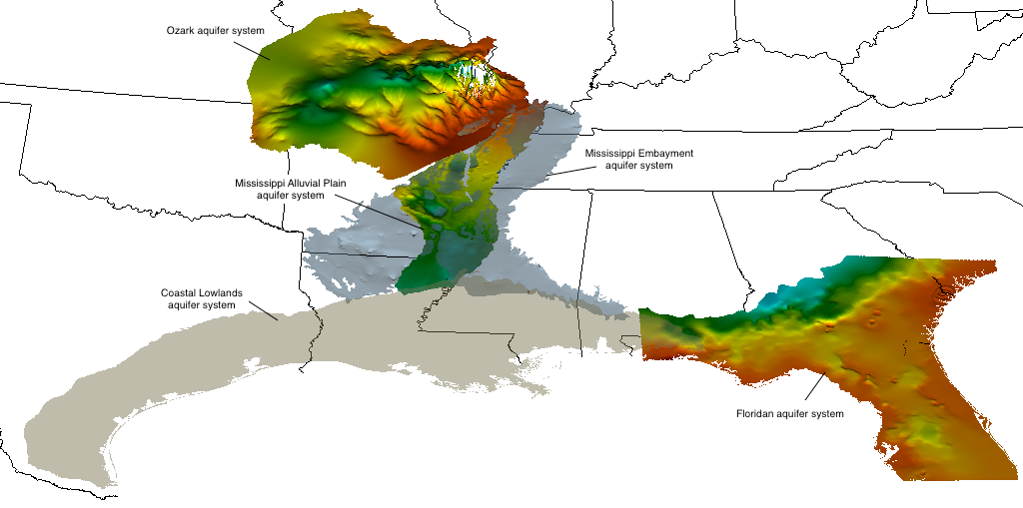
Figure 6. Oblique map showing relation of the CLAS to four ongoing or completed groundwater availability studies. (Colors indicate simulated or measured potentiometric surfaces; variable scales; all surfaces at 50 times vertical exaggeration).
Water use throughout the availability studies directly adjacent to the CLAS accounted for over 16 billion gallons per day in the year 2000, or 21 percent of the total water use from all Principal Aquifers in the U.S. (Maupin and Barber, 2005). Of these systems, the CLAS ranks third at 2,370 Mgal/day behind the MAP (9,290 Mgal/day) and the Floridan (3,640 Mgal/day). The evaluation of the CLAS in context with adjoining groundwater availability studies provides consistent and integrated information of the current status of the resource across political and geographic boundaries. Through numerical simulation, which entails a refined understanding of existing monitoring networks and aquifer properties, a more detailed water budget may be produced to better compare, contrast, and quantify groundwater as a National resource in the CLAS area.

Relation to other USGS Regional and National Programs, Projects and Mission Areas
The USGS National Water-Quality Assessment (NAWQA) Project is undertaking studies across the Nation to better assess predictors of susceptibility to contamination of public supply wells through modeling and mapping (M&M). These studies attempt to utilize previous or ongoing numerical models developed through groundwater availability studies. A recent M&M study began in the MERAS area and extends into the coastal uplands; both groundwater systems adjoin the CLAS. Because of the proximity and similarities in all study areas, information gained through the CLAS may be applicable to current or future M&M investigations. Additionally, because the M&M work in the coastal uplands involve assimilation of existing GAM models, the tools and knowledge gained through the conversion of these models within M&M are directly applicable to the coastal lowland GAM models acquired from TWDB. Aside from M&M involvement in the region, NAWQA also samples public supply wells for many constituents such as major ions, metals, nutrients, and others. These data can be of use in numerical modeling of the CLAS to better constrain flow directions and recharge estimates.
The CLAS model will address goals of the National Water Census, a USGS research initiative, to assess national water availability. Water availability is a function of natural factors and man-made processes that can be broken down into the individual components comprising a water budget. Basic components of water budgets are precipitation, evapotranspiration, surface-water and groundwater flows, changes in surface-water and groundwater storage, withdrawals, and interbasin transfers. Another objective of the National Water Census is to study seasonal variations in water-budget components. During the proposed study, both long-term and seasonal changes to groundwater withdrawals, groundwater flows, and groundwater storage in the CLAS are expected to be documented or simulated. This information will be useful for the future development of a more complete water budget and assessment of water availability for the region.
The LMG-WSC will initiate an investigation in support of the Resources and Ecosystems Sustainability, Tourist Opportunities, and Revived Economies of the Gulf Coast States (RESTORE) Act to evaluate the watershed and streamflow characteristics of coastal streams and rivers within the CLAS study area. The study is designed to evaluate streamflow alteration and temporal changes in streamflow metrics. The potential collaboration between the CLAS and RESTORE project teams will allow an opportunity to combine tasks within the two efforts. Heavy groundwater use in some basins in Alabama and Mississippi have altered streamflow and would result in changes to the streamflow metrics. The separate datasets developed for the two projects (RESTORE - basin characteristics, streamflow metrics, GAP analysis; CLAS - water use and irrigation, groundwater level metrics and trends, calibrated streambed conductance) can be combined through a collaborative team approach to fully evaluate the surface-water groundwater interaction, the effect of groundwater withdrawals on streamflow, and possible alterations to the streamflow metrics. The RESTORE streamflow metrics project is expected to begin in fiscal year 2017 allowing time for joint planning and identification of common datasets during 2016 and early 2017.
USGS Texas Water Science Center (TXWSC) staff are currently piloting an environmental assessment in cooperation with the USGS energy resources program. This assessment is focused on the potential groundwater quality and availability impacts resulting from open pit and in situ mining of an undiscovered uranium deposit in the sediments of south Texas, which includes formations that constitute the CLAS. The results from the proposed CLAS analysis will be useful to the uranium assessment to provide critical inputs into the portions of environmental assessment related to CLAS hydraulic properties and groundwater gradients, as well as the expected response to local and subregional portions of the CLAS to mining activities.
The USGS Wetlands and Aquatic Research Center (WARC) in Lafayette, Louisiana is conducting ongoing research on wetlands and aquatic ecology including the potential alterations of the systems in relation to groundwater salinity, declining groundwater levels, increasing water extraction for agricultural and other use, and drought/climate change. Investigations by WARC are being conducted on the ecology of tidal freshwater forested wetlands and being evaluated in terms of changes in salinity and relative sea-level rise (rising water levels or land subsidence). Additional investigations in wetland ecology, mangrove forests, and green-tree reservoirs have identified climatic and sea level changes, increased salinity in groundwater, and changes in water availability as possible key drivers for wetland and coastal ecosystem health. The CLAS investigation will provide more complete data sets on water withdrawals near the ecosystems under investigation, provide measured and simulated hydrographs to evaluate changes in groundwater levels, and provide an evaluation of possible surface-water loss to groundwater as water levels decline. WARC is also conducting research on the effects of freshwater remediation and the decrease in salinity levels that are conducive to plant regeneration and population growth. Management scenarios that result in decreased groundwater withdrawal, rising groundwater levels, and potential increased freshwater discharge to affected wetlands could be tested in models developed from the CLAS effort. The land subsidence package for MODFLOW6 may provide additional information on subsidence due to groundwater pumping and the potential impact on ecosystems due to relative sea level rise. The CLAS investigation will provide an opportunity for direct collaboration and possible linkage between the groundwater investigation and models and the research on macroecologic models for the northern Gulf of Mexico and hydrologic drivers for changes to the ecosystems.

Relation to local USGS projects, stakeholder needs, and collaborative opportunities - Need stakeholder letter of support
Several local and regional stakeholders have expressed interest the proposed CLAS groundwater availability analysis. These include academic institution, current cooperators, as well as other regulatory entities with interest is using the proposed modeling analysis to increase understanding of the CLAS. Several of these are described in more detail below.

The Houston area groundwater model (HAGM) (Kasmarek, 2012) is the fourth version of a numerical groundwater flow and land surface subsidence model for the southeast Texas portion of the CLAS region. The model is used by the Harris-Galveston subsidence district, the Fort Bend subsidence district and Texas Water Development Board as a resource planning tool. Current discussions are underway to update the HAGM to include more recent forcing conditions, as well as to use more physically-based boundary conditions. Part of these discussions includes the concept of using the regional-scale MODFLOW6 model, developed as part of this project, to set distal boundary conditions for the next HAGM version. This multiscale modeling approach would allow the HAGM to use a finer discretization and also occupy a smaller, more focus spatial extent.

The Baton Rouge sands model is being calibrated to simulate groundwater flow and saltwater transport in 10 aquifers that comprise the CLAS in the Baton Rouge, Louisiana area. Hydrologic structure, head observations, and withdrawal data that have been compiled in the model are transferable to the Coastal Lowlands model. Estimated hydraulic conductance and storage coefficients may also be transferable. Data compiled and resulting from the Coastal Lowlands model may also be transferable to Baton Rouge model, including recharge rates, surface-water groundwater interaction, and conditions along the Baton Rouge model boundaries. We anticipate the results of this modeling analysis can be used to provide important near-field boundary conditions to the Baton Rouge sands, resulting in a decreased computational burden and more consistency between the CLAS model and the Baton Rouge sands model.
A groundwater flow model of the Chicot aquifer in southwestern Louisiana is expected to be developed by a team of LSU researchers led by Dr. Frank Tsai. A proposal to create the model has been submitted to the State Water Resources Research Institute Program. The USGS Baton Rouge office would play a small role in that project, compiling structural data from geophysical logs and providing water-use information, all of which could also be used in Coastal Lowlands model. Dr. Tsai has also indicated that he would use results from the Coastal Lowlands model to establish boundary conditions in the Chicot aquifer model.
The CLAS investigation will directly support, and be supported by, an ongoing cooperative investigation in Harrison County, Mississippi. The investigation is being conducted to evaluate the ground-water resources of Harrison County, Mississippi. Since 1997, water samples have been collected at selected wells screened in the Citronelle, Graham Ferry, Pascagoula, Hattiesburg, and Catahoula Sandstone aquifers within the CLAS. Samples from the wells are analyzed for field properties (temperature, pH, specific conductivity, and color), total dissolved solids, chloride, iron, and manganese (Burt and Welch, 2007). Water levels are also measured at the wells to determine long-term water-level trends in the aquifers. The resulting information forms the foundation for many of the area's water-resources management and planning activities and allows for the early detection of possible problems for example, saltwater intrusion and contamination. (J. Barlow, undated at http://ms.water.usgs.gov/projects/HarrisonCounty/). During 1990 through 2010, Harrison County experienced a 13% growth in total population, 60% increase in public-supply population, 52% increase in groundwater withdrawals for public-water supply and 22% increase in groundwater withdrawals for self-supplied industrial use (Solley and other, 1993; Maupin and others, 2014). The increase in population and groundwater withdrawals in Harrison County Mississippi are representative of the increase stress to the CLAS in southern Mississippi.
The Mississippi Office of Land and Water Resource (OLWR), Groundwater Division has recently completed the correlation of borehole geophysical logs to delineate available aquifers within the Coastal Lowland Aquifer System in 13 counties of southeastern Mississippi. The Data derived from the analysis and interpretation of these logs is being utilized to delineate and characterize the major aquifers throughout the project area. The data and copies of the geophysical logs will be available to the USGS to evaluate and update the hydrogeologic framework of the CLAS (OLWR, undated)
Groundwater from the Coastal Lowland Aquifer System is an important source of water for irrigation, public-water supply and industrial uses in south Alabama. Water use from Baldwin and Mobile Counties alone has increased about 140% since 2000. The increased water has been associated with increased population growth in the coastal counties and rapid increases in irrigation (Solly and others, 1994, Maupin and others, 2014). Due to the increased groundwater use, the GSA, Groundwater Assessment Program (http://gsa.state.al.us/gsa/water/index.html) maintains a network of about 25 periodic and 5 real-time observation wells. Groundwater levels at 16 observation wells in the CLAS of south Alabama have set record low water levels since about 2005. The Geologic Survey of Alabama (GSA) and the Alabama Department of Economic and Community Affairs (ADECA) Office of Water Resources have been in discussion with the USGS LMG WSC regarding water use and potential groundwater issues associated with overuse of the aquifer, rapidly increasing irrigation, population growth, and water quality changes in the coastal aquifers. GSA is conducting an investigation on groundwater availability in Alabama and has started their evaluation in the coastal lowlands areas. Assessment of the groundwater in Alabama is currently underway by the GSA and will result in a series of reports describing groundwater availability, recharge, and groundwater withdrawals and impacts. The investigations are beginning in southeast Alabama (Cook and others, 2014). The GSA assessment of the areas counties underlain by the CLAS will be one of the next studies conducted and the GSA program will collaborate and share data and resources with the CLAS investigation.
The declining water levels in the CLAS and the increased agricultural and irrigation activities have resulted in a number of problems. Salt-water encroachment is a significant problem in the CLAS in areas with rapid increase in groundwater withdrawals for public-water supply in the coastal communities and for industrial use along bays and estuaries (Gillett and others 2000). Development in the coastal areas underlain by the CLAS has impacted coastal streams, Mobile Bay, and groundwater. An initiative is being conducted through funding resulting from the Deepwater Horizon oil spill to evaluate geologic, hydrologic, and geochemical characteristics, land-use impacts, and stream and estuary health (Cook, 2015). The increase in high intensity agriculture and irrigation has resulted in high nitrate concentrations in groundwater (Dowling and others, 2004). The high nitrate concentrations in groundwater and potential discharge to submarine groundwater discharge along the coast and in estuaries and lagoons have been linked to the occurrence of harmful algal blooms (HABs) in coastal water of south Alabama (Liefer and others 2009, Montiel, 2015, and Su, 2013). While the CLAS model will not explicitly simulate saltwater encroachment or other geochemical processes, the model will be developed to allow future simulation of these issues. Estimates of coastal flux volumes will be calculated using the model.
A groundwater model of the lower San Antonio River Basin to investigate potential effects of nearby groundwater pumping on streamflow in the river and its major tributaries is currently in development by the USGS in cooperation with the San Antonio River Authority. This model is currently in development and spans the San Antonio area south/southeast to the Gulf Coast. A portion of the CLAS is included within the study area and will be simulated to depths of municipal well supply. More detailed information for development of this more local scale model has been requested and received from local groundwater conservation districts. This local scale data will also aid in the CLAS model development.

Expected Results and Products
The expected products of the CLAS study include the following:
- Project web page providing information including objectives of the study, progress to date, data, data releases and publications and presentations.
- Scientific Investigations Report on the hydrogeologic framework, updated conceptual model (hydrologic conditions), development of the unconditioned numerical model (including model input datasets, and the prior uncertainty of model parameters).
- Journal article detailing the development of the new MODFLOW6 subsidence package and its application to the CLAS model
- Journal article detailing conditioning of the ensemble, predictive uncertainty, and data worth analysis.
- Professional Paper describing trends and projections in groundwater availability (water budget analysis) and subsidence in the CLAS, including evaluation of regional monitoring network (printed)
- Fact Sheet describing key findings (printed)
- Stochastic version of the GWWebFlow model viewer for CLAS model

Expected data management / data release products include:
- Data Release 1: Framework (surfaces and point data)
- Data Release 2: Conceptual model and model archive 1 (which includes water use datasets and model construction datasets as well as the prior uncertainty description and the unconditioned ensemble of parameters)-- see http://water.usgs.gov/GIS/metadata/usgswrd/XML/sir2016_5022_usgsdatarelease.xml as example
- Data Release 3: Model archive 2: Conditioned ensemble, updated model datasets, and predictive uncertainty results (which includes model scenarios to investigate current groundwater availability, trends, increases in water use, climate change/drought)

Project Schedule
See Appendix 1 (separate document – PDF).

Budget
The total requested funds (gross) are $1,557,650 over a 5-year period. This results in an approximate (net) funding of $1,073,123.20 to cover the following costs:

Name | FY 17 | FY 18 | FY 19 | FY 20 | FY 21 | Total Hours per Staff | Total Salary+Benefits (Net Cost)
Carmichael, John (Jack) | 520 |  |  |  |  | 520 | $33,254.00
Clark, Brian R | 320 | 1120 | 1040 | 680 | 540 | 3700 | $259,870.60
Foster, Linzy | 320 | 1120 | 1040 | 1120 | 540 | 4140 | $209,169.40
Gordon, John D |  |  | 120 | 60 | 120 | 300 | $23,281.20
Houston, Natalie A |  | 1040 |  |  |  | 2080 | $55,244.80
Kasmarek, Mark C | 520 |  |  |  |  | 1040 | $35,630.40
Lovelace, John K | 520 |  |  |  |  | 520 | $41,007.20
Ramage, Jason K |  |  | 520 |  |  | 520 | $25,256.40
Sargent, B. Pierre | 1040 |  |  |  |  | 1040 | $61,464.00
Terry, Deanna E | 80 |  |  |  |  | 80 | $3,691.20
Vrabel, Joseph |  |  |  |  | 160 | 160 | $7,926.40
Wallace, David S | 1040 |  |  |  |  | 1040 | $35,588.80
White, Jeremy T | 520 | 520 |  | 520 | 40 | 1600 | $101,370.80
Wilson, Jennifer | 100 | 100 | 100 | 100 | 100 | 500 | $27,368.00
Annual Hour Totals | 4460 | 3900 | 2820 | 2480 | 1500 | 15160 | $920,123.20
Table 1. Project hours per personnel per fiscal year and salary breakdown per personnel

Task | FY 17 | FY 18 | FY 19 | FY 20 | FY 21 | Task/Subtask Total
Task 1 Framework | $109,891.60 | $27,622.40 |  |  |  | $137,514.00
Task 2 SUB package | $31,673.20 | $32,541.60 |  |  |  | $64,214.80
Task 2 Water Use Compilation | $97,052.80 | $27,622.40 |  |  |  | $124,675.20
Task 2 Observation Dataset Compilation | $18,259.20 |  |  |  |  | $18,259.20
Task 2 Development of Prior Uncertainty Distributions | $18,259.20 |  |  |  |  | $18,259.20
Website Setup | $3,691.20 |  |  |  |  | $3,691.20
Task 2 Updated Conceptual Model, Numerical Model Development |  | $121,908.80 | $9,052.80 |  |  | $130,961.60
Task 2 Development of Scenarios |  | $9,377.60 | $87,900.80 |  |  | $97,278.40
Task 3 Conditioning of Ensemble |  |  | $62,644.40 | $64,433.20 |  | $127,077.60
Task 3 Predictive Uncertainty |  |  |  | $66,034.40 | $2,726.80 | $68,761.20
Task 4 GW Avail. Assessment |  |  |  | $15,679.20 | $78,457.20 | $94,136.40
GWWeb Flow Stochastic Viewer |  |  |  |  | $7,926.40 | $7,926.40
Management | $5,169.00 | $5,313.00 | $5,465.00 | $5,626.00 | $5,795.00 | $27,368.00
Annual Salary Totals | $283,996.20 | $224,385.80 | $165,063.00 | $151,772.80 | $94,905.40 | $920,123.20
Table 2. Task/subtask salary costs per fiscal year.

Other Expenses:
Travel for meetings/presentations 10k per year | $50,000
Journal Article SUB package | $4,000
SIR framework, updated conceptual model, the prior, model, unconditioned ensemble | $25,000
Journal Article Conditioned model and predictive uncertainty | $4,000
Professional Paper | $40,000
Fact Sheet | $10,000
Computing hardware | $20,000
Table 3. Costs for other expenses related to travel, publications, and computing power.

 | Cost Center
Fiscal Year | Texas | Lower MS Gulf
2017 | $232,289.85 | $224,452.99
2018 | $235,172.36 | $110,234.88
2019 | $187,553.99 | $105,801.28
2020 | $176,305.18 | $71,561.02
2021 | $155,444.90 | $58,828.52
Total | $986,766.28 | $570,878.69 | $1,557,644.97
Table 4. Gross cost estimates per year, per water science center.

Communications Plan
An important part of stakeholder and public engagement is web presence. To best serve the numerous cooperators as well as the general public, we will develop a significant web presence, including a general information/project status web page, as well as dedicated map-based viewers for both the hydrostratigraphic framework as well as the model inputs and outputs throughout the span of the project timespan. The web page will contain information related to project objectives, products, progress, and how this project relates to ongoing issues of groundwater availability for local and state stakeholders.

Given the broad spatial extent of this project and the high-level of interest in the CLAS, stakeholders will be engaged across several municipalities, regions and states. Potential stakeholders include:
- Harris Galveston Subsidence District
- Fort Bend Subsidence District
- Lone Star Groundwater Conservation District
- Texas Water Development Board
- Texas Commission on Environmental Quality
- Louisiana Water Resources Commission
- Louisiana Department of Natural Resources
- Louisiana Department of Transportation and Development
- Capital Area Ground Water Conservation Commission
- Louisiana Rice Growers Association
- Mississippi Department of Environmental Quality
- Alabama Department of Economic and Community Affairs
- Alabama Office of Water Resources
- Alabama Department of Environmental Management
- Geologic Survey of Alabama
- Northwest Florida Water Management District
- Florida Department of Environmental Protection

Since several members of the project staff have previously-developed relationships with many of these stakeholders, we will rely on individual project members to informally communicate project information on an as-needed basis as these project members know their local cooperators and stakeholders best.

In addition to the informal stakeholder engagement, we will also have regularly-scheduled, formal presentations at key project milestones, including:
- Project initiation
- Project completion of various products (framework, conceptual model, numerical model)
- Project completion

Quarterly or semi-annual board meetings of known organizations will be used to initiate face-to-face meetings with potential stakeholders in the first year of the project. Beyond the first year, virtual meetings may substitute in place of some face-to-face contacts. Project members in each participating state will identify potentially interested stakeholders to include in milestone updates and involvement on the project.
Periodic progress updates will be supplied to WAUSP through written communication or conference calls.
Typically, multiple conferences with strong USGS and stakeholder attendance are available throughout each year. Project presentations at these conferences will seek to display project milestones and introduce upcoming products. In many instances, conference presentations provide additional implicit deadlines within the project to promote overall timeliness.
Monthly calls will be set up between task leaders on the CLAS project to discuss progress, troubleshoot technical/data issues, discuss upcoming meetings and presentations, and to set targets for the next meeting.

Data -Management and Model-Archiving Plan
The CLAS project will follow the guidelines and requirements described in the OSQI Instructional Memorandum (IM OSQI 2015-01) for data management and the Office of Groundwater Technical Memorandum 2015.02 for model archival and any new guidelines for data management and model archival to support the research and published results, assure that the data and models are available for future research, and to assure the data and models are available to the public and other researchers.

A detailed data management plan for the CLAS will be developed in FY2016. The data management plan will rely on the data management process described in the USGS Data Management web site (http://www.usgs.gov/datamanagement/index.php) and the Data Management Plan Guidance available through the National Water Census data management web site, http://water.usgs.gov/watercensus/internal/. The data management plan will include information on the data to be compiled from outside agencies, data collected by the USGS for other projects, data compiled by the USGS for the CLAS projects, preparation of the appropriate metadata to describe the data, and procedures/resources to publish, share, and archive the data and model files. The project data and associated metadata will be loaded and available through an appropriate data catalog and portal, such as National Water Information System, ScienceBase, National Groundwater Monitoring Network pages, or the WRD NSDI Node.

Data management forms have been completed as part of this work plan for select datasets and planned data releases and are included as Appendix 2 (see separate document). The current set of data management forms will be revised and additional forms added to accommodate the full range of data activities and releases for the CLAS project. The Mississippi Alluvial Plain (MAP) investigation in the LMG WSC will coordinate with the CLAS study on shared resources and staffing specifically for data management and archival.

Data Input - new and existing data
Existing water use data from AWUDS
New water-use data from state and local sources
Site-Specific groundwater withdrawals from the Coastal Lowland Aquifer System
National Land Cover database
Model files and data sets - RASA Gulf Coast Aquifer
Model files and data sets - Texas Water Development Board (TWDB) Southern Gulf Coast Aquifer Groundwater Availability Model (GAM)
Model files and data sets - TWDB Central Gulf Coast Aquifer GAM
Model files and data sets - TWDB Northern Gulf Coast Aquifer GAM
Model files and data sets - TWDB Yegua-Jackson GAM
Water level and streamflow data from National Water Information System (NWIS)
Water level data and streamflow data from the Texas Water Development Board (TWDB) Groundwater Database (GWDB), Geological Survey of Alabama, and other state and local agencies
Geophysical logs

Planned data releases
Data Release: Hydrogeologic framework (surfaces and point data)
Data Release: Conceptual model and model archive 1 (includes water use datasets)
Data Release: Model archive 2

Groundwater models for the CLAS will be archived and made available following the policy and guidelines established in Office of Groundwater Technical Memorandum 2015.02. The CLAS model will be documented to a manner that can be accessed and will allow evaluation and reproduction of the published model results. The model files and supporting data will be electronically archived on an USGS WSC server and on a public-access data repository. The procedures and a public-access repository for groundwater models are currently not fully defined by OGW. At a minimum, data releases for the models will be available through a repository and formatted similar to the repository for the model described in “Simulated Effects of Alterations to the Hydrologic System on the Distribution of Salinity in the Biscayne Aquifer in Broward County, Florida” SIR 2016-5022 by Hughes, Sifuentes, and White and available at http://water.usgs.gov/GIS/metadata/usgswrd/XML/sir2016_5022_usgsdatarelease.xml. The model archives will be verified and approved by the WSC approving official and verified by the WSFT using the Model Archive Verification and Approval Form. A copy of the form is included in the Data Management Appendix.

Key Project Personnel
Primary project personnel, their planned roles, and areas of expertise:

Linzy Foster
TXWSC
Project lead, Modeling, GIS, SWB

Brian Clark
LMGWSC
Project lead, Modeling, GIS, SWB

Jeremy White
TXWSC
Software/code development, uncertainty analysis

Natalie Houston
TXWSC
Water use, GIS

John Lovelace
LMGWSC
Water use

Jack Carmichael, Wade Kress
LMGWSC
Hydrogeologic framework

Mark Kasmarek
TXWSC
Hydrogeologic framework

Selected References:
Barlow, P.M., Cunningham, W.L., Zhai, Tong, and Gray, Mark, 2014, U.S. Geological Survey Groundwater Toolbox, a graphical and mapping interface for analysis of hydrologic data (version 1.0): User guide for estimation of base flow, runoff, and groundwater recharge from streamflow data: U.S. Geological Survey Techniques and Methods, book 3, chap. B10, 27 p., http://dx.doi.org/10.3133/tm3B10.
Burt, Jr., D.E., and Welch, H.L., 2007, Quality of water in selected wells, Harrison County, Mississippi, 1997–2005: U.S. Geological Survey Open-File Report 2007-1287, 16 p.
Chandler, R.V., Moore,J.D., and Gillett, Blakeney., 1985, Ground-water chemistry and salt-water encroachment, Baldwin County: Geological Survey of Alabama, Bulletin 126, 166 p. http://www.gsa.state.al.us/documents/pubs/onlinepubs/Bulletins/B126.pdf
Clark, B.R., Hart, R.M., and Gurdak, J.J., 2011, Groundwater availability of the Mississippi embayment: U.S. Geological Survey Professional Paper 1785, 62 p.
Chowdhury, A.H., Wade, S., Mace, R.E., and Ridgeway, C., 2004, Groundwater availability model of the central Gulf Coast aquifer system: numerical simulations through 1999: TWDB, 114 p.
Chowdhury, A.H., and Mace, R.E., 2007, Groundwater resource evaluation and availability model of the Gulf Coast aquifer in the Lower Rio Grande Valley of Texas: Texas Water Development Board Report 368, 119 p.
Cook, Marlon R., Moss, Neil E.,. Jennings, Steven P., McKinney, Mac, Rogers, Alana L., Smith, Kenneth M., Hinson, Amye S. and Norman, Ralph, 2014, Alabama Water Resource Assessment Groundwater Availability In Southeast Alabama: Scientific Data For Water Resource Development, Protection, Policy, And Management, Protection, Policy, And Management: Geological Survey Of Alabama, Open-File Report 1406, 125 p. http://www.gsa.state.al.us/gsa/water/publications/OFR/OFR%201406.pdf
Cook, Marlon, 2015, Monitoring and Restoration of Alabama Coastal Streams, in Proceedings of the 2015 Alabama Water Resources Conference & Symposium, September 2015, Orange Beach, Alabama, p14, http://aaes.auburn.edu/wrc/wp-content/uploads/sites/108/2015/10/2015-AL-WR-Conference-Proceedings.pdf
Coplin, L.S., and Galloway, Devin, 1999, Houston-Galveston, Texas—Managing coastal subsidence, in Galloway, Devin, Jones, D.R., and Ingebritsen, S.E., eds., Land subsidence in the United States: U.S. Geological Survey Circular 1182, p. 35–48.
Deeds, N.E., Yan, Tingting, Singh, Abhishek, Jones, T.A., Kelly, V.A., Knox, P.R., and Young, S.C,, 2010, Final Report: Groundwater Availability Model for the Yegua-Jackson aquifer: Texas Water Development Board, 582 p.
Dial, D.C., and Sumner, D.M., 1989, Geohydrology and simulated effects of pumpage on the New Orleans aquifer system at New Orleans, Louisiana: Louisiana Department of Transportation and Development Water Resources Technical Report no. 46, 54 p.
Doherty, J.E., Hunt, R.J., and Tonkin, M.J., 2010, Approaches to highly parameterized inversion: A guide to using PEST for model-parameter and predictive-uncertainty analysis: U.S. Geological Survey Scientific Investigations Report 2010–5211, 71 p., available at http://pubs.usgs.gov/sir/2010/5211.
Dokka, R.K., 2006, Modern-Day Tectonic Subsidence in Coastal Louisiana: Geology, v. 34, p. 281-284.
Dowling, C.B., Poreda, R.J., Hunt, A.G., Carey, A.E. 2004, Ground water discharge and nitrate flux to the Gulf of Mexico: Ground Water, 42 (3) (2004), pp. 401–417
Evenson, E.J., Orndorff, R.C., Blome, C.D., Bohlke, J.K., Herschberger, P.K., Langenheim, V.E., McCabe, G.J., Morlock, S.E., Reeves, H.W., Verdin, J.P., Weyers, H.S., and Wood, T.M., 2012, Strategic directions for U.S. Geological Survey water science, 2012–2022—Observing, understanding, predicting, and delivering water science to the Nation: U.S. Geological Survey Open-File Report 2012–1066, 42 p.
Gabrysch, R.K., 1979, Approximate altitude of water levels in wells in the Chicot and Evangeline aquifers in the Houston area, Texas, spring 1977 and spring 1978: U.S. Geological Survey Open-File Report 79–334, 4 sheets.
Gabrysch, R.K., and Bonnet, C.W., 1975, Land-surface subsidence in the Houston-Galveston region, Texas: Texas Water Development Board Report 188, 19 p.
Gabrysch, R.K., and Neighbors, R.J., 2005, Measuring a century of subsidence in the Houston-Galveston region, Texas, USA, in Seventh International Symposium on Land Subsidence, Shanghai, P.R. China, October 23–28, 2005, Proceedings: p. 379–387.
Galloway, Devin, Jones, D.R., and Ingebritsen, S.E., eds., 1999, Land subsidence in the United States: U.S. Geological Survey Circular 1182, 177 p., available at http://pubs.usgs.gov/circ/circ1182/
Gillett, Blakeney, Raymond, Dorothy E., Moore, James D., and Tew, Berry H., 2000, Hydrogeology and Vulnerability to Contamination of Major Aquifers in Alabama - Area 13: Geological Survey of Alabama, Circular 199A, 68 p , http://www.gsa.state.al.us/documents/pubs/onlinepubs/Circulars/area13rpt.pdf
Goldstein, Michael, and Wooff, David, 2007, Bayes linear statistics: theory and methods, Chichester, England, John Wiley, 536 p.
Griffith, J.M., 2003, Hydrogeologic framework of southeastern Louisiana: Louisiana Department of Transportation and Development Water Resources Technical Report no. 72, 21 p.
Grubb, H.F., 1984, Planning report for the Gulf Coast Regional Aquifer-System Analysis in the Gulf of Mexico coastal plain, United States; U.S. Geological Survey Water-Resources Investigations Report 84-4219, 30 p.
Grubb, H. F., 1998, Summary of hydrology of the regional aquifer systems, Gulf Coastal Plain, south-central United States: U.S. Geological Survey Professional Paper 1416-A, 75 p.
Heywood, C.E., Griffith, J.M., and Lovelace, J.K., 2014, Simulation of groundwater flow in the "1,500-foot" sand and "2,000-foot" sand, with scenarios to mitigate saltwater migration in the "2,000-foot" sand of the Baton Rouge area, Louisiana: U.S. Geological Survey Scientific Investigations Report 2013-5227, 63 p.
Heywood, C.E., Lovelace, J.K., and Griffith, J.M., 2015 (version 1.1), Simulation of groundwater flow and chloride transport in the "1,200-foot" sand with scenarios to mitigate saltwater migration in the "2,000-foot" sand of the Baton Rouge area, Louisiana: U.S. Geological Survey Scientific Investigations Report 2015-5083, 69 p.
Hutchison, W.R., Hill, M.E., Anaya, R., Hassan, M.M., Oliver, W., Jigmond, M., Wade, S., and Aschenbach, E., 2011, Groundwater management area 16 groundwater flow model: Texas Water Development Board, 306 p.
Hydrogeologic, Inc., 2002, Modeling of Ground Water Flow in Walton, Okaloosa, and Santa Rosa Counties, Florida: Northwest Florida Water Management District, 117 p.
Kasmarek, M.C., 2012, Hydrogeology and simulation of groundwater flow and land-surface subsidence in the northern part of the Gulf Coast aquifer system, Texas, 1891–2009: U.S. Geological Survey Scientific Investigations Report 2012-5154, 55 p., available at http://pubs.usgs.gov/sir/2012/5154/
Kasmarek, M.C., and Robinson, J.L, 2004, Hydrogeology and simulation of ground-water flow and land-surface subsidence in the northern part of the Gulf Coast aquifer system, Texas: U.S. Geological Survey Scientific Investigations Report 2004–5102, 111 p., available at http://pubs.usgs.gov/sir/2004/5102/
Kasmarek, M.C., and Strom, E.W., 2002, Hydrogeology and simulation of groundwater flow and land-surface subsidence in the Chicot and Evangeline aquifers, Houston area, Texas: U.S. Geological Survey Water-Resources Investigations Report 02–4022, 61 p., available at http://pubs.usgs.gov/wri/wri024022/
Kasmarek, M.C., Gabrysch, R.K., and Johnson, M.R., 2009, Estimated land-surface subsidence in Harris County, Texas, 1915–17 to 2001: U.S. Geological Survey Scientific Investigations Map 3097, 2 sheets, available at http://pubs.usgs.gov/sim/3097/
Kasmarek, M.C., Houston, N.A., and Ramage, J.K., 2009, Water-level altitudes 2009 and water-level changes in the Chicot, Evangeline, and Jasper aquifers and compaction 1973–2008 in the Chicot and Evangeline aquifers, Houston-Galveston region, Texas: U.S. Geological Survey Scientific Investigations Map 3081, 3 p., 16 sheets, available at http://pubs.usgs.gov/sim/3081/
Kasmarek, M.C., Ramage, J.K., Houston, N.A., Johnson, M.R., and Schmidt, T.S., 2015, Water-level altitudes 2015 and water-level changes in the Chicot, Evangeline, and Jasper aquifers and compaction 1973–2014 in the Chicot and Evangeline aquifers, Houston-Galveston region, Texas (ver. 1.1, October 2015): U.S. Geological Survey Scientific Investigations Map 3337, pamphlet, 16 sheets, scale 1:100,000, available at http://dx.doi.org/10.3133/sim3337/
Kazmann, R.G, and Heath, M.M, 1968, Land subsidence related to ground-water offtake in the New Orleans area: Gulf Coast Association of Geological Societies Transactions, v. 18, p. 108-113.
Kunstmann, Harald, Kinzelbach, Wolfgang, and Siegfried. Tobias, 2002, Conditional first-order second-moment method and its application to the quantification of uncertainty in groundwater modeling, Water Resources Research, v. 38, no. 4, p. 6-1 - 6-14, 1035, doi:10.1029/2000WR000022.
Liefer, J. D., MacIntyre, H.L., Novoveská, Lucie, Smith, W.L., and Dorsey, C.P., 2009, Temporal and spatial variability in Pseudo-nitzschia spp. in Alabama coastal waters: a “hot spot” linked to submarine groundwater discharge?: Harmful Algae, v. 8, no. 5, p 706–714, doi:10.1016/j.hal.2009.02.003
Lin, Jin, Snodsmith, J.B., Zheng, Chunmiao, and Wu, Jianfeng, 2009, A modeling study of seawater intrusion in Alabama Gulf Coast, USA: Environmental Geology, v. 57, no. 1, p 119-130.
Lovelace, J.K., 1999, Distribution of saltwater in the Chicot aquifer system of southwestern Louisiana, 1995-96: Louisiana Department of Transportation and Development Water Resources Technical Report no. 66, 61 p.
Lovelace, J.K., Fontenot, J.W., and Frederick, C.P., 2004: Withdrawals, water levels, and specific conductance in the Chicot aquifer system in southwestern Louisiana, 2000-03: U.S. Geological Survey Scientific Investigations Report 2004-5212, 56 p.
Lovelace, J.K., 2007, Chloride concentrations in groundwater in East and West Baton Rouge Parishes, Louisiana, 2004–05: U.S. Geological Survey Scientific Investigations Report 2007–5069, 27 p.
Martin, Angel, Jr., and Whiteman, C.D., 1999, Hydrology of the Coastal Lowlands aquifer system in parts of Alabama, Florida, Louisiana, and Mississippi: U.S. Geological Survey Professional Paper 1416-H, 51 p.
Martin, A. Jr. and Whiteman, C.D., 1990, Calibration and sensitivity analysis of a ground-water flow model of the Coastal Lowlands aquifer system in parts of Louisiana, Mississippi, Alabama, and Florida: U.S. Geological Survey Water-Resources Investigations Report 89-4189, 57 p.
Maupin, M.A., and Arnold, T.L., 2010, Estimates for self-supplied domestic withdrawals and population served for selected principal aquifers, calendar year 2005: U.S. Geological Survey Open-File Report 2010-1223, 10 p.
Maupin, M.A., and Barber, N.L., 2005, Estimated withdrawals from principal aquifers in the United States, 2000: U.S. Geological Survey Circular 1279, 46 p.
Maupin, M.A., Kenny, J.F., Hutson, S.S., Lovelace, J.K., Barber, N.L., and Linsey, K.S., 2014, Estimated use of water in the United States in 2010: U.S. Geological Survey Circular 1405, 56 p., available at http://dx.doi.org/10.3133/cir1405.
Miller, J.A., 1990, Ground Water Atlas of the United States: Segment 6, Alabama, Florida, Georgia, South Carolina: U.S. Geological Survey Hydrologic Atlas 730-G, 28 p.
Montiel, Daniel, 2015, Examining The Importance Of Submarine Groundwater Discharge (SGD) In A River Dominated Estuary: Example Of Mobile Bay, Alabama, in Proceedings of the 2015 Alabama Water Resources Conference & Symposium, September 2015, Orange Beach, Alabama, p. 28, http://aaes.auburn.edu/wrc/wp-content/uploads/sites/108/2015/10/2015-AL-WR-Conference-Proceedings.pdf
Murgulet, Dorina and Tick, Geoffrey, 2008, The extent of saltwater intrusion in southern Baldwin County, Alabama: Environmental Geology, v. 55, no. 6, p 1235-1245.
Murgulet, Dorina and Tick, Geoffrey, 2009, Assessing the extent and sources of nitrate contamination in the aquifer system of southern Baldwin County, Alabama: Environmental Geology, v. 58, no. 5, p. 1051-1065.
Murray, G.E., 1961, Geology of the Atlantic and Gulf Coastal Province of North America: New York, Harper Brothers, 692 p.
Noble, J.E., Bush, P.W., Kasmarek, M.C., and Barbie, D.L., 1996, Estimated depth to the water table and estimated rate of recharge in outcrops of the Chicot and Evangeline aquifers near Houston, Texas: U.S. Geological Survey Water-Resources Investigations Report 96–4018, 19 p.
Nyman, D.J., 1984, The occurrence of high concentrations of chloride in the Chicot aquifer system of southwestern Louisiana: Louisiana Department of Transportation and Development Water Resources Technical Report no. 33, 75 p.
Nyman, D.J., Halford, K.J., and Martin, A. Jr., 1990, geohydrology and simulation of flow in the Chicot aquifer system of southwestern Louisiana: Water Resources Technical Report no. 50, 65 p.
Oliver, D.S., Reynolds, A.C., and Liu, Ning, 2008, Inverse Theory for Petroleum Reservoir Characterization and History Matching, Cambridge University Press, May 2008, 394 p.
OLWR, Mississippi Office of Land and Water Resources, undated, Miocene (Grand Gulf) Aquifers: Miss Department of Environmental Quality, http://www.deq.state.ms.us/mdeq.nsf/page/L&W_WaterResourcesManagement?OpenDocument
Prakken, L.B., 2009, Groundwater resources in the New Orleans area, 2008: Louisiana Department of Transportation and Development Water Resources Technical Report no. 80, 36 p.
Reilly, T.E., Dennehy, K.F., Alley, W.M., and Cunningham, W.L., 2008, Ground-Water Availability in the United States: U.S. Geological Survey Circular 1323, 70 p., available at http://pubs.usgs.gov/circ/1323/
Renken, R.A., 1998, Ground Water Atlas of the United States: Segment 5, Arkansas, Louisiana, Mississippi, U.S. Geological Survey Hydrologic Atlas 730-F, 28 p.
Renken, R.A., 1996, Hydrogeology of the southeastern Coastal Plain aquifer system in Mississippi, Alabama, Georgia, and South Carolina: U.S. Geological Survey Professional Paper 1410-B, 111 p.
Ryder, P.D., 1988, Hydrogeology and predevelopment flow in the Texas Gulf Coast Aquifer systems: U.S. Geological Survey Water Resources Investigation Report 87-4248, 109 p.
Ryder, P.D., 1996, Ground Water Atlas of the United States: Segment 4, Oklahoma, Texas
U.S. Geological Survey Hydrologic Atlas 730-E, 30 p.
Ryder, P.D. and Ardis, A.F., 2002, Hydrology of the Texas Gulf Coast Aquifer Systems: U.S. Geological Survey Professional Paper 1416-E, XX p.
Sargent, B.P., 2011 (revised December 2012), Water Use in Louisiana, 2010: Louisiana Department of Transportation and Development Special Report No. 17, 135 p.
Solley, Wayne B., Pierce, Robert R and. Perlman, Howard A., 1993, Estimated use of water in the United States in 1990: U.S. Geological Survey, Circular 1081, 86 p, https://pubs.er.usgs.gov/publication/cir1081
Strom, E.W., Houston, N.A., and Garcia, C.A., 2003a, Selected hydrogeologic datasets for the Chicot aquifer, Texas: U.S. Geological Survey Open-File Report 03–297, 1 CD–ROM.
Su, Ni, Burnett, W.C., MacIntyre, H.L., Liefer, J.D., Peterson, R.N., and Viso, Richard, 2013, Natural Radon and Radium Isotopes for Assessing Groundwater Discharge into Little Lagoon, AL: Implications for Harmful Algal Blooms,” Estuaries and Coasts, v. 37, no. 4, p. 893–910, doi:10.1007/s12237-013-9734-9.
Tarantola, Albert, 2005, Inverse Problem Theory and Methods for Model Parameter Estimation, SIAM, 342 p.
Welter, D.E., White, J.T., Hunt, R.J., and Doherty, J.E., 2015, Approaches in highly parameterized inversion— PEST++ Version 3, a Parameter ESTimation and uncertainty analysis software suite optimized for large environmental models: U.S. Geological Survey Techniques and Methods, book 7, chap. C12, 54 p., http://dx.doi.org/10.3133/tm7C12.
Westenbroek, S.M., Kelson, V.A., Dripps, W.R., Hunt, R.J., and Bradbury,K.R., 2010, SWB-A modified Thornthwaite-Mather Soil-Water-Balance code for estimating groundwater recharge: U.S. Geological Survey Techniques and Methods 6-A31, 60 p.
White, J.T., Fienen, M.N., and Doherty, J.E. (in review). pyEMU: a python framework for environmental model uncertainty analysis. Environmental Modelling and Software.
White, J.T., Doherty, J.E., and Hughes, J.D., 2014, Quantifying the predictive consequences of model error with linear subspace analysis, Water Resources Research, v. 50 , 1152{1173. URL: http://dx.doi.org/10.1002/2013WR014767. doi:10.1002/2013WR014767.
Whiteman, C.D., Jr., 1980, Measuring local subsidence with extensometers in the Baton Rouge area, Louisiana, 1975-79: Louisiana Department of Transportation and Development, Office of Public Works Water Resources Technical Report no. 20, 18 p.
Williams, T.A., and Williamson, A.K., 1989, Estimating water-table altitudes for regional groundwater flow modeling, U.S. Gulf Coast: Ground Water, v. 27, no. 3, p. 333–340.
Yuill, Brendan., Lavoie, Dawn., and Reed, D.J., 2009, Understanding Subsidence Processes in Coastal Louisiana: Journal of Coastal Research, Special Issue 54, p. 23-36.

