Method Development to Estimate National Water Use Associated with Unconventional Oil and Gas – Phase 1
Kathleen Rowland (ND WSC), Kyle Blasch (WY-MT WSC), Joanna Thamke (WY-MT WSC), Roy Sando (WYMT WSC), Aldo “Skip” Vecchia (ND WSC), Janet Carter (SD WSC), Joshua Valder (SD WSC), Greg Delzer (SD WSC)

Introduction
Understanding the relation between production of energy and the water used to produce the energy is necessary component of any successful long-term energy strategy within the United States (U.S.). This relation applies to the entire life-cycle of both renewable and nonrenewable forms of energy and includes extraction, production, refinement, delivery, and disposal of waste byproducts. A summary of renewable and nonrenewable forms of energy is provided in Appendix 1 and serves as a framework for the categorization of energy types and the quantification of water use associated with energy development.

Currently nonrenewable forms of energy, such as fossil fuels, are the primary forms of energy used within the U.S. During 2011 crude oil accounted for 36.2 percent of all U.S. energy consumption, primarily for transportation (EIA, 2012). This was followed by natural gas and coal consumption primarily for electric power generation, accounting for 25.5 percent and 20.4 percent, respectively (EIA, 2012). According to the U.S. Geological Survey (USGS) (USGS, 2015), fossil fuels consisting of coal, crude oil, and natural gas are categorized as conventional (vertical drilling) or continuous (horizontal - hereafter referred to as unconventional) based primarily on their disposition within the environment. Conventional oil and gas accumulations are described as “discrete accumulations with well-defined hydrocarbon-water contacts, where the hydrocarbons are buoyant on a column of water. Conventional accumulations commonly have relatively high matrix permeabilities, have obvious seals and traps, and have relatively high recovery factors” (USGS, 2015). Because of the ease of extraction, conventional oil and gas extraction has historically been the most cost-effective to develop.

Recently, technological advances such as horizontal drilling, scarcity of access to conventional oil and gas fields, and the rise of oil and gas prices have resulted in development of unconventional oil and gas (UOG) accumulations. UOG accumulations are described as, “an oil resource that is dispersed continuously throughout a geologic formation(s) rather than existing as discrete, localized occurrences, such as those in conventional accumulations. Unconventional resources often require special technical drilling and recovery methods” (USGS, 2015). (Additional definitions are listed in Appendix 2.) Over the past decade changing technology has enabled a tremendous increase in access to unconventional plays across the nation.

Unconventional oil and gas development increases the potential to adversely affect water resources and ecosystems. The USGS is currently coordinating multiple interdisciplinary studies to assess the possible adverse effects (these studies are summarized in Appendix 3). Potential water-quality effects include spills from leaking wells, pipelines, pits or accidents that occur during the handling and disposal of the typically saline produced waters. In addition to potential effects on water quality, water availability and the potential for reduction in aquifer storage volumes are important considerations. The process of developing an oil well in the Williston Basin requires large volumes of water for initial fracturing processes; about 2 million gallons per well (National Geographic, 2013). The very high salinity of formation water from the Bakken and Three Forks plays requires approximately 3 to 4 times more water (6.6 to 8.8 million gallons) of additional water is needed to maintain these wells over the course of their life (30-40 years). The relatively recent (2005-present) utilization of UOG development to extract petroleum products in the Williston Basin provides a unique opportunity to characterize water use associated with UOG development. That is, water use in the Basin was relatively similar from year to year prior to 2005 and, thus, any substantive change in water use since then can be attributed to water use needs to support UOG development. As such, this provides the unique ability to better characterize water use associated with UOG development in the Basin and, subsequently, water use in other tight oil plays in North America.

National Oil and Gas Resources
The USGS Energy Resources Program conducts scientific investigations to assess the potential for undiscovered oil and gas resources in priority geologic provinces in the U.S. and around the world. Two methods are used; one for assessing conventional oil and gas resources and one for assessing unconventional oil and gas resources (USGS National Assessment of Oil and Gas Resources Team and Biewick, 2014).

The last comprehensive National Assessment (1995) used plays as the basic level of assessment (Schmoker, 2005). Plays are established primarily according to similarities of the rocks in which petroleum occurs. The U.S. Energy Information Administration recently (January 8, 2015) updated information which identifies current shale plays in the conterminous U.S. based on data from various published studies (fig. 1) (As of April 2015: http://www.eia.gov/oil_gas/rpd/shale_gas.pdf). Since 2000, the USGS National Oil and Gas Assessment (NOGA) uses subdivisions of the total petroleum system as the basic level of assessment as they are considered to be more closely associated with the generation and migration of petroleum than are plays (Schmoker, 2005). The NOGA has been reassessing basins of the U.S. that are considered to be priorities for oil and gas resource development, rather than assessing all of the basins of the U.S. These 32 basins (table 2) represent about 97% of the discovered and undiscovered oil and gas resources of the United States (As of April 2015: http://energy.usgs.gov/OilGas/AssessmentsData/NationalOilGasAssessment.aspx).

Of the 32 basins reassessed for undiscovered oil and gas resources, 14 were reassessed for unconventional oil (table 2, fig. 2). The total mean undiscovered, technically recoverable volume of oil in the U.S was estimated to be 13,038 million barrels. The majority (56 percent or 7,375 million barrels) of mean undiscovered oil is within the Williston Basin (Gaswirth and others, 2013). This is followed by about 13 and 7 percent estimated for the Gulf Coast and Alaska’s North Slope, respectively. The Powder River Basin is ranked seventh (3.3 percent) and is proposed as a likely candidate for Phase II work (discussed later). Water-use research in the Powder River Basin will complement a soon to be completed, in depth, USGS groundwater model for the Williston and Powder River Basins. The Permian Basin, Gulf Coast, and Alaska’s North Slope are also proposed for Phase II work; however, only one will be selected. Selection will be based on how recently UOG development has been occurring in the basin, with emphasis on the one with the most recent, and robust development. A basin with these characteristics will further develop and calibrate water-use coefficients and provide useful parameters for extrapolation to other tight oil plays.

In consideration of the 32 basins reassessed for undiscovered, technically recoverable unconventional gas in the U.S., the total mean was estimated to be 737.62 trillion cubic feet (table 2). The largest estimated mean volume (18 percent; 131.98 of 737.62 trillion cubic feet) was associated with the Gulf Coast, followed by the Marcellus Shale and Southwestern Wyoming at 11.4 and 11.1 percent, respectively. The estimated volume of undiscovered continuous gas was much less for the Williston Basin, which ranked 15th of the 32 basins; about 1 percent (7.61 of 737.62 trillion cubic feet) of undiscovered gas was estimated in the Williston Basin.

Unconventional accumulations of oil in the U.S. are being produced using horizontal drilling technologies, which expose a larger amount of reservoir for thin horizontal units to the wellbore than vertical wells, and hydraulic fracturing, which stimulates movement of hydrocarbons in tight-oil reservoirs (Gaswirth and others, 2013). These relatively recent technological advances have rapidly expanded the production from continuous formations in the Northern Great Plains, most notably the Bakken and Three Forks Formations in North Dakota and Montana. Oil production in North Dakota alone has increased from a nominal level in 2005 to over 1 million barrels per day in 2014 (Aasand, 2014). Similar patterns in production can be assumed in other continuous formations around the U.S., all of which collectively highlight the need to develop an approach to better characterize water use associated with unconventional oil and gas development. These continuous formations include the Barnett shale (Ft. Worth Basin, TX), Eagle Ford (Gulf Coast Basin, TX), Haynesville shale (Gulf Coast Basin, LA and TX), Fayetteville shale (Arkoma Basin, Arkansas), and Marcellus shale/Utica shale (Appalachian Basin, PA).

[Note: UOG plays to be tentatively selected for further review and possible analysis for this project will be the next 13 plays listed after the Williston Basin in this table.]

National UOG Water Use
Gallegos and Varela (2015) conducted an analysis of nearly 160,000 oil and gas wells from these basins (Table 2) contained in the IHS database (IHS Energy, 2011) that were hydraulically fractured from 2000-2010 across the conterminous United States. The authors estimate an average water use of 9.2 acre-ft per well for this period. The authors found an increase in water use with time, more water used to hydraulically fracture horizontal wells compared to vertical and directional wells, and more water used to hydraulically fracture gas wells compared to oil wells.

Haines (2015) methods of assessing water and proppant quantities associated with UOG development. His methods rely heavily on the methods used by the USGS Energy Resources Program to assess potentially recoverable oil and gas resources within particular geologic formations. The USGS assessment methodology for continuous petroleum accumulations includes fundamental concepts such as geologically defined assessment units, and probabilistic input values including well-drainage area, sweet- and non-sweet-spot areas, and success ratio within the untested area of each assessment unit. The methods proposed in this workplan will assess direct and indirect water uses and will rely on perspective and needs for the National Water-Use program and are not geologically-focused. These two approaches of assess water use in UOG areas have distinct focuses and purposes, making them complimentary methods to assess water needs related to UOG development.

The USGS Energy Resources Program has a license to access the IHS database which is the most comprehensive database for UOG water use in the nation. While access to the database would be advantageous to this study and to the USGS water use program, the private database has an annual cost about $500,000. Unfortunately, USGS programs outside of the Energy Resources Program are unable to use the same license.

The U.S. Environmental Protection Agency recently (June 2015) completed an assessment of potential impacts of hydraulic fracturing for oil and gas on drinking water resources (USEPA, 2015). The assessment includes information for water acquisition with estimates of water use per well and cumulative water use and consumption. The information is presented at a state and county scale for counties where water use for hydraulic fracturing exceeded 10 percent of the 2010 total water use estimated by the USGS. This assessment is useful for understanding an overall estimate where there is a substantial amount of water used for UOG; however, not all counties with UOG water use were included.

Williston Basin Study Area
The Williston Basin is a large intracratonic; roughly circular, sedimentary basin located in western North Dakota, northwestern South Dakota and eastern Montana and encompasses parts of the Canadian provinces of Saskatchewan and Manitoba (fig. 3). The basin covers approximately 300,000 square miles and is deepest at its center, which is located beneath Williston, North Dakota, with the strata (or formations) becoming both shallower and thinner towards its margins.

Oil and gas was discovered in the basin in the 1920s and 1930s but producing well development did not start in North Dakota until the early 1950s (As of April, 2015: http://aoghs.org/states/north-dakota-williston-basin/). The first well in the Bakken Formation was drilled in 1951 near Tioga in northwest North Dakota. It soon became evident that conventional (vertical) drilling techniques would not yield the amounts of recoverable crude needed to make oil recovery in this play profitable. Though the Bakken Formation covers nearly 200,000 square miles in the Williston Basin, oil and gas development was also limited because the formation was of low permeability and about 5% porosity or less. Cuttings from borehole drilling in this formation yield rock material that is dense with no pores evident to the naked eye. However, to the touch, these cuttings have an “oily” or “greasy” feel indicating the presence of crude oil. Even though estimates of the oil reserves for this formation would continue to rise over the next several decades, actual development of the oil and gas resources in the region peaked and waned over this period depending on the economic oil market and political climate at the time.

Recoverable oil in Bakken
The retrieval of recoverable oil and gas in the Bakken Formation depended on the resources available as well as the advancement in extraction techniques. Throughout the years various studies focused on the Bakken reserves with no two reports agreeing on the amount of recoverable oil and gas.
- 1974 – A landmark paper by Dow recognized the Bakken Formation as a major source for the oil produced in the Williston Basin and suggested the Bakken was capable of generating 10 billion barrels (BBL) of oil in the US and Canada (Dow, 1974)
- 2008 –USGS published a report estimating between 3.0 and 4.3 BBL of recoverable oil in the US portion of the Bakken Formation.
- 2008 ND Department of Mineral Resources estimated 167 BBL of oil but only 2.1 BBL recoverable with current technology in North Dakota.
- 2013 – USGS estimated 7.4 BBL of technically-recoverable oil in the US portion of the Bakken and Three Forks Petroleum Assessment Areas.

Development of Unconventional Oil and Gas in the Bakken Formation and North Dakota
Unconventional oil and gas development in the Bakken Formation began to expand in the late 1990’s with the application of horizontal drilling, hydraulic fracturing technology, and refinements in other support technologies. Moreover, higher prices for both domestic and foreign oil at this time enabled the more cost intensive UOG development required in the Bakken Formation to be economically viable.

North Dakota’s oil production increased from 2.5 million barrels (bbl) per month in 2004 to more than 16.5 million bbl per month by the end of 2011 (fig. 4), more than a six-fold increase (Helmes 2012). In 2011, North Dakota produced a record 152.9 million bbl of crude oil, which is an increase of more than 35 percent from the previous record of 113 million bbl set a year earlier. In June 2012, North Dakota’s oil production averaged 660 thousand barrels per day (bbl/d) which is an increase of 3 percent from the previous month and an increase of 71 percent over June 2011 (fig. 5). Driving these production gains is output from the Bakken Formation in the Williston Basin, which averaged 594 thousand bbl/d in June 2012, an increase of 85 percent over the June 2011 average. In 2014, North Dakota was producing 1 million bbl/d and moved behind Texas as the 2nd largest oil producing state. The Bakken Formation now accounts for 90 percent of North Dakota’s total oil production. (Energy Information Administration, 2012). According to the North Dakota Department of Mineral Resources (2012), there were 4,141 wells in production in the North Dakota Bakken Formation during June 2012, which is an increase of 4 percent from May 2012 and an increase of 68 percent from the number of wells producing in June 2011. The increasing number of oil rigs underscores the quickening pace of drilling in the region. Data from Baker Hughes (2012) show that in the Williston Basin, the average weekly count of active horizontal-drilling rigs totaled 209 in June 2012, essentially unchanged from the May 2012 average but 26 percent higher than the June 2011 average. Most of these rigs are positioned in the Bakken Formation (fig. 3).

Despite the expansive reach of the Bakken formation, its depth, thickness, and maturity (the amount of oil in the source rock) varies throughout the area. The variation of the resource probably means future exploration and production will move from “hot” spot to “hot” spot rather than uniformly across the formation. And as technology advances, marginal plays will likely become more economical to produce – or conversely, in times of depressed oil and gas prices, less likely to be developed.

UOG Water Use in the Williston Basin
In 2012, records kept by the North Dakota State Water Commission indicated that 12,629 acre-feet of surface and ground water were used for fracking purposes, approximately seven acre-feet of water per well (North Dakota Water Commission, written commun. 2014). That amounts to 4% of North Dakota’s 2012 consumptive use. Currently, both groundwater and surface water from the Missouri River and its tributaries are being used for well drilling and development. Observed water level declines and reductions in flowing wells have prompted resource managers in North Dakota to restrict withdrawals for energy production from certain aquifers such as the Cretaceous age Fox Hills aquifer (Wanek, 2009; Fischer, 2013). Moreover, the U.S. Environmental Protection Agency (EPA) estimates that nearly all water used for hydraulic fracturing requires disposal (Kusnetz, 2012) and is effectively removed from the hydrologic cycle.

Energy development is expected to progress for the next 30 years within the Williston Basin, with a continued increase in the number of wells drilled and an increase in the associated worker populations. These projections are raising questions by local, state, tribal, and federal stakeholders as to the source and availability of water to meet this future demand, effects on downstream users, and the effects on the environment. The objectives of this topical water use study presented below are directly based on the questions generated within the Williston basin and echoed across the nation on characterizing water use associated with UOG development.

Topical Study: UOG Water Use Estimation

The topical water use investigation will be conducted in a series of three phases. The initial phase will focus on quantifying water use associated with UOG in the Williston Basin and developing a water use estimation model and accompanying uncertainty methods. Phase 2 will test the model in several other plays within the nation to evaluate its capabilities. Phase 3 will finalize the water use estimation model and uncertainty methods and distribute for a national assessment.

Phase One Objectives

The objectives of the phase 1 investigation are to:
1. Obtain and analyze water use, source, reuse, and disposal data for direct (e.g., hydraulic fracturing, borehole maintenance) indirect (e.g., crew camps, road dust abatement), and ancillary (e.g., recreation) processes related to unconventional oil and gas development in the Williston Basin from 2005-2015.
2. Develop water use estimation methodology that can be incorporated into a digital model to estimate water use for UOG development to include direct and indirect water-use coefficients and consumptive-use coefficients for UOG processes.
3. Quantify uncertainty associated with water use estimation techniques.

General Methods and Approach
The approach to satisfying the objectives will consist of an eight task process (Tasks A-H). Several tasks will be conducted concurrently, though others require completion of previous tasks. Projected timing of these tasks is reflected in the workplan (Table 4).

Task A: Information gathering

Objective(s):
- Collect information on a select number of the 14 UOG plays throughout the Nation (table 2) to obtain sufficient understanding of the lifecycle of processes (source, use, and disposal) associated with UOG development and water uses involved with these processes (table 3).
- Collect information on the Williston Basin to obtain sufficient understanding of the lifecycle of processes associated with UOG development and water uses involved with the processes in this basin.

Subtask A.1. Description of UOG plays throughout US
During this subtask a select number of the 14 UOG plays throughout the Nation (listed in table 2) will be researched to obtain a sufficient understanding of their magnitude, UOG processes, productivity, data reporting requirements, existing literature, and recognized experts for these plays.

Subtask A.2. Detailed description of UOG development within the Williston Basin
During this subtask the same investigation as in subtask in A.1 will be conducted but in a more detailed manner for the period 2005 through 2015.

Subtask A.2.1. Identification of UOG development; direct, indirect, and ancillary processes; and associated water use within the Williston Basin.

During this task the UOG development processes will be investigated in detail and a lifecyle of sources, water uses, and disposal options will be identified and described (table 3). Experts from USGS energy program, government agencies (federal, state, and local), private industries, tribal entities, trade groups, and non-profit organizations will be contacted to create a catalogue of processes.

Subtask A.2.2. Data availability: ownership, type, description, source, and availability
Various data sources and data sets in the unconventional oil and gas arena will be investigated and documented for use suitability in this topical study and for future use. In addition, data bases not subject to PII or security requirements will be stored in accessible areas.
Table 3. Sources, process, and disposal of water-use data categorization (UN= unknown)
Entity | Type of water use | Description of water use | Database Source(s) | Availability
Public and rural water supply – SW and GW | Source | Domestic self-served  Domestic supplied | North Dakota State Water Commission Water Permitting Data Base (NDSWC Permit DB)  USGS NWIS WU Aggregated DB | On-line through North Dakota State Water Commission; also through NDSWC personnel  USGS NWISWeb
Commercial Supply | Source | Water depots | NDSWC Permit DB | On-line
Wildcat water supplies | Source | Farms/ranches  Potholes | NDSWC Permit DB  UN | On-line  UN
Trucking firms | Delivery | Carriers for water for well drilling, maintenance, road dust abatement | State commerce – commercial / Department of Transportation | On-line
Energy production Wells | Direct process use | Fracked wells data (initial water use, well description, monthly reported produced water, fracked dates well development, etc.) | IHS  FracFocus | Assembled and available
Maintenance water | Direct process use | Water to maintain well efficiency | Oil/Gas Companies | UN
Water treatment for well development | Direct process use | Use, Recycle, Reuse
Road dust abatement | Ancillary process use | Use for keeping dust down on well-traveled, non-developed roads DOT | DOT – see trucking firms | UN
Man-camps | Ancillary process use | Use of water much as in a motel / hotel / dormitory settings | NDSWC Permit DB  Individual | On-line
Industrial | Ancillary process use | Hotels; Laundromats; Car Washes | NDSWC Permit DB  USGS NWIS WU Aggregated DB | On-line  USGS NWISWeb
Public and rural water use – SW and GW | Ancillary process use | Public suppliers / rural water systems / rural water districts | NDSWC Permit DB  NDDH  USGS NWIS WU Aggregated DB | Online  USGS NWISWeb Paper files (?)
Commercial Disposal | Disposal | Disposal wells | North Dakota Department of Health (NDDH DB) | Paper files (?)
Municipal Wastewater treatment | Disposal | Groundwater disposal or surface water disposal | NDDH DB  Individual Municipal Suppliers | Individual offices
Rural Wastewater treatment | Disposal | Groundwater disposal or surface water disposal | NDDH DB; Individual Rural Water Systems | Individual offices
[Note: This table is subject to change based on additional information gathered during Phase 1.]

Subtask A.3. Development of a data acquisition strategy
An initial plan will be developed for the project based on the information in the previous subtask. Data acquisition will be organized into:
- Assembled and available through other agencies or databases.
- Recorded but not compiled - needs to be obtained from the recording agency and assembled.
- Not recorded but can be solicited / limited survey.
- Not available.
Data will also be prioritized based on significance to overall water use. Data that constitutes a small volume of the overall lifecycle may be exempted as inconsequential. After available data are assembled and assessed, then remaining data needs can be assessed. Remaining data might need to be collected through the limited survey. If a survey is necessary, an outside partner, such as the North Dakota Water Commission or South Dakota Department of Environment and Natural Resources, will be sought to conduct the survey and transmit results in a digital format.

Subtask A.4. Development of data plan
During this subtask a data plan will be developed for the storage and processing of data collected during this task and later tasks. The data plan will be in accordance with all USGS and DOI security and archiving protocols. The data plan will include how data will be categorized, filtered, amended, and populated into databases, required metadata, and the establishment of a geodatabase. National Water Census has a data management plan / guidance (http://water.usgs.gov/watercensus/internal/) that includes templates for identifying existing and newly created data sets. An initial data plan will be developed in FY15 and revised in future project years as needed.

Subtask A.5. Product “Fact Sheet”
A fact sheet (2-4 pages) describing the project, the scope of the investigation, and the anticipated data and report products will be developed within the first year of the project. This fact sheet will be used as an educational and outreach tool for cooperators and other interested parties.

Subtask A.6. Project Website
A Web site will be developed at the beginning of phase 1 describing the same material as the fact sheet. The web site will be updated continually and annually to communicate investigation progress. The location of the main web site will likely be on the North Dakota Water Science Center website and can be linked to other Centers or USGS websites (also topical study info will be on National Water Census – internal / external websites). Content and graphic displays will conform to the new USGS website structure which has yet to be promulgated.

Task B. Water-use lifecycle process data collection and synthesis

Objective(s):
- Collect available data on water use associated with water-use lifecycle processes.
  - Direct - focus on energy production wells, maintenance water, and water treatment
  - Ancillary – industrial use; well pad upkeep, road dust abatement;
  - Indirect – recreational; non-public supplied domestic use
  - Source data – public and rural water supplies, commercial supplies, water depots
  - Disposal, reuse, and recycle
- Synthesize data for application in the UOG water use estimation model.

Subtask B.1. Two-step data collection
Collection of data will be conducted in a two-step approach to generate an immediate understanding of the available data and their significance and to satisfy federal policies on soliciting information from the public. The first step will sample a small number of sources from each of the entities described in Task A (Table 3). The second step will follow up with more complete sampling based on the findings from the first step. [PIs will balance the time and fiscal requirements to obtain data and value of those data. Processes using or disposing the greatest volume of water will be considered the most valuable.]

Subtask B.1.1.a. Collection of centralized data
Data for processes that have already been collected will be sampled to determine their overall importance to water use. As an example, water use data reported for hydraulic fracturing will be obtained from the North Dakota Geological Survey, Division of Oil and Gas. Number of samples required to adequately describe the process populations will be determined from initial review of data sets / information currently available. Data that has been collected into a centralized location but has not been assembled will be also be sampled.

Subtask B.1.1.b. Initial survey of decentralized data
Data for processes that have not already been collected will be collected through on-site surveys of the process operators during fall 2015 – spring 2016. Surveys will be developed based on our understanding of the processes. Some research may need to be completed to design the appropriate phase 1 surveys. Surveys will be conducted in person or over the phone. After each survey, new questions may arise as we gain knowledge on the variability of the processes. The initial survey will be administered to 9 random entities. Analysis of the data based on those entities that responded and those entities that did not respond will be completed.

Subtask B.1.2.a. Secondary survey of decentralized data
A secondary survey will be administered during the summer of 2016 to a sample of the population based on the original 9 surveys. The surveys may be modified before the secondary effort based on what was learned in the initial surveys. A sample of those respondents that did not respond will have to be tried again. The secondary survey will be administered through collaboration with a University and/or with a local or state agency.

Subtask B.2. Data QA/QC and basic data analysis
The data will be quality assured, quality controlled, and analyzed.

Subtask B.2.1. Data QA/QC and population into databases
QA/QC procedures will be developed and changes to data will be recorded such as the elimination of erroneous data. Data will be input into appropriate databases.

Subtask B.2.2. Basic data analysis
Sample distributions and basic statistics will be calculated for the collected data to provide initial understanding. The data will be used to answer the question if we have sampled a sufficient number of entities to understand the underlying population and to properly represent the water use for each process. At this time it may be that certain processes are considered minor (i.e., within the error of major water use processes) and can be discounted within the water use estimation model. The data will be used in later tasks to create water use coefficients and uncertainty estimates.

Subtask B.3. Product “Williston Water-use data”
A USGS report(s) (or journal article) will be published detailing the water use data collected within the Williston basin particularly associated with both direct and indirect processes.

Task C. UOG water-use estimation model development

Objective(s):
- Develop UOG source, water use, and disposal estimation methodology
- Develop water use coefficients and consumptive use coefficients for UOG processes.
- Develop a digital UOG water use estimation model that can estimate water use associated with the lifecycle of direct and ancillary processes.

Subtask C.1. UOG source, water use, and disposal estimation methodology

Subtask C.1.1. Estimation methodology for processes with available data
During this subtask estimation protocols/equations will be developed to estimate water use based on the data variables provided for each well. For example, water use for a well may differ based on length, number of stages, proppant type, geologic unit, and operator.

Subtask C.1.2. Estimation methodology for processes with no available data
For some plays and processes data may not be available or only partially available. This is usually dependent upon whether the data are required to be reported or if the data are considered proprietary. Techniques to estimate water use will be developed for both of these circumstances. For the case of partial data, sample statistics may be used to estimate water use for the entire population. For the case of no data available, data for similar plays and processes will need to be developed.

Subtask C.2. Develop water-use and consumptive-use coefficients

Subtask C.2.1. Develop water use coefficients
Water use coefficients will be developed as the water-use estimation procedures are being created. The coefficients will depend on the processes and their operation. Likely a sample distribution of the data will be used to generate a statistic that most accurately represents the central tendency of the population. A range of values will also be provided.

Subtask C.2.2. Develop consumptive use coefficients
Consumptive use for the processes will be estimated using observation or using literature values. For example, observations of water use and disposal for hydraulic fracturing indicate nearly 100 percent consumption through loss in the formation or through waste disposal injection. Literature values will be used for processes such as domestic and municipal water use which do not consumptively use 100 percent of the water. For some processes ground-truth measurements may be conducted as long as they are cost effective. Municipal and industrial wastewater disposal records will be assessed to see if any of the water is being reintroduced to the watershed via those means of treatment and disposal. Tracking the movement and quantities of water (from source to use to disposition) will need to be included in the development of consumptive use coefficients and displayed in a visual manner such as a map or budget.
Subtask C.3. Develop water use estimation model

Subtask C.3.1. Develop water use estimation model
Model equations will be developed to estimate water use for a play based on information describing UOG processes within an area, such as the number of UOG wells, the worker population, fracking information, etc. The water use estimation model will be based on an arithmetic accounting of water use based on the magnitude of the UOG development. The challenge to creating the model will be in generating estimates based on limited data. Data collected in the Williston Basin, which has a greater availability than many other plays, may serve as a default data set for water use when local data in other plays are not available. Or, if data are only partially available, a hybrid estimate may be created. It is anticipated that a parametric, maximum-likelihood based estimation approach will be required to handle such complications as censored data, measurement error, and small sample sizes. Bayesian estimation methods may be useful in cases when certain parameters cannot be estimated because of insufficient data.

Subtask C.3.2. Model software
The digital estimation model will be written in R and the input/output will be handled in a spreadsheet model format with a user GUI. The selection of a final format for the user interface will be based on the, input and output data requirements, and input from likely users and stakeholders. There are numerous R applications available for the GUI, so one option would be to base the software (both the numerical calculations and user interface) entirely on R. However, other public-domain software will be considered.

Subtask C.3.3. Model components
Input requirements for the model include the following considerations:
- Independent variables – number of wells, processes, year drilled (age of well) which can affect methods and volumes of water used, sources, treatment, disposal, water use per well reporting, population, etc. (final list to be determined)
- Identify minimum data requirements for an estimate (e.g., number of wells, population)
- Surrogate data such as oil and gas production numbers that we can link to water use
- Associated uncertainty with input data
- Ideally monthly data values – but may just be annual
- Site-specific information
- Input data description or metadata
- Data statistical distributions to represent a population based on a sampling of the data

Model structure / parameters:
- Water-use and consumptive use coefficients (distribution and uncertainty included)
- Generic or local coefficient(s) for water use processes based on areas without data

Output requirements:
- Site-specific monthly values and annual values
- Output data description
- Uncertainty associated with output

Estimation tools:
- Exploratory options such as changing input values by a certain percentage.
- Set output to be conservative, mean, median, best case scenarios
- Uncertainty identification. (Identify which processes have the most uncertainty and from which components of the data and calculations.)
- Sensitivity identification. (Identify which processes affect the overall water use estimate the most.)

Subtask C.4. Product “Water Use Estimation Model”
A USGS publication or JA will be written documenting the water use coefficients and the uncertainty analyses tools (Task D).

Task D. UOG water use estimation uncertainty analyses

Objective(s):
- Develop uncertainty analysis tools to provide a measure of accuracy for water use estimation that are applicable to UOG water use estimates based on the availability and value of the data. The techniques should be general enough to apply to other water use categories.

Subtask D.1. Develop uncertainty estimation techniques
Uncertainty techniques will be evaluated for calculating the accuracy of UOG water use estimates. Sources of uncertainty originate with the variability within the data to describe the processes and the scaling of these data for a total water use estimate. Statistical error propagation techniques will be used to evaluate uncertainty in water-use estimates for each category (hydraulic fracturing, dust abatement, etc.) and uncertainty in total water use summed over different categories. Statistical sampling methods for finite populations will be used to estimate total water use for categories without readily available data. The finite population consists of all producers in a particular oil and gas play. For example, there are about 70 producers currently active in the Bakken formation. A stratified random sample of 6 producers will be selected based on the number of wells operated by each producer (this scenario assumes that total water use is highly correlated with the number of wells in operation). The sampling will be desired to optimize the estimate of total water use for all producers on information collected from the sampled producers.

Subtask D.2. Develop uncertainty estimation techniques for plays with limited data
Additionally, water use data are not available for all UOG plays and certainly not available for all lifecycle processes. Data available for processes in a certain play will have their own unique variability. These variabilities will be represented within the uncertainty measurement. For other plays data for the same processes are not available and thus other tools will have to be employed to estimate uncertainty. Based on the results from Subtask D.1, for the Bakken formation, variables (readily available data such as well type, fracking method, miles of dirt roads in a particular radius of each well, etc.) will be identified. For an individual, relatively independent, water use category with readily available, fairly accurate data for the response and explanatory variables, multiple regression analysis may be used to produce unbiased estimates of water use for that category. An example of this type of category may be fracking water use. The regression equations would serve as the basis for transferring results to other UOG plays with similar processes. However, for estimating water use for inter-dependent categories, some of which may have poorly defined data, structural equation modeling (SEM) may be more appropriate. In this framework, water use for two or more categories is linked through a series of simultaneous equations which may have latent (unobservable) variables and measurement error. Other multivariate modeling techniques such as generalized additive models (GAM) or regression trees may be considered depending on data availability.

Subtask D.3. Defining confidence intervals, minimum water use, and maximum water use
These techniques will require minimum amounts of data to test the representativeness of the data and a minimal amount to assign any type of reasonable confidence intervals with the output. The use of the source and disposal data will be used to potentially limit the uncertainty of water use estimates.

Task E. Estimate UOG water use in the Williston Basin using the UOG water use estimation model and uncertainty analyses

Objective(s):
- Populate and execute the UOG water use estimation model for the Williston Basin with the uncertainty analyses.
- Describe the scientific implications of the water use and uncertainty output for the Williston basin.

Subtask E.1. Run the UOG water use estimation model for the Williston Basin
The synthesized UOG and water use data for the Williston Basin will be populated in the UOG water use estimation model to estimate the overall annual water use for 2005 to 2015 (and beyond, as data become available). UOG activities began ramping up in the Williston Basin in about 2006, so 2005 is a good baseline year. The water use will be calculated for each process as well as for the total amount. Recordkeeping diminishes the further back in time from 2015 so that in 2005 data are scarce. This however will provide the opportunity to test the uncertainty tools historically within the Williston basin that can then be applied to plays in other parts of the nation that do not have substantial data describing their water use.

Subtask E.2. Interpret the model results for the Williston Basin
The estimated UOG water use data will be discussed in terms of the total water use as well as the requirements for each lifecycle process. The discussion will compare the overall sources of groundwater and surface water, the processes using the most water, the processes with the greatest variability, the processes with the least understanding or data, and the trends in recycling and disposal. Data from the model will be interpreted by aggregating water use output by the appropriate spatial extent(s) such as hydrologic unit codes, aquifers, and counties.

Subtask E.3. Product “Williston Basin UOG water use”
A USGS publication or journal article will be produced to communicate the information in the previous subtask. This data will be presented to stakeholders within the Williston Basin.

Task F. Evaluation of water use estimation model and uncertainty analyses

Objective(s):
- Evaluate the functionality of the UOG water use model and corresponding uncertainty analyses.

Subtask F.1. Evaluation of model and uncertainty estimation tools
The model and the uncertainty analyses will be evaluated for use in the Williston basin according to each lifecycle processes. Processes will be evaluated for confidence in water use estimates and to identify those processes that are less understood. Water use processes within the model are not necessarily complex, yet the challenge is in estimating water use values for plays and processes with limited data. The uncertainty for the processes with limited data may be substantial.

Subtask F.2. Modification of the initial model
After the initial evaluation, portions of the model may be amended to improve its functionality or to alter how data are considered for those processes with insufficient data. The evaluation is intended to provide future users with both an understanding of what lifecycle processes are the most important, the data that are most relevant, and the parts of the estimation model that do very well with these inputted data. It will also provide the future user an understanding of the reduction in accuracy if certain data are not provided to the estimation model.

Subtask F.3. Product “Water Use Model”
A USGS publication or journal article will be written and published describing the water use estimation model. This document will be an instruction manual for the model.

Task G. Evaluation of testing areas

Objective(s):
- Identify other plays to evaluate the applicability and accuracy of the UOG water use estimation model being developed in phase 1.

Subtask G.1. Evaluating UOG plays for phase 2 trials
During this task other UOG plays will be evaluated for testing the UOG water use estimation model and uncertainty techniques during phase 2 and 3 (appendix 3). The plays will be selected based on lifecycle processes identified; availability of data; similarities and differences of lifecycle processes with the Williston basin; current understanding of the play; available collaboration with local experts; and potential stakeholder needs.

The Powder River Basin is proposed as a likely candidate for Phase II work. Water-use research in the Powder River Basin will complement a soon to be completed, in depth, USGS groundwater model for the Williston and Powder River Basins (combined). The Permian Basin, Gulf Coast, and Alaska’s North Slope are also proposed for Phase II work; however, only one will be selected. Selection will be based on how recently UOG development has been occurring in the basin, with emphasis on the one with the most recent, and robust development. A basin with these characteristics will further develop and calibrate water-use coefficients and provide useful parameters for extrapolation to other tight oil plays.

Task H. Data and model management

Objective(s):
- Archive data gathered and produced within this study.
- Archive the model according to USGS policies.
- Install the model on a forum such as Water Portal (web-based) for users to use online or to download.

Subtask H.1. Data and metadata archival

Subtask H.1.1. Archival of data and metadata
This subtask will be accomplished throughout the duration of the project. The data plan developed in task A will provide the direction for the final disposition of data. A data manager will be identified who will work with all other investigators to make sure the data are input into the proper database (SWUDS, AWUDS, NWIS, etc.) and that the appropriate metadata are being collected. Raw data, modified data, and interpretive data will all need to be recorded and populated into a database or published in an electronic data series.

Subtask H.1.2. Develop a data catalogue
The data manager will create a data catalogue for this project that includes the type of data, metadata, database, amount populated, and other items needed to ensure that all USGS data policies are followed.

Subtask H.1.3. Timelines for archival
Data and metadata will be populated into the databases. As soon as a dataset is considered reviewed and sufficient for analysis, it will be scheduled for archival. The archival process should occur within 9 months of its final review.

Subtask H.2. UOG water use estimation model archival
Once the UOG water use estimation model is finalized the appropriate archiving of the model will commence. USGS and WMA policies will be consulted based on the most appropriate location for the model archival.

Subtask H.3. Install model on a public forum
The model will be provided to the public via USGS website such as Water Portal.

Products
Multiple communications, data, and report products will be produced during phase 1 to inform the water use community of the ongoing effort, archive collected data in a publicly available database, and to promulgate interpretive findings.
- A fact sheet (2-4 pages) will be produced at the beginning of phase 1 describing the project, the scope of the investigation, and the anticipated data and report products.
- A Web site will be developed at the beginning of phase 1 describing the same material as the fact sheet. The web site will be updated annually to communicate investigation progress. The location of the main web site will likely be on the North Dakota Water Science Center website and can be linked to other Centers or USGS websites. Content and graphic display will conform to the new USGS website structure which has yet to be promulgated.
- Data collected during this study will be archived in the most appropriate database. Water use data will be populated in the USGS Site-Specific Water Use Database (SWUDS). Data will be stored in a geodatabase to preserve geographic information. All data will be appropriately cataloged in metadata files associated with the geodatabase. Proprietary data will be managed according to applicable USGS and DOI policies.
- The model and uncertainty estimation tools will be installed on a national USGS web site available to the public. The actual site will be determined based on input from the USGS Water Census Program.
- USGS Scientific Investigations Reports and journal articles will document the water use associated UOG development. The content of several manuscripts will include the results of water use data collection associated with direct and indirect processes, water use estimation techniques including water use coefficients and consumptive use coefficients, uncertainty estimation techniques, and UOG water use for the Williston Basin.

Timeline
Work for Phase 1will start on October 1, 2015 (FY 2016) and end in September 30, 2018 (FY 2018). The following list includes FTE time and other resources needed for project completion.

Table 4. Approximate schedules for proposed workplan tasks FY16. FY17-19 timeline (not included here) will adjusted accordingly during project.
Workplan Element | FY16  4th quarter work for FY16 was moved to FY17 to accommodate a request by NWC to reduce the FY16 budget. Work for FY16 schedule will be adjusted within the fiscal year as needed.
Task A: Information Gathering | 1st | 2nd | 3rd | 4th
A.1. National description of UOG plays in US
A.2. Detailed description of UOG development within the Williston Basin
A.3. Development of a data acquisition strategy
A.4. Development of data plan
A.5. Product “Fact Sheet”
A.6. Project Website
Task B: Direct UOG and ancillary UOG water use data collection and synthesis | 1st | 2nd | 3rd | 4th
B.1. Two-phase data collection
B.2. Data QA/QC and basic analysis
B.3. Product “Williston water use data”
Task C: UOG water use estimation model development | 1st | 2nd | 3rd | 4th
C.1. UOG source, water use, and disposal estimation methodology

C.2. Develop water use coefficients and consumptive use coefficients
C.3. Develop water use estimation model
C.4. Product “Water use coefficients and uncertainty tools”
Task D: UOG water use estimation uncertainty analyses | 1st | 2nd | 3rd | 4th
D.1. Develop uncertainty estimation techniques

D.2. Develop uncertainty estimation techniques for plays with limited data

D.3. Defining confidence intervals, minimum water use, and maximum water use
Task E: Estimate UOG water use in the Williston Basin using the UOG water use estimation model and uncertainty analyses | 1st | 2nd | 3rd | 4th
E.1. Run the UOG water use estimation model for the Williston Basin
E.2. Interpret the model results for the Williston Basin
E.3. Product “Williston Basin UOG water use”
Task F: Evaluation of water use estimation model and uncertainty analyses | 1st | 2nd | 3rd | 4th
F.1. Evaluation of model and uncertainty estimation tools
F.2. Modification of the initial model
F.3. Product “Water Use Model”
Task G: Evaluation of testing areas | 1st | 2nd | 3rd | 4th
G.1. Evaluating UOG plays for phase 2 trials
Task H: Data and model management | 1st | 2nd | 3rd | 4th
H.1. Data and metadata archival
H.2. UOG water use estimation model archival
H.3. Install model on a public forum

Budget / Resources
1. The primary resource necessary for this project are personnel with data surveying expertise, water use expertise, SWUDS expertise, statistics expertise, UOG expertise, data management expertise, and model programming expertise. Scientists from the North Dakota WSC, South Dakota WSC, and the Wyoming-Montana WSC will be the primary investigators on this project and satisfy many of the expertise requirements. For those areas that require additional assistance the team will seek assistance from other scientists in the USGS.
North Dakota Water Science Center – Kathleen Rowland and Skip Vecchia
South Dakota Water Science Center – Josh Valder and Greg Delzer
Wyoming-Montana Water Science Center – Joanna Thamke and Roy Sando

2. National Research Program (Rick Healy has indicated an interest in this program.). Also, collaborations with the USGS Toxics program on UOG environmental impacts may provide some expertise. Any environmental / biological work will entail discussions with the Northern Prairie Wildlife Research Center in North Dakota as well as with similar offices in adjoin states.Finally overlapping interest in water use with the Energy, Minerals, and Environment Health Mission Area will provide some excellent data and techniques to evaluate the potential for certain plays.

3. Non-USGS collaborators: Non-USGS collaborations will be essential to the success of this effort and acceptance on the state, regional, and national scale. Interested parties from academia; private industry; local, state, and federal agencies; and non-profits will be invited to collaborate on the study. The primary purpose will be to assist our efforts in scaling this project from the Williston basin to the national scale. Experts on UOG water use for other plays will be invited to collaborate. This will improve the overall quality of our investigation and reduce project costs. Water use experts from Colorado and Texas have already been identified, but others will be added for the additional plays such as the Marcellus.

4. The primary resources necessary for this project are personnel, survey policy expertise, water use expertise, SWUDS expertise, and programming expertise.

5. Additional resources will be required for travel for on-site survey data collection, meetings with data providers, meetings with stakeholders, and meetings with collaborators in other plays.

6. There will not be significant resources required for field work equipment or computing resources, though some data storage devices will be required.

Table 5. Estimated costs for proposed work tasks.
Description | FY- 2016 (gross dollars) | FY- 2017 (gross dollars) | FY- 2018 (gross dollars)
TASK A
A.1. National description of UOG plays in US
Budget for FY16 has been revised and supplied as separate table to this document.
Budgets for FY17 and F18 will be adjusted according to workplan progress in FY16 and supplied at a later date. Note: Work plans for these two years also will be adjusted at the same time.
A.2. Detailed description of UOG development within the Williston Basin
A.3. Development of a data acquisition strategy
A.4. Development of data plan
A.5. Product “Fact Sheet”
A.6. Project Website
Totals
TASK B
B.1. Two-phase data collection
B.2. Data QA/QC and basic analysis
B.3. Product “Williston water use data”
Totals
TASK C
C.1. UOG source, water use, and disposal estimation methodology

C.2. Develop water use coefficients and consumptive use coefficients
C.3. Develop water use estimation model
C.4. Product “Water use coefficients and uncertainty tools”
Totals
TASK D
D.1. Develop uncertainty estimation techniques

D.2. Develop uncertainty estimation techniques for plays with limited data

D.3. Defining confidence intervals, minimum water use, and maximum water use
Totals
TASK E
E.1. Run the UOG water use estimation model for the Williston Basin
E.2. Interpret the model results for the Williston Basin
E.3. Product “Williston Basin UOG water use”
Totals
TASK F
F.1. Evaluation of model and uncertainty estimation tools
F.2. Modification of the initial model
F.3. Product “Water Use Model”
Totals
TASK G
G.1. Evaluating UOG plays for phase 2 trials
Totals
TASK H
H.1. Data and metadata archival
H.2. UOG water use estimation model archival
H.3. Install model on a public forum
Totals
TOTAL ALL TASKS

References Cited

Aasand, Emily, 2014, ND Bakken reaches1 million barrels per day: The Bakken, June 17, 2914. Accessed as of May 7, 2015 at: http://www.thebakken.com/articles/677/nd-bakken-reaches-1-million-barrels-per-day

Dow, W.G., 1974, Application of oil-correlation and source rock data to exploration in
Williston basin: American Association of Petroleum Geologists Bulletin, v. 58, p.
1253-1262. (From Julie LeFever: http://www.energyandcapital.com/resources/bakken-oil-field)

EIA, March 2012, Monthly Energy Review, Table 1.3 Primary Energy Consumption by Source (Quadrillion BTU), 7, HTTP://WWW.EIA.GOV/TOTALENERGY/DATA/MONTHLY/PDF/MER.PDF

EIA, March 2012, Monthly Energy Review, Table 7.2A Electricity Net Generation. GENERATION. HTTP://WWW.EIA.DOE.GOV/TOTALENERGY/DATA/MONTHLY/PDF/MER.PDF

Fischer, Kimberly (2013). Groundwater Flow Model Inversion to Assess Water Availability in the Fox Hills-Hell Creek Aquifer (ND Water Resource Investigation No. 54. Bismarck, ND: North Dakota State Water commission. Retrieved from swc.nd.gov/4dlink9/4dcgi/GetContentPDF/PB-2246/WRI%2054.pdf

Gallegos, T.J., and Varela, B.A., 2015, Trends in hydraulic fracturing distributions and treatment fluids, additives, proppants, and water volumes applied to wells drilled in the United States from 1947 through 2010—Data analysis and comparison to the literature: U.S. Geological Survey Scientific Investigations Report 2014–5131, 15 p., http://dx.doi.org/10.3133/sir20145131.

Gaswirth, S.B., Marra, K.R., Cook, T.A., Charpentier, R.R., Gautier, D.L., Higley, D.K., Klett, T.R., Lewan, M.D., Lillis, P.G., Shenk, C.J., Tennyson, M.E., and Whidden, K.J., 2013, Assessment of undiscovered oil resources in the Bakken and Three Forks Formations, Williston Province, Montana, North Dakota, and South Dakota, 2013, U.S. Geological Survey Fact Sheet FS 2013-3013, 4 p.
Haines, Seth S., 2015, Methodology for assessing quantities of water and proppant injection, and water production associated with development of continuous petroleum accumulations: U.S. Geological Survey Open File Report 2015-1117, 18 pgs.
Helms, Lynn. 2012. Accessed as of March 3, 2015: https://www.dmr.nd.gov/oilgas/directorscut/directorscut-2012-02-10.pdf
IHS Energy, 2011, Petroleum Information Data Model (PIDM) 2.5 data management system: IHS Inc. [Available from IHS, 15 Inverness Way East, Englewood, CO 80112.]

Kusnetz, N., 2012, The Bakken oil play spurs a booming business – in water: High Country News. August 6, 2012. Online at https://www.hcn.org/issues/44.13/the-bakken-oil-play-spurs-a-booming-business-in-water.

North Dakota Industrial Commission, 2014, Historical monthly Bakken oil production statistics: North Dakota Industrial Commission, Department of Mineral Resources, Oil and Gas Division, http://www.dmr.nd.gov/oilgas/stats/historicalbakkenoilstats.pdf, accessed on February 14, 2014.
Schmoker, J.W., 2005, U.S. Geological Survey assessment concepts for continuous petroleum accumulations: Chapter 13 of Petroleum systems and geologic assessment of oil and gas in the southwestern Wyoming Province, Wyoming, Colorado, and Utah, U.S. Geological Survey Digital Data Series DDS-69-D, 7 p.
U.S. Environmental Protection Agency, 2015, Assessment of the potential impacts of hydraulic fracturing for oil and gas on drinking water resources (external review draft): U.S. Environmental Protection Agency, EPA/600/R-15/047, 998 pgs.
U.S. Geological Survey, 2015, Energy Resources Program: Energy Glossary & Acronym List, http://energy.usgs.gov/GeneralInfo/HelpfulResources/EnergyGlossary.aspx, accessed on May 7, 2015
U.S. Geological Survey National Assessment of Oil and Gas Resources Team, Biewick, R.H., 2014, Map of assessed tight-gas resources in the United States, 2014, U.S. Geological Survey Digital Data Series DDS-69-HH, 6 p.
Wanek, Alan (2009). Recommended Decision for the City of Alexander Water Permit Application No. 5990. Office of the State Engineer, North Dakota State Water Commission, Bismarck, ND. Retrieved from Fischer (2013), above, as Appendix D, Page 131.

Figure 1—Current and prospective shale plays in the conterminous United States.

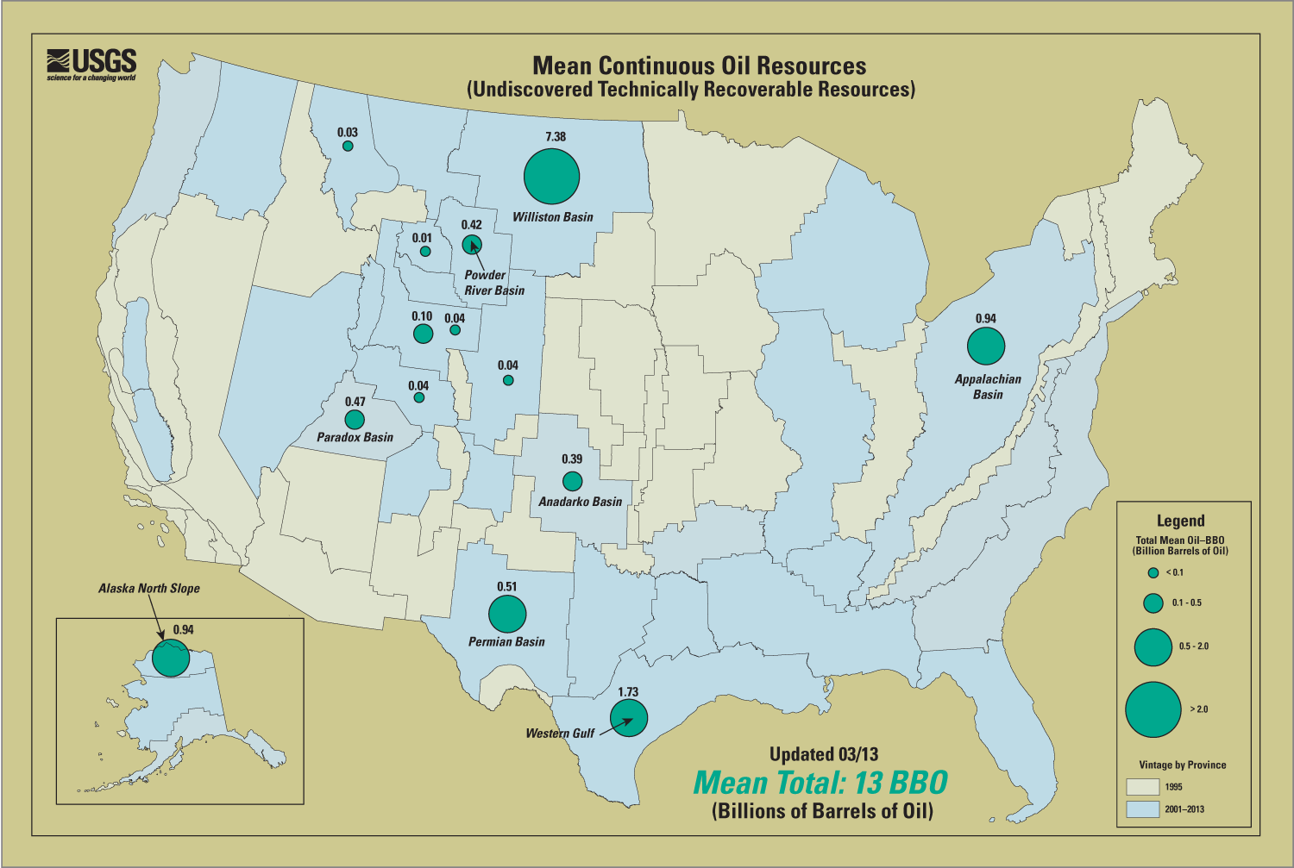
Figure 2—Mean continuous, technically recoverable, oil resources in the United States. [Accessed March 6 from: http://certmapper.cr.usgs.gov/data/noga00/natl/graphic/2013/mean_cont_oil_2013_large.png]

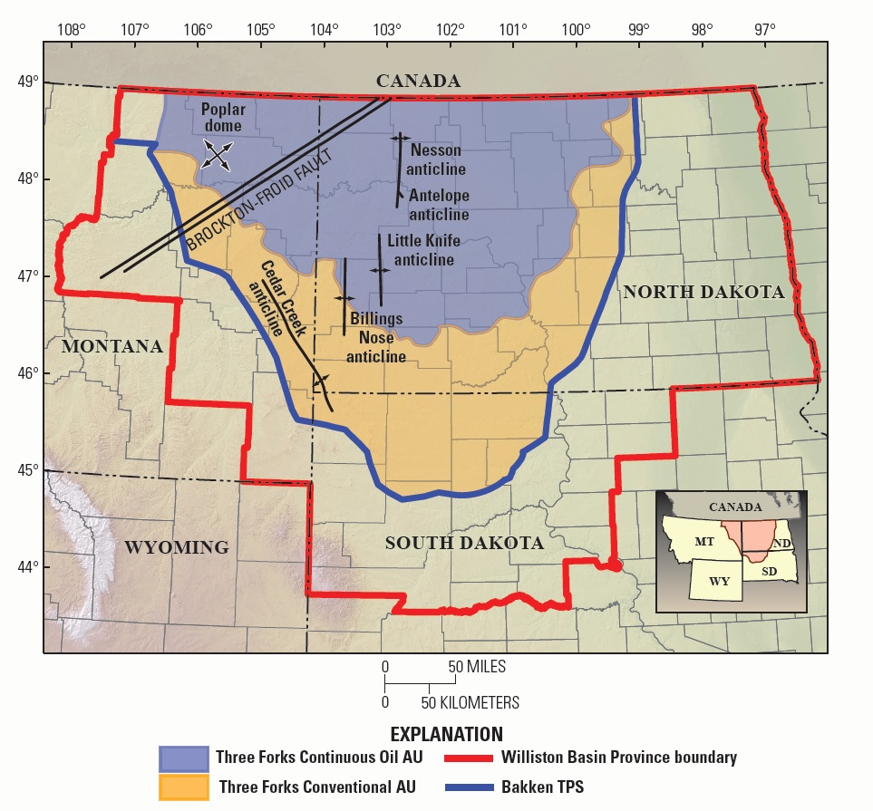
Figure 3— Boundaries for the Williston basin, Bakken TPS, and Three Forks AUs.

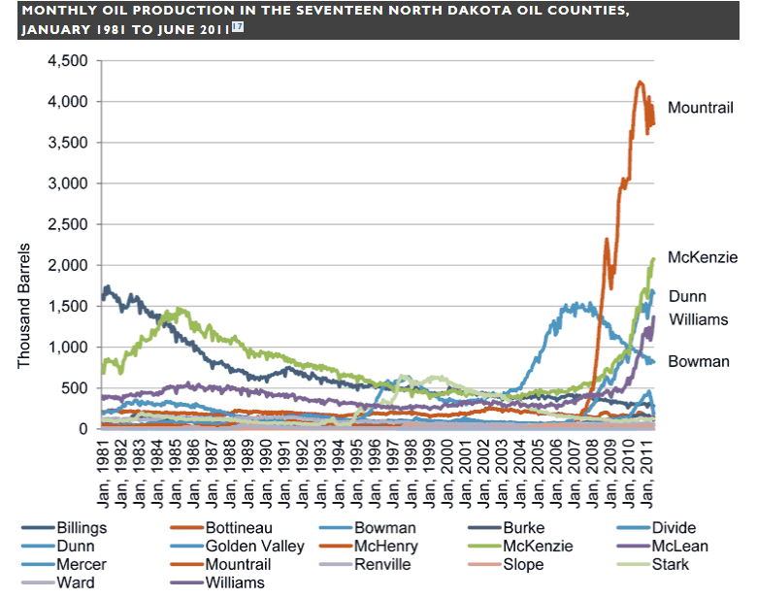

Figure 4 – Monthly oil production by North Dakota Counties, January 1981 to January 2011.

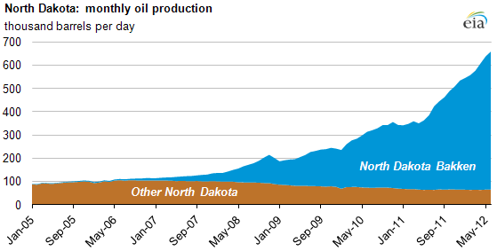
Figure 5 – North Dakota’s monthly oil production (Energy Information Agency, 2012)

Appendix 1. Energy matrix: types, reservoirs, and extraction technologies. [Rows shaded grey are discussed in this water-use workplan. Rows shaded light green are partially or fully quantified during water-use compilations.]

Sustainability | Resource | Material | 2011 U.S. Energy Consumption, in percent¹ | Development Type | Product or Phase | Process | Description | References | Additional Water Use Requirements
Non-Renewable | Fossil | Coal | 20.4 | Conventional | Coal | Strip Mining; | -- | -- | Power plants; transportation
Non-Renewable | Fossil | Coal | 20.4 | Conventional | Coal | Deep Tunneling | -- | -- | Power plants; transportation
Non-Renewable | Fossil | Crude Oil | 36.2 | Conventional | Discrete Formations | Vertical well; primary recovery (natural forcing); Secondary recovery (artificial injection of water, air, CO2, natural gas); Thermally enhanced oil recovery methods [TEOR] using steam or fire flooding; addition of surfactants; CO2 flooding; microbial treatments) | -- | -- | Refining
Non-Renewable | Fossil | Crude Oil | 36.2 | Unconventional (continuous) | Oil Shale and other tight formations | Vertical well; Horizontal well; Hydraulic Fracturing; Directional drilling | A sedimentary rock infused with kerogen, which is a mixture of waxy high molecular weight hydrocarbons. | IEA's World Energy Outlook 2011 report; Gallegos and Varela, 2015 | Refining
Non-Renewable | Fossil | Crude Oil | 36.2 | Unconventional (continuous) | Tar Sands (oil sands) | Tertiary recovery (Thermally enhanced oil recovery methods [TEOR] using steam or fire flooding; addition of surfactants; CO2 flooding; microbial treatments; open pit mining; Toe-to-Heel Air Injection [THAI]; steam assisted gravity drainage; Cold heavy oil production with sand [CHOPS]) | Bitumen(high molecular weight hydrocarbons) found mixed with sand and clay | IEA's World Energy Outlook 2011 report | Refining
Non-Renewable | Fossil | Crude Oil | 36.2 | Unconventional (continuous) | Heavy Oil | Tertiary recovery (Thermally enhanced oil recovery methods [TEOR] using steam or fire flooding; addition of surfactants; CO2 flooding; microbial treatments; open pit mining; Toe-to-Heel Air Injection [THAI]; steam assisted gravity drainage; Cold heavy oil production with sand [CHOPS]) | -- | IEA's World Energy Outlook 2011 report | Refining
Non-Renewable | Fossil | Crude Oil | 36.2 | Unconventional (continuous) | Gas to Liquid | -- | -- | IEA's World Energy Outlook 2011 report | Refining
Non-Renewable | Fossil | Crude Oil | 36.2 | Unconventional (continuous) | Coal –base liquid | -- | -- | IEA's World Energy Outlook 2011 report | Refining
Non-Renewable | Fossil | Crude Oil | 36.2 | Unconventional (continuous) | Gas to Liquid | -- | -- | IEA's World Energy Outlook 2011 report | Refining
Non-Renewable | Fossil | Natural Gas | 25.5 | Conventional | Gas | Natural pressured wells, artificial lifting; artificial injection (water, steam. gas) | -- | -- | --
Non-Renewable | Fossil | Natural Gas | 25.5 | Unconventional (continuous) | Deep Gas | -- | -- | -- | --
Non-Renewable | Fossil | Natural Gas | 25.5 | Unconventional (continuous) | Shallow Biogenic Gas | Vertical and horizontal Well Pumping | -- | -- | --
Non-Renewable | Fossil | Natural Gas | 25.5 | Unconventional (continuous) | Shale Gas | Vertical and horizontal well pumping; Hydraulic fracturing | -- | Gallegos and Varela, 2015 | --
Non-Renewable | Fossil | Natural Gas | 25.5 | Unconventional (continuous) | Tight Gas | Vertical and horizontal well pumping; Hydraulic fracturing | -- | -- | --
Non-Renewable | Fossil | Natural Gas | 25.5 | Unconventional (continuous) | Coal bed methane | Pump out water | -- | -- | --
Non-Renewable | Fossil | Natural Gas | 25.5 | Unconventional (continuous) | Gas Hydrates | -- | -- | -- | --
Non-Renewable | Uranium Ore | Uranium (Nuclear Energy) | 8.5 | Unconventional (continuous) | -- | -- | -- | -- | Nuclear Reactor
Renewable | Hydro | Water | 3.3 | Conventional | High elevation reservoirs | Dams (turbines) | -- | -- | Evaporative losses
Renewable | Biofuels | Organic matter | 4.5 | Conventional | Crops (ethanol); | Agriculture | -- | -- | Refining
Renewable | Biofuels | Organic matter | 4.5 | Conventional | Waste products | Agriculture; Forestry | -- | -- | Power Plant
Renewable | Wind | Wind | 1.5 | Conventional |  | Windmills | -- | -- | --
Renewable | Solar (direct) | Solar energy | 1.5 | Unconventional (continuous) | Active collection of solar energy | Solar arrays | -- | -- | Cleaning of solar panels;
Renewable | Solar (direct) | Solar energy | 1.5 | Unconventional (continuous) | Passive collection of solar energy | Heating | -- | -- | --
Renewable | Geothermal | Geothermal | 1.5 | Conventional |  | -- | -- | -- | --
Renewable | Ocean Tide | Ocean Tide | 1.5 | Conventional |  | -- | -- | -- | --
¹ EIA, MONTHLY ENERGY REVIEW, MARCH 2012, TABLE 1.3 PRIMARY ENERGY CONSUMPTION BY SOURCE (QUADRILLION BTU), HTTP://WWW.EIA.GOV/TOTALENERGY/DATA/MONTHLY/PDF/MER.PDF

Appendix 2. Terminology
Consumptive water use – removed from immediate “reuse” or removed from hydrologic cycle. The part of water withdrawn that is not available for immediate use (http://water.usgs.gov/watuse/wuglossary.html).
Continuous oil and gas accumulations – Commonly are regional in extent, have diffuse boundaries, and are not buoyant on a column of water. Continuous accumulations have very low matrix permeabilities, do not have obvious seals and traps, are in close proximity to source rocks, are abnormally pressured, and have relatively low recovery factors. Included in the category of continuous accumulations are hydrocarbons that occur in tight sand reservoirs, shale reservoirs, basin-centered reservoirs, fractured reservoirs, and coal beds.
Conventional oil and gas accumulations – Are discrete accumulations with well-defined hydrocarbon-water contacts, where the hydrocarbons are buoyant on a column of water. Conventional accumulations commonly have relatively high matrix permeabilities, have obvious seals and traps, and have relatively high recovery factors.
Direct water use – water used during the well drilling and hydraulic fracturing process.
Disposal – the elimination of waste water through evaporation, underground injection, release into a surface water body, or released on the ground surface.
Flowback – is a water-based solution that flows back to the surface during and after the completion of hydraulic fracturing. It consists of the fluid used to fracture the formation. The fluid contains clays, chemical additives, dissolved metal ions and total dissolved solids (TDS). The water has a murky appearance from high levels of suspended particles. Most of the flowback occurs in the first seven to ten days while the rest can occur over a three to four week time period. The volume of recovery is anywhere between 20% and 40% of the volume that was initially injected into the well. The rest of the fluid remains absorbed in the formation.
Formation water – water naturally located within the formation before development.
Fracturing fluid – The fracturing fluids used for shale stimulations consist primarily of water but also includes a variety of additives. The type of chemical additives used in a typical fracture treatment varies depending on the conditions of the specific well and formation being fractured. There are primarily three types of fracturing fluids currently used. These are water frac or slick water, linear gel, and crosslinked gel.
Gel frac – Crosslinked gel is water containing any of the gelling agents used in linear gel and a crosslinker like boron (B), zirconium (Zr), titanium (Ti) or aluminum (Al). Other possible additives are buffers, biocide, surfactant, breaker, and clay control. This fluid has a high viscosity of 100 – 1000 cP, which results in better proppant transport and wider fracs compared to linear gel frac fluid. Large proppant sizes like 20/40 and 16/30 are common with this fluid. Crosslinked gel is more damaging to the proppant pack than linear gel and it is commonly used in oil and high liquid wells.
Linear gel is water containing a gelling agent like guar, HPG, CMHPG, or xanthan. Other possible additives are buffers, biocide, surfactant, breaker, and clay control. This fluid has a medium viscosity of 10 – 30 cP, which results in improved proppant transport and wider frac compared to water frac fluid. Medium proppant size like 30/50 is common with this fluid. Linear gel is more damaging to the proppant pack than water frac and it is commonly used in both gas and oil wells.
Hydraulic fracturing – Also referred to as hydrofracking, hydrofracturing, and fracking, is a well development process that involves injecting water under high pressure into a bedrock formation via the well. This is intended to increase the size and extent of existing bedrock fractures.
Hydraulic fracturing water – water used to hydraulically fracture a well.
Indirect water use – water used for processes associated with energy development other than well drilling and the hydraulic fracturing process.
Maintenance water – water used within the well to reduce corrosion from saline water and other contaminants.
Play – in geology, a petroleum play, or simply a play, is a group of oil fields or prospects in the same region that are controlled by the same set of geological circumstances.
Produced water – water generated with the extraction of oil and gas products.
Proppant – a proppant is a material that will keep an induced hydraulic fracture open, during or following a fracturing treatment and is used to aid the extraction of oil and gas from reservoir rocks, which is mainly used in the hydraulic fracturing process to increase the productivity of natural gas and oil wells. There are currently three types of proppant: quartz sand; resin-coated sand, and ceramic sand (sintered bauxite, which is the strongest) and most ecofriendly.
Slick water frac – Water frac is water containing a friction reducer and possibly a biocide, surfactant, breaker or clay control additive. This fluid has a low viscosity of 2 – 3 cP, which requires a high pump rate to transport proppant. Small proppant size like 40/70 is common with this fluid due to its low viscosity. Water frac is the least damaging to the proppant pack of the three frac fluid types and it is commonly used in gas wells.
Unconventional oil and gas development – see continuous oil and gas

Appendix 3. Recently-completed and ongoing USGS investigations in the Williston Basin, June 2015 [This document will be supplied separately when new updates are added to the file. This document is maintained by the Montana Water Science Center for use by regional USGS personnel.]

Appendix 4. Proposed Workplan for Phases 2 and 3

Phase 2

Objectives–
- Estimate UOG water use for selected plays throughout the nation using the UOG water use estimation model and uncertainty tools to evaluate their performance and utility.
- Research any changing UOG technologies that may have arisen in the first phase.
- Update the UOG water use model and uncertainty tools for national use.

Methods-
Task 1. Information gathering
- Extend / acquire data sets from test plays (e.g., Wyoming, Texas, and Alaska)
Task 2. Re-evaluate changing UOG technology
- Conduct a literature review and discussions with oil and gas industry experts and water resources agencies
Task 3. Update the model to reflect any changes in recent technologies or water use.
Task 4. Running models for two or three additional test sites (shale plays)
Task 5. Evaluate the model based on results from task 4.
Task 6. Update the model for national use. This may include the population of data libraries to reflect the water use associated with processes from the different test plays or other national plays.

Products-
- Evaluation of model and modification
- Journal article or SIR detailing results of water use estimates from the test sites.
- Update model documentation

Phase 3

Objectives-
- Quantify water use associated with UOG for the nation.
- Identify any spatial patterns or temporal trends within the national UOG programs. (For example the source of the ground or surface waters used or methods of disposal and reuse.)
- Update and finalize model.

Methods-
Task 1. Information gathering
- Extend / acquire data sets from remaining plays (e.g., Colorado, Texas, Arkansas, Pennsylvania)
Task 2. Update and finalize model with any potential changes learned from phase 2 and in conducting phase 3.
Task 3. Running model(s) for Nation
Task 4. Generate national summary statistics, spatial patterns, temporal trends and associate water use resources issues.

Products-
- Journal article or SIR describing the shale plays in US and associated trends, comparing similarities and differences
- Final model development and update of model documentation

