USGS National Water Census Focus Area Study
Work Plan

for

“Water Availability and Use to Meet Competing Societal and Ecological Needs in Southeastern Atlantic Coastal Basins of the Carolinas”

Prepared by:
Chad Wagner, Bruce Campbell, Paul Conrads, Ana Maria Garcia, Tom Cuffney, Douglas Smith and Jason Fine
South Atlantic Water Science Center
September 30, 2015


Project Title: Water Availability and Use to Meet Competing Societal and Ecological Needs in Southeastern Atlantic Coastal Basins of the Carolinas
Project Chief: Chad Wagner, South Atlantic Water Science Center; (919) 571-4021; cwagner@usgs.gov
Key Project Personnel: Jim Landmeyer, Bruce Campbell, Paul Conrads, Fred Falls, Jason Fine, Ana Maria Garcia, Tom Cuffney, Kris McSwain, Douglas Smith – South Atlantic Water Science Center; Rodney Knight – Lower Mississippi-Gulf Water Science Center; Mary Freeman – Patuxent Wildlife Research Center; Adam Terando – Southeast Climate Science Center
Fiscal Contact: Dianna Jarvis, Administrative Officer; (803)750-6182; dljarvis@usgs.gov

Project Summary: The coastal regions of the United States are substantially more crowded than the United States as a whole (NOAA, 2012). These growing coastal areas represent a nexus of natural resources and economic opportunity. Sustainable growth necessitates stewardship of coastal natural resources through sound data collection and forward modelling that support environmental protection. Although other areas of the United States are also growing, the land limitations in coastal regions often results in higher population densities, and a sharper, more focused interface between fresh and saltwater ecosystems, where a slight change in one ecosystem, such as overpumpage of groundwater to meet industrial demands, may result in an aquifer becoming too saline for potable use. Coastal areas of the Southeastern United States, particularly in the Carolinas, are experiencing increased annual pulses of tourist populations that often place unanticipated stresses on the status quo, especially during times of natural disasters, such as hurricanes or earthquakes. The effects of additional stressors, such as sea-level rise or drought, on these ecosystems are not fully known. This proposed Focus Area Study (FAS) is designed to provide data and develop tools to help address the challenges that water managers face in the Southeastern Atlantic Coastal Basins of the Carolinas. Refined water-use data will be compiled. The proposed FAS will leverage existing multi-year, water-quantity and –quality projects and published groundwater and surface-water models, to expand, develop, and publish scientifically defensible tools that will be used to answer water availability concerns for multiple, competing societal and ecological needs. Personnel from the South Atlantic, Lower Mississippi-Gulf Water Science Centers, Patuxent Wildlife Research Center, Southeast Climate Science Center, University of South Carolina and North Carolina State University will collaborate on the proposed FAS and the stakeholders/partners include municipalities, water-suppliers, State regulatory and resource management agencies, universities, wildlife refuges, non-profit environmental stewardship groups of the coastal Carolinas

Background

Population growth has more than tripled since the 1970s in the Coastal Plain portions of the Lower Cape Fear River and Lower Pee Dee/Waccamaw River Basins in North Carolina and South Carolina, a region bounded by the Atlantic Ocean, Atlantic Intracoastal Waterways, and tidally affected brackish rivers (proposed FAS, fig. 1). For example, the combined Myrtle Beach–Grand Strand, SC and Wilmington, NC metropolitan area is one of the most populated regions along the Southeastern Atlantic coastline, with a population of 673,552 in 2013, which represents an increase of 43% since 2000 (U.S. Census Bureau, 2014). Additionally, an estimated 14 million people annually visit the Myrtle Beach area and planned Interstate expansions into the region from I-95 will provide the potential for increased transient and permanent population growth and water use demands. This confluence of people and geography has presented unique challenges to water resources managers and environmental regulators and in an area highly susceptible to the effects of hurricanes, routine droughts, and climate change/sea-level rise.
The rapid growth of the coastal Carolinas has caused stresses and adaptation on the quantity and quality of source water in the region. For example, groundwater from deep, sandy aquifers in the Grand Strand part of the Lower Pee Dee River Basin historically was the principal source of water for municipal, industrial, agricultural, and Federal needs. However, over pumping lowered the groundwater levels 100’s of feet (Pelletier, 1985), which led the State of South Carolina to regulate pumping and designate this area as the Waccamaw Capacity Use Area. Similar potential capacity-use restrictions also are being considered for aquifers in southeastern NC. Beginning in the 1970s in Wilmington area and in the 1980’s for the Myrtle Beach area, surface-water sources began to replace groundwater (Carswell and others, 1988) as it became unfeasible to economically pump groundwater from the increasingly lower water levels, treat water for taste and odor issues, and mitigate against saltwater encroachment. Reduced water availability has already led to the regional practice of Aquifer Storage and Recovery (ASR) of surface water for removal during peak seasonal demands in municipal use and to stabilize saltwater encroachment in aquifers at the coastline. In the Waccamaw and Cape Fear Rivers, the USGS real-time gaging network monitors the location of the freshwater-saltwater interface downstream from the municipal water-supply intakes.
Currently (2014) there are known issues that will further reduce water availability. The two main water suppliers in the Lower Cape Fear River Basin pump and treat surface water from the Cape Fear River at a rate equal to the 7Q10 flow rate (calculated using data through the late 1990’s). However, recent low-flow analysis using streamflow data through 2012 indicate a potential reduction in 7Q10 on the lower Cape Fear River by more than 50% (Weaver, J.C, oral commun., 2014), which will drastically impact water-availability in the region Saltwater encroachment from over pumping and sea-level rise particularly threaten the area’s barrier island communities, requiring the purchase of surface water from mainland public utilities as competing demands for these resources increase.

It is clear a sensitive balance of freshwater resources is at play in the coastal Carolinas. The current and future water capacity for potable use is stressed and in direct competition with the recreational and ecological flow requirements of freshwater resources. In order to facilitate economically and environmentally sustainable growth in the area, decision support tools based on defensible data and model simulations are needed by local and state water managers to understand the quantity and quality of water supplies, and the interaction of the groundwater and surface-water flow systems to permit the best allocation of the available freshwater resources. There is an immediate opportunity to build on and leverage recently completed and ongoing studies and real-time monitoring in the study area. The USGS completed studies in 2007 and 2013 that evaluated how future sea-level rise and reductions in streamflows may affect salinity intrusion and threaten municipal water supplies in the Lower Pee Dee River portion of the proposed FAS (Conrads and Roehl, 2007; Conrads and others, 2013). In addition, local stormwater regulating bodies in coastal Horry County, SC, have cooperatively funded the construction of an extensive network of real-time streamflow and water-quality monitoring stations throughout coastal Horry County. Recently, the National Integrated Drought Information System (NIDIS) initiated a pilot drought early warning system study that addresses drought in the coastal ecosystems of North and South Carolina. The focus of the Carolinas pilot includes developing a salinity-based drought index using USGS real-time data and scenario modeling using environmental response variables and the newly developed USGS coastal drought index to better understand the impacts of low flows on coastal ecosystems.

Study Justification
Ongoing and projected increases in permanent and tourist population, extreme natural events (droughts/hurricanes/earthquakes), and potential changes in climate will place additional stress on societal and ecological systems currently (2014) competing for water resources in many coastal communities, particularly in the Myrtle Beach–Grand Strand, South Carolina (SC) and Wilmington, North Carolina (NC) metropolitan areas (fig. 1). Changes in streamflow patterns and withdrawals from surface-water and groundwater, in conjunction with projected climate change and sea-level rise will change the water availability and salinity-intrusion dynamics of coastal rivers and aquifers. Several municipal water-supply intakes are located along the coastal regions of the Carolinas and are proximal to the present day saltwater-freshwater interface in tidal rivers and aquifers. Increases in the extent of salinity intrusion resulting from increased water use and climate change/sea-level rise will threaten the availability of freshwater resources in the vicinity of these surface-water and groundwater-supply intakes.
To effectively manage these water supplies to meet societal and ecological uses, water-resource managers will need estimates of how potential changes in population growth, land-use, and climate will impact aquifer water levels and the frequency, duration, and magnitude of streamflow and salinity intrusion near water-supply intakes. Existing regional groundwater, surface-water and ecological response models will be enhanced or developed to provide decision support tools to investigate the impact of historic, current, and future groundwater and surface-water withdrawal and climate change scenarios on societal and ecological water demands. Combined, these enhanced models and associated DSSs will provide new data and tools that can be used by managers to plan future surface-water allocations and groundwater development and withdrawals as stakeholders evaluate potential consequences on ecology and susceptibility of the aquifers to saltwater contamination. The approaches and new techniques developed as part of this proposed FAS can be transferred to other rapidly growing coastal metropolitan areas that are either currently dealing with similar water availability conflicts or will be in the near future.

Overall Study Objectives
- Compile refined water-use data and disaggregate to at least the HUC-8 level, for those sources in the study area with the largest areas of uncertainty from the 2010 water-use compilation by the USGS, such as agriculture, public supply, industrial, mining, irrigation, aquaculture, and golf.
- Leverage existing groundwater-flow models (regional NC-SC Coastal Plain and local Onslow County, NC) developed by USGS modeling staff in North and South Carolina to develop a refined groundwater-flow and saltwater-intrusion model of the surficial, Castle Hayne, Crouch Branch/Peedee, and McQueen Branch/Black Creek aquifers for the study area. The groundwater models will be used to simulate results of historic and future stresses on the groundwater system in the coastal areas.
- Surface-water models of the study area will be developed (Cape Fear River basin) or leveraged/applied (Pee Dee/Waccamaw River basin) to simulate watershed response to various scenarios of extreme climate events (droughts, hurricanes, etc.), climate and land-use changes and water-use in order to evaluate changes in water-balance, flow regimes, flood peaks and volumes, and groundwater recharge. The hydrologic model will also provide necessary streamflow data for use by the ecological response models.
- Leverage the existing PRISM-2 decision support system (DSS) for the Atlantic Intracoastal Waterway (AIW) and the Waccamaw River near Myrtle Beach, South Carolina to evaluate potential changes in salinity from projected land-use/water-use and climate change scenarios at water-supply intakes.
- Empirical ecological response models relating fish and macroinvertebrate metrics to streamflow metrics and land use will be developed for the PeeDee/Waccamaw and Cape Fear River basins using daily flows obtained from the surface-waters models. These ecological models will be used to forecast community changes associated with the various water-use, land-use (urbanization), and climate change scenarios developed by the Coastal Carolinas FAS and Southeast Climate Science Center.
Geographic Scope
The lower parts of the Pee Dee/Waccamaw River and Cape Fear Basins will be studied (fig. 1). The lower parts of each basin are challenged with increased competition for natural resources on account of limited space, higher permanent and tourist populations, and the dynamic equilibria that exist between groundwater and surface-water availability and saltwater intrusion. This coastal area, as well as more inland areas, also is represented by a thick sequence of unconsolidated sediments of the Atlantic Coastal Plain (outer coastal plain) physiographic province.

Approach
The FAS will be divided into 5 main tasks: Societal Water-Use Data Compilation, Population and Climate Change Scenarios, Groundwater Modeling, Surface-water Modeling, and Ecological Response Modeling. The approaches that will be used to complete these 5 tasks are described in the following section.
Societal Water-Use Data Compilation
The Coastal Carolinas FAS will provide new data and develop tools to address challenges that face water users in the Southeastern Atlantic Coastal Basins of the Carolinas. The primary tools that will be developed as part of the FAS will be numerical models that will be driven by state-of-the-science input parameters. The inputs to the models will include those parameters that act as “stresses” to the water budgets in the FAS region. Data for multiple water-use categories will be developed and used in the models developed and applied for the FAS.

The USGS publishes national water-use estimates at 5-year intervals. These estimates are produced using a variety of data sources that are unique to each state. The development of water-use estimates is required for some categories of water usage and non-mandatory for other categories. In recent years, it has been mandatory for the USGS in each state to produce estimates of water use for public supply, domestic, industrial, irrigation, livestock, mining, thermoelectric power generation, and aquaculture. It has not been mandatory to produce estimates of water used for commercial, hydroelectric power generation, and wastewater. Therefore, estimates of water use for these three categories are currently not available for North Carolina (NC) and South Carolina (SC).

The most recent and complete USGS water-use estimates available were developed for the year 2010. The estimated amount of water used in 2010 for public supply, domestic, industrial, crop irrigation, golf course irrigation, livestock, mining, thermoelectric power generation, and aquaculture will be reported to at least the HUC-8 level for the FAS region. The amount of water withdrawn from groundwater and surface-water sources for each of these water-use categories will also be reported. Site-specific water-use data for 2010 are available or will be developed for some water-use categories. For other categories, only county-wide estimates can be developed due to limitations in available data. For categories with no site-specific data and only county-wide estimates available, the 2010 county estimates will be disaggregated using established methods (Dickens and others, 2011, Diehl and other, 2013; Hutson, 2007, Lovelace, 2009) so that water use estimates for all mandatory water-use categories will be reported to at least the HUC-8 level in the FAS region.

Two of the largest quantified categories of water-use in the proposed FAS are industrial and public supply (Barber, 2009; Barber, 2014). However, there is considerable uncertainty in the quality of industrial and public-supply water-use data available for the FAS region. For example, there is great disparity between the water suppliers identified in the EPA and the State of North Carolina’s public-supply databases, and potentially significant inaccuracies related to domestic water-use estimates. These issues need to be resolved to provide the most accurate water-use information possible. For the FAS, discrepancies between the public supply databases will be resolved and improved estimates of domestic water use will be developed. Industrial water-use estimates will also be improved by increased efforts to verify the accuracy of reported data and to ascertain if a complete listing of industrial users is included in data sources (for NC).

The FAS will leverage the ongoing funded work to build a site-specific database in NWIS (using SWUDS) that will identify the location of public water-supply distribution systems, groundwater and surface-water withdrawal points, and provide information related to the conveyance and ultimate usage (in 2010) of the water withdrawn for public water-supply systems in the FAS region. As part of the FAS, we will utilize these public-supply water-use data reported for 2010 and endeavor to get public-supply pumpage data at the system level into the SWUDS database for 2015. Wastewater returns for 2010 (possibly 2015 as well) will be developed and reported to at least the HUC-8 level to help identify and track water movement within the FAS region. Additional site-specific water use information will be developed for 2010 and possibly 2015 using existing and newly compiled (for 2015) power generation, industrial, and golf course irrigation data. Provided sufficient location information is available in the data sources, the appropriate HUC-8 (at least) location will be identified for withdrawals made for industrial purposes. Site-specific power generation data will also be used to report water usage to at least the HUC-8 level for that category. Golf Course irrigation estimates will be reported to at least the HUC-8 level by identifying the location of each course and using estimates of turf grass water requirements (in NC) or real water usage rates (in SC) for each golf course located within the FAS region. Site-specific wastewater data will be obtained and aggregated to at least the HUC-8 level in NC and existing site-specific wastewater data HUC-8 (at least) data from SC will be compiled for 2010 and possibly 2015.

Because of inherent limitations in the available data, only county-wide aggregated water use estimates can be developed for crop irrigation, livestock, aquaculture, mining, and domestic water-use categories. The 2010 and possibly 2015 county-wide aggregated estimates for these categories will be disaggregated so that all water-use estimates will be reported to, at least, HUC-8 geographic regions within the FAS. These disaggregated estimates will be derived using established methods (Dickens and others, 2011, Diehl and other, 2013; Hutson, 2007, Lovelace, 2009). Another important data product that is planned to be developed will be estimates of consumptive irrigation water use. We plan to use an available 30-meter resolution grid of estimates of evapotranspiration generated using the Simplified Surface Energy Balance algorithms (Senay and others, 2011) along with GIS maps (from the most recent annual Cropland Data Layer from the NASS-USDA) to generate consumptive water-use related to irrigation in the study area. The Cropland Data Layer provides detailed information on the location, area and type of crop being grown. Therefore, consumptive irrigation water-use estimates can be associated with the primary crops being grown in the study area.

Water-use estimates from the 1990 to 2010 USGS water-use compilations will be refined and reported to at least the HUC-8 level for selected categories. These estimates will be developed for use in model calibration and to provide enough information to define trends in water usage across the FAS region. The existing water-use estimates from the previous water-use compilations will be disaggregated for the FAS region only. The disaggregation of data will be limited to categories that represent the largest percentage of water use in the area (public supply, power generation, industrial, and golf course irrigation) and will be performed using previously described and established methods. The newly refined HUC-8 (at least) level water-use estimates developed for the FAS will be entered into AWUDS.

Some water-use data for 2015 may be obtained soon enough to be included in the FAS models. Data needed to develop estimates for public-supply, domestic, industrial, power generation, golf course irrigation, and wastewater categories will be sought as soon as possible following the end of calendar year 2015. The 2015 data for public supply, domestic, industrial, and wastewater categories will be obtained from the Department of Environment and Natural Resources for NC, the Department of Health and Environmental Control for SC and in some cases, directly from the primary water-suppliers/users in the study area. Power generation data will be obtained directly from the power companies with the understanding that the estimates developed for the FAS may differ from the estimates that are scheduled to be provided by the National Water Use team and released in early 2017. Because water-use data will not be available from several data sources until late 2016 to early 2017, it will not be possible to completely develop and incorporate 2015 estimates for all water-use categories into the FAS models. However, all 2015 water-use estimates for mandatory categories will be reported to at least the HUC-8 level, entered into AWUDS, and published in the water-use report that will be produced as part of the FAS.

To help improve the accuracy of the models, an attempt will be made to include monthly data for some of the largest water-use categories. The data sources will be queried to obtain monthly withdrawal values. If available, these monthly data will include water withdrawals made for public supply, power generation, and industrial water use. Wastewater discharges may also be obtained as part of this task. Because monthly data are not available for most water-use categories, the effort to obtain monthly data will be limited to the primary categories that represent the largest percentage of water use in the study area (public supply, power generation, industrial, and golf course irrigation).

A water-use report will be written and published as part of the FAS. The report will include new or refined water-use estimates that will be used in the FAS models as well as the 2015 water-use estimates that may not be generated in time for use in the models. The report will also provide documentation and details about how the water-use estimates were updated and describe the methods used to disaggregate estimates for the HUC-8 (at least) areas within the FAS region.

Population and Climate Change Scenarios
Depending upon stakeholder input, existing population change forecasts from the US Census Bureau (U.S. Census Bureau, 2012) or spatial urban growth scenarios based on research from NC State University and the USGS Southeast Climate Science Center (SECSC) (Meentemeyer et al., 2013; Terando et al., 2014) (see fig. 2) can be applied to the study area to drive various water-use scenarios that will be simulated with the groundwater and surface-water models. The proposed research will focus on the following three main specific tasks:
- Implement V-I-S (vegetation-impervious surface-soil) modeling technique to generate past and current land cover composition maps using Landsat Thematic Mapper imagery.
- Simulate future (at least 2065) spatial urban growth based on various scenarios using the Future Urban-Regional Environment Simulation (FUTURES) model (Meentemeyer et al., 2013) (fig. 2).
- Provide GIS data that are consistent with the National Land Cover Dataset (NLCD) format such that they can be incorporated into surface-water and groundwater models to understand how future spatial urban growth scenarios may impact water-use in the study area.
The FAS team will work with local public-water suppliers to develop estimated future water-use scenarios based upon their own projections and the population and land-use change forecasts developed as part of the FAS.
Through close cooperation with the SECSC, the FAS will consider employing either the most current and applicable downscaled global climate models and greenhouse gas emission scenarios to project regional precipitation and temperature change or plausible forecasted regional precipitation and temperature scenarios from published literature, which will be necessary input to the groundwater, surface-water and ecological response models discussed herein. Two or three different plausible precipitation and temperature scenarios will be developed for use in the modeling tasks.

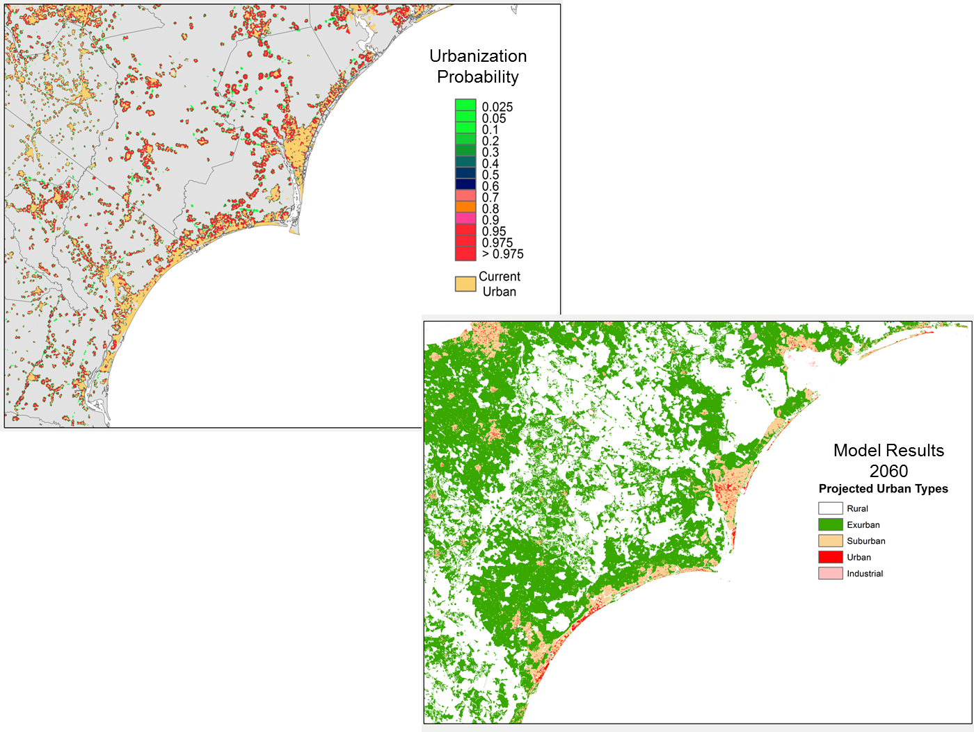
Figure 2. Examples of land-use change and spatial urban growth scenarios that will be developed for use in the Coastal Carolina Focus Area Study

Groundwater Modeling
The Atlantic Coastal Plain aquifers and confining units of North and South Carolina are composed of crystalline carbonate rocks, sand, clay, silt, and gravel and contain large volumes of high-quality groundwater. The aquifers have a long history of use dating back to the earliest days of European settlement in the late 1600s. Groundwater use from the Atlantic Coastal Plain aquifers in North and South Carolina has increased during the past 70 years as the population has increased along with demands for municipal, industrial, and agricultural water needs. While North and South Carolina work to increase development of water supplies in response to the rapid growth in these coastal populations, the States are facing a number of unanswered questions regarding availability of groundwater supplies and the best methods to manage these important supplies.
An in-depth assessment of groundwater availability of the Atlantic Coastal Plain aquifers of North and South Carolina was completed in 2008 by the U.S. Geological Survey (Campbell and Coes, 2010), the South Carolina Department of Natural Resources (SCDNR), and the North Carolina Division of Water Resources (NCDWR). This assessment included (1) a determination of the present status of the Atlantic Coastal Plain groundwater resources; (2) an explanation for how these resources have changed over time; and (3) development of tools to assess the system’s response to stresses from potential future climate variability. Results from numerous previous investigations of the Atlantic Coastal Plain by Federal and State agencies were incorporated into this effort. The Campbell and Coes (2010) model (see fig. 3) developed as part of that effort was last calibrated to 2004 conditions, which are now over 10 years old and during that time there have been many changes in groundwater withdrawal patterns and use in the North and South Carolina Coastal Plain.

Objectives
The first objective of this task of the FAS is the develop and updated and calibrated groundwater flow model of the study area that can be used to inform resource decisions based on various current and future groundwater-use scenarios. A second objective is to convert the groundwater flow model into a dual-density SEAWAT model for up to two localized population centers within the study area to evaluate potential saltwater intrusion into aquifers from groundwater pumpage scenarios.

Tasks
A flow chart of the groundwater modeling approach and how it is integrated with the other aspects of the proposed FAS is outlined in figure 4. The existing Atlantic Coastal Plain groundwater flow model (Campbell and Coes, 2010) will be modified to include FAS-specific data (fig. 3). The existing groundwater-flow model of the North Carolina–South Carolina Atlantic Coastal Plain (Campbell and Coes, 2010) will be updated using MODFLOW-2005 (Harbaugh, 2005) by decreasing the grid spacing in the surficial aquifer from the original model grid-spacing of 2 x 2 miles in the FAS area and slightly beyond. The new surficial aquifer grid spacing will be determined as the model construction proceeds and will be limited by available computer software and hardware resources. In addition, other model layers grid spacing may be reduced if sufficient data, such as groundwater use or groundwater levels are available for specific areas. A commercial graphical user interface will be used to enhance pre- and post-processing tasks, as well as to allow for visualization, ease of use, and updating. This modeling effort will include all of the Atlantic Coastal Plain aquifers in the study area.
The Campbell and Coes (2010) groundwater flow model will be modified in several important ways. Modifications will include converting the surficial layer from a specified head boundary to active model cells that can simulate groundwater – surface-water interactions and to reduce the model cell size appropriately in the surficial layer. These changes will facilitate the direct incorporation of ET demands and assess the water availability potential of the surficial aquifer in the FAS. Several new MODFLOW packages make these modifications possible. MODFLOW-NWT (Niswonger and others, 2011) will be used to improve solution of unconfined groundwater-flow challenges and MODFLOW-USG (UnStructured Grid) (Panday and others, 2013) will be used to modify the original numerical grid, which will allow the flexibility to focus grid resolution along rivers and around wells, for example, or to sub-discretize individual layers to better represent hydrostratigraphic units and to better simulate groundwater – surface water interactions within the surficial layer of the model. The model also will be modified to simulate groundwater – surface water interactions by using the Streamflow Routing-2 package (Niswonger and Prudic, 2005) and streamflow data from the surface-water model described below.
The Campbell and Coes (2010) model simulated only the major rivers such as the Savannah, North and South Edisto, and the Peedee Rivers in the inner Coastal Plain. The updated model will attempt to simulate smaller streams along with the major rivers in both the inner and outer Coastal Plain. Stream networks will be included in the model in the surficial aquifer at a scale that is allowed by the computer resources. The updated groundwater-flow model for the FAS will extend to natural hydrologic boundaries, such as the Fall Line to the north and the offshore extent of the aquifer to the southeast, to properly simulate groundwater flow.
The original downgradient model boundaries (seaward) were simulated as no-flow boundaries and there was no variable density component to the boundary condition. The updated model will use a new MODFLOW package, the Seawater Intrusion 2 (SWI2) package (Bakker and others, 2013) that allows three-dimensional vertically integrated variable-density groundwater flow and seawater intrusion in coastal multi-aquifer systems to be simulated using MODFLOW-2005. Use of the SWI2 package will allow a more realistic simulation of the seaward aquifer boundaries than the original model.

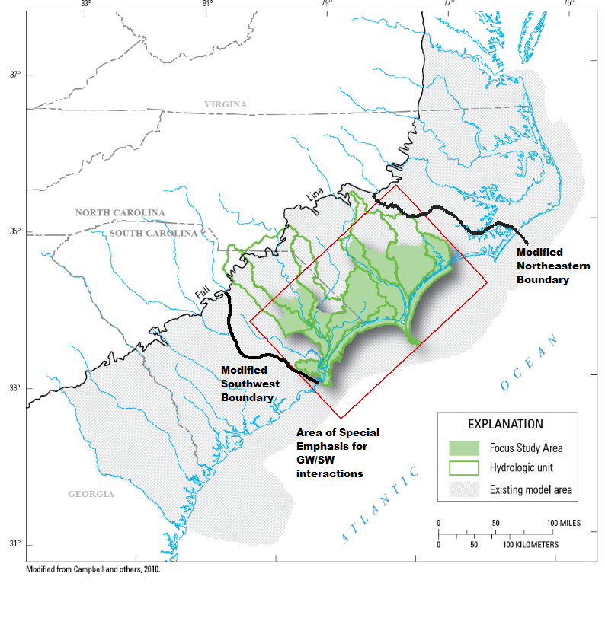
Potential SEAWAT model areas
Figure 3. Proposed groundwater modeling domain for the Coastal Carolinas Focus Area Study
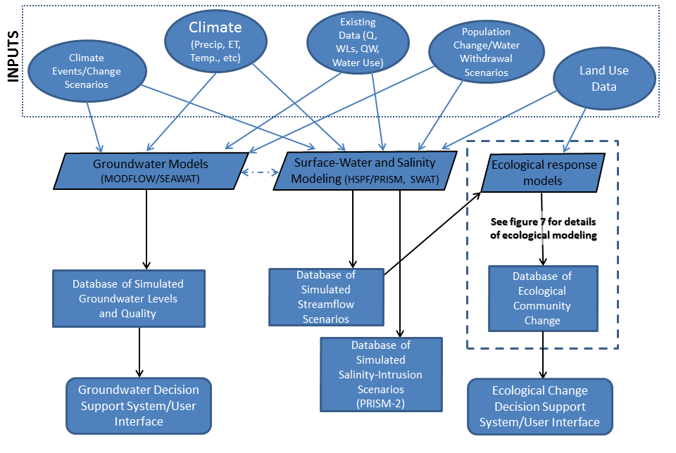
Figure 4. Conceptual design of model integration and decision support systems for proposed Coastal Carolina National Water Census Focus Area Study
The boundary conditions from the Campbell and Coes (2010) model will be re-evaluated and modified as appropriate to best represent the natural hydrologic conditions. The proposed boundary conditions for the FAS groundwater-flow model are depicted in figure 3 (referred to as “modified boundaries”). The model domain may be extended to cover the entire Coastal Plain of South Carolina and coincide with the original southwest boundary of the Campbell and Coes (2010) model (see fig. 3) if a separate groundwater modeling project with the South Carolina DNR and DHEC is funded, which would leverage the proposed work in this FAS.
The following are specific tasks that will be conducted to achieve the groundwater modeling objectives:
Task 1: Data Acquisition
- Compile existing hydrostratigraphic data: This task will include compiling all data necessary to update the regional hydrogeologic framework at a finer scale, especially in the surficial aquifer layer of the model. Existing geologic reports and maps, subsurface data and hydrogeologic information will be assembled to refine the current hydrostratigraphy presented in Gellici and Lautier (2010). Project personnel will work closely with state or local agency scientists who have extensive knowledge of the proposed study area.
- Compile and interpret existing aquifer-test data: Aquifer-test data are available from several sources in the study area. Recent data from the USGS, state agencies, and the project partners will be collected, interpreted, and input into the model.
- Compile existing groundwater-level data: There are several sources of groundwater-level data in the study area. Existing reports, the USGS database, North Carolina Department of Environment and Natural Resources, South Carolina Department of Natural Resources, and South Carolina Department of Health and Environmental Control will be the primary sources of historic and recent groundwater-level data collected in the area.
- Refine the existing regional hydrogeologic framework to incorporate recent data: The current hydrogeologic framework for the proposed study area will be refined, where needed, using currently available stratigraphic and hydrogeologic data. The refined framework would use existing wells that have the required data available (geophysical logs, cores, and drill cuttings descriptions).
- Collect and compile water-use data: Groundwater use data from 2005 to 2015 of the study will be acquired from the appropriate state agencies and water suppliers. Data from 2015 will likely not be available until late 2016 or early 2017.
Task 2. Re-Calibrate Model to Past and Recent (2010 and 2015) Conditions
The groundwater flow model will be re-calibrated to the following conditions 1) predevelopment, 2) 1982, 3) 2004, and 4) 2010 and 2015 (once available). Since water-use data from 2015 will likely not be available until late 2016 or early 2017, initial calibration will be conducted using 2010. Once 2015 data are available, they can be input in the model for validation. The model will be calibrated with an automated parameter-estimation approach using the computer program PEST (Doherty, 2005). The objective of the calibration process is to minimize the weighted sum-of-squares differences between model-generated groundwater-level values and stream baseflows and between field water-level measurements and stream baseflows.
Task 3. Convert MODFLOW model into a SEAWAT-2000 variable-density model
The re-calibrated MODFLOW model will be converted into a SEAWAT-2000 variable-density model (Langevin and others, 2003) for up to two selected localized population centers (e.g. Wilmington, NC and Georgetown, SC) (see fig. 3). These variable-density models will be calibrated using all available groundwater levels and water-quality data, such as those recently compiled and collected by McSwain and others (2014). SCDNR is collecting specific conductance data from Cretaceous monitoring wells in the Grand Strand area that can be used. North Carolina municipalities have to collect and report specific conductance data for groundwater data, specific to the CCFAS are the New Hanover County municipalities. Also NC DWR collects chloride data intermittently but they have also have some long-term data that can be used in the SEAWAT model calibration process.
Task 4. The MODFLOW and surface-water models will be combined using a “soft” link
Outputs from the updated, calibrated groundwater flow model will be “soft” linked to the projects surface-water and ecological models. That is, there won’t be a direct hard coded link but various groundwater model outputs - simulated heads, fluxes, and water quality - will be made available to other models and used to inform them.
Task 5. Run MODFLOW and SEAWAT models for future scenarios and coordinate with surface-water models.
The re-calibrated groundwater flow model, and associated DSS will be used to 1) simulate results of historic and future stresses on the groundwater system in the coastal areas, 2) simulate and evaluate impacts of ET and various water-use scenarios in the study area on groundwater surface-water interactions, and 3) determine the potential susceptibility of the aquifers to lateral saltwater encroachment and upward leakage of brackish, deep groundwater as a result of over-pumping shallower aquifers and sea-level rise.

Surface-water Modeling and Salinity-Intrusion Simulations
Surface-water models of the study area will be developed to simulate streamflow and salinity, including potential effects of projected water-use and climate change, at existing USGS gaging stations and ungaged locations in the study area. The primary surface-water concern in the lower Pee Dee/Waccamaw River basin within the study area is salinity intrusion at municipal intakes and near tidal freshwater wetlands of the Savannah National Wilderness Refuge (WNWR). The primary concern in the lower Cape Fear River basin is freshwater availability from upstream basins. Given that the primary water-use concerns differ between the PeeDee/Waccamaw and Cape Fear River basins, separate modeling tools will be developed for the study area. The proposed surface-water modeling and associated salinity intrusion DSS for the PeeDee/Waccamaw River basin and how they will likely integrate with the other components of the proposed FAS is presented in figure 4.

Surface-water modeling of the Cape Fear River Basin
A surface-water model of the Cape Fear River will be developed using the Soil and Water Assessment Tool (SWAT) (Arnold and Fohrer, 2005). The SWAT model is a physically-based watershed model with the capability of incorporating water-use data. The model will operate on a daily time step, which is the required timestep to support the data input requirements of the ecological response models (discussed herein). The modeled area of the Cape Fear River basin will be sub-divided into smaller, discrete hydrologic response units (HRUs) (approximately 12-digit) from LIDAR-based topographical analysis with outlets that coincide with the ecological sites (figure 5). The upstream extents of the area of focus for the surface-water model will coincide with the extent needed for incorporating ecological data, essentially the topographic divide of the HUC-4.
Objectives
The model will simulate streamflows while accounting for water-use and climate-change scenarios at ungaged ecological sites and key locations for water-supply (for example Cape Fear River at Lock 1) in the study area. The incorporation of existing water use will be accomplished by coordinating the data compilation and the model needs during the first year of model development. Streamflow for future climate conditions will be simulated by the surface-water model using either projected regional precipitation and temperature scenarios from the aforementioned downscaled climate models, supplied by the USGS SECSC and(or) plausible changes in temperature and precipitation patterns documented in literature.

Tasks

- Compile hydrology (National Hydrography Dataset catchments), LIDAR or National Elevation Dataset (NED) topography data, STATSGO soils data, and National Landcover Datasets maps.
- Compile a water use dataset that is representative of current conditions and can be used in the SWAT model for the calibration period (1990 – 2010). Since water-use data from 2015 will likely not be available until late 2016 or early 2017, the baseline conditions model will be conducted using 2010 water-use data.
- Develop a SWAT model for Cape Fear River that has a spatial resolution consistent with the needs of the ecological analysis and the incorporation of water use data. The likely spatial extent will be the entire drainage basin (HUC4), and at least 8-digit HUC resolution.
- Calibrate SWAT model using existing streamflow and water use data that ideally cover a period of at least 20 years (1990-2010). This length of time is considered adequate for establishing the model baseline given that it covers a period of both wet weather and dry weather years. Model calibration will be approached systematically at multiple locations throughout the watershed to ensure that spatial heterogeneities are accurately represented. The Cape Fear River model will be operated at daily time-step.
- The calibrated SWAT model of the Cape Fear River basin will be used to develop the following scenarios:
- Baseline, recent (2010) and permitted water-use conditions scenario.
- Forecasted population growth scenario for water-use
  - Projected population and land-use change conditions will be simulated by the surface-water model using forecasts supplied by the Southeast Climate Science Center and NC State University.
- Climate change scenario
  - Projected streamflow for future climate conditions will be simulated by the surface-water model using two or three plausible forecasted regional precipitation and temperature scenarios, supplied by the Southeast Climate Science Center and (or) published literature.
- Documentation of the SWAT model may be combined with the ecological response modeling in a journal article or may take the form of a stand-alone USGS Series Publication.
EXPLANATION
Elevation
Streams
HUC-8 watershed boundary
Raleigh, NC
Wilmington, NC

Figure 5. Example of SWAT model discretization of the Cape Fear River basin in North Carolina for development of ecological response models.

Surface-Water Modeling of the Pee Dee/Waccamaw River basin and the Application of the Salinity Intrusion Decision Support System
The freshwater-saltwater interface in surface-water bodies along the coast is an important factor in the ecological and socio-economic dynamics of coastal communities. It influences community composition in freshwater and saltwater ecosystems, determines fisheries spawning habitat, and controls freshwater availability for municipal and industrial water intakes. The upstream extent of salinity is affected by the flow characteristics of estuarine rivers, including baseflow, seasonal and interannual variability, and the timing and magnitude of very large and very low flows. One consequence of the low elevation gradient of coastal rivers is the relatively large extent of tidal freshwater conditions. The marshes and swamps that developed along rivers in these tidal areas are habitat for a broad variety of flora and fauna.

A decision support system (DSS) was developed to evaluate the salinity dynamic of the Atlantic Intracoastal Waterway (AIW) and the Waccamaw River given it’s susceptibility to saltwater intrusion at municipal surface-water intakes. The first version of the Pee Dee River and Intracoastal Waterway Salinity Intrusion Model-Decision Support System (PRISM DSS) was developed for the purpose of re-licensing hydroelectric dams in North Carolina by the Federal Energy Regulatory Commission and evaluating the effect of regulated flows on the salinity intrusion along the AIW and the Waccamaw River (Conrads and Roehl, 2007). The PRISM DSS was enhanced (PRISM-2 DSS) by adding functionality for evaluating climate change and sea-level rise (SLR) impacts on salinity intrusion frequency, magnitude, and duration (Conrads and others, 2013). These versions of PRISM simulate salinity at three locations on the Waccamaw River and four locations on the AIW.

Objectives for simulating streamflow and salinity for the Yadkin-Pee Dee River Basin
An existing HSPF model will simulate streamflows while accounting for water-use and climate change at ungaged sites in the study area and the PRISM-2 DSS will be used to simulate salinity at the gaging station location along the Waccamaw River and AIW (fig.6). Similar to the objectives for the SWAT model for the Cape Fear River basin, the incorporation of existing water use will be accomplished by coordinating the data compilation and the model needs during the first year of the study. Likewise, streamflow for future climate conditions will be simulated by the surface-water model (HSPF) using projected regional precipitation and temperature scenarios from the aforementioned downscaled climate models that will be supplied by the USGS SECSC or plausible forecasted regional precipitation and temperature scenarios from published literature.

Tasks

- Streamflow simulations:

The task of application of the HSPF model for the Pee Dee/Waccamaw River, similar to the SWAT model application to the Cape Fear River basin, and will be used to develop the following scenarios:

- Land-use and water-use change scenarios:
  - Baseline, recent (2010 or 2015, if available) and permitted water-use conditions scenario
  - Forecasted population growth scenario for water-use
    - Projected population and land-use change conditions will be simulated by HSPF using forecasts supplied by the Southeast Climate Science Center and NC State University.

- Climate change scenarios:
Projected streamflow for future climate conditions will be simulated by HSPF using two or three forecasted regional precipitation and temperature scenarios, supplied by the Southeast Climate Science Center or taken from published literature.

- Salinity Intrusion Scenarios:
The PRISM-2 DSS will be used to evaluate salinity response due to alternative land-use, water-use, and climate-change scenarios. Simulated streamflow inputs generated from the surface-water model of the Pee Dee/Waccamaw River basin (HSPF) can be used as inputs to the PRISM-2 DSS to evaluate the tidal response. Changes in streamflow and sea level can be simulated separately and in combination by modifying hydrographs and (or) coastal water-level inputs. For example, using user-defined hydrograph streamflow inputs, users can simulate changes to salinity dynamics at strategic locations on the basis of altered streamflow patterns to the coast. These streamflow inputs can be determined anecdotally (for example, surface-water withdrawal increases of 15 percent or 10-percent drier summers and falls) or by using hydrographs simulated from the surface-water model.

- Documentation of the PRISM-2 Scenarios

A USGS interpretive series report or journal article that summarizes the approach, methodology, and results of the PRISM-2 simulations of streamflow and salinity scenarios will be written.

Figure 6. The existing water level, temperature, and salinity stations in PRISM-2 and those that would be used to develop the PRISM-3 Decision Support System and the current acquisition boundary of the Waccamaw National Wildlife Refuge (dark green).

Potential enhancements to PRISM
There are two issues that the Coastal Carolina FAS Team needed to address with the application of the DSS for the study. There are known enhancements that would greatly improve the utility of PRISM-2 to address effects of climate change from changes in flows and tidal water levels. These enhancements would include changes to the parameters, additional simulation locations, increasing the simulation period, and upgrades to the DSS operating system. The two versions of PRISM that are available only simulate salinity at three locations on the Waccamaw River and four locations on the AIW (fig.6). There has been an expressed need from coastal resource managers and researchers to simulate water level and temperature at additional gaging station locations. Including these enhancements in the development of a PRISM-3 version would allow scientists and resource managers to evaluate the effects of changes in water use, including climate change, on the riverine water level, water temperature, and salinity in the lower portion of the tidal freshwater marsh of the Waccamaw National Wildlife Refuge (WNWR) and water levels for the non-tidal, fresh-water locations. Unlike the PRISM and PRISM-2 DSSs, the domain of the PRISM-3 application would not include the Atlantic Intracoastal Waterway (AIW) but include additional simulations points (gaging locations) farther upstream on the Waccamaw and Pee Dee Rivers (fig.6, table 1).
Table 1. Stations used for input and output parameters in the PRISM DSS applications.
[WL, water level; Temp, water temperature]
Input parameters |  | Output parameters |  | PRISM Version
USGS Station number | Parameter | USGS Station number | Parameter
02110777 | WL, Temp | 02110755 | Salinity | PRISM-1, PRISM-2
02110500 | Flow | 02110760 | Salinity | PRISM-1, PRISM-2
02131000 | Flow | 02110770 | Salinity | PRISM-1, PRISM-2
02132000 | Flow | 02110777 | Salinity | PRISM-1, PRISM-2
02135000 | Flow | 02110809 | Salinity | PRISM-1, PRISM-2
02136000 | Flow | 021108125 | Salinity | PRISM-1, PRISM-2
 |  | 02110815 | Salinity | PRISM-1, PRISM-2
 |  | 02110802 | WL, Temp | PRISM-3
 |  | 02110809 | WL, Temp | PRISM-3
 |  | 02110815 | WL, Temp | PRISM-3
 |  | 021108125 | WL, Temp | PRISM-3
 |  | 02110704 | WL, Temp | PRISM-3
 |  | 02110707 | WL, Temp | PRISM-3
 |  | 02135200 | WL, Temp | PRISM-3
 |  | New USC gage | WL | PRISM-3

The PRISM-2 DSS was developed prior to the transition from 32-bit to 64-bit software applications. The characteristics of the various versions of the PRISM DSSs are summarized in Table 2. In addition to enhancing the DSS with additional parameters and simulation locations, PRISM-3 would be upgraded to a 64-bit application.
Table 2. Characteristics of the versions of the PRISM Decision Support Systems
Decision Support System | Model domain | Input parameters | Parameter(s) simulated | User controllable inputs | Database period | Operating system
PRISM | Waccamaw River and AIW | Upstream flow and coastal water level | Salinity | Regulated flow | 1995-2002 | 32-bit
PRISM-2 | Waccamaw River and AIW | Upstream flow and coastal water level | Salinity | Regulated and unregulated flow, sea level | 1995-2009 | 32-bit
PRISM-3 | Pee Dee and Waccamaw Rivers | Upstream flow and coastal water level | Salinity, water temperature, and water level | Regulated and unregulated flow, sea level | 1995-2015 | 64-bit

Although there is an express need for enhancements to PRISM-2 DSS, the time and budget constraints of the study does not allow for this to be the primary objective over simulating flows and salinity projections for the Pee Dee/Waccamaw River basin. However, the development of PRISM-3 DSS will be pursued with interested parties (for example, The Nature Conservancy and U.S. Fish and Wildlife Service) and described further in the “Potential Leveraged Projects/Research” section of the work plan.

Ecological Response Modeling
Climate change, land-use, and mean daily streamflows will be the primary drivers of the ecological (fish and invertebrate) response models. Existing fish (Tennessee and Apalachicola, Chattahoochee, Flint (ACF) River basins) and invertebrate (Delaware and NC) response models will serve as the starting points for the development of empirical flow-biology response models for the Pee Dee/Waccamaw and Cape Fear River basins. These existing models will be used to determine if the land-use and flow characteristics that are important in determining biological responses in ACF, TN, Delaware, and NC are also important in the Pee Dee/Waccamaw and Cape Fear River basins or whether other variables are more important in determining responses. These comparisons will help determine whether ecological-flow response models can be generalized over large geographic areas or whether these models need to be basin specific.
Objectives
Empirical models relating fish and macroinvertebrate metrics to flow metrics and land use will be developed for the PeeDee/Waccamaw and Cape Fear River basins using daily flows obtained from existing HPSF (PeeDee/Waccamaw) and SWAT (Cape Fear) models. These ecological flow models will be compared with TN, ACFB, DEL, and NC State-wide models to determine whether a generalized flow-response model can be developed or whether basin-specific models are necessary for understanding ecological responses to flow. These models will also be used to forecast community changes associated with the various water-use, land-use (urbanization), and climate change scenarios developed by the Coastal Carolinas FAS and SECSC. The Coastal Carolinas FAS ecological flow-response models substitute space for time when modeling biological responses to changes in water use, land cover, and climate change. The Cape Fear data set includes 41 sites that have data that has been collected in multiple years (5 to 13) over the period 1983-2012. This provides a unique opportunity to test the validity of the space for time approach to modeling by examining how well the Coastal Carolinas FAS models predict changes over time at a few sites with long-term records that have exhibited changes in land use and flow characteristics over time.
The Coastal Carolinas FAS ecological-flow response models will also be used to test the efficacy of flow standards for the protection of ecological integrity in streams and rivers by adding these ecological flow standards into current and projected flow and water-use scenarios. For example, SC has implemented a flow standard based on 7Q₁₀ and a NC commissioned Science Advisory Board has recommended an 80% flow-by standard for NC streams (NC DENR, 2013). These simulations will help determine how realistic these flow standards are in light of current and projected flow conditions and will provide an opportunity to examine how societal and ecological water demands compete as climate changes and human demand for water increase.

Tasks

The ecological response modeling approach is outlined in figure 7. The process of ecological modeling will involve the following tasks:
- Acquisition of fish and invertebrate data from North and South Carolina State biomonitoring programs from STORET (e.g., NC has >1,000 invert and >900 fish sites collected over 30 years) and(or) directly from the State (South Carolina Department of Health and Environmental Control lists 87 sites on the Pee Dee River from which biological collections (inverts only) have been made. These sites have been sampled at various times from 1987-present). These data may be supplemented with other data sources as required.
- Review of biological sampling sites to determine which ones are appropriate for modeling responses in time and space. GIS tools will be used to locate monitoring sites in each basin, determine their proximity to structures known to influence flows and assemblages (e.g., dams, major waste water discharges, road crossings, agriculture and urban areas), and to determine their proximity to each other (i.e., identify sites that represent the same stream). Sites will be evaluated to determine the type of modeling that they will support:
  - basin-wide representation of biological conditions that can be used to relate land use and hydrologic factors to biology at the a large spatial scale; and
  - sites with multiple years of sampling data that can be used to validate space-for-time models.
- Sites will also be reviewed to determine if sample collection and processing methods are compatible (e.g., NC DENR uses several sample collection and processing methods and uses categorical methods to represent invertebrate abundances). The review process will produce a database listing fish and invertebrate sites along with assemblage data, land use, and other relevant data for the construction of biological response models.
- Work with Coastal Carolinas FAS hydrologists to develop models of daily flows for biological sites in the PeeDee/Waccamaw and Cape Fear River basins using an existing HPSF model and the SWAT model developed as part of the FAS. This work will serve as the foundation for developing flow-response models in year 1 of the project and layering in water-use (year 2) and climate and land-use (urbanization) scenarios (year 3). This approach will allow for the development of ecological flow-response models early in the CCFAS project and incorporation of change scenarios (water use, precipitation, urbanization) as they are developed.

- Review of existing response models and application to PeeDee/Waccamaw and Cape Fear River basins. The biological response modelers (Freeman, Knight, Cuffney, Kennen, Qian) will meet to review the fish and invertebrate models that they have developed (Freeman and others, 2013, Knight and others, 2012, 2013) and evaluate the data needs and applicable spatial and temporal needs of each model in the context of the data available for the PeeDee/Waccamaw and Cape Fear River basin study. A strategy for modifying existing models and(or) developing new models will be developed at this meeting.
- Calculation of ecologically relevant flow statistics. Ecologically important flow statistics will be calculated using USGS Eflow Stats package for R developed by WaterSMART (Thompson and Archfield, 2013). The Eflows stats package uses mean daily flow data for a period of record (e.g., 20 years) to calculate statistics describing the magnitude, frequency, duration, timing and rate of change of streamflows (National Water Census-Data Portal, 2014). Flow data from gaging stations and surface-water models will serve as input to the Eflow Stats package.
- Testing efficacy of ecological flow criteria. Both NC and SC have recognized the need to establish flow criteria for the protection of ecological integrity in their streams and rivers. SC has implemented a flow standard based on 7Q₁₀ flow while a NC commissioned Science Advisory Board has recommended an 80% flow-by standard (NC DENR, 2013). The effects that implementing different ecological flow standards (e.g., 7Q₁₀, 80% flow by) will have on water availability for societal purposes and on the protection of fish and invertebrates during drought will be evaluated using the flow-response models developed in this project. Daily flow projections based on current conditions and climate and population change scenarios will be coupled with ecological flow criteria and flow-response models to determine the likelihood that ecological flows could be achieved under current conditions and likely climate and land-use scenarios.

- Testing and improving flow-response models. The biological response modelers will work together with stakeholders and Song Qian (University of Toledo) to evaluate the applicability of the current models, develop new models with greater applicability to the Waccamaw and Cape Fear River basins, and to assess model uncertainty (e.g., using Bayesian analysis to better represent regional and site-specific uncertainty in the models).

- Publication of results. The underlying surface-water, ecological models and model results will be published in peer-reviewed journals and(or) a USGS Series Publication.

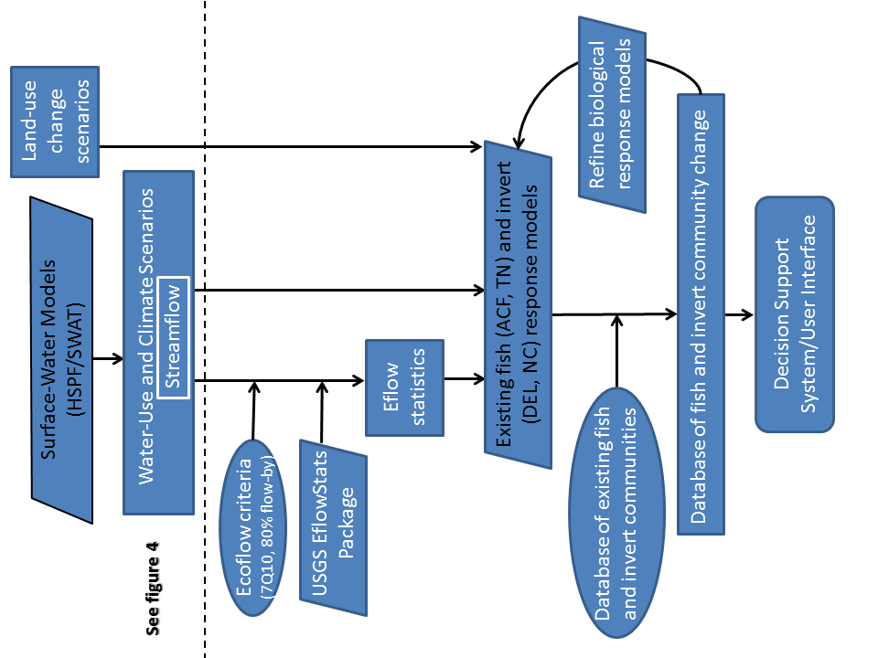
Figure 7. Conceptual design of ecological response modeling and decision support system for the proposed Coastal Carolina National Water Census Focus Area Study
Expected Results and Products
- Updated AWUDS database that includes refined and more representative water-use estimates at the HUC-8 or 10 level and updated SWUDS database for site specific water-use data from points of diversion or withdrawals within the study area for 2000 - 2015, with a focus on industrial, public/domestic and golf course irrigation water-use categories. Consumptive irrigation water-use estimates from cropland within the FAS.
- Refined groundwater flow (MODFLOW) and variable-density (SEAWAT) models, a new surface-water model of the Cape Fear River basin, salinity-intrusion scenarios of the Pee Dee/Waccamaw River basin and ecological response models based on various stakeholder-driven projected water-use and climate change scenarios will be served through the National Water Census (NWC) Data Portal.
- Individual DSSs will be developed for aquifer, and ecological response to various surface-water and groundwater withdrawal and land-use scenarios resulting from a range of population growth projections and climate change/sea-level rise scenarios. Depending upon stakeholder needs and preferences, the DSSs could take the form of a queryable database library, an interactive desktop GIS interface or two/three-dimensional graphical representation of modeled results. It is anticipated that the groundwater DSS may have a GIS-based user interface, the surface-water DSS will leverage a user interface that was previously developed by Conrads and others (2013) (PRISM-2), and the ecological response DSS may have a spreadsheet-based user interface. Regardless of the exact form, all of the DSSs and user interfaces will allow users to select areas of interest or gaged locations and retrieve predictions of aquifer water levels and quality (in select areas), salinity or ecological conditions based on a predefined library of modeled water-withdrawal, ecological-flow requirement, and(or) climate change/sea-level rise scenarios. The decision on where/how to serve the DSSs will be determined through close communication with the NWC team and CIDA.
- A USGS series report documenting the water-use compilation will be published. Two separate USGS series reports will be published to document the groundwater-flow/SEAWAT models and surface-water/salinity modeling and use of associated DSSs. A journal article(s) will be published to document the ecological response models.

Project Schedule
A summary of the proposed work and report schedule is provided in table 3.

Budget
A summary of the proposed budget for the Coastal Carolinas FAS is provided in table 4.
Key Project Personnel
The following is a list of primary project personnel and their planned roles and areas of expertise:
- Chad Wagner (surface-water modeling; project management);
- Bruce Campbell, Jason Fine (groundwater modeling);
- Paul Conrads (SW salinity modeling/ DSS);
- Ana Maria Garcia (SW modeling);
- Doug Smith, Fred Falls, Jim Landmeyer (water-use data);
- Tom Cuffney, Rodney Knight, Mary Freeman (ecologic response modeling);
- Adam Terando (climate projections)
- Ross Meetemeyer (NC State, population growth and land-use change modeling)

Potential Leveraged Research/Projects
The Coastal Carolina FAS has the potential of leveraging USGS and Water Census resources to leverage a number of water-use related studies for the Coastal Carolina study area. The common aspects of these leverage studies is a strong scientific connection with the Coastal Carolina FAS but due to budgetary and time constraints of the FAS timeline and time necessary for the coordination of potential funding resources, the Coastal Carolina FAS team did not want to make the deliverable products of these studies a critical element of the Coastal Carolina FAS to meet the needs of interested agencies and organizations.
Enhancement of the PRISM-DSS Application
The primary potential leveraged project is related to the further enhancement of the PRISM-DSS application. For many years state and federal government agencies and nongovernmental organizations such as The Nature Conservancy (TNC) have actively worked to acquire and maintain protected areas within the tidal freshwater reaches of rivers along the southeast coast. As the potential impacts of climate change are better understood greater emphasis is being placed on developing and implementing adaptation plans that will guide decisions about conservation investments. An area of current focus is the Waccamaw National Wildlife Refuge (WNWR) along the Waccamaw and Pee Dee Rivers in Georgetown and Horry Counties, South Carolina. Long-term climate change can have two major effects on riverine estuaries such as the Waccamaw River. The first is sea-level rise (SLR), which will increase the inland extent of tide and saltwater influence. The second major effect is changing flows in the rivers that drain to the coast. These effects will have acute and long-term effects on vegetation and on soil and groundwater salinities of tidal freshwater swamps of the WNWR.
The U.S. Geological Survey – South Atlantic Water Science Center (USGS-SAWSC) developed the Pee Dee River and Intracoastal Waterway Salinity Intrusion Model-Decision Support System (PRISM DSS; Conrads and Roehl, 2007; Conrads and others, 2013) to evaluate the effect of regulated streamflow and climate change on the salinity dynamics of the Waccamaw River near the southern extent of the WNWR. Currently (2015) there are two limitations to the PRISM DSS for evaluating potential climate change impacts on the WNWR. The first is that the DSS only simulates salinity and does not simulate water levels, the second is that the study domain does not cover the spatial extent of the WNWR, and the third is fundamental upgrade to from a 32- to 64-bit application. These enhancements would include changes to the parameters, additional simulation locations, increasing the simulation period, and upgrades to the application operating system. The development of PRISM-3 will be accomplished with a technical team of researchers from the USGS, the University of South Carolina, Advanced Data Mining International (ADMi), and TNC. We are currently in conversations with potential cooperators that could provide funding for the development of PRISM-3.
Objective for the PRISM-3 DSS Application
The PRISM-2 DSS will be enhanced to develop a third version, PRISM-3 DSS, to evaluate water availability issues in the vicinity of the WNWR (fig. 4). These enhancements will allow the PRISM3-DSS to be used to evaluate potential changes in salinity, water level, and water temperature from projected water-use and climate change scenarios at water-supply intakes and on tidal freshwater forested marshes of the WNWR and temperature effects (along with salinity) on the occurrence of Vibrio bacteria in the Waccamaw River (Deeb, 2013).

Tasks
The development of the PRISM-3 DSS and documentation will involve the following tasks:

- Data Cleanup and Filling (Technical Lead – USGS)
The database will be extended from 2009 to 2015. The data for the input and output parameters (table 1) will be retrieved from NWIS, checked for and short-term (hours) of interpolation data for tidally affected sites. The output data will include water-level data from a recently (2014-15) instrumented gaging station by the University of South Carolina (fig. 4, table 1).

- Training of Artificial Neural Network Models (Technical Lead – ADMi and USGS)
Artificial neural network (ANN) models for the output parameters (table 2) will be trained using the 20-year data base. The approach to developing and training the ANN models will be similar to the approach used for the PRISM-2 DSS (Conrads and others, 2013). Training of the ANN models include signal processing and decomposition include low-pass tidal filtering of spectral filtering of the input parameters.

- Programing the PRISM-3 DSS Application (Technical Lead – ADMi)
The PRISM-3 DSS, like the previous DSSs, will use sub-models that will be integrated in a user-friendly Excel/Visual Basic program called the “Simulator”. The Simulator requires no typing to operate or to obtain output. It will contain a historical database of USGS gaging time series (including hindcasted values) to allow for running long-term simulations. Run-time monitoring and Simulator output will be in the form of supporting graphics and Excel worksheets. Incorporate constrained optimization routine into the Simulator. A historical database is read into the simulator along with the ANN sub-models at the start of a simulation. By using GUI controls, the user can evaluate various streamflow scenarios and sea-level-rise scenarios. The outputs generated by the simulator are written to files for post processing in Microsoft Office ExcelTM or other analysis software packages. The PRISM-3 DSS also provides streaming graphics for each gage during simulations. Due to the changes in the study domain from PRISM-2 to PRISM-3, very little code from PRISM-2 will be usable for PRISM-3. A user manual will describe installation, operation, and features of the Simulator.

- Simulate Water-Use Alternative Scenarios: (Technical Lead – USGS and USC)

The PRISM-3 DSS will be used to evaluate tidal water-level and salinity response due to
alternative water-use scenarios. Simulated streamflow inputs generated from the surface-water model of the Pee Dee River basin (HSPF) can be used as inputs to the PRISM-3 DSS to evaluate the tidal response. Changes in streamflow and sea level can be simulated separately and in combination by modifying hydrographs and (or) coastal water-level inputs. For example, using user-defined hydrograph streamflow inputs, users can simulate changes to salinity dynamics at strategic locations on the basis of altered streamflow patterns to the coast. These streamflow inputs can be determined anecdotally (for example, surface-water withdrawal increases of 15 percent or 10-percent drier summers and falls) or by using hydrographs simulated from the surface-water model. Finally, output from the PRISM-3 DSS can be used for salinity data input to the Ecological Response model and DSS.

- Document Development of PRISM-3 and Scenarios (Technical Lead – USGS)
A USGS interpretive series report summarizing the approach, methodology, and results of the study will be written. A draft of the final report will be available at the end of the project and the final report will be released after obtaining USGS Director Approval.
Additional Potential Leveraged Research/Projects
The following are areas of other projects that could be leveraged by the proposed work associated with the Coastal Carolinas FAS.
- Evaluating the level of uncertainty in the downscaling of the Global Climate Models at the scale of the Coastal Carolina FAS.
- Field verification of Gabriel Senay’s research on remote sensing of evapotranspiration using existing and new data collected from forested, wetlands and agricultural areas within the Coastal Carolinas FAS.
- Regional water-balance modeling utilizing the SPARROW model
- Evaluation of salinity impacts on bald-cypress trees, using long-term salinity record and tree cores from the Coastal Carolinas FAS.

References
Arnold, J.G. and N. Fohrer, 2005, SWAT2000: current capabilities and research opportunities in applied watershed modeling. Hydrological Processes. 19(3): 563-572.
Barber, N.L., 2009, Summary of estimated water use in the United States in 2005: U.S. Geological Survey Fact Sheet 2009-3098, 2 p.
Barber, N.L., in press, Summary of estimated water use in the United States in 2010: U.S. Geological Survey Fact Sheet 2014-XXXX, 2 p.
Bicknell, B.R., Imhoff, J.C., Kittle, J.L., Jr., Donigian, A.S., Jr., and Johanson, R.C., 1997, Hydrological Simulation Program--Fortran, User's manual for version 11: U.S. Environmental Protection Agency, National Exposure Research Laboratory, Athens, Ga., EPA/600/R-97/080, 755 p.
Campbell, B.G., and Coes, A.L., eds., 2010, Groundwater availability in the Atlantic Coastal Plain of North and South Carolina: U.S. Geological Survey Professional Paper 1773, 241 p., 7 pls.
Carswell, W. J., Sanders, C. L., Jr., and Johnson, D. M., 1988, Freshwater supply potential of the Atlantic Intracoastal Waterway near Myrtle Beach, South Carolina 1988 , USGS Water-Resources Investigations Report: 88-4066 (http://pubs.er.usgs.gov/publication/wri884066)
Conrads, P.A., and Roehl, E.A., Jr., 2007, Analysis of salinity intrusion in the Waccamaw River
and Atlantic Intracoastal Waterway near Myrtle Beach, South Carolina, 1995–2002: U.S.
Geological Survey Scientific Investigations Report 2007–5110, 41 p., 2 apps. (available
online at http://pubs.water.usgs.gov/sir2007-5110)
Conrads, P.A., Roehl, E.A., Jr., Daamen, R.C., and Cook, J.B., 2013, Simulation of salinity
intrusion along the Georgia and South Carolina coasts using climate-change scenarios:
U.S. Geological Survey Scientific Investigations Report 2013–5036, 92 p. + 5 apps.
(http://pubs.usgs.gov/sir/2013/5036/)
Deeb, R., 2013, Climate change effects on Vibrio bacteria in the Winyah Bay Estuary and the projected spread of vibrio under future climate change scenarios, Master Thesis, Earth and Environmental Resource Management, College of Arts and Sciences, University of South Carolina , Columbia, SC.
Dickens, J.M., Forbes, B.T., Cobean, D.S., and Tadayon, Saeid, 2011, Documentation of methods and inventory of irrigation data collect for the 2000 and 2005 U.S. Geological Survey Estimated use of water in the United States, Comparison of USGS-compiled irrigation data to other sources, and recommendations for future compilations: U.S. Geological Survey Scientific Investigations Report 2011-5166, 61 p.
Diehl, T.H., Harris, M.A., Murphy, J.C., Hutson, S.S., and Ladd, David, E., 2013, Methods for estimating water consumption for thermoelectric power plants in the United State: U.S. Geological Survey Scientific Investigations Report 2013-5118, 78 p., (also available online at http://dx.doi.org/10.3133/sir20135188).
Freeman, M.C., G.R. Buell, L.E. Hay, W.B. Hughes, R.B. Jacobson, J.W. Jones, S.A. Jones, J.H. Lafontaine, K.R. Odom, J.T. Peterson, J.W. Riley, J.S. Schindler, J. Stephen, C. Shea, J.D. Weaver, 2013, Linking river management to species conservation using dynamic landscape scale models. River Research and Applications, 29: 906 – 918.
Hutson, Susan S., comp., 2007, Guidelines for preparation of state water-use estimates for 2005: U.S. Geological Survey Techniques and Methods Book 4, Chap. E1, 36 p. (also available online at http://pubs.usgs.gov/tm/2007/tm4e1/).
Knight, R.R., Murphy, J.C., Wolfe, W.J., Saylor, C.F., and Wales, A.K. 2013. Ecological limit functions relating fish community response to hydrologic departures of the ecological flow regime in the Tennessee River basin, United States. Ecohydrology doi: 10.1002/eco.1460.
Knight, R.R., Wolfe, W.J., and Gain, W.S., 2012, Regression Models of Ecological Streamflow Characteristics in the Cumberland and Tennessee River Valleys. Ecohydrology 5: 613–627. doi: 10.1002/eco.246
Langevin, C.D., Shoemaker, W.B., and Guo, Weixing, 2003, MODFLOW-2000, U.S. Geological Survey Modular Ground-Water Model Documentation of the SEAWAT-2000 Version with the Variable-Density Flow Process (VDF) and the Integrated MT3DMS Transport Process (IMT): U.S. Geological Survey Open-File Report 03-426, 43 p.
Lovelace, John K., 2009, Method for estimating water withdrawals for livestock in the United States, 2005: U.S. Geological Survey Scientific Investigations Report 2009-5041, 7 p.
McSwain and others, 2014, Hydrogeology and salt water intrusion of the Castle Hayne and Peedee aquifers near Wilmington, North Carolina: U.S. Geological Survey Scientific Investigations Report 2014-XXX.
Meentemeyer, R. K., Tang, W., Dorning, M. A., Vogler, J. B., Cunniffe, N. J., & Shoemaker, D. A, 2013, FUTURES: Multilevel Simulations of Emerging Urban–Rural Landscape Structure Using a Stochastic Patch-Growing Algorithm. Annals of the Association of American Geographers, 103(4), 785–807. doi:10.1080/00045608.2012.707591
National Water Census-Data Portal, 2014, Streamflow Statistics Calculator. http://cida.usgs.gov/nwc/ang/#/workflow/streamflow-statistics/select-site
National Oceanic and Atmospheric Administration, 2012, Population trends along the Coastal United States–1980-2008: NOAA National Ocean Servive, Coastal Trends Report Series
Niswonger, R.G., Panday, Sorab, and Ibaraki, Motomu, 2011, MODFLOW-NWT, A Newton formulation for MODFLOW-2005: U.S. Geological Survey Techniques and Methods 6-A37, 44 p.
Niswonger, R.G., and Prudic, D.E., 2005, Documentation of the Streamflow-Routing (SFR2) Package to include unsaturated flow beneath streams—A modification to SFR1: U.S. Geological Survey Techniques and Methods 6-A13, 50 p.

North Carolina Department of Environment and Natural Resources, 2013, Recommendations for estimating flows to maintain ecological integrity in streams and rivers in North Carolina. Report submitted to NC DENR by the North Carolina Ecological Flows Science Advisory Board. http://www.ncwater.org/files/eflows/sab/EFSAB_Final_Report_to_NCDENR.pdf.

Panday, Sorab, Langevin, C.D., Niswonger, R.G., Ibaraki, Motomu, and Hughes, J.D., 2013, MODFLOW-USG version 1: An unstructured grid version of MODFLOW for simulating groundwater flow and tightly coupled processes using a control volume finite-difference formulation: U.S. Geological Survey Techniques and Methods, book 6, chap. A45, 66 p.
Senay, G.B., Budde, M.E., and Verdin, J.P., 2011, Enhancing the Simplified Surface Energy Balance (SSEB) approach for estimating ET–Validation with the METRIC model: Agricultural Water Management (98):606-618.
Terando, A. J., Costanza, J., Belyea, C., Dunn, R. R., McKerrow, A., & Collazo, J. A., 2014, The southern megalopolis: using the past to predict the future of urban sprawl in the southeast u.s. PloS One, 9(7), e102261. doi:10.1371/journal.pone.0102261
Thompson, J. and S. Archfield, 2013, EflowStats: Returns Hydrologic Indicator stats for a given set of data. R package version 3.0.
U.S. Census Bureau, 2012, 2012 National Population Projections: Accessed at http://www.census.gov/population/projections/data/national/2012.html, on August 26, 2014.
U.S. Census Bureau, 2014, Popultation change estimates: accessed at http://www.census.gov/population/metro/data/index.html, on June 10, 2014.
Whitehead, J., Tufford, D., Dow, K., and Carbone, G., 2011, Assessing the impact of salt-water intrusion in the Carolinas under future climatic and sea-level conditions, Charleston, S.C., SC Sea Grant Consortium/NC Sea Grant, Final project report NOAA Grant No. NA08OAR4310715, 23 p.

