Water Availability and Use Science Program
Training Modules
FY 2017 End-of-Year Report
November 20, 2017

- PROJECT ACCOMPLISHMENTS/CONTRIBUTIONS (FY 2017)

The national water-use compilation efforts for 2015 made substantial progress in FY2017. The USGS National Water Use Science Project (NWUSP) provided complete national county-level datasets for livestock, mining and aquaculture water use. In addition, site-specific thermoelectric-power generation models for 2015 water use and consumption were completed and provided to each USGS Water Science Center water-use specialist. These data were either directly used for the compilation, or were used to verify data provided from thermoelectric-power generation facilities or State agencies. These data represent a complete set of site-specific withdrawals and consumptive use for the 2015 calendar year at the facility level, with associated minimum and maximum model estimates. Using 2010 data, a comparison between EIA data, USGS model results, and USGS 2010 compilation results at the plant level was published in FY2017 (http://onlinelibrary.wiley.com/doi/10.1111/1752-1688.12551/abstract;jsessionid=F3F170B777E103A0C0A8AB63BD958C6F.f03t04).The NWUSP continued to work closely with CLU scientists to provide a complete national dataset of county-level irrigation consumptive-use estimates, based on 1-KM satellite imagery and the Simplified Surface Energy Balance model. These irrigation and thermoelectric consumptive-use estimates for 2015 provide the first complete national county-level datasets of consumptive use for these two categories since 1995. Finally, a data release and companion summary report for 2015 county-level total population, public supply and domestic withdrawals and deliveries were published, representing one of the fastest releases of water-use data ever (https://doi.org/10.5066/F7TB15V5) (https://pubs.usgs.gov/of/2017/1131/ofr20171131.pdf). New software capabilities to the USGS National Water Information System (NWIS) aggregated water use database (AWUDS) were implemented to store water-use data by principal aquifer at the county level. A project to compile 2015 county-aquifer use for all major categories was begun in FY2017.
The USGS National Water Use Science program (part of the Water Availability and Use Science Program; WAUSP) provides the only nationally consistent information on the status and trends of human water use activities. Since 1950, this program has published national reports in five-year increments; the only Federal agency to report national data for so long. See the website for a full listing of program publications beyond the 5-year reports (http://water.usgs.gov/watuse/50years.html). These data are integrated into our understanding of the natural systems, and provide water resource managers and other science investigations the information that is needed to make informed management decisions, and explain hydrologic processes and the impacts man has on them.

(2) PROJECT WORKPLAN AND BUDGET FOR FY 2018

The compilation itself is largely funded by each WSC’s support of a specialist to compile data for their State (including DC and Territories). It is not possible without great effort to compute the total costs of a compilation, but historical estimates (>10 years old) showed that, on average, the WSC expenses for an average State was about $100,000 per WSC. It is conceivable that compilations might run two to three times that much for large States like California, Texas, New York or Florida.
Project Activities and timelines:
WSC water-use specialists continue to submit water-use and ancillary data for regional review via data-aging capabilities in AWUDS. Work during FY2018 will be a period for completing data compilation, review, approval, and complete dataset reporting. Because the national workshop instructions gave priority to the public supply and domestic categories, these data were successfully releases by the end of FY2016. A full national dataset and trends report is not possible until all category datasets are compiled and is scheduled for mid-FY2018.
The national compilation of groundwater use by principal aquifers and major categories at the county level will be completed in FY2018. A companion report with the data, as well as a methods report will be completed by end of FY2018.
National Water Use Science Team FY2018 budget, including support staff and FY2018 principal aquifer work as follows:

- TOTAL: $1,735,000
- Salary
- Equipment/supplies (list only major items)
- Contracts (identify)
- Publications
- Travel
- Provide the total funding broken out by cost center so that the program can allocate the funding appropriately. (see NWUSP_FY18_Budget_14Oct2017.xlsx)
(3) NOTEWORTHY COLLABORATIONS, MEETINGS, TECHNICAL TRANSFER ACTIVITIES, SPIN-OFF PROJECT DEVELOPMENTS, AND ACKNOWLEDGEMENTS

Collaboration within USGS included the USGS MIT (Minerals Information Team) for mining information continued through FY2017 to help resolve questions in data used for 2015 compilation. Outside collaboration with US Department of Agriculture was established when methods were developed for livestock and aquaculture to facilitate the national team building these county estimates. These collaborations continue today. Other collaboration includes work with US Department of Energy, Energy Information Administration with regards to EIA survey data (2013) questionnaire forms, data QAQC, and model development for thermoelectric power withdrawals and consumptive use. Collaboration with CLU Program and EROS staff have been instrumental in providing national 1 KM resolution evapotranspiration data (for irrigation consumptive use), and understanding the correct use and interpretation of this data with regards to water-use data needs. Collaboration with US EPA Office of Ground Water and Drinking Water has provided new updates to SDWIS datasets, which are the source for public-supply facility and system data. Conversations continue with US EPA and exchanges of information are helping to better understand the data they have.
(4) Report Products, Bibliographic Update, Data Releases, and Groundwater-Model Archives
Dieter, C.A., and Maupin, M.A., 2017, Public supply and domestic water use in the United States, 2015: U.S. Geological Survey Open-File Report 2017-1131, 6 p., https://doi.org/10.3133/ofr20171131.
Dieter, C.A., Linsey, K.S., Caldwell, R.R., Harris, M.A., Ivahnenko, T.I., Lovelace, J.K., Maupin, M.A., and Barber, N.L., 2017, Estimated use of water in the United States county-level data for 2015: U.S. Geological Survey data release, accessed October 3, 2017, at https://doi.org/10.5066/F7TB15V5.
Harris, Melissa A. and Timothy H. Diehl, 2017. A Comparison of Three Federal Datasets for Thermoelectric Water Withdrawals in the United States for 2010. Journal of the American Water Resources Association (JAWRA). 53(5): 1062-1080. https://doi.org/10.1111/1752-1688.12551
Harris, M.A., and Diehl, T.H., 2017, Thermoelectric power plant water withdrawals and associated attributes for three Federal datasets in the United States, 2010: U.S. Geological Survey data release, https://doi.org/10.5066/F7HX19VW
(5) PROJECT TEAM DIRECTORY –
Molly Maupin, National Water Use Science Team Lead for NWULT; Idaho WSC, Boise; 208-387-1307; mamaupin@usgs.gov; oversight on 2015 compilation and WAUSP liaison for water use activities in Focus Area Studies and Topical Studies.
Cheryl Dieter, NWULT Regional Specialist-Northeastern States; Maryland WSC, Baltimore; 443-498-5537; cadieter@usgs.gov; In addition to regional work, Cheryl coordinates activities and training with wateRuse programming and support team. She is also the co-chair for WUDR (Water Use and Data Research, aka State cooperative grants) (not included in this budget).
Melissa Harris, NWULT Regional Specialist-Southeastern States; LMG-Tennessee, Nashville; 615-837-4792; mharris@usgs.gov; In addition to regional work, Melissa is the lead on the national thermoelectric power model (not included in this budget).
Tamara Ivahnenko, NWULT Regional Specialist-Central States; Colorado WSC, Pueblo; 719-562-2848; ivahnenk@usgs.gov; In addition to regional work, Tammy is co-coordinator for interpretation and dissemination of irrigation consumptive use dataset.
Rodney Caldwell, NWULT Regional Specialist-Western States; WY-MT WSC, Helena; 406-457-5933; caldwell@usgs.gov; In addition to regional work, Rod is co-coordinator for interpretation and dissemination of irrigation consumptive use dataset.
Nancy Barber, NWULT Database Coordinator; SA WSC-Norcross, Georgia; 678-924-6627; nlbarber@usgs.gov; Database coordinator and liaison to NWIS and Water Use User Group (WUUG). Provides support to national team with data dissemination in reports and on the web. Lead on PS SWUDS effort (not in this budget)
John Lovelace, NWULT Member; LMG-Louisiana, Baton Rouge; 225-298-5481 X3210; jlovelac@usgs.gov; In addition to being a NWULT team member, John has oversight on the national county estimates for livestock, mining and aquaculture.
Kristin Linsey, Support Member, New York WSC, Troy; 518-285-5636; kslinsey@usgs.gov; Krissi provides national county and huc populations, assistance in national report publication, and is lead for the OED on-line training (not included in budget).

(6) PHOTOS, ANIMATIONS, AND GRAPHICS –
Total population and public-supply withdrawals by state and source, 2015.
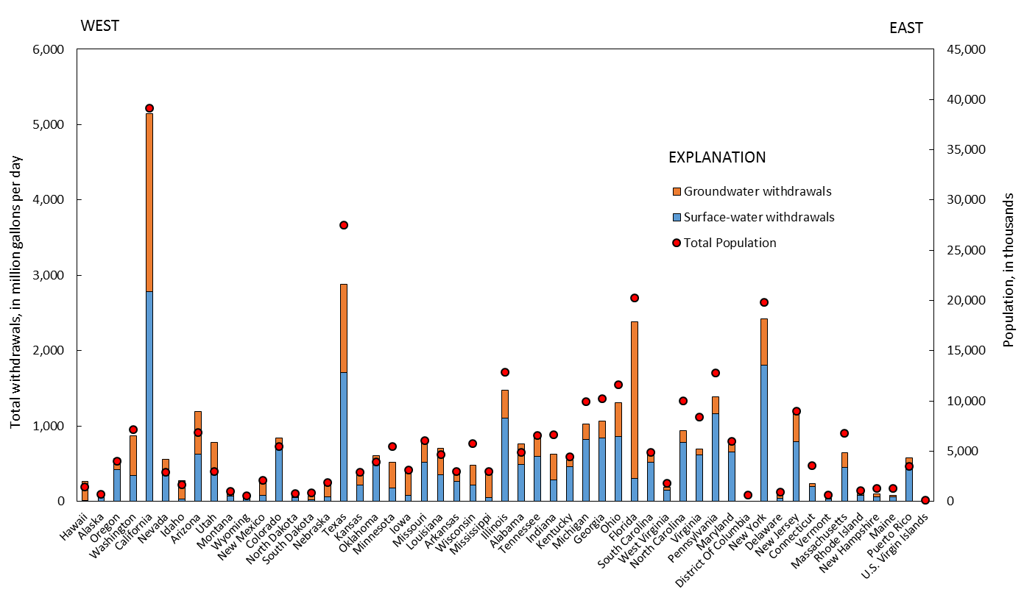
Total domestic water use by state, 2010 and 2015.
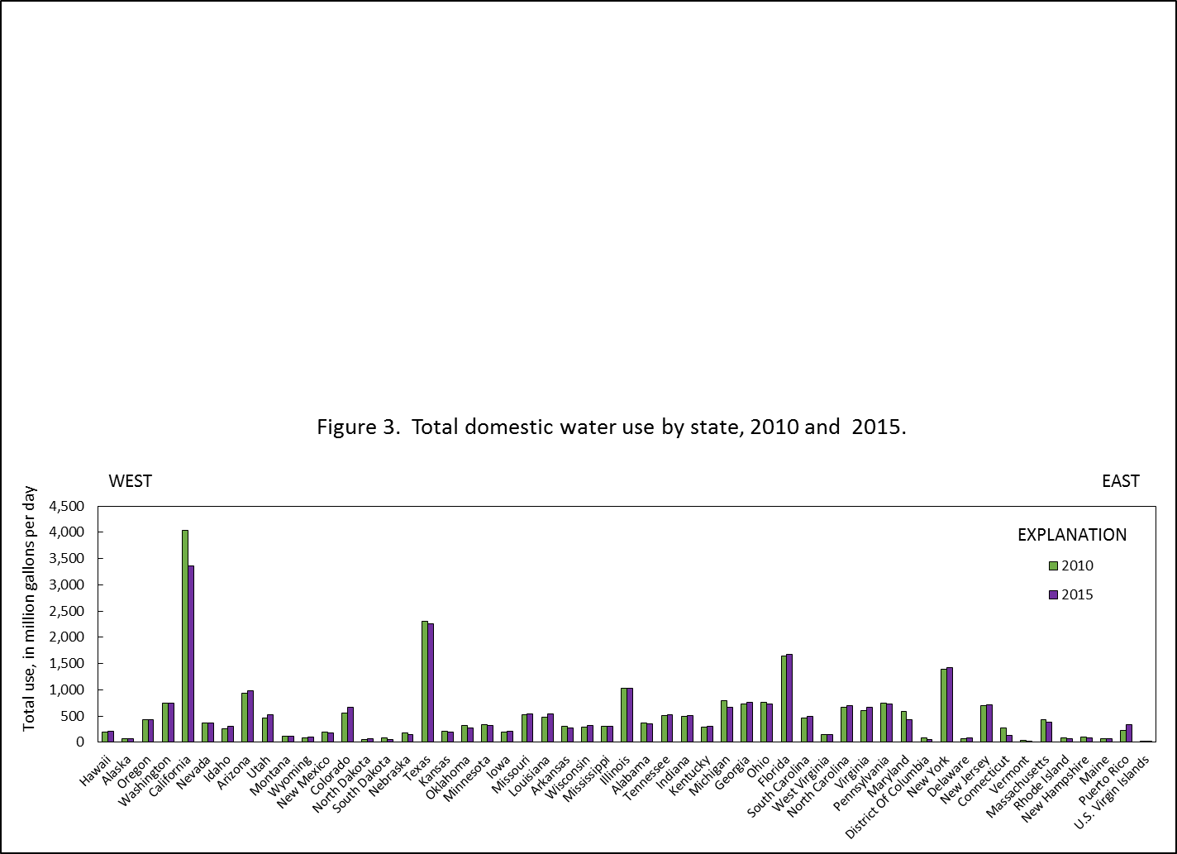
Total domestic per capita water use by state, 2010 and 2015.
