Water Availability and Use Science Program
Regional Groundwater Availability Projects
Transboundary Aquifer Assessment Program

(1) PROJECT ACCOMPLISHMENTS/CONTRIBUTIONS (FY 2017)

Arizona Water Science Center: The Spanish translation of the Binational Study of the Transboundary San Pedro Aquifer (press release), published in English in FY16, was finalized under the auspices of the International Boundary and Water Commission (IBWC). Response to the release included a radio interview. A paper on the binational San Pedro and Santa Cruz Aquifers was invited for publication in a special issue of a journal summarizing issues and progress on assessment and management of transboundary aquifers around the world.
Follow up activities include the San Pedro website, a public portal for data and information, and a database of binational San Pedro data using the USGS ScienceBase platform.
A parallel binational report for the transboundary Santa Cruz Aquifer is in preparation, and expected to be submitted for review by the end of the fiscal year.

New Mexico Water Science Center: Field investigations using novel tracers to determine the contribution of deep groundwater to flow and salinity in the shallow groundwater and surface-water systems in the Mesilla Basin aquifer continued. Discrete groundwater samples were analyzed for aqueous geochemical and isotopic tracers. Effectiveness of the sampling device and method for the ultra-trace radioisotopes of argon and krypton were evaluated by comparing results of tritium concentrations to the krypton-85 content. Good agreement between the analyses, especially in samples with undetectable tritium, indicates that the ultra-trace procedure is effective and confirms that introduction of atmospheric air has not occurred. Analysis of borehole temperature profiles to locate upflow zones in the Mesilla Basin continued. A one-dimensional heat-transport model is used to estimate vertical groundwater flow rates at the upflow zones on the basis of temperature profiles. Volumetric fluxes will be quantified on the basis of vertical flow rates, areal heat flow estimates, and the location of saline surface waters. This work will improve understanding of the interactions between fresh and saline groundwater, and aid in the sustainable use of the groundwater resource. Work in the Mesilla Basin is a collaborative effort with the New Mexico Water Resources Research Institute and New Mexico State University.

Texas Water Science Center: - Discrete groundwater samples were collected from Hueco Bolson production wells near Fillmore Pass, and analyzed for geochemical and isotopic tracers. These data will support the New Mexico Water Science Center’s investigation into cross-basin groundwater movement. Time domain electromagnetic (TDEM) soundings were also collected in the vicinity of utility blend wells near Loop 375. These wells are used to blend pumped groundwater with permeate produced by the Kay Bailey Hutchison desalination plant. Potential brackish groundwater intrusion is of interest in this area, and these soundings will help USGS investigate the location of the interface between fresh and brackish groundwater. These data were collected in coordination with El Paso Water and the U.S. Army Air Defense Artillery Center.

At two scoping meetings with the Mexican Section of IBWC, U.S.-Mexico technical working group meetings for both the Mesilla Basin/Conjos-Medanos and the Hueco Bolson aquifers were set for Fall, 2017 with the goal of identifying binational studies that can be jointly pursued by both countries. The IBWC Groundwater Summit, which will focus on transboundary aquifers, is tentatively scheduled for April, 2018.

(2) PROJECT WORKPLAN AND BUDGET FOR FY 2018

Overall Project Objectives:
The United States (U.S.)-Mexico Transboundary Aquifer Assessment Program (TAAP) was established under the 2006 Act (Public Law 109-448) to “develop and implement an integrated scientific approach to identify and assess priority transboundary aquifers. The area designated by the Act includes transboundary aquifers shared between the States of Sonora and Chihuahua in Mexico and the States of Arizona, New Mexico, and Texas in the United States. The TAAP represents a collaboration among the U.S. Geological Survey (USGS) Water Science Centers and the Water Resources Research Institutes (WRRI) of Arizona, New Mexico, and Texas. The U.S. and Mexican State Departments facilitate bilateral projects and collaboration with Mexican universities and federal agencies such as the National Water Commission.

FY18 Approach and Activities:
Working under the auspices of the USGS Water Availability and Use Science Program, TAAP will continue to strengthen collaboration with U.S. cooperators and stakeholders. The TAAP will also work to broaden and deepen cooperation and collaboration between Mexico and the United States, including development of an International Boundary and Water Commission (IBWC)/ Comisión Internacional de Límites y Aguas (CILA) sponsored Groundwater Summit, and new binational technical working groups for the Mesilla Basin/Conejos Médanos and Hueco Bolson aquifers. TAAP will work to develop a standard approach for hydrologic assessment of transboundary aquifers. This approach will allow for general assessments of all aquifers with increased focus on a subset prioritized by population, economic growth, environmental factors, and the importance of groundwater to the local population. The Approach is divided into seven tasks: 1) geology and baseline studies; 2) hydrogeology; 3) water quality; 4) water availability and use; 5) regional studies; 6) social and economic science; and 7) collaboration, stakeholder engagement, and outreach. Contributions by the WRRIs are complementary to, and in some cases collaborative with, the work by the WSCs. Together, the work of the WSCs and WRRIs will present a physical and socio-economic picture of the transboundary region.

FY18 Summary Workplan:

AZWSC
Personnel from the USGS Geology, Minerals, Energy, and Geophysics Science Center (GMEG) will carry out geologic mapping with Mexican colleagues in some of the more important tributaries to the Santa Cruz River, which includes the Nogales, Sonora area, with publication of an updated geologic map of the area. With the publication of the Binational Santa Cruz Aquifer Report, associated geophysical field work, and new published geologic maps and structural models for several areas within the basin, the foundation is laid for the construction of a hydrogeologic framework model for the binational Santa Cruz aquifer. An interpretive report and associated database are expected to be submitted for review by the end of the fiscal year.

NMWSC
In order to characterize the deep groundwater system in the Mesilla Basin and determine the contributions of deep groundwater flow and salinity to the shallow groundwater and surface water systems, discrete water-quality samples will be collected from ten existing wells located throughout the Mesilla Basin. Aqueous geochemical data will be compared with ultra-trace dissolved gas concentrations to improve knowledge of recharge mechanisms, flow paths, residence times and aquifer mixing. Work will expand to analyzing temperature profiles in wells to identify lateral groundwater flow and to evaluate regional groundwater flow paths with heat-flow maps.

The work will be presented in two abstracts, “Geochemical and isotopic determination of deep groundwater contributions and salinity to the shallow groundwater and surface water systems, Mesilla Basin, New Mexico, Texas, and Mexico” and “Using temperature profiles to estimate saline groundwater fluxes to the Rio Grande and shallow aquifer system in the Mesilla Basin, New Mexico” at the 2017 American Geophysical Union and the 2018 National Groundwater Association Conferences and will be published as journal articles with similar titles. Data from the temperature profiles will be published as a data release.

TXWSC
Following the goals outlined in the 5-year strategic workplan, in FY18 the TXWSC will collect additional TDEM soundings of the Hueco Bolson aquifer in the vicinity of Loop 375 and in-situ measurements of the vertical distribution of dissolved solids in the water table. These data along with TDEM data collected in FY17 will be used to complete an initial investigation into the location of the interface between fresh and brackish groundwater. Results of this investigation will be presented in an SIR, with a targeted publication date of the end of FY18.

Using lessons learned from previous efforts to compile a geodatabase of well data for the U.S. Army Air Defense Artillery Center, the TXWSC also plans to begin a comprehensive Hueco Bolson data compilation for the Hueco Bolson. These data will include well locations, borehole logs, time-series and discrete data measurements, and water use information. The data will be compiled into a geodatabase for use by USGS and the Texas Water Resources Institute in a cooperative effort to improve the current Hueco Bolson groundwater model by incorporating a water quality component. The geodatabase, along with groundwater quality data collected under TAAP during FY16-FY17, are expected to be submitted for review by the end of the fiscal year.

In addition to the above efforts, the TXWSC will continue to work with the International Boundary and Water Commission to identify projects that can be jointly pursued by both the United States and Mexico.

Binational:
In addition to individual work, the WSCs and WRRIs will continue to develop opportunities for binational collaboration through establishment of binational technical working groups for the Messila Conejos-Medanos and the Hueco Bolson aquifers. All groups with work with IBWC to plan and participate in the IBWC Groundwater Summit in April, 2018.

Budgets in support of the broader binational goals and of the activities laid out in the FY18 summary workplan are as follows:

Arizona Water Science Center
Salary - $129,666
Equipment/Supplies (software) - $5,000
Contracts - $10,000
Publications - $12,000
Travel - $10,000
Total: 166,666

New Mexico Water Science Center
Salary - $98,838
Equipment and Supplies - $3,565
Contracts – Lab - $36,224
Travel - $29,040
Total - $167,667

Texas Water Science Center
Salary - $124,200
Equipment/supplies - $1,121
Contracts - $2,739
Publications - $15,600
Travel (field work and meetings) - $23,006
Total - $166,666
(3) NOTEWORTHY COLLABORATIONS, MEETINGS, TECHNICAL TRANSFER ACTIVITIES, SPIN-OFF PROJECT DEVELOPMENTS, AND ACKNOWLEDGEMENTS
Significant cooperator/collaborator meetings:
1) Official visit of a delegation of the TAAP-Texas research team from the Texas Water Resources Institute (TWRI) and Texas A&M University to Saltillo and Cuatrocienegas Coahuila to meet with faculty, researchers, and water users to explore collaboration and joint research opportunities (November, 2016). Presentation of current research on transboundary aquifers between Mexico and Texas to faculty of the Universidad Autonoma de Coahuila.
A Vanguardia news article on this collaboration and transboundary aquifers between the State of Coahuila and Texas received the State of Coahuila Annual Journalism Award 2017. TWRI Vanguardia news article (1)
TWRI Vanguardia news article (2)
An interview with TAAP researchers was also recorded: TWRI Vanguardia interview
2) Several meetings with Cluster Minero Petrolero de Coahuila, S.A de C.V. which opened new linkages with NGOs and private companies working on water (Lesser and Associates, S.A de C.V. and Mina Associates) and oil and gas development in the northern part of Mexico that provided access to unpublished and private data. These data were used in two articles in the journals Groundwater (2017) and Journal of Hydrology, Special Issue on Transboundary Aquifers of the Americas (forthcoming).
3) Binational meetings on May 10 (Ciudad Juarez) and July 21 (El Paso) with IBWC/CILA to discuss establishment of binational technical working groups on the Mesilla Basin and Hueco Bolson aquifers. Initial meetings are planned for Fall, 2017.
4) Santa Cruz Aquifer Binational Meeting, February 8, 2017. Meeting with IBWC, WRRC, and Mexican counterparts.

Special sessions at technical meetings or workshops:
“The U.S.-Mexico Transboundary Aquifer Assessment Program: Accomplishments to Date.” Special Technical Session. Universities Council on Water Resources/National Institutes for Water Resources Annual Conference, Fort Collins, Colo., June 14, 2017. Presenters: William Alley, National Ground Water Association; Delbert Humberson, United States Geological Survey (USGS) Texas Water Science Center; Anne-Marie Matherne, USGS New Mexico Water Science Center; Ismael Minjarez-Sosa, Universidad de Sonora.

“The U.S.-Mexico Transboundary Aquifer Assessment Program: Ongoing Work and Future Directions.” Special Technical Session. Universities Council on Water Resources/National Institutes for Water Resources Annual Conference, Fort Collins, Colo., June 14, 2017. TAAP-affiliated Presenters: Elia Tapia, University of Arizona Water Resources Research Center (UA WRRC); Rosario Sanchez, Texas Water Resources Institute (TWRI); Aracely Tellez, New Mexico Water Resources Research Institute (NM WRRI); Maria Milanes-Murcia, NM WRRI; Jacob Petersen-Perlman, UA WRRC.

Scientific water resources assessment, current and future efforts with specific approach on transboundary aquifers along the CANADA-US and US-Mexico borders. “Shared Waters of North America.” First Special Session. XVI World Water Congress. Cancun, Mexico. 30 May 2017. TAAP-affiliated Presenters: Zhuping Sheng, TWRI; Andrew Teeple, USGS; Luis Antonio Rascón Mendoza, Comisión Internacional de Límites y Aguas (CILA); James Callegary, USGS; Sam Fernald, NM WRRI.

Policies and issues on transboundary water resources with specific approach on transboundary waters along the US-Canada and US-Mexico borders. “Shared Waters of North America”. Second Special Session. XVI World Water Congress. Cancun, Mexico. 30 May 2017. TAAP-affiliated Presenters: Maria Milanés-Murcia, NM WRRI; Sharon Megdal, UA WRRC; José de Jesús Luévano Grano, CILA; Rosario Sanchez, TWRI.

Integration of science and policy in the management of transboundary water resources with specific approach on transboundary aquifers along the US-Canada and US-Mexico borders; and vision by agency leaders. “Shared Waters of North America”. Third Special Session. XVI World Water Congress. Cancun, Mexico. 30 May 2017. TAAP-affiliated Presenters: Edward Drusina, International Boundary and Water Commission; Roberto Fernando Salmón Castelo, CILA; Rubén Chávez Guillén, CONAGUA.

Training courses or workshops:
TWRI - hosted one visiting scholar from Autonomous University of Baja California. Mexico, to train on MODFLOW model development. Began upgrade the MODFLOW model for the Hueco Bolson.

“The Binational Study of the Transboundary San Pedro Aquifer: Results and Future Directions.” Forum in Sierra Vista, AZ. 20 June, 2017. Groups represented: University of Arizona, City of Sierra Vista, Office of Representative Martha McSally, Office of Senator Jeff Flake, USGS, Cochise County, Arizona Department of Environmental Quality, Friends of the San Pedro River, Sierra Vista citizens.

Special project meetings or presentations designed for technology or information transfer:
Binational Technical Meeting Regarding the Transboundary Santa Cruz Aquifer. March 2, 2017. Rio Rico, AZ. Groups represented: UA WRRC, USGS, Universidad de Sonora (UNISON), CONAGUA, International Boundary and Water Commission (IBWC).

Technical Meeting Regarding Climate Change Impact Assessment in the Upper Santa Cruz River Basin. March 31, 2017. Attendees: Sharon B. Megdal (UA WRRC), Jacob Petersen-Perlman (UA WRRC), Elia M. Tapia (UA WRRC), Eylon Shamir (Hydrologic Research Center (HRC).

Successful project development work (spin-offs):
In part because of experience gained working internationally with TAAP, USGS hydrologist James Callegary was one of two USGS scientists tasked with co-leading a workshop on watershed management in Burkina Faso (West Africa) with the US Army Corps of Engineers. James gave presentations on groundwater hydrology and water quality, and co-presented on remote sensing with Robert Mason, Chief of the USGS Office of Surface Water . The workshop took place May 15-19, 2017, and was funded by the US military (AFRICOM).

Acknowledgements:
Local radio interviewed USGS scientist James Callegary regarding the report entitled, “Binational Study of the Transboundary San Pedro Aquifer”. James was the lead author of the study which was published by the International Boundary and Water Commission:
https://news.azpm.org/p/news-spots/2017/1/4/103836-us-mexico-water-study-sets-collaboration-precedent-official-says/

USGS hydrologist, James Callegary, was invited to present at a public forum hosted by the University of Arizona on the topics of groundwater sustainability and the transboundary San Pedro aquifer. The forum took place in Sierra Vista, Arizona on January 20, 2017. An introduction to the presentation was published in the Sierra Vista Herald: “Saturday workshop offers San Pedro insight - Groundwater Presentation: Illuminating Underground Riches our Invisible Resource” (TAAP - San Pedro workshop news article)

USGS hydrologist, James Callegary was invited to give a talk at the 16th World Water Congress in Cancun, Mexico on his experience with US-Mexico Transboundary Aquifer Assessment. The presentation was given on May 30, 2017 during a series of sessions focusing on transboundary aquifers shared between the US and Canada, and the US and Mexico.

(4) Report Products, Bibliographic Update, Data Releases, and Groundwater-Model Archives
Publications:
Arizona Water Resources Research Center, 2017, TAAP-A/S Bulletin on the Binational Study of the Transboundary Aquifer (in English and Spanish), 6 p. Available at https://wrrc.arizona.edu/sites/wrrc.arizona.edu/files/pdfs/TAAP-bulletin-2017.pdf
Callegary, J.B., Minjárez Sosa, I.,Tapia Villaseñor, E.M., P dos Santos, P., Monreal Saavedra, R., Grijalva Noriega, F.J., Huth, A.K., Gray, F., Scott, C.A., Megdal, S.B., Oroz Ramos, L.A., Rangel Medina, M., and Leenhouts, J.M., 2016, Estudio Binacional sobre el Acuífero Transfronterizo del Río San Pedro (Spanish version): Comisión Internacional de Límites y Aguas Informes y Estudios, 189 p., accessed August 7, 2017 at https://www.ibwc.gov/Files/San_Pedro_Binational_Report_ESP_Final_2016.pdf.

Megdal, S.B. 2017. The Cooperative Framework for the Transboundary Aquifer Assessment Program: A Model for Collaborative Transborder Studies. Arizona Water Resource. Summer. Available at https://wrrc.arizona.edu/sites/wrrc.arizona.edu/files/pub-pol-rev-summer-2017_0.pdf

Sanchez, R. and Eckstein, G., 2017, Aquifers shared between Mexico and the United States: Management Perspectives and Their Transboundary Nature: Groundwater, vol. 55, pp. 495–505, doi:10.1111/gwat.12533.

Shamir, Eylon. 2017. Climate Change Impact Assessment in the Upper Santa Cruz River Basin. Available at https://wrrc.arizona.edu/sites/wrrc.arizona.edu/files/FinalReport_08152017_TAAP_EylonShamir.pdf

Teeple, A.P., 2017, Geophysics- and geochemistry-based assessment of the gchemical characteristics and groundwater-flow system of the U.S. part of the Mesilla Basin/Conejos-Médanos aquifer system in Doña Ana County, New Mexico, and El Paso County, Texas, 2010–12: U.S. Geological Survey Scientific Investigations Report 2017–5028, 183 p., https://doi.org/10.3133/sir20175028.

Abstracts and Presentations:
· Alley, William, 2017, The U.S.-Mexico Transboundary Aquifer Assessment Program - the first five years: Universities Council on Water Resources/National Institutes for Water Resources Annual Conference, Fort Collins, Colo., June 14, 2017.
Callegary, J.B., Minjárez Sosa, I., Megdal, S.B., Tapia Villaseñor, E.M., Rodríguez Burgueño, J.E., Kennedy, J.R., and Ramirez Hernandez, J., 2017, U.S.-Mexico transboundary aquifer assessment: Aquifers of the Upper San Pedro, Santa Cruz, and Lower Colorado: XVI World Water Congress, Cancun, Mexico, May 30, 2017.
Matherne, A.M., and Robertson, Andrew, 2017, US-Mexico Transboundary Aquifer Assessment Program - New Mexico investigations: Universities Council on Water Resources/National Institutes for Water Resources Annual Conference, Fort Collins, CO, June 14, 2017.
Megdal, S.B., 2017, The Joint Cooperative Framework for the Transboundary Aquifer Assessment Program: Shared Borders of North America World Water Congress Special Session Part 2: Policy Issues. XVI World Water Congress, Cancun, Mexico, May 30, 2017. https://wrrc.arizona.edu/sites/wrrc.arizona.edu/files/pdfs/share-borders-north-america-2017.pdf
Minjarez, J. I., Callegary, J. B., Tapia, E. M., Monreal, R., Grijalva, F., Gray, F., and Scott, S. B., 2017, The Binational Report of the Transboundary San Pedro Aquifer, successful experience on binational work: Universities Council on Water Resources/National Institutes for Water Resources Annual Conference, Fort Collins, CO, June 14, 2017.
Pepin, Jeff; Robertson, Andrew J., Ferguson, Christina, and Burns, Erick, 2017, Using heat as a tracer to estimate saline groundwater fluxes from the deep aquifer system to the shallow aquifers and the Rio Grande in the Mesilla Basin, New Mexico, USA: Abstract to the American Geophysical Union Fall Meeting, December 11-15, 2017.
Petersen-Perlman, J.D., 2017, Additional dialogue on the US-Mexico Transboundary Aquifer Assessment Program: Past, present, and future: Universities Council on Water Resources/National Institutes for Water Resources Annual Conference, Fort Collins, Colo., June 14, 2017.
Petersen-Perlman, J.D. and Megdal, S.B., 2017, Efforts towards transboundary groundwater assessment and governance: Transboundary Aquifer Assessment Program in Arizona and Sonora: American Association of Geographers Meeting 2017, Boston, MA, April 9, 2017. https://wrrc.arizona.edu/sites/wrrc.arizona.edu/files/Petersen-Perlman_AAG_4_9_17.pdf
Robertson, Andrew J., Carroll, Kenneth, Kubicki, Chris, Purtschert, Roland, 2017, Geochemical and isotopic determination of deep groundwater contributions and salinity to the shallow groundwater and surface water systems, Mesilla Basin, New Mexico, Texas, and Mexico, Abstract to the American Geophysical Union Fall Meeting, December 11-15, 2017.
Sanchez, Rosario, and Eckstein, G., 2017, Aquifers shared between Mexico and the U.S.: Management perspectives and their transboundary nature: Universities Council on Water Resources/National Institutes for Water Resources Annual Conference, Fort Collins, Colo., June 14, 2017.
Tapia, E.M., Megdal, S.B. and Petersen-Perlman, J.D., 2017, The U.S. Mexico Transboundary Aquifer Assessment Program in Arizona: Current and future efforts: Universities Council on Water Resources/National Institutes for Water Resources Annual Conference, Fort Collins, Colo., June 14, 2017. https://wrrc.arizona.edu/sites/wrrc.arizona.edu/files/UCOWR_EMTAPIA_09142017b.pdf
Tapia, E.M., Callegary, J.B., Minjarez Sosa, I., Monreal Saavedra, R., Grijalva Noriega, F.J., Gray, F., Petersen-Perlman, J.D., and Megdal, S.B, 2017, The Transboundary Aquifer Assessment Program and the binational study of the San Pedro Aquifer: XVI World Water Congress, Cancun, Mexico. 29 May- 3 June, 2017. https://wrrc.arizona.edu/sites/wrrc.arizona.edu/files/pdfs/TAAP-poster-2017.pdfeo
Teeple, A.P. and Humberson, D.G., 2017, Transboundary Aquifer Assessment Program: Assessment of the Mesilla Bolson/Conejos-Médanos and Hueco Bolson Aquifer Systems: Universities Council on Water Resources/National Institutes for Water Resources Annual Conference, Fort Collins, Colo., June 14, 2017.
Tellez, Aracely, and Milanes-Murcia, Maria, 2017, The Mesilla Valley Basin Aquifer the impact of water regimes on riparian vegetation. Can cooperation, conservation strategies, and policies ensure the sustainability of groundwater?: Universities Council on Water Resources/National Institutes for Water Resources Annual Conference, Fort Collins, Colo., June 14, 2017.

(5) PROJECT TEAM DIRECTORY –
Anne-Marie Matherne, NM WSC, 505-830-7971, matherne@usgs.gov, , TAAP Point of Contact
Andrew Robertson, NM WSC, 505-830-7975, ajrobert@usgs.gov, NM TAAP Project Chief, Mesilla Basin hydrogeology
James Callegary, AZ WSC, 520-670-6671 x294, jcallega@usgs.gov, AZ TAAP Project Chief, San Pedro and Santa Cruz Basins hydrogeology
Delbert Humberson, TX WSC, 512-436-1146, dhumberson@usgs.gov, TX TAAP Project Chief, Hueco Bolson hydrogeology
(6) PHOTOS, ANIMATIONS, AND GRAPHICS –

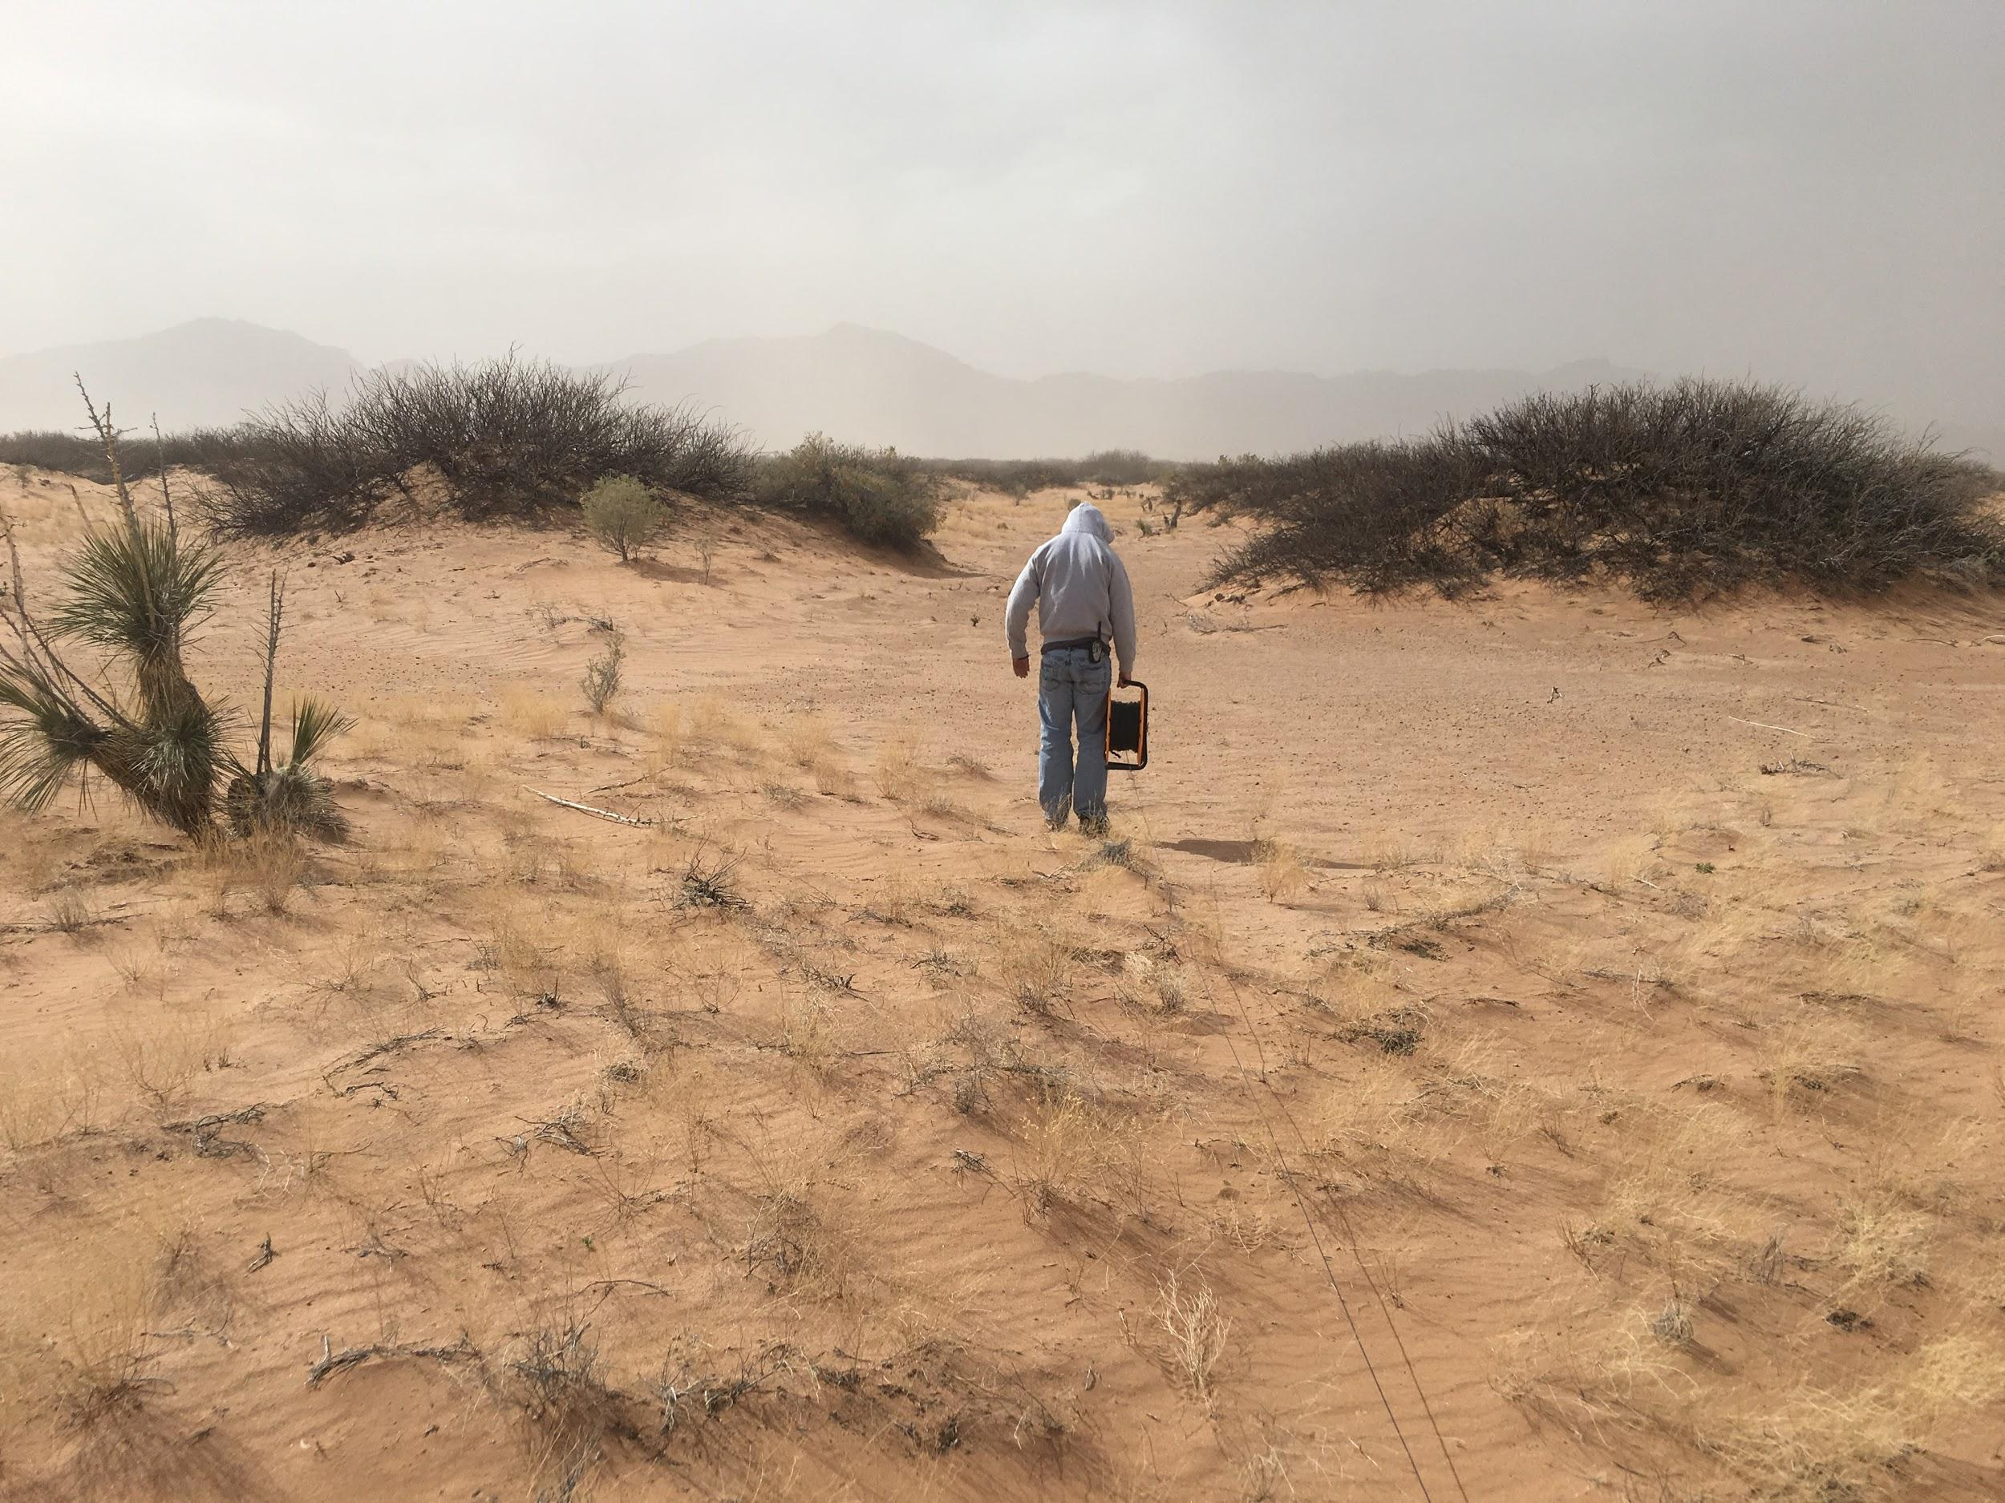
USGS Hydrologist, Daniel Tebo, unspooling electrical line during a sandstorm to collect TDEM soundings in the Hueco Bolson. February 28, 2017. El Paso, Texas.
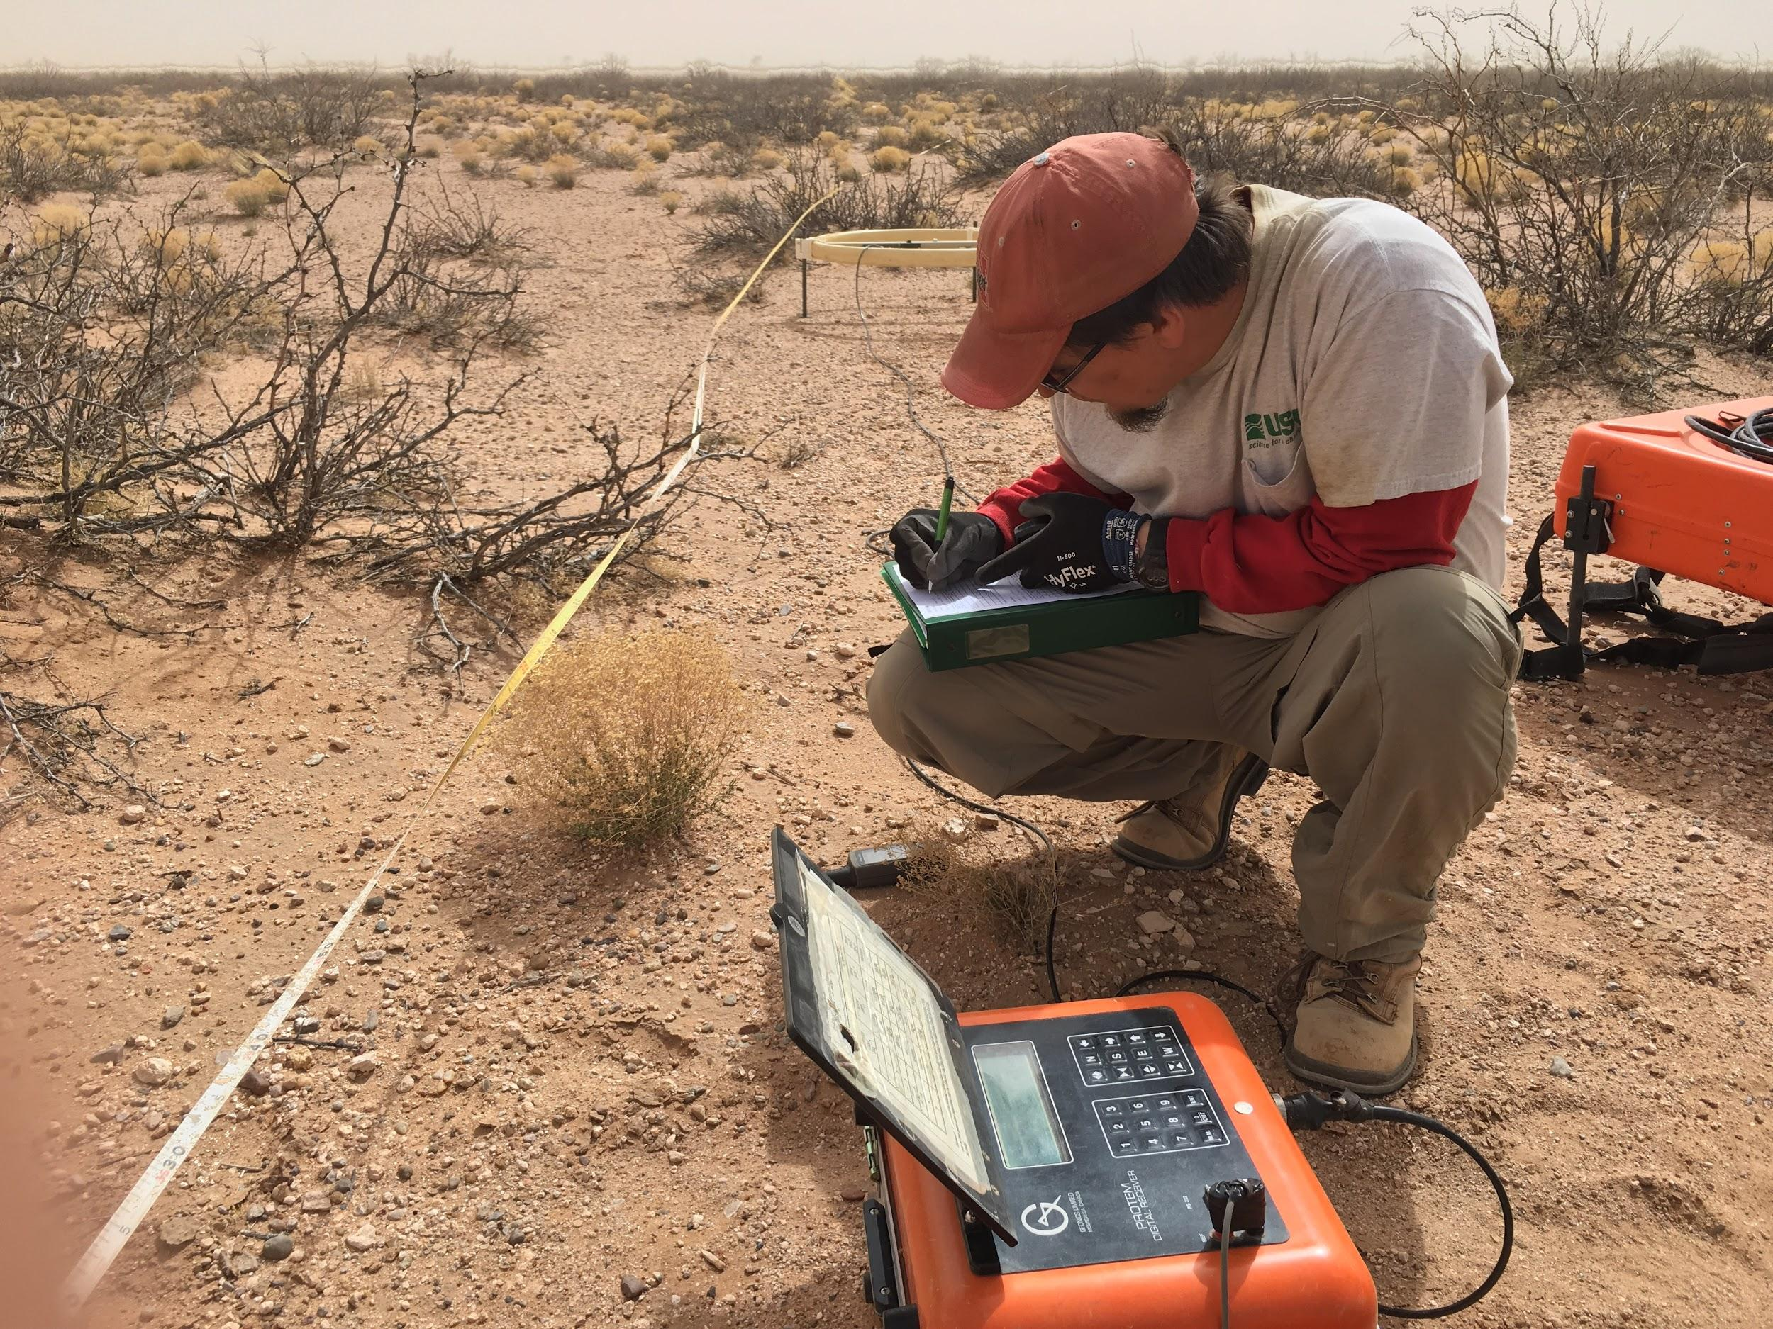
USGS Hydrologist, Andrew Teeple, collecting TDEM sounding data during a sandstorm in the Hueco Bolson. February 28, 2017. El Paso, Texas.

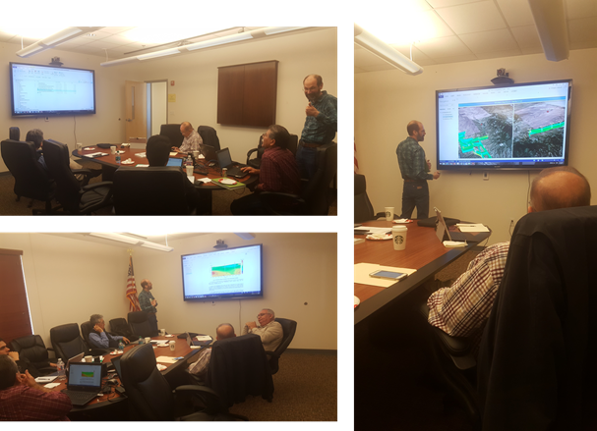
Binational Technical Meeting Regarding the Transboundary Santa Cruz Aquifer. March 2, 2017. Rio Rico, Arizona. James Callegary, Arizona Water Science Center, presenting.
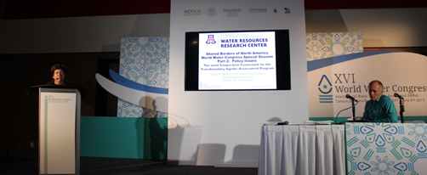
XVI World Water Congress. Shared Borders of North America World Water Congress Special Session Part 2: Policy Issues. Sharon Megdal, Director, Arizona Water Resources Research Center, presenting.

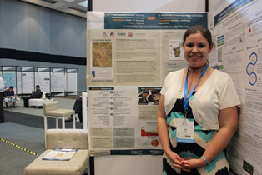
XVI World Water Congress. The Transboundary Aquifer Assessment Program and the Binational Study of the San Pedro Aquifer. Elia Tapia, Arizona Water Resources Research Center, presenting.

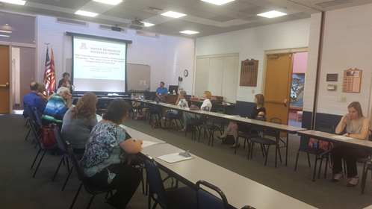
The Binational Study of the Transboundary San Pedro Aquifer: Results and Future Directions Forum. June 20, 2017. Sierra Vista, Arizona. Sharon Megdal, Director, Arizona Water Resources Research Center, presenting.

