Transboundary Aquifer Assessment Program
(1) Project Accomplishments/Contributions (FY2016)
Program funding for the US-Mexico Transboundary Aquifer Assessment Program (TAAP) was re-initiated in 2016 with a $1M appropriation. TAAP was authorized in 2006 (P.L. 109-448), and $2M was appropriated during FY 2008-2010. One of the most significant accomplishments from that period was the establishment of a collaborative binational working group culminating in the signing of an agreement between the two countries to jointly study shared aquifers. The program integrates innovation and collaboration between research universities through the National Institutes for Water Resources and USGS Water Science Centers of Texas, New Mexico, and Arizona, working together on priority aquifers in groundwater-dependent border communities subject to stress from development and drought. The program also represents a full scientific partnership with Mexico and the International Boundary and Water Commission. Working under the auspices of the USGS Water Availability and Use Science Program, 2016 funding provided an opportunity to continue and build on collaborative transboundary work that continued at a reduced level after 2010.
Because of the hiatus in TAAP funding and project work, the chief goal for 2016 was to re-establish discussions with Mexican officials and colleagues regarding collaboration towards TAAP goals: the planning, development, and execution of science to develop critical knowledge about shared binational groundwater resources. A binational meeting was hosted in El Paso, TX by the International Boundary and Water Commission on September 29, 2016 that brought together representatives of Mexican and United States federal and state agencies and universities. Discussions identified priorities for both countries, and opportunities for binational collaboration that will shape future projects under the TAAP program.
Other TAAP accomplishments for 2016 include release of the Binational San Pedro Aquifer Report and two draft reports, a geochemical and geophysical study of the Mesilla Basin/Conejos- Médanos aquifer system and a binationally-authored, bilingual report with Mexican partners on the Santa Cruz River Aquifer. Field efforts include geologic mapping by USGS and Mexican geologists in the Nogales, Sonora area and sampling of groundwater in the Mesilla, Hueco-Bolson, and Jornada Basins to establish baseline geochemistry and investigate the contribution of deep groundwater to flow and salinity in surface and near-surface systems.
(2) Project Workplan and Budget for FY 2017
The anticipated FY17 budget is the same as FY16, and projects by each of the six entities will continue activities laid out in the Tactical Workplan submitted in FY16. Of $1M allocated to the TAAP, $500,000 is allocated to the WRRI and managed through that Program.
In FY17, the TAAP will continue to broaden and deepen the collaboration between Mexico and the United, including exploring the potential for creation of a trinational groundwater monitoring network with Mexico and Canada. We will work to develop a standard approach for hydrologic assessment of transboundary aquifers. This approach will allow for general assessments of all aquifers with increased focus on a subset prioritized by population, economic growth, environmental factors, and the importance of groundwater to the local population. Further work, related to the priority Santa Cruz aquifer in Arizona, will include publication of a hydrologic conceptual model of the Patagonia Mountains and a binational assessment. A ScienceBase database and StoryMap website will be developed and published for the San Pedro aquifer in Arizona. On the priority Mesilla Basin/Conejos Médanos and Hueco Bolson aquifers in New Mexico and Texas, further work will include publication of a geochemical and geophysical assessment. We will begin work on binational assessments of the New Mexico and Texas priority transboundary aquifers.
Budgets in support of the broader binational goals and of the activities laid out in the Tactical Workplan are as follows:
Arizona Water Science Center
Salary - $129,666
Equipment/Supplies (software) - $5,000
Contracts (WIWSC for StoryMap development) - $10,000
Publications (SIR – Patagonia Mt. Hydrologic Conceptual Model) - $12,000
Travel - $10,000
Total: 166,666
New Mexico Water Science Center
Salary - $98,838
Equipment and Supplies - $3,519
Contracts – Lab - $36,224
Travel - $29,040
Total - $167,667
Texas Water Science Center
Salary - $78,503
Equipment/supplies - $7,600
Contracts - $53,644
Travel (field work and meetings) - $26,920
Total - $166,667

(3) Noteworthy Collaborations, Meetings, Technical Transfer Activities, and Spin-off Project Developments
(1) Briefing to DOI Assistant Secretary Jennifer Gimbal – March 30 – briefing to Asst. Sec. Gimbal on TAAP history and on prior and on-going TAAP-related work arising from initial (FY2008-10) funding. Possible directions in light of renewed (2016) funding were presented.
(2) USGS/IBWC/Universities of Sonora and Arizona – May 26 - Binational meeting regarding the new TAAP funding and request to reinitiate binational work with Mexico in Texas and New Mexico. The San Pedro and Santa Cruz binational transboundary aquifer reports were also discussed.
(3) USGS/University of Sonor – June 16 – Arizona-Sonora technical committee meeting focusing on the binational Santa Cruz Aquifer report –discussions related to newly published geological analyses and chapter assignments for revision of English-language draft.
(4) USGS/WRRI Strategic Planning Meeting – June 29, Las Vegas, Nevada – meeting of members of the US TAAP team to review prior and on-going work, identify short-term goals, and plan further steps. Planning began for the binational meeting with Mexico.
(5) USGS Groundwater Workshop (August 29-September 2) presentations:
James Leenhouts – U.S.-Mexico Transboundary Aquifer Assessment Program (TAAP): Developing knowledge and tools needed to inform joint management of binational aquifers.
James Callegary – with I. Minjárez Sosa, E.M. Tapia Villaseñor, P. dos Santos, R. Monreal Saavedra, F.J. Grijalva Noriega, A.K. Huth, F. Gray, C.A. Scott, S.B. Megdal, L.A. Oroz Ramos, M. Rangel Medina, and J.M. Leenhouts – Binational study of the transboundary Upper San Pedro and Santa Cruz Aquifers.
Andrew Teeple – Geochemistry-based assessment of the geochemical characteristics and groundwater flow systems of the U.S. part of the Mesilla Basin/Conejos Médanos aquifer system in Doña Ana County, New Mexico, and El Paso County, Texas.
Andrew Teeple –Geophysics-based assessment of geochemical characteristics and groundwater-flow system of the U.S. part of the Mesilla Basin/Conejos Médanos aquifer system in Doña Ana County, New Mexico, and El Paso County, Texas.

(6) Binational U.S.-Mexico TAAP meeting hosted by the International Boundary and Water Commission, September 29, 2016. The chief objective was to re-establish discussions with Mexican officials and colleagues regarding collaboration towards TAAP goal of working together on priority transboundary aquifers.

(4) Report Products and Bibliographic Updates (compiled 8-23-16)
Browning-Aiken, Anne, Scott, C.A., Varady, R.G., and Megdal, S.B., 2010, Spanning transboundary waters in North America (Atravesando las aguas transfronterizas en América del Norte, Traverser les eaux transfrontières en Amérique du Nord): Newsletter of International Network of Basin Organizations.

Callegary, JB, Jeff Langeman, Jim Leenhouts, Peter Martin, 2013, Challenge theme 2: assuring water availability and quality in the 21st century: Chapter 4 in United States--Mexican Borderlands--facing tomorrow’s challenges through USGS science, eds. Randall Updike, Eugene Ellis, William Page, Melanie Parker, Jay Hestbeck, William Horak, USGS Circular 1380-4

Callegary, J., Megdal, S.B., Scott, C.A., and Vandervoet, P.L. 2013, Arizona/Sonora section of the Transboundary Aquifer Assessment Program. In Alley, W. (Ed.) Five-year interim report of the United States-Mexico Transboundary Aquifer Assessment Program: 2007–2012: U.S. Geological Survey Open-File Report 2013-1059. pp. 5-18. Reston, VA: U.S. Geological Survey. http://pubs.usgs.gov/of/2013/1059/pdf/ofr2013-1059.pdf

Callegary, J.B., Minjárez Sosa, I., Tapia Villaseñor, E.M., dos Santos, P., Monreal Saavedra, R., Grijalva Noriega, F.J., Huth, A.K., Gray, F., Scott, C.A., Megdal, S.B., Oroz Ramos, L.A., Rangel Medina, M., Leenhouts, J.M., 2016, San Pedro River Aquifer Binational Report: International Boundary and Water Commission, 170 p.

Culbertson, Chris, Lytle, W.E., McMillan, M.M., Sternberg, B.K., and Withers, K.B., 2010, Transient electromagnetic (TEM) investigation of microbasin morphology along the Santa Cruz River, Nogales, Arizona: University of Arizona, Geophysical Field Methods Spring, 2010 Course Report, accessed June 19, 2012.
http://www.lasi.arizona.edu/GEN%20416-516%202010%20Final%20Report.pdf.

Gungle, Bruce, Callegary, J.B., Paretti, N.V., Kennedy, J.R., Eastoe, C.J., Turner, D.S., Dickinson, J.E., Levick, L.R., and Sugg, Z.P., 2016, Hydrological conditions and evaluation of sustainable groundwater use in the Sierra Vista Subwatershed, Upper San Pedro Basin, southeastern Arizona: U.S. Geological Survey Scientific Investigations Report 2016–5114, 90 p.,http://dx.doi.org/10.3133/sir20165114.

Kambhammettu, B.V.N.P., Chandramouli, S., and King, J.P., 2011, An improved DEM aggregation technique for models with non-uniform resolution: International Journal of Geomatics and Geosciences, v. 1, no. 4, p. 962–970.

Kambhammettu, B.V.N.P., King, J.P., and Allena, Praveena, 2011, Evaluation of mountain-front recharge estimation techniques for Southern New Mexico basins: International Journal of Water Resources and Environmental Engineering, v. 3, no. 3, p. 66–72.

Kambhammettu, B.V.N.P., Schmid, Wolfgang, King, J.P., and Creel, B.J., 2012, Effect of elevation resolution on evapotranspiration simulations using MODFLOW: Ground Water, v. 50, no. 3, p. 367–375.

Lincicome, A.D., 2011, DRASTIC groundwater vulnerability assessment of the Santa Cruz and San Pedro aquifers: The University of Arizona, Soil, Water, and Environmental Sciences, Master’s Thesis.

Maddock, Thomas, III, Baird, K.J., Hanson, R.T., Schmid, Wolfgang, and Ajami, Hoori, 2012, RIP-ET: A riparian evapotranspiration package for MODFLOW-2005: U.S. Geological Survey Techniques and Methods 6–A39, 76 p.

McAndrew, R.M., 2011, Subsurface contaminant transport modeling in the upper Santa Cruz Basin: The University of Arizona, Hydrology and Water Resources, Master’s Thesis.

Megdal, S.B. 2008, Front-row view of federal water lawmaking shows process works – U.S. Mexico Transboundary Aquifer Assessment Act pondered, passed, and signed. In Norman, L., Hirsch, D., and Ward, W. (Eds.), Proceedings of a USGS workshop on facing tomorrow’s challenges along the U.S. Mexico border; monitoring, modeling, and forecasting change within the Arizona-Sonora transboundary watersheds: U.S. Geologic Survey Circular 1322. Reston, VA: U.S. Geologic Survey.

Megdal, S.B. 2012, Groundwater use and re-use in the transboundary Santa Cruz River Basin. World Water Development Report 4(2), 528.
http://unesdoc.unesco.org/images/0021/002156/215644e.pdf#page=406

Megdal, S.B., Sencion, R., Scott, C., Diaz, F., Callegary, J., and Varady, R. 2010, Institutional assessment of the transboundary Santa Cruz and San Pedro Aquifers on the United States-Mexico border. Preproceedings from ISARM2010 International Conference: Transboundary Aquifers: Challenges and New Directions. Paris, France: UNESCO.
http://unesdoc.unesco.org/images/0021/002116/211661e.pdf

Megdal, S.B., and Scott, C. 2011, The importance of institutional asymmetries to the development of binational aquifer assessment program: The Arizona-Sonora experience. In Viaggi, D. (Ed.) [Special Issue on Water Policy]. Water 3(3), pp. 949-963.
http://dx.doi.org/10.3390/w3030949

Megdal, Sharon, Varady, Robert, Vandervoet, Prescott, and Scott, Chris, 2012, Water allocation under uncertainty: Groundwater and effluent in the United States – Mexico transboundary Santa Cruz River Basin: The Third United Nations World Water Development Report (WWDR4) Case Studies Volume, UNESCO.

Michelsen, Ari, Alley, William, Sheng, Zhuping, King, J.P., Darr, Michael, Megdal, S.B., and Cafaggi, Felix, 2011, Transboundary aquifer assessment program [abst.]: Panel, American Water Resources Association 2011 Annual Water Resources Conference, Albuquerque, N.M., November 7–10, 2011.

Michelsen, Ari, Sheng, Zhuping, Creel, B.J., and Harris, Bill, 2010, Transboundary Aquifer Assessment Program: Challenges and opportunities [abst.]: Universities Council on Water Resources/National Institutes for Water Resources, Seattle, Wash., July 13–15.

Milman, A., and Scott, C.A., 2010, Beneath the surface: Intranational institutions and management of the United States – Mexico transboundary Santa Cruz aquifer: Environment and Planning C: Government and Policy, v. 28, p. 528–551.

Scott, C.A., 2011, The water-energy-climate nexus: Resources and policy outlook for aquifers in Mexico: Water Resources Research, v. 47, doi:10.1029/2011WR010805.

Scott, C.A., Megdal, Sharon, Oroz, L.A., Callegary, James, and Vandervoet, Prescott, 2012, Effects of climate change and population growth on the transboundary Santa Cruz aquifer: Climate Research, v. 51, p. 159–170, doi: 10.3354/cr01061.

Scott, C., Megdal, S.B., Oroz, L., Callegary, J., and Vandervoet, P. 2012, Climate change and population growth impacts on the transboundary Santa Cruz aquifer. Climate Research 51(2), pp. 159-170. http://dx.doi.org/10.3354/cr01061.

Scott, C.A., and Pasqualetti, M.J., 2010, Energy and water resources scarcity: Critical infrastructure for growth and economic development in Arizona and Sonora: Natural Resources Journal, v. 50, no. 3, p. 645-682

Scott, C.A., and Pineda-Pablos, N., 2011, Innovating resource regimes: Water, wastewater, and the institutional dynamics of urban hydraulic reach in northwest Mexico: Geoforum, v. 42, no. 4, p. 439–450, doi:10.1016/j.geoforum.2011.02.003.

Stewart, A.M., Callegary, J.B., Smith, C.F., Gupta, H.V., Leenhouts, J.M., and Fritzinger, R.A., Use of the continuous slope-area method to estimate runoff in a network of ephemeral channels, southeast Arizona, U.S.A.: Journal of Hydrology, v. 472–473, p. 148–158.

Texas Water Resources Institute and New Mexico Water Resources Research Institute, 2008, U.S.-Mexico Transboundary Aquifer Assessment Program- Arizona (TAAP-A/S): Fact Sheet.

Texas Water Resources Institute and New Mexico Water Resources Research Institute, 2009, U.S.-Mexico Transboundary Aquifer Assessment Program- Arizona (TAAP-A/S): Fact Sheet.

Texas Water Resources Institute and New Mexico Water Resources Research Institute, 2010, U.S.-Mexico Transboundary Aquifer Assessment Program- Arizona (TAAP-A/S): Fact Sheet.

Texas Water Resources Institute and New Mexico Water Resources Research Institute, 2011, U.S.-Mexico Transboundary Aquifer Assessment Program- Arizona (TAAP-A/S): Fact Sheet.

Vandervoet, P., Megdal, S.B., and Scott, C. 2013, Los acuíferos transfronterizos Santa Cruz y San Pedro en Arizona y Sonora: Estado actual y análisis de meta-datos [The Santa Cruz and San Pedro transboundary aquifers of Arizona and Sonora: Current status and metadata analysis]. In Cordova, G., Dutram, J., Lara, B., and Rodriguez, J. (Eds.), Fortaleciendo el diálogo social: El desarrollo humano transfronterizo en la región Sonora-Arizona [Strengthening social dialogue: Transboundary human development in the Sonora-Arizona region]. Hermosillo, Sonora, Mexico: Universidad de Sonora Press.

Varady, R., Scott, C., and Megdal, S.B. 2010, Transboundary aquifer institutions, policies, and governance: A preliminary inquiry. Preproceedings from ISARM2010 International Conference: Transboundary Aquifers: Challenges and New Directions. Paris, France: UNESCO.
http://unesdoc.unesco.org/images/0021/002116/211661e.pdf

Wilder, M., Scott, C.A., Pineda-Pablos, N., Varady, R.G., Garfin, G.M., and McEvoy, J., 2010, Adapting across boundaries: Climate change, social learning, and resilience in the U.S. – Mexico border region: Annals of the Association of American Geographers, v. 100, no. 4, p. 917–928.

(5) Acknowledgements/Endorsements and Testimonials (Quotes)

(6) Project Team Directory
Anne-Marie Matherne, NM WSC, 505-830-7971, matherne@usgs.gov, , TAAP Point of Contact, NM TAAP Project Chief
Andrew Robertson, NM WSC, 505-830-7975, ajrobert@usgs.gov, Mesilla Basin hydrogeology
James Callegary, AZ WSC, 520-670-6671 x294, jcallega@usgs.gov, AZ TAAP Project Chief, San Pedro and Santa Cruz Basins hydrogeology
Delbert Humberson, TX WSC, 512-436-1146, dhumberson@usgs.gov, TX TAAP Project Chief, Hueco Bolson hydrogeology

(7) Photos, Animations, and Graphics

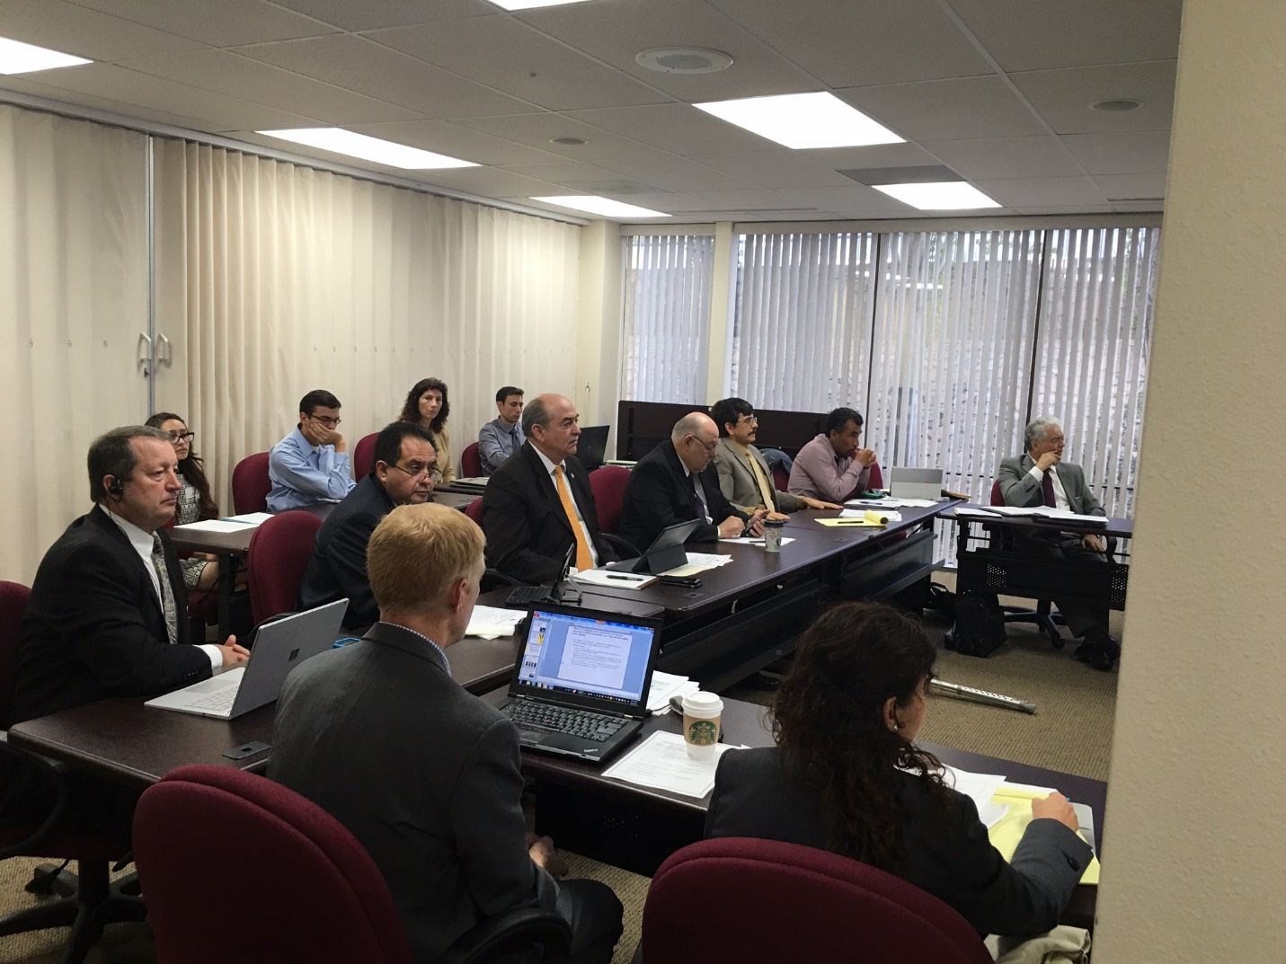

Bi-national TAAP meeting, El Paso TX, Sept. 29, 2016. Key players included are (left to right) Bill Cunningham, Jose Nunez (IBWC), Edward Drusina (IBWC Commissioner), Roberto Salmon (CILA Commissioner), and Antonio Rascos (CONAGUA).

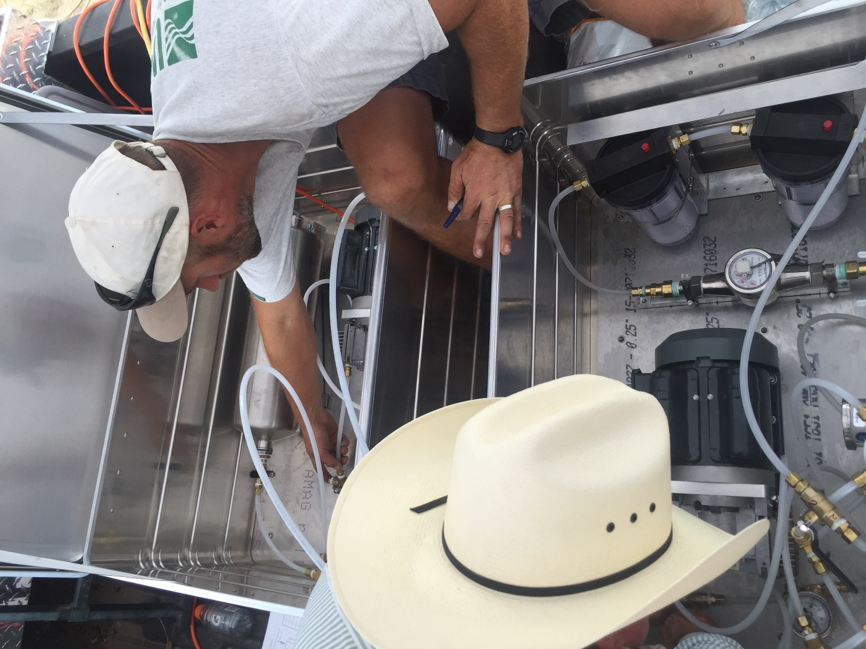
Andrew Robertson, USGS New Mexico Water Science Center and New Mexico State University personnel leak-testing the groundwater degassing device for ultra-trace noble gas isotope collection, Mesilla Basin, New Mexico.

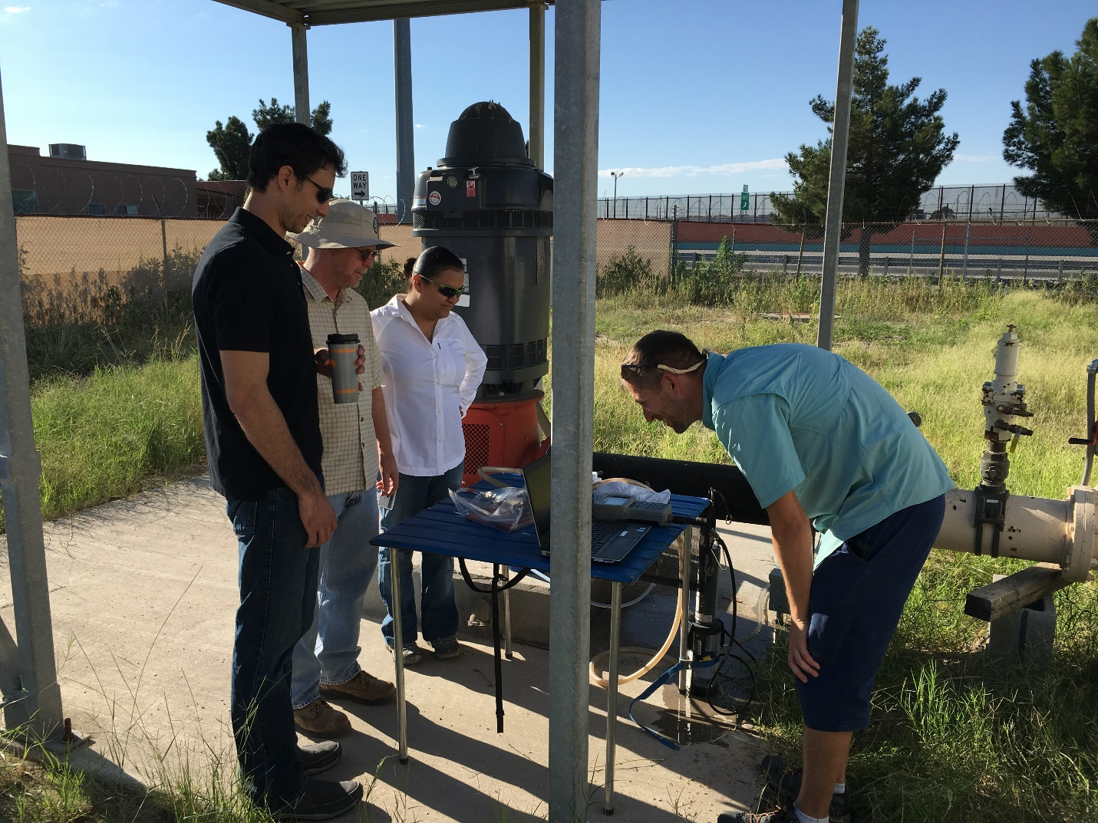
Chris Braun, from the Texas Water Science Center, demonstrates USGS sampling methods to employees of the United States Section of the International Boundary and Water Commission.

