Water Availability and Use Science Program
Red River Focus Area Study
Fiscal Year 2018 End-of-Year Report
September 11, 2018

(1) PROJECT ACCOMPLISHMENTS/CONTRIBUTIONS (Fiscal Year [FY] 2018)
Water Use Study Component
The water withdrawal estimates in the Red River basin will be refined and enhanced to provide a more detailed picture of water use in the basin. Work continued on most of the water-use component objectives, as detailed below. The work is primarily being done by water-use compilers in Louisiana and Texas.
During FY18, it was decided that it is more important for the water use team to enter all data into NWIS than to produce an SIR for the water use study component. The Water Use team will publish data releases as needed to supplement the information stored in NWIS. In addition, the Water Use team will provide background and supporting information to the groundwater and surface-water model SIR’s to describe the water withdrawals used in the models.
- Estimation and compilation of water-withdrawals during 2010 and 2015 delineated by 8-digit hydrologic unit codes (HUC8s). The 2010 water compilations that were added to the Red River FAS workplan in FY17 have been revised continually through FY18 due to errors at the state water agencies; those revisions have not been completed or approved as of this date. The 2015 water compilations for all states were reviewed, corrected, and approved during FY18. Once the 2010 data are finalized, the water-use team can complete the disaggregation from county and reaggregation to HUC8s. Also, during FY18 it was decided that area-based disaggregation was not appropriate for public supply and thermoelectric categories. Obtained the information needed for population-based disaggregation of the public supply and individually-assigned-to-HUC8s for the thermoelectric categories.
- Estimation of withdrawals from the Red River alluvial and Seymour aquifers in areas of Oklahoma and Texas above the Lake Texoma Dam from 1995–2014 to support groundwater modeling efforts. This objective was completed during FY16. During FY18, it was decided to extend the end date from 2014 to 2016 because much of the ecological flows data, which relies heavily on the groundwater model output, is from recent years. The new 2015 and 2016 groundwater withdrawal estimates were completed during FY18. In addition, all data in groundwater model area (OK and TX) were added to SWUDs.
- Estimation of surface-water withdrawals from 1980–2014 to support surface-water modeling efforts. This objective was completed during FY16. During FY18, it was decided to extend the end date from 2014 to 2016 because much of the ecological flows data, which relies heavily on the surface-water model output, is from recent years. The new 2015 and 2016 surface-water withdrawal estimates were completed during FY18. In addition, all data were added to SWUDs and intake site files were created during the process as needed.
- Estimation of inter-basin water transfers. This objective was completed in during FY17. A description and table of the data were provided to the surface-water model team for inclusion in the surface-water model Scientific Investigations Report (SIR).
- Estimation of consumptive use of water withdrawn in the basin. During FY18 it was determined that consumptive use for irrigation should be the primary focus for this task. The approach was modified to be a comparison of consumptive use estimation methods for two areas in the study area – an irrigated area in the TX Panhandle versus a non-irrigated area in northwestern LA. This task was placed lowest on the water-use priority list.
- Estimation of withdrawals, returns, and other data for selected categories of use that are optional for the 2015 national water-use compilation. Two non-mandatory elements were prioritized during FY18: 1) wastewater returns and 2) hydroelectric instream and offstream. Data were compiled and added to AWUDS in LA and OK.

The water use team worked with Toby Welborn with the Texas Water Science Center (WSC) Data and Spatial Studies section to develop a data visualization plan for the water use data. They decided to focus on the 2010 and 2015 water withdrawal compilations by HUC8s. A modification of the 2015 national water use by county data visualization (link) will be developed that will include changes in the map extent (use FAS study area) and subdivisions (use HUC8s instead of counties) plus a time slider (fig. 1).
Groundwater Study Component
A numerical groundwater-flow model will be constructed for selected alluvial aquifers upstream from Lake Texoma that are connected to the Red River: the Seymour aquifer near the Red River, Red River alluvium, the Salt Fork Red River alluvium, and the North Fork Red River alluvium. Work continued on the groundwater-flow model study component, as detailed below:

- Incorporated final data sets from the North Fork (Smith and others, 2017) and Salt Fork Red River alluvium (Ellis and others, in prep) models
- Finished building the steady-state model and got it running (fig. 2).
- Extended model end date from 2014 to 2016 because much of the ecological flows data, which relies heavily on the groundwater model output, is from recent years. Incorporated the new groundwater withdrawal data from the water use team. Coordinated with the surface-water model team to incorporate their new years of data into the groundwater model.
- Ran pumping scenarios on the North Fork model area and shared results with the ecological flows team for a preliminary analysis of the methods and approach that will eventually be applied to the entire model area. Used results to co-author an abstract and presentation with ecological flows team for March 2018 fisheries conference (see section 4, deliverables).
- Much of FY18 was spent fixing bugs, correcting observation data as problems were discovered, and preparing for calibration of the steady-state model.

Derek Ryter worked with Toby Welborn with the Texas WSC Data and Spatial Studies section to develop a data visualization plan for the groundwater model. They decided to load the model into GWWebFlow (link), a web-based groundwater model viewer. A limited number of pre-determined predictive scenarios will be run, and their output loaded to GWWebFlow for exploration.
References cited:
Ellis, J. and others (in prep) Hydrogeology and simulated effects of groundwater withdrawals in the Salt Fork Red River alluvial aquifer, southwestern Oklahoma: U.S. Geological Survey Scientific Investigations Report.
Smith, S.J., Ellis, J.H., Wagner, D.L., and Peterson, S.M., 2017, Hydrogeology and simulated groundwater flow and availability in the North Fork Red River aquifer, southwest Oklahoma, 1980–2013: U.S. Geological Survey Scientific Investigations Report 2017–5098, 107 p., https://doi.org/10.3133/sir20175098.
Surface-Water Study Component
A daily time-step Precipitation Runoff Modeling System (PRMS) watershed model will be constructed for the entire Red River basin to simulate and evaluate the effects of various combinations of precipitation, climate, land use, soils, geology, and topography on basin response. Work continued on the surface-water model study component as detailed below:

- Extended model end date from 2014 to 2016 because much of the ecological flows data, which relies heavily on the PRMS output, is from recent years. Incorporated the new surface-water withdrawal data from the water use team.
- The majority of FY18 focused on calibration of the PRMS watershed model (approximately 150 gages), which proved to be more difficult than anticipated (fig. 3).
- Enlisted help from PRMS technical experts Jacob LeFontaine and Lauren Hay to help diagnose problem gages/calibrations and identify ways to speed the calibration process
- Incorporated new national parameter file (dynamic land use) into the model that improved calibrations for about half of the gages.
- Provided subset of model output to ecological flows and groundwater model teams so they could prepare to incorporate the surface-water model output into their tasks.
- Model calibration completed August 2018.
- LeFontaine and Hay reviewed model and calibration, cautioned about daily-data limitations, and gave overall approval
- Incorporated water use data into calibrated gages, ran model statistics and checked calibrations, and in many cases saw improvement.

Rheannon Hart worked with Toby Welborn with the Texas WSC Data and Spatial Studies section to develop a data visualization plan for the surface-water model. Identified the major findings to highlight – smaller basins have much more variability than larger basins, areas that need more data collection, and tributary flow greatly impacted by surface-water withdrawals. Will visualize data through time series plots, and show flow data for selected hydrologic response units (tables, graphs, and download capabilities).
Ecological Flows Study Component
A summary of available fish community data for the Red River basin (Oklahoma, Texas, Arkansas, and Louisiana) were compiled (fig. 4) and will be analyzed to determine how streamflow alterations have affected fish. Work continued on the ecological flows component as detailed below:

- Worked with the Groundwater-Flow Model team to temporally and spatially link fish species with groundwater model pumping scenarios in an area where data density and overlap were adequate for data analyses (North Fork Red River alluvium). Used results to write an abstract and presentation for March 2018 fisheries conference (see section 4, deliverables).
- Discovered that overlap between fish data and model areas is greatest for more recent years, particularly 2015 and 2016. Both model end dates extended to 2016 to better link all FAS components.
- Worked with Surface-Water Model team to prepare for PRMS output. Received examples of model output to develop database and processing scripts.
- Compiled land cover data and developed a disturbance index based on Falcone and others (2010)
- Prepared data tables for data release

Shannon Brewer worked with Toby Welborn with the Texas WSC Data and Spatial Studies section to develop a data visualization plan for the ecological flows study component. Identified the major findings to highlight – species of conservation concern under different flow-regime scenarios and fish traits demonstrate relations among flow alteration and species persistence.

Reference cited:
Falcone, J.A., Carlisle, D.M., and Weber, L.C., 2010, Quantifying human disturbance in watersheds: Variable selection and performance of a GIS-based disturbance index for predicting the biological condition of perennial streams: Ecological Indicators, v. 10, p. 264–273.
(2) PROJECT WORKPLAN AND BUDGET FOR FY 2019
Fiscal year 2019 is a one-year extension for the Red River FAS to complete all remaining tasks and deliverables. All data sets will be released through ScienceBase, as child items of the National Water Census community. The Groundwater-Flow Model and Surface-Water Model study components will each produce an SIR; the Water Use team will contribute as needed to each SIR. The Ecological Flows task will produce one or more journal articles.
Water Use Study Component
During FY19, work will conclude on all component objectives and the data will be added to NWIS, released in ScienceBase, and (or) included in the groundwater and surface-water model SIRs and model archives. The work will be completed by the water-use compilers in Louisiana and Texas. The tasks and brief descriptions of work plans for FY19 are listed below. Additional details are available in the “Workplan for FY19 Extension of the Red River Basin Focus Area Study.”
- Estimation and compilation of water-withdrawals during 2010 and 2015 delineated by 8-digit hydrologic unit codes (HUC8s). Once the 2010 and 2015 compilations are approved, the disaggregation to HUC8s can proceed. Python and R scripts have been prepared to perform the disaggregation from county to HUC8 based on census population (for public supply category) and geographic area (for all other categories). Updates to AWUDS and publication in ScienceBase will follow.
- Estimation of withdrawals from the Red River alluvial and Seymour aquifers in areas of Oklahoma and Texas above the Lake Texoma Dam from 1995–2016 to support groundwater-flow modeling efforts. A written description of the data compilation methods, data sources, and highlights of the dataset will be provided to the groundwater-modeling team for inclusion in their report. The complete data set will be published in ScienceBase with the groundwater model files.
- Estimation of surface-water withdrawals from 1980–2016 to support surface-water modeling efforts. A written description of the data compilation method, data sources, and highlights of the dataset will be provided to the surface-water modeling team for inclusion in their report. The complete data set will be published in ScienceBase with the surface-water model files.
- Estimation of inter-basin water transfers. Complete, no work in FY19.
- Estimation of consumptive use of water withdrawn in the basin. This task was given lowest priority and its scope reduced to irrigation consumptive use in two selected areas in the basin after discussions with the National Water-Use Leadership Team.
- Estimation of withdrawals, returns, and other data for selected categories of use that are optional for the 2015 national water-use compilation. Two non-mandatory elements are of greatest interest: 1) wastewater returns and 2) hydroelectric instream and offstream. Data compilations are in progress and will be added to AWUDS once complete.
Groundwater Study Component
Early in FY19, the steady-state model will be calibrated and the transient model will be constructed. The results from PRMS will be incorporated into the transient model, it will be calibrated, and various groundwater withdrawal scenarios will be completed. The groundwater-flow model construction and calibration methods will be documented in an SIR along with discussions of the predictive scenarios. All input data and other components of the model will be documented, archived, and released in a groundwater model archive through ScienceBase.
Surface Study Component
PRMS output will be provided to the Groundwater-Flow Model and Ecological Flows teams for use in their analyses. The surface-water model construction and calibration methods will be documented in an SIR. All input data and other components of the model will be documented, archived, and released in a surface-water model archive through ScienceBase.
Ecological Flows Study Component
Complete species detection analysis and develop hierarchical models using PRMS output to examine the relationships among species, traits, flow, and other landscape characteristics (such as land use). The data will be released in ScienceBase, and data compilation methods and interpretation will be provided in one or more journal articles.
Budget for FY19
The Red River FAS requested an additional $225,000 in FY19 to support project activities in a one-year extension (table 1).

Table 1. Estimated FY19 funding for Red River FAS, itemized by Water Science Center and project component.
Water Science Center (WSC)  Project component | Salary | Other Expenses (travel, publishing) | Total
TX WSC – Austin, TX  Project Management, Water Use | $46,000 | $4,000 | $50,000
LMG WSC – Baton Rouge, LA  Water Use | $27,000 | $3,000 | $30,000
OK WSC – Oklahoma City, OK  Groundwater-Flow Model | $43,000 | $7,000 | $50,000
LMG WSC – Little Rock, AR  Surface-Water Model | $55,000 | $5,000 | $60,000
OK COOP* – Stillwater, OK  Ecological Flows | $31,000 | $4,000 | $35,000
TOTAL | $202,000 | $23,000 | $225,000
*COOP: Cooperative Fish and Wildlife Research Unit at Oklahoma State University

(3) NOTEWORTHY COLLABORATIONS, MEETINGS, TECHNICAL TRANSFER ACTIVITIES, SPIN-OFF PROJECT DEVELOPMENTS, AND ACKNOWLEDGEMENTS
- Collaborations:
  - Worked with the Texas Water Science Center Data and Spatial Studies section to develop the storbyboard concept and data visualizations for the final iteration of the Red River FAS website.
- Meetings:
  - An overview and update on the Red River FAS was presented at the 38th Annual Meeting of the Red River Compact Commission in April 2018.
  - A presentation about groundwater and Red River fish populations was given at the Southern Division American Fisheries Society Annual Meeting in March 2018.
  - WAUSP technical review with presentations from all study component leads in June 2018.
- Acknowledgements:
  - The Red River FAS would like to recognize PRMS technical experts Lauren Hay and Jacob LeFontaine for their assistance with the calibration of the surface-water model in addition to their guidance on the appropriate use of model outputs.

(4) REPORT PRODUCTS, BIBLIOGRAPHIC UPDATE, DATA RELEASES, AND GROUNDWATER-MODEL ARCHIVES
Mollenhauer, R., Brewer, S.K., Ryter, D., and Moore, D., 2018, Local colonization and extinction of Red River stream fishes in relation to groundwater contributions: Abstract for Southern Division American Fisheries Society Annual Meeting, San Juan, Puerto Rico, p. 14. Available online: https://sd.fisheries.org/wp-content/uploads/2015/12/SDAFS-2018-Abstract-Book.pdf (accessed September 13, 2018).
Evenson, E.J., Jones, S.A., Barber, N.L., Barlow, P.M., Blodgett, D.L., Bruce, B.W., Douglas-Mankin, K., Farmer, W.H., Fischer, J.M., Hughes, W.B., Kennen, J.G., Kiang, J.E., Maupin, M.A., Reeves, H.W., Senay, G.B., Stanton, J.S., Wagner, C.R., and Wilson, J.T., 2018, Continuing progress toward a national assessment of water availability and use: U.S. Geological Survey Circular 1440, 64 p., https://doi.org/10.3133/cir1440.
(5) STUDY TEAM DIRECTORY
Jennifer Wilson
Austin, TX
jenwilso@usgs.gov
512-927-3527
Study coordinator
Diana Pedraza
San Antonio, TX
dpedraza@usgs.gov
210-691-9237
Data management
Pierre Sargent
Baton Rouge, LA
psargent@usgs.gov
225-298-5481 x3211
Water use team lead
Natalie Houston
Austin, TX
nhouston@usgs.gov
512-927-3565
Water use team member
Derek Ryter
Oklahoma City, OK
dryter@usgs.gov
402-613-3323
Groundwater-flow model team lead

Rheannon Hart
Little Rock, AR
rmhart@usgs.gov
501-228-3664
Surface-water model team lead
Victor Roland
Nashville, TN
vroland@usgs.gov
615-837-4754
Surface-water model team member
Shannon Brewer
Stillwater, OK
Shannon.brewer@okstate.edu
405-744-9841
Ecological flows team lead
Robert Mollenhauer
Stillwater, OK
mollenh@ostatemail.okstate.edu
405-744-6342
Ecological flows team member

(6) PHOTOS, ANIMATIONS, AND GRAPHICS

Figure 1. Prototype of water-use estimates by HUC for a FAS (Colorado River FAS data used in this example).
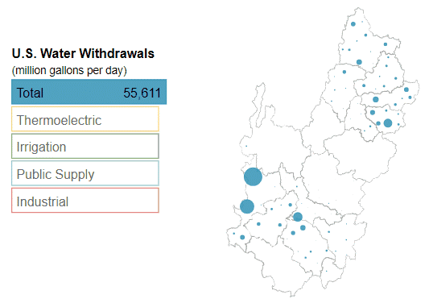

Figure 2. Saturated thickness from initial steady-state groundwater-flow model run of the Upper Red River principal alluvial aquifers.
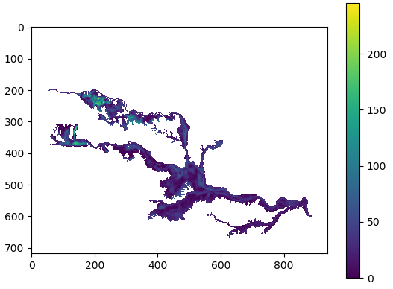
ft
Figure 3. Preliminary PRMS calibration results for the Red River basin.
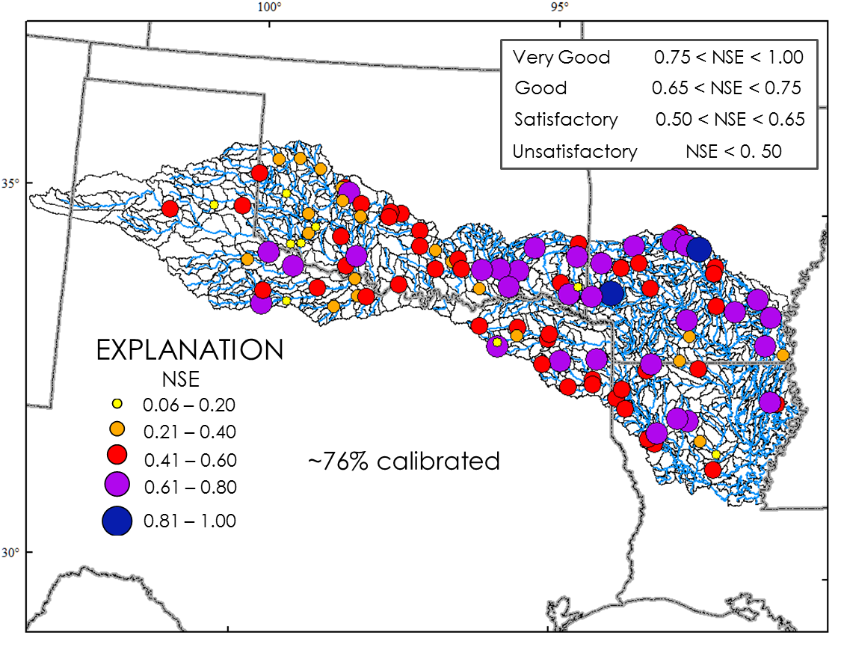

Figure 4. Map of the Red River basin showing locations of georeferenced fish surveys from 1980 to 2016 compiled by the Ecological Flows team for the FAS.

