Water Availability and Use Science Program
Red River Focus Area Study
Fiscal Year 2017 End-of-Year Report
September 21, 2017

(1) PROJECT ACCOMPLISHMENTS/CONTRIBUTIONS (Fiscal Year [FY] 2017)
Water Use
The water withdrawal estimates in the Red River basin will be refined and enhanced to provide a more detailed picture of water use in the basin. Work continued on most of the water-use component objectives, as detailed below. The work is primarily being done by water-use compilers in Arkansas, Louisiana, New Mexico, Oklahoma, and Texas. John Lovelace was replaced by Pierre Sargent as the Water Use lead in February 2017.
- Estimation and compilation of water-withdrawals during 2015 delineated by 8-digit hydrologic unit codes (HUCs). Updated this objective in the workplan to include 2010 data because they were already completed by the state water-use data compilers. 2015 data from Arkansas, Louisiana, and Oklahoma were collected and withdrawals were estimated during the end of FY16 and beginning of FY17. 2015 data from New Mexico and Texas were provided by State agencies in May 2017. 2015 data were compiled by county or parish in the USGS Aggregate Water Use Data System (AWUDS) and are awaiting review and approval by the Regional Water-Use Specialist; Tammy Ivahnenko began their review in July/August 2017. Some categories of 2015 data are still being developed (link to google doc?)
- Estimation of withdrawals from the Red River alluvial and Seymour aquifers in areas of Oklahoma and Texas above the Lake Texoma Dam from 1995–2014 to support groundwater modeling efforts. This objective was completed during FY16.
- Estimation of surface-water withdrawals from 1980–2014 to support surface-water modeling efforts. This objective was completed during FY16.
- Estimation or enhancement of irrigation withdrawals using GIS-based crop-cover data. This objective was eliminated from the workplan following the semi-annual technical reviews and a follow-up call with members of the National Water Use Leadership Team (Molly Maupin and Nancy Barber) in April 2017. The decision to eliminate it was based on the lack of new data that would be produced; it was essentially a method comparison exercise that was no longer able to be supported by the study.
- Estimation of inter-basin water transfers. This objective was completed in June 2017. Data will be published in a table in the water use Scientific Investigations Report (SIR).
- Estimation of consumptive use of water withdrawn in the basin. This objective was reduced in scope following the semi-annual technical reviews and a follow-up call with members of the National Water Use Leadership Team in April 2017. The consumptive use of water for irrigation was completed for all states as part of the 2015 compilation. The consumptive use for thermoelectric is provided by the National Water Use Team. This objective is to be completed during FY 18.
- Estimation of withdrawals, returns, and other data for selected categories of use that are optional for the 2015 national water-use compilation. This objective was reduced in scope following the semi-annual technical reviews and a follow-up call with members of the National Water Use Leadership Team in April 2017. Two non-mandatory elements will be prioritized: 1) wastewater returns and 2) hydroelectric instream and offstream. The commercial element may be done in states where there is substantial self-supplied use. This objective is to be completed during FY 18.
Groundwater-Flow Model
A numerical groundwater-flow model will be constructed for selected alluvial aquifers (fig. 1) upstream from Lake Texoma that are connected to the Red River: the Seymour aquifer near the Red River, Red River alluvium, the Salt Fork Red River alluvium, and the North Fork Red River alluvium. Work continued on the groundwater-flow model component, as detailed below:
- Well lithologic logs were acquired to delineate the configuration of the Red River alluvial aquifer and refine the base of the Seymour aquifer
- Construction of the hydrogeologic framework for the groundwater-flow model was completed
- Parameters from the Seymour (Ewing and others, 2004) and North Fork Red River model (Smith and others, in press) were imported
- Preliminary data for the Red River and Salt Fork Red River alluvium were collected
- Water-level observation data and groundwater withdrawal data from the Water Use Team were incorporated into the model
- Streamflow-Routing package was incorporated into the model.
Surface-Water Model
A daily time-step Precipitation Runoff Modeling System (PRMS) watershed model will be constructed for the entire Red River basin to simulate and evaluate the effects of various combinations of precipitation, climate, land use, soils, geology, and topography on basin response. Work continued on the surface-water model component as detailed below:
- Wrote several programming scripts; used them for quality assurance checks and formatting of the surface-water withdrawal data provided by the Water Use team
- Resolved various issues with input data that resulted in unreasonable model output
- Pulled dynamic parameters (such as percent impervious cover, cover type, snow and rain intercepts) from the National Hydrologic Model and implemented them in the Red River PRMS
- Incorporated interbasin transfers provided by the Water Use team
- Calibrated the entire basin for “natural flows”
- Began matching model output with direct observations of streamflow
- Worked with the Groundwater-Flow Model team to loosely couple the two models and provide baseflow for the groundwater model
Ecological Flows
A summary of available fish community data for the Red River basin (Oklahoma, Texas, Arkansas, and Louisiana) were compiled and will be analyzed to determine how streamflow alterations have affected fish. Work continued on the ecological flows component as detailed below:
- Contacted multiple agencies and research entities within each state and compiled data sets
- Collected data from online databases
- Georeferenced all datasets were (meaning, locations of collection were identified)
- Checked all data for quality assurance.
- Compiled information on the ecological characteristics of each species
- Defined the ranges for each species based on ecoregions
- Matched each location sampled between 1980 and 2015 to the PRMS grid cells so hydrologic information could be matched to ecological collections
- Used a subset of the data to develop the code necessary to run detection models on the completed dataset
(2) PROJECT WORKPLAN AND BUDGET FOR FY 2018
Fiscal year 2018 is final year for the Red River FAS and several deliverables or products are scheduled to be release by the study. All data sets will be released through ScienceBase, as child items of the National Water Census community. The Water Use, Groundwater-Flow Model, and Surface-Water Model tasks will each produce an SIR. The Ecological Flows task will produce one or more journal articles.
Water Use
During FY18, work will conclude on all component objectives and the data will be released in ScienceBase and (or) a water-use SIR. The work will primarily be done by water-use compilers in Louisiana and Texas. The tasks and brief descriptions of work plans for FY18 are listed below. Additional details are available in the project work plan.
- Estimation and compilation of water-withdrawals during 2010 and 2015 delineated by 8-digit hydrologic unit codes (HUCs). Review comments from the Regional Water-Use Specialist will be addressed. Water withdrawals will be disaggregated from the county level and then re-aggregated to HUC-8s. The data will be housed in AWUDS, released in ScienceBase, and data compilation methods and interpretation will be provided in a water-use SIR.
- Estimation of withdrawals from the Red River alluvial and Seymour aquifers in areas of Oklahoma and Texas above the Lake Texoma Dam from 1995-2014 to support groundwater-flow modeling efforts. The 2014 public supply data will be housed in SWUDS, all of the data will be released in ScienceBase, and data compilation methods and interpretation will be provided in a water-use SIR.
- Estimation of surface-water withdrawals from 1980-2014 to support surface-water modeling efforts. The 2014 public supply data will be housed in SWUDS, all of the data will be released in ScienceBase, and data compilation methods and interpretation will be provided in a water-use SIR.
- Estimation or enhancement of irrigation withdrawals using GIS-based crop-cover data. This objective was eliminated from the workplan.
- Estimation of inter-basin water transfers. The data will be published in a short table in the water-use SIR.
- Estimation of consumptive use of water withdrawn in the basin. Work on this task will commence in FY18. The EPA’s National Pollutant Discharge Elimination System (NPDES) and Permit Compliance System (PCS) databases will be used to estimate site-specific discharges and return flows and subtracted from site-specific withdrawals to determine public supply consumptive use rates, when possible. Site-specific estimates will be aggregated for each HUC-8 and stored in AWUDS, released in ScienceBase, and data compilation methods and interpretation will be provided in a water-use SIR.
- Estimation of withdrawals, returns, and other data for selected categories of use that are optional for the 2015 national water-use compilation. Work on this task will commence in FY18. Two non-mandatory elements will be prioritized: 1) wastewater returns and 2) hydroelectric instream and offstream. The commercial element may be done in states where there is substantial self-supplied use. When possible, site-specific and (or) county-level data will be compiled and aggregated to the HUC-8 level. Data aggregated to HUC-8 will be stored in AWUDS, released in ScienceBase, and data compilation methods and interpretation will be provided in a water-use SIR.
Groundwater-Flow Model
Early in FY18, the results from the Precipitation Runoff Modeling System (PRMS) will be incorporated into the groundwater-flow model. Then the model will be calibrated and various groundwater withdrawal scenarios will be completed. Particular scenarios will be constructed with input from stakeholders. The construction and calibration methods will be documented in a groundwater-flow model SIR along with discussions of the predictive scenarios. All input data and other components of the model will be documented, archived, and released in a groundwater model archive through ScienceBase.
Surface-Water Model
Validation of the PRMS will be completed in early FY18. Model output will be provided to the Groundwater-Flow Model and Ecological Flows teams for use in their analyses. Predictive scenarios will be constructed with input from stakeholders. The construction and calibration methods will be documented in a surface-water model SIR along with discussions of the predictive scenarios. All input data and other components of the model will be documented, archived, and released in a surface-water model archive through ScienceBase.
Ecological Flows
The species detection models will be completed in early FY18. After the PRMS streamflow data are received, hierarchical models will be developed to examine the relationships among species, traits, flow, and other landscape characteristics (such as land use). Will work with the Groundwater-Flow Model team to temporally and spatially link fish species with groundwater model scenarios where data density and overlap exist, most likely focusing on the North Fork of the Red River and Red River alluvium. The data will be released in ScienceBase, and data compilation methods and interpretation will be provided in one or more journal articles.
Budget for FY18
The Red River FAS requests $500,000 to support project activities in FY18 (table 1.) The total amount is unchanged from the original project work plan.
Table 1. Estimated FY18 funding for Red River FAS, itemized by Water Science Center and project component.
Water Science Center  Project component | Salary | Travel | Total
TX WSC – Austin, TX  Project Management, Water Use | $93,350 | $10,000 | $103,350
LMG WSC – Baton Rouge, LA  Water Use | $65,000 | $5,000 | $70,000
OK WSC – Oklahoma City, OK  Groundwater-Flow Model | $155,000 | $5,000 | $160,000
LMG WSC – Little Rock, AR  Surface-Water Model | $110,000 | $10,000 | $120,000
OK COOP* – Stillwater, OK  Ecological Flows | $41,650 | $5,000 | $46,650
TOTAL | $465,000 | $35,000 | $500,000
*COOP: Cooperative Fish and Wildlife Research Unit at Oklahoma State University

(3) NOTEWORTHY COLLABORATIONS, MEETINGS, TECHNICAL TRANSFER ACTIVITIES, SPIN-OFF PROJECT DEVELOPMENTS, AND ACKNOWLEDGEMENTS
- Collaborations:
  - Worked with the Upper Rio Grande FAS and Texas Water Science Center Data and Spatial Studies section to develop a website for the study (fig. 2) using the Upper Rio Grande FAS website as a template. The website was made publicly available and linked through the National Water Census website in April 2017: https://webapps.usgs.gov/watercensus/redriver_fas/
- Meetings:
  - A poster providing an overview of the study was presented at the Red River Valley Association annual convention in February 2017.
  - An overview and update on the Red River FAS was presented during the Red River Valley Association annual regional water resource conference in May 2017.
  - Organized a stakeholder meeting in Texarkana, TX, to provide detailed presentations on each study objective. The half-day meeting in May 2017 was attended by about 30 stakeholders and included valuable discussions between FAS teams and stakeholder organizations.
  - An overview of the study with additional focus on the surface-water model was presented at the annual meeting of the Red River Compact Commission in May 2017.
- Technical transfer activities:
  - Met with personnel at the Bureau of Reclamation (BOR), Great Plains Region, Oklahoma-Texas Area Office in January and April 2017. Provided updates and coordinated direction of USGS and BOR studies so as not to duplicate efforts and ensure complimentary products.
- Spin-off project developments:
  - Journal article from the Surface-Water Model team about resilience of Red River in response to climate extremes and increasing regional water demand.
- Acknowledgements:
  - The Red River FAS would like to acknowledge the Red River Valley Association (RRVA) for their continued support of the study. The RRVA holds quarterly meetings at various locations in the basin and has featured speakers from the FAS at almost every meeting held over the last 2 years. In addition, the RRVA has sent multiple announcements to its email distribution list about the FAS stakeholder meetings, greatly increasing awareness and attendance.
(4) REPORT PRODUCTS, BIBLIOGRAPHIC UPDATE, DATA RELEASES, AND GROUNDWATER-MODEL ARCHIVES
None to include at this time.

(5) STUDY TEAM DIRECTORY
Jennifer Wilson
Austin, TX
jenwilso@usgs.gov
512-927-3527
Study coordinator
Diana Pedraza
San Antonio, TX
dpedraza@usgs.gov
210-691-9237
Data management

Samantha Wacaster
Little Rock, AR
srwacaster@usgs.gov
501-228-3670
Data management
Pierre Sargent
Baton Rouge, LA
psargent@usgs.gov
225-298-5481 x3211
Water use team lead
Natalie Houston
Austin, TX
nhouston@usgs.gov
512-927-3565
Water use team member
Carol Becker
Oklahoma City, OK
cjbecker@usgs.gov
405-810-4436
Water use team member

Amy Galanter
Albuquerque, NM
agalanter@usgs.gov
505-830-7939
Water use team member
Derek Ryter
Oklahoma City, OK
dryter@usgs.gov
402-613-3323
Groundwater-flow model team lead
Rheannon Hart
Little Rock, AR
rmhart@usgs.gov
501-228-3664
Surface-water model team lead
Victor Roland
Little Rock, AR
vroland@usgs.gov
615-837-4754
Surface-water model team member
Shannon Brewer
Stillwater, OK
Shannon.brewer@okstate.edu
405-744-9841
Ecological flows team lead
Robert Mollenhauer
Stillwater, OK
mollenh@ostatemail.okstate.edu
405-744-6342
Ecological flows team member

(6) PHOTOS, ANIMATIONS, AND GRAPHICS

Figure 1. Selected alluvial aquifers upstream from Lake Texoma that will be included in the groundwater-flow model. Aquifers included are: the North Fork Red River alluvium, the Salt Fork Red River alluvium, the Seymour aquifer near the Red River, and the Red River alluvium.
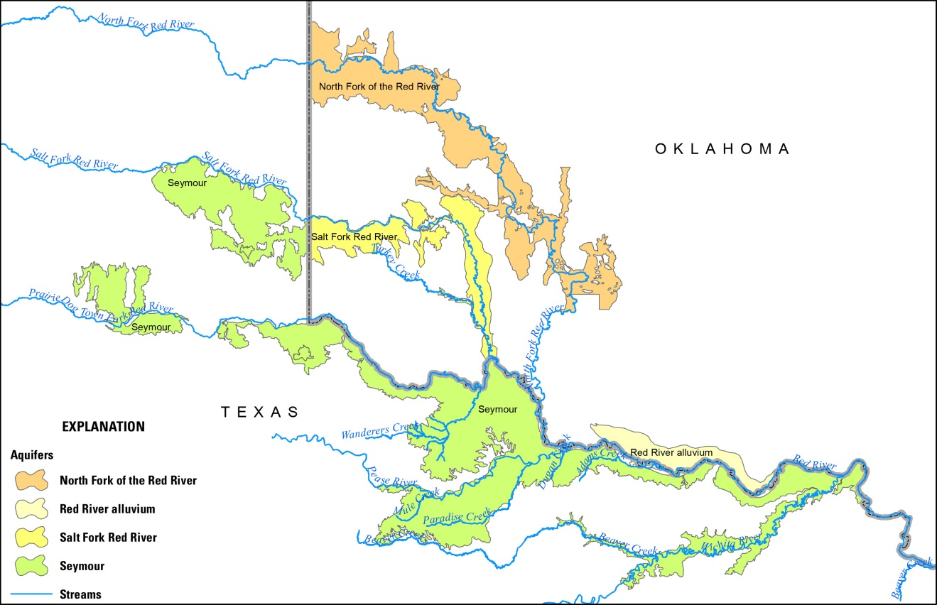

Figure 2. Screenshot of the new study website, accessible by the public at: https://webapps.usgs.gov/watercensus/redriver_fas/index.html

