Water Availability and Use Science Program
Red River Focus Area Study
FY 2016 End-of-Year Report
November 10, 2016

(1) PROJECT ACCOMPLISHMENTS/CONTRIBUTIONS (FY 2016)
Water Use
Work began on 7 water-use component objectives. The work is primarily being done by water-use specialists in Arkansas, Louisiana, New Mexico, Oklahoma, and Texas. The tasks and brief descriptions of progress during FY 2016 are listed below.
- Estimation and compilation of water-withdrawals during 2015 delineated by 8-digit hydrologic unit codes (HUCs). Data currently are in various states of collection or estimation in each state. In Arkansas and Louisiana, USGS personnel are in the process of collected and estimating withdrawals. In Oklahoma, New Mexico, and Texas, State agencies compile and estimate withdrawals and provide the data to the USGS. Data from agencies in New Mexico and Oklahoma are not expected to provide data to the USGS until late 2016 or early 2017.
- Estimation of withdrawals from the Red River alluvial and Seymour aquifers in areas of Oklahoma and Texas above the Lake Texoma Dam from 1995-2014 to support groundwater modeling efforts. Historic withdrawals from alluvial aquifers and the Seymour aquifer in Texas and Oklahoma have been compiled and delivered to the groundwater modeler, Derek Ryter.
- Estimation of surface-water withdrawals from 1980-2014 to support surface-water modeling efforts. Historic surface-water withdrawals in Arkansas, Louisiana, Oklahoma, and Texas have been compiled and delivered to the surface-water modeler, Rheannon Hart. The New Mexico Office of the State Engineer confirmed that no surface-water withdrawals have taken place within the study area in New Mexico.
- Estimation or enhancement of irrigation withdrawals using GIS-based crop-cover data. Work on this task will begin in FY-17.
- Estimation of inter-basin water transfers. Annual rates of interbasin transfers are mostly complete for Louisiana and Texas. Work is ongoing in Oklahoma, but has not yet begun in Arkansas and New Mexico.
- Estimation of consumptive use of water withdrawn in the basin. Data on return flows in Oklahoma have been obtained from the NPDES database. Work has not yet started in the other 4 states, but will begin in FY-17.
- Estimation of withdrawals, returns, and other data for selected categories of use that are optional for the 2015 national water-use compilation. Work on this task will begin in FY-17.

Groundwater Modeling
Alluvial aquifers in the upper basin (fig. 1) were delineated and selected for analysis based on amount of previous work that has been done and their contribution to the hydrologic system in the basin (fig. 2). The Washita River alluvial aquifers were not included because little work has been completed or published except for very generalized numerical groundwater-flow models from the 1970s and early 1980s. The North Fork Red River alluvial aquifer model will be published early in FY 2017 and will be incorporated in this study. Preliminary model information has already been acquired. Alluvium along the North Fork Red River downstream from the North Fork model extent will be included to connect the North Fork model to the Red River.

A numerical groundwater-flow model for the Seymour aquifer in Texas and part of western Oklahoma (fig. 2) was published (Ewing and others, 2004). Parts of the Seymour that provide base flow to the Red River or tributaries have been included in this study. The Seymour model also included the westernmost parts of the Salt Fork Red River aquifer. Hydrologists at the Oklahoma Water Science Center are currently working on a hydrogeologic study of the Salt Fork Red River alluvial aquifer. The Salt Fork aquifer is not going to be published in time to use the model in the RRFAS, but was included because part was published in the Seymour report, and data for other parts of the aquifer will be provided by the ongoing study. A narrow strip of the Red River alluvium will also be included to connect the Seymour aquifer, which is an upland deposit to the Red River. The Red River does not flow over the Seymour aquifer.

Most of the data necessary for building the model have been collected. Wells in Texas and Oklahoma with water-level observations have been acquired along with water-level data (fig. 3). Water-level data for the Seymour model only extended to 2000, so additional data was acquired to include the period to 2014. Preliminary groundwater and surface-water water-use data have been collected from Texas and Oklahoma. The pumping wells are shown in figure 4. Although most of the aquifers already have hydraulic and thickness information from other studies, well lithologic logs (fig. 5) were acquired to provide information on some areas and refine parts of the Seymour aquifer.

Surface Water Modeling
The PRMS model framework for the entire Red River Basin has been constructed. The lower basin has been calibrated and validated and can now be used to apply surface-water use in order to understand natural and human factors controlling surface-water availability, quantitatively assess streamflow in ungaged basins, identify and describe fundamental information pertaining to current conditions and trends, and plan and manage surface-water resources.
Ecoflows
Existing fish assemblage data associated with the Red River and major tributaries are being summarized from a variety of sources. We have contacted agencies from each state of the study area and requested existing data:

Texas Parks and Wildlife Department
Oklahoma Department of Wildlife Conservation
Oklahoma Water Resources Board
Oklahoma Blue Thumb
Oklahoma Conservation Commission
Texas Commission of Environmental Quality
Louisiana Department of Environmental Quality
Louisiana Department of Wildlife and Fisheries
Arkansas Department of Environmental Quality
New Mexico Environmental Department
New Mexico Department of Game and Fish

We have queried data from the Fishes of Texas (http://www.fishesoftexas.org/data/) and the Multistate Aquatic Resources Infomration System (Maris, http://www.marisdata.org/) databases that were georeferenced. We have also pulled data from VertNET (http://vertnet.org/ ) and iDigBio (https://www.idigbio.org/). We have also contacted several University partners including Bill Matthews, Christopher Taylor, and Sara Cartwright (Sam Noble Museum). Most of the data obtained to date have been more useful for occurrence rather than abundance. However, we have some old reports that were provided by the Oklahoma Department of Wildlife Conservation and we are manually entering those data into a spreadsheet. Information about sampling methods, gear, and effort will be obtained and data resulting from the most systematic methods will be used (i.e., standardized samples) to evaluate flow alteration where available so we will eventually have to split our data into two data sets. Fish-collection records continue to be compiled into a centralized location, georeferenced, quality controlled for accuracy, and matched to grid cells of the PRMS model.

(2) PROJECT WORKPLAN AND BUDGET FOR FY 2017
Water Use
During FY-17, work will continue or commence on 7 water-use component objectives. The work is primarily being done by water-use specialists in Arkansas, Louisiana, New Mexico, Oklahoma, and Texas. The tasks and brief descriptions of work plans for FY 2017 are listed below. Additional details are available in the project work plan.
- Estimation and compilation of water-withdrawals during 2015 delineated by 8-digit hydrologic unit codes (HUCs). Withdrawal data for 2015 will be obtained or estimated and compiled by county and 8-digit HUC. The data will be entered into SWUDS and AWUDS.
- Estimation of withdrawals from the Red River alluvial and Seymour aquifers in areas of Oklahoma and Texas above the Lake Texoma Dam from 1995-2014 to support groundwater modeling efforts. Historic withdrawals from alluvial aquifers and the Seymour aquifer in Texas and Oklahoma will be entered into SWUDS.
- Estimation of surface-water withdrawals from 1980-2014 to support surface-water modeling efforts. Historic surface-water withdrawals in Arkansas, Louisiana, Oklahoma, and Texas have been compiled, but will be modified as needed based on instruction s from for input into the surface model. Annual irrigation withdrawal rates will be disaggregated to monthly withdrawals using observations from irrigation wells in Arkansas to establish typical temporal irrigation patterns. The irrigation patterns are expected to be modified to suit climate conditions in parts of Oklahoma and Texas based on input from local agricultural experts.
- Estimation or enhancement of irrigation withdrawals using GIS-based crop-cover data. Irrigated areas and crop types will be extracted from the USDA Cropland Data Layer and, along with other data, including irrigation consumption rates from Gabriel Senay, will be input into the IIWEM model to estimate irrigation withdrawals by HUC-8. Results will be compared to 2015 withdrawal estimates obtained or estimated by the water-use specialists in the 5 study-area states for the 2015 national water-use compilation.
- Estimation of inter-basin water transfers. Ongoing documentation or estimation of interbasin transfers in each state will be completed and compiled into a spreadsheet, which will be published as a data release in Science Base.
- Estimation of consumptive use of water withdrawn in the basin. Work on this task will continue or commence in each state. Return flows for public suppliers and industries will be compiled using data from NPDES and PCS databases, then subtracted from withdrawal rates to estimate consumptive use. Consumptive use rates for thermos-electric power generation will be estimated by Melissa Harris. Consumptive use rates for irrigation will be estimated by Gabriel Senay.
- Estimation of withdrawals, returns, and other data for selected categories of use that are optional for the 2015 national water-use compilation. Work on this task will commence during FY-17. Sources of information for the various non-mandatory data categories will be identified and exploited. Data will be entered into SWUDS.
Groundwater Modeling
In FY 2017 the model will be constructed and calibrated. The cell size will be determined to provide detail necessary and still be manageable. The model will use the Streamflow Routing package, Well package, and Recharge package simulate groundwater flow and use and determine the effects of pumping on groundwater resources and streamflow. The PRMS model output will provide runoff and base flow information to the model. A soil-water balance model will be run to estimate recharge on the scale of the model grid.
The calibrated model will be used to run predictive scenarios to analyze the effects of water use on the groundwater in storage and streamflow. Particular scenarios will be constructed with input from stakeholders.
Surface Water Modeling
Calibration and validation of the Upper Basin will be completed in FY17. Near the end of the FY work will begin on linking the surface and groundwater models.
Ecoflows
How alterations to natural flow regimes have affected biota drives a large portion of contemporary research in stream ecology. However, the underlying mechanisms responsible for changes in local warmwater stream fish assemblages remain poorly understood. In addition, there is a high degree of uncertainty in long-term predictions of the distribution and abundance of warmwater fishes over coarse spatial scales. We propose a trait-based approach using random forests (RF) to:
(1) Determine how alterations to the natural flow regime (NFR) have changed the functional diversity of Red River fish assemblages,
(2) Examine how functional traits explain local fish assemblages in the Red River basin, and
(3) Develop groups based on functional and ecological traits to provide a basis for comparison of ecosystem dynamics in the Red River to other river basins.
The foundation of this project rests in obtaining existing ecological data. We received funding in August 2016 so our start was delayed, but I do not believe the project is behind a significant degree as a result. We have sent all data requests, though we still receive emails that have been forwarded to new contacts within agencies. We are entering data from some old reports that were provided by the Oklahoma Department of Wildlife Conservation. We will continue to compile data until we feel we have represented the fishery across the region with the best data available. We will also continue to georeferenced the data. In FY17, we will start compiling traits across the species and split the data sets into ‘occurrence models’ and ‘abundance models’. Some of the data provided to date are clearly only suited for modeling species presence (i.e., no sampling effort was reported) which represents one resolution whereas we will examine changes in abundance with data where abundance can be reliably provided (i.e., effort was reported by the collecting agency). Our goal is to have the data set up for pairing with hydrologic data by the end of FY17.
(3) NOTEWORTHY COLLABORATIONS, MEETINGS, TECHNICAL TRANSFER ACTIVITIES, SPIN-OFF PROJECT DEVELOPMENTS, AND ACKNOWLEDGEMENTS
The RRFAS has been presented at Stakeholder meetings, to inform other State and Federal entities of the work being conducted. The work has also been presented at the Red River Compact meetings (with occasional phone-call updates) which has State representatives from Louisiana, Arkansas, Texas, and Oklahoma.
The RRFAS work is directly tied to the USGS National Hydrologic Model (NHM), in that the RRFAS grid is based directly on the Geospatial Fabric of the NHM (https://www.usgs.gov/media/videos/prms-national-hydrologic-model). Also, starting parameters were obtained for the entire RRFAS study area based on the parameters of the NHM with the lower portion of the RRFAS having starting calibrated parameters. Because the RRFAS is based off the NHM, once the RRFAS PRMS model is calibrated, the parameters will be transferred back into the NHM for best starting parameters for future modeling work.
Additionally, the RRFAS PRMS surface-water model is also directly linked to the Gulf Coastal Plains and Ozarks (GCPO) LCC surface-water modeling work (http://gcpolccapps.org/projects/ProjectPage.aspx?id=287). The GCPO model provided the starting parameter set for the lower portion of the RRFAS (below Lake Texoma Dam). These calibrated parameters were input into the NHM which were subsequently downloaded for the RRFAS.
There have been several professional meetings that have highlighted activities in the Red River basin over the last year. At each of these meetings, we have been able to provide an overview of this project which was of interest to the agencies and professionals in attendance. For example, there was a Kiamichi River Research Symposium (i.e., The Kiamichi River is a major tributary to the Red River, Oklahoma) that was held in McAlaster and we presented on portions of this project and another that was funded by the Landscape Conservation Cooperatives. Both projects address aspects of flow alteration. There will also be a landscape symposium held at the Natural Resources Conference in Feb 2017 and we are working with USFWS and Texas Tech to provide the presentation
Athearn, N, S Brewer, and A Pease. 2017. Watershed-based Conservation Planning for Improved Flow Regimes (Red/Arkansas River Systems). Oklahoma Natural Resources Conference, Oklahoma City.
(4) Report Products, Bibliographic Update, Data Releases, and Groundwater-Model Archives
None to include at this time.

(5) PROJECT TEAM DIRECTORY
Kristine Blickenstaff
Fort Worth, Tx.
kblickenstaff@usgs.gov
817-614-0642
RRFAS project chief
John Lovelace
Baton Rouge, La.
jlovelac@usgs.gov
225-298-5481 ext. 3210
Water-use team lead
Natalie Houston
Austin, Tx
nhouston@usgs.gov
(512) 927-3565
water-use team member
Drew Westerman
Little Rock, Ar.
dawester@usgs.gov
501-516-6399
water-use team member
Aaron Pugh
Little Rock, Ar.
apugh@usgs.gov
501-228-3653
water-use team member
Carol Becker
Oklahoma City, Ok.
cjbecker@usgs.gov
405-810-4436
water-use team member
Jeff Cordova
Albuquerque, NM
jcordova@usgs.gov
505-830-7985
water-use team member

Pierre Sargent
Baton Rouge, La
psargent@usgs.gov
225-298-5481 x3211
water-use team member
Angela Collier
Baton Rouge
acollier@usgs.gov
225-298-5481 x3223
water-use team member
Derek Ryter
Oklahoma City, Ok.
dryter@usgs.gov
402-613-3323
Groundwater modeling team lead
Rheannon Hart
Little Rock, Ar.
rmhart@usgs.gov
501-228-3664
Surface water modeling team lead
Victor Roland
Little Rock, Ar.
vroland@usgs.gov
615-837-4754
Surface water modeling team member
Shannon Brewer
Stillwater, Ok.
Shannon.brewer@okstate.edu
405-744-9841
Ecoflows team lead
Robert Mollenhauer
Stillwater, Ok.
mollenh@ostatemail.okstate.edu
405-744-6342
Ecoflows team member

(6) PHOTOS, ANIMATIONS, AND GRAPHICS 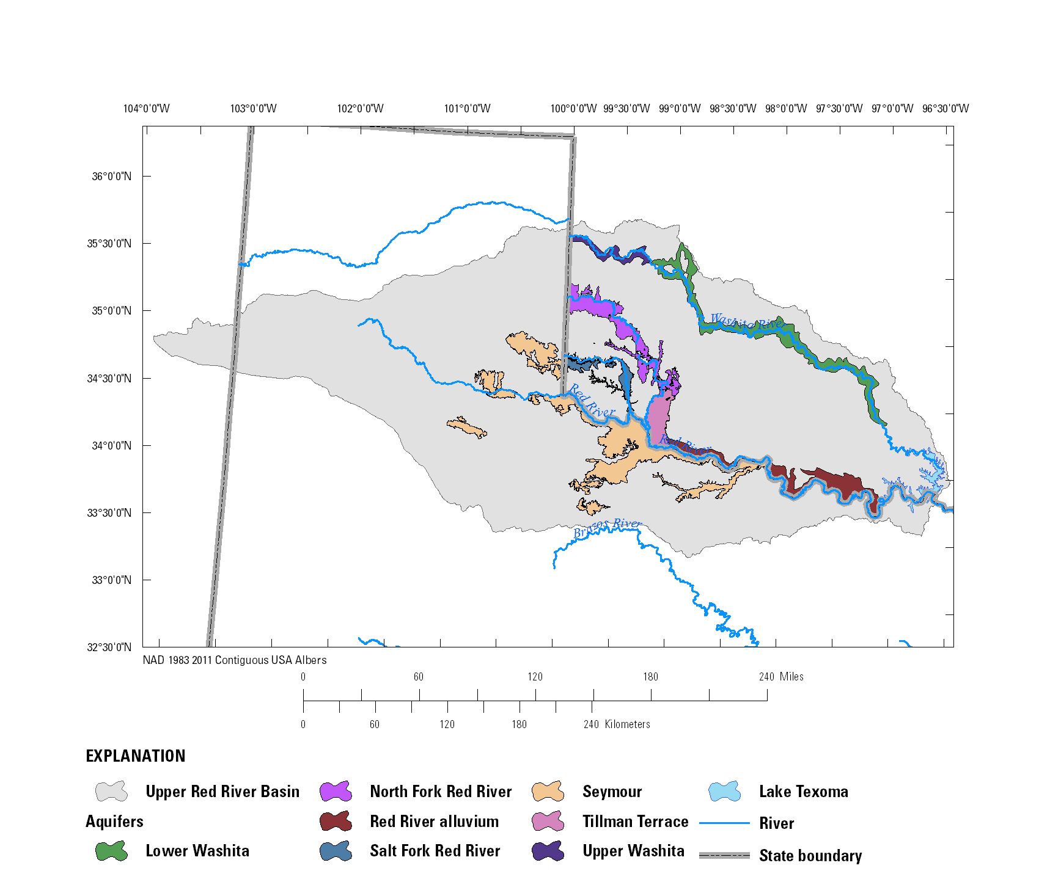
Figure 1: Alluvial aquifers in the upper Red River Basin, Texas and Oklahoma
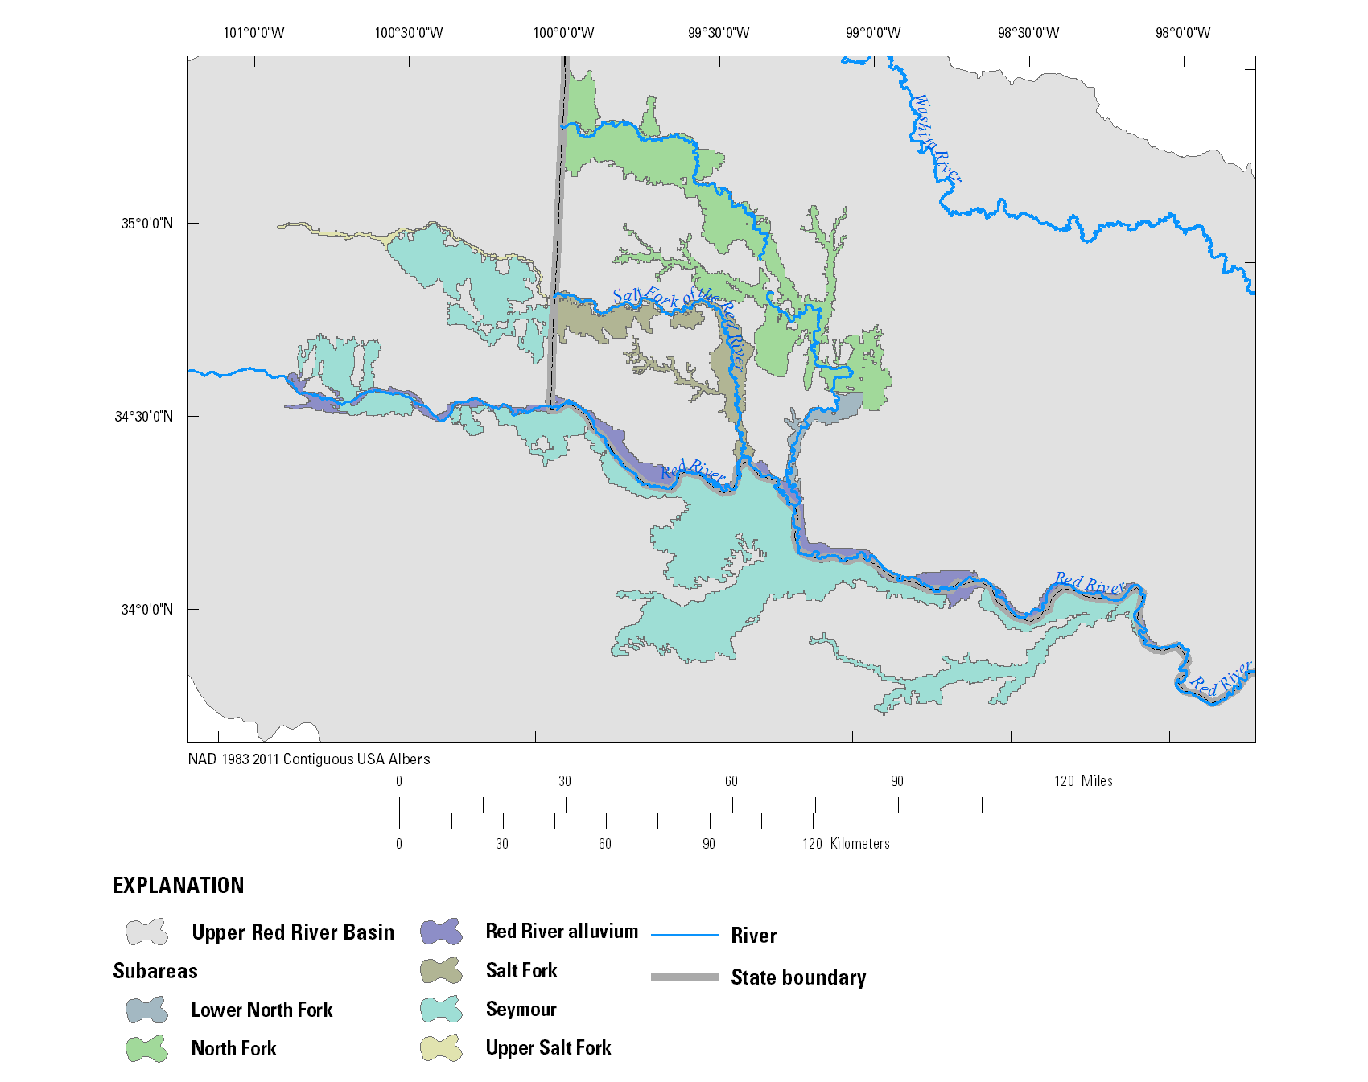
Figure 2: Subareas included in the Red River Focus Area Study model
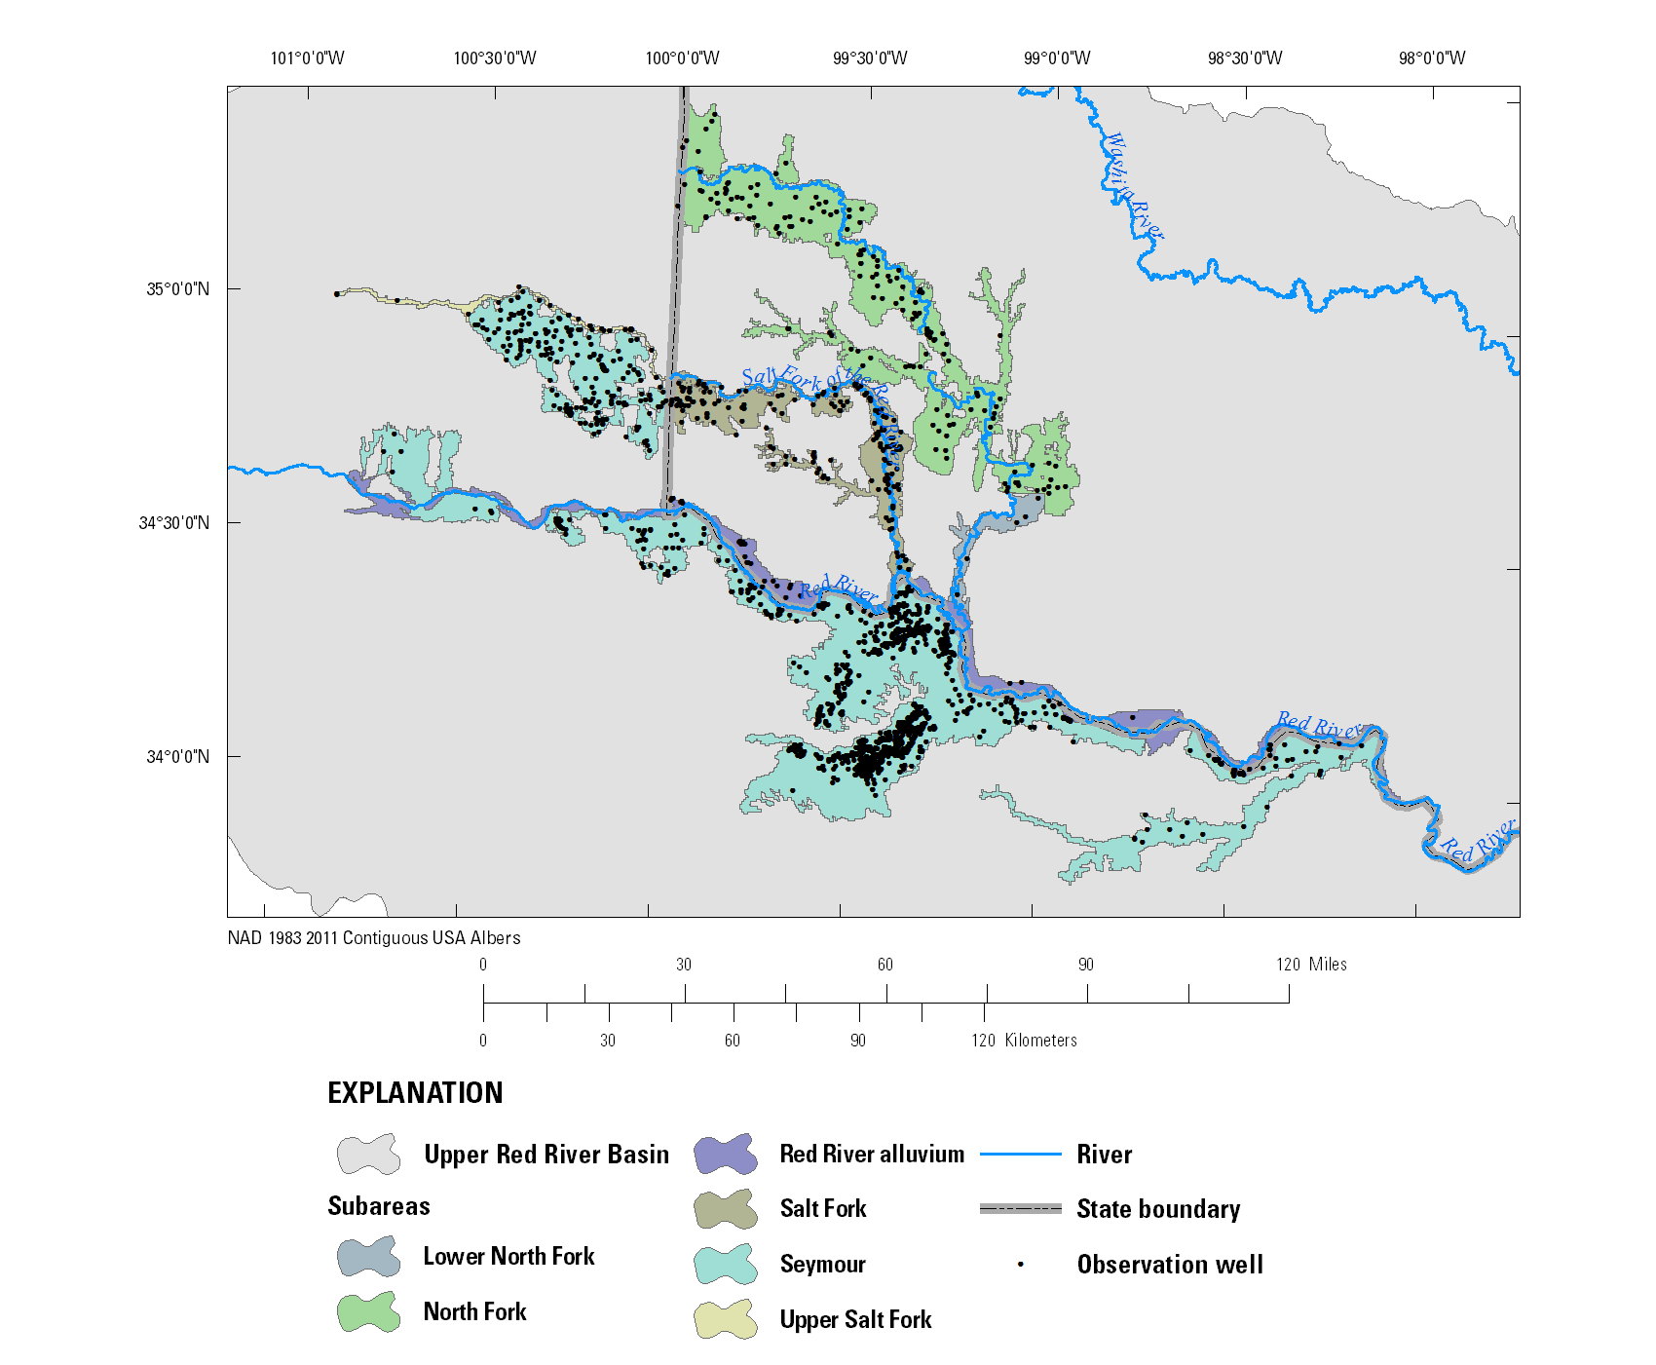
Figure 3: Wells with water-level observations
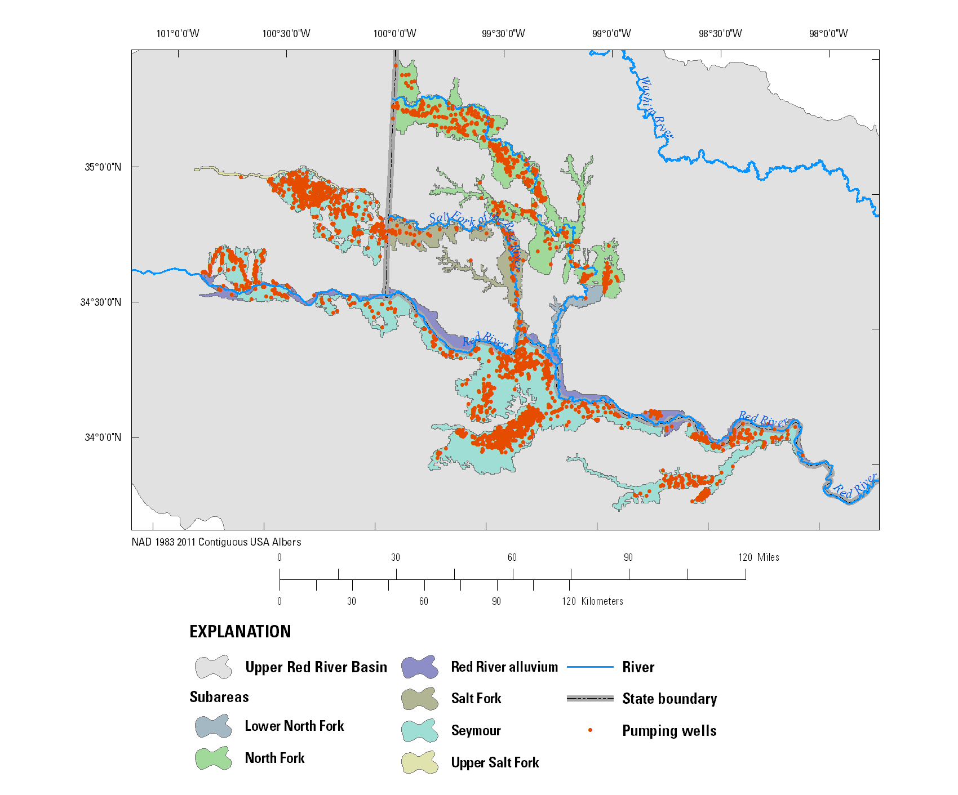
Figure 4: Groundwater use
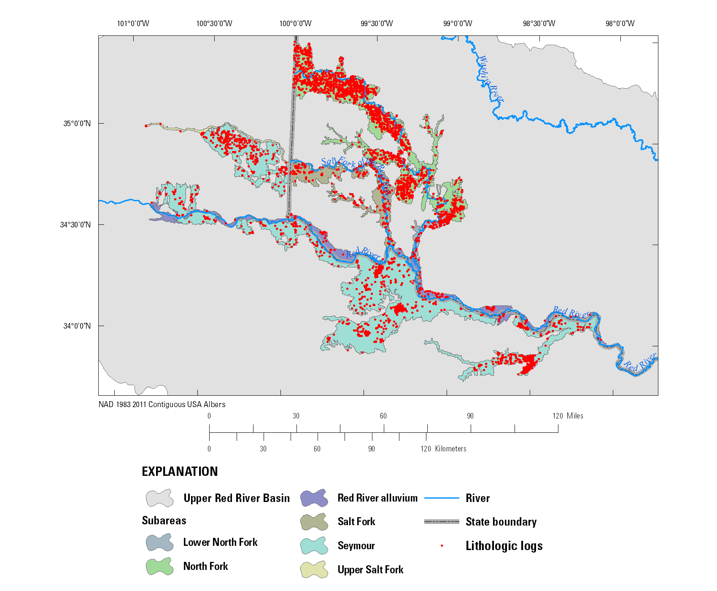
Figure 5: Lithologic logs to refine hydraulic properties and base of aquifer
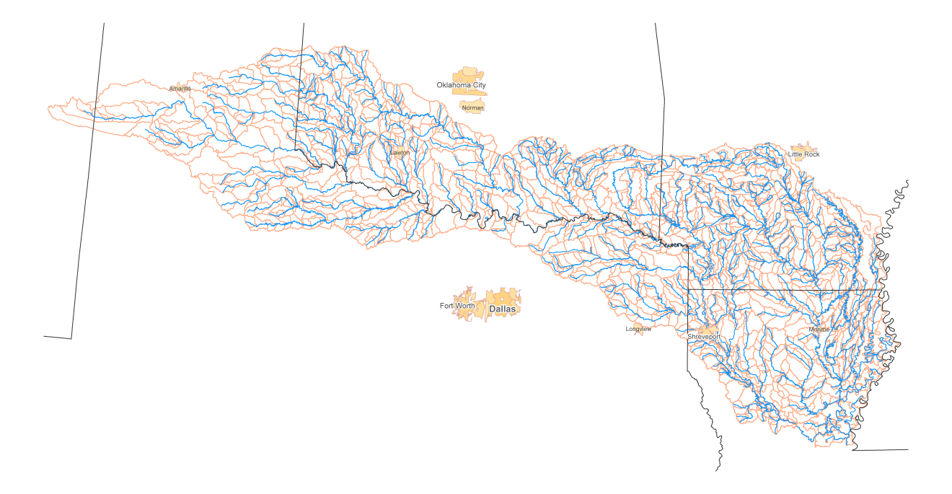
Figure 6: Hydrologic Response Units (HRUs) and stream segments in the Red River Precipitation Runoff Modeling System (PRMS) surface-water model

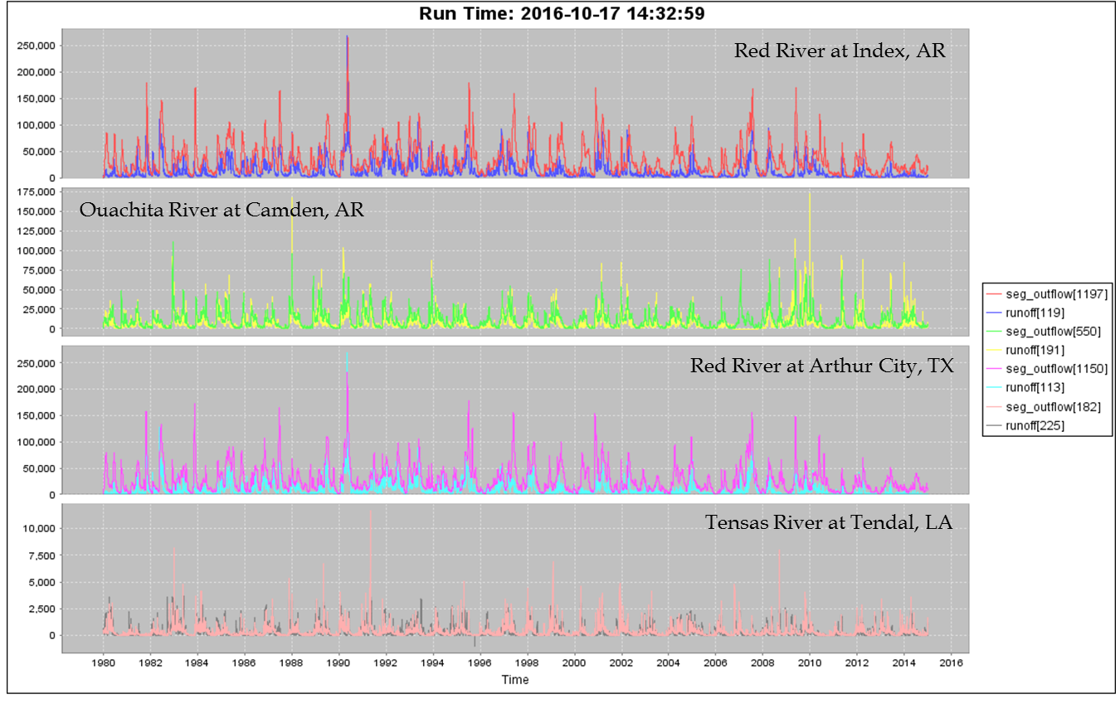
Figure 7: Preliminary model runs for select gages in the RRFAS (seg_outflow = simulated flow; runoff = observed flow)

Figure 8: The study area (bottom panel) located within the United States (top panel).The black dots indicate fish samples that were obtained from the Fishes of Texas and Maris websites

