Water Availability and Use Science Program

Regional Groundwater Availability Projects

FY 2016 End-of-Year Report Request

September 12, 2016

(1) PROJECT ACCOMPLISHMENTS/CONTRIBUTIONS (FY 2016)
Ozark groundwater availability study: supporting open data
Throughout FY16, the USGS has worked to meet new open data requirements by providing online data releases of interpretive studies within the Ozark study area. These data releases include:
- Compilation and interpretation of streamflow gain and loss;
- Long-term estimation of groundwater withdrawals for all major categories;
- Interpretation of the altitude and thickness of hydrogeologic units;
- Digitization of karst features.
- GIS release of previously published potentiometric contours
Each data release provides information to further the overall objective to quantitatively assess the Ozark Plateaus groundwater system. The primary tool for this assessment is the development of a regional groundwater-flow model of the Ozark Plateaus, which is currently in the early stages of report draft. Streamflow gain and loss is used directly to guide refinements to the model that affects groundwater and surface water interaction. The long-term estimation of groundwater withdrawals provide the human-induced stress on the system from 1900 to 2015, used in the model. The geometry of each hydrogeologic unit is used to construct the three-dimensional framework of the model, and knowledge of karst features and interpreted water levels allow additional insight into the condition and trends of the groundwater-flow system.

In addition to the data release of the altitude and thickness of the Ozark system hydrogelogic units, the accompanying Scientific Investigations Report was recently published online. This report summarizes the geometry of the units and the methods employed to interpolate the refined unit surfaces.
(2) PROJECT WORKPLAN AND BUDGET FOR FY 2017
Objectives: The objectives of the study in FY17 consist of:
- Completion of a transient numerical model
  - Refinement of history matching
  - Final parameter identifiability
  - Publication of model documentation (currently in first draft)
  - Model archive data release
- Publication of water use (journal article – in review)
- Publication of hydrologic conditions – approved
- Draft documentation of final report – Groundwater availability of the Ozark system
  - Simulations of pumping and climate scenarios
  - Evaluation of high salinity water movement
  - Data worth analysis
- Project web page maintenance
- Project communication (pertinent conferences and meetings)

Budget:
LMGWSC staff/SPN | $256,032
MOWSC staff | $48,345
ORWSC staff | $4,719
TXWSC staff | $15,904
Total | $325,000

(3) NOTEWORTHY COLLABORATIONS, MEETINGS, TECHNICAL TRANSFER ACTIVITIES, SPIN-OFF PROJECT DEVELOPMENTS, AND ACKNOWLEDGEMENTS
60th annual Midwest ground water conference, Oct. 14-15, 2014, Bentonville, AR, Purpose: Conference draws attendees from the Dakotas to Kentucky and Ohio to Arkansas and provides an opportunity for projects and research to be presented with a broad collection of groundwater professionals. Convener: Illinois River Watershed Partnership
2016 Joint annual meeting –March 20-23, 2015, Osage Beach, MO, Purpose: Two day conference to provide a forum for discussion of water supply, distribution, and treatment in the Ozarks, Convener: Missouri Water Environment Association/American Water Works Association
Water conference 2015, October 22-23, 2015, Springfield, MO, Purpose: To provide an opportunity for all stakeholders interested in water issues - cities, towns, counties, business and industry, agriculture, academics, utilities, elected officials, state and federal agency representatives, and other groups whose missions relate to water - to discuss current water issues and our regional water future., Convener: Tri-State Water Resource Coalition and Missouri State University
Knierim, K.J., Clark, B.R., Nottmeier, A.M., Westerman, D., and Worland, S., 2016, Groundwater use in the Ozark Plateaus aquifer system: challenges for accurately quantifying withdrawal rates by location: oral presentation, Geological Society of America 2016 South-Central Section Meeting, Baton Rouge, LA, March 21-22, 2016
Arkansas Water Plan Review meeting, Little Rock, AR, Presentation and discussion of Ozark system work with Arkansas Natural Resources Commission
Arkansas Natural Resources Commission, Little Rock, AR, Purpose: Regular commission meeting.
Tri-State Water Coalition Board of Directors meeting, May, 2016, Presented update of the Ozark groundwater availability study with preliminary water use estimates

(4) Report Products, Bibliographic Update, Data Releases, and Groundwater-Model Archives

Westerman, D.A., Gillip, J.A., Richards, J.M., Hays, P.D., Clark, B.R., 2016, Altitudes and thicknesses of hydrogeologic units of the Ozark Plateaus aquifer system in Arkansas, Kansas, Missouri, and Oklahoma: U.S. Geological Survey Scientific Investigations Report 2016–5130, 32 p., http://dx.doi.org/10.3133/sir20165130.
Westerman, D.A., Gillip, J.A., Richards, J.M., Hays, P.D., Clark, B.R., 2016, Altitudes and Thicknesses of Hydrogeologic Units of the Ozark Plateaus Aquifer System in Arkansas, Kansas, Missouri, and Oklahoma: U.S. Geological Survey data release, http://dx.doi.org/10.5066/F7HQ3X0T.
Knierim, K. J., Nottmeier, A. M., Worland, S., Westerman, D. A., and Clark, B. R., 2016, Groundwater withdrawal rates from the Ozark Plateaus aquifer system, 1900 to 2010, U.S. Geological Survey data release, https://dx.doi.org/10.5066/F7GQ6VV1.
Nottmeier, A.M., 2016, Regional potentiometric surface dataset of the Ozark aquifer in Arkansas, Kansas, Missouri, and Oklahoma, November 2014 - January 2015: U.S. Geological Survey data release, http://dx.doi.org/10.5066/F74747XS.
Turner, N.L., Knierim, K.J., Kresse, T., 2016, Sinkholes and Springs of the Ozark Physiographic Province, northern Arkansas, from Topographic Maps: U.S. Geological Survey data release, http://dx.doi.org/10.5066/F7XK8CNZ.
(5) PROJECT TEAM DIRECTORY - Please provide a list of personnel that are currently active on your project along with their affiliation, location, phone, email address, and very brief statement of their role on your project.
Brian Clark
USGS – LMGWSC
Fayetteville, AR
479.442.4888
brclark@usgs.gov
Project lead

Katherine Knierim
USGS – LMGWSC
Little Rock, AR
501.228.3600
kknierim@usgs.gov
Water use estimates

Phil Hays
USGS – LMGWSC
Fayetteville, AR
479.575.7343
pdhays@usgs.gov
Conceptual model

Drew Westerman
USGS – LMGWSC
Little Rock, AR
501.228.3643
dawester@usgs.gov
Hydrogeologic units

Joe Richards
USGS – MOWSC
Rolla, MO
573.308.3568
richards@usgs.gov
Hydrogeologic units, model support

(6) PHOTOS, ANIMATIONS, AND GRAPHICS – Please provide link to, or file of, your best digital photos, animations or graphics of project activities that clearly illustrate how you are going about achieving project goals or the significance of results. A brief caption is needed for each submitted image. A description of what is being seen should accompany the animation. These may be used in future WAUSP web pages or planning documents.

Time-series animation of estimated water use categories in the Ozark system: (prepared as supplemental data for upcoming water use report)
https://drive.google.com/a/doi.gov/file/d/0B7PTvJSGF5o3LW5od2wtRDJva1U/view?usp=sharing

AVI version of animation prepared for the USGS Groundwater meeting in Reno, NV. Animation portrays previously completed groundwater availability study areas:
https://drive.google.com/a/doi.gov/file/d/0B7PTvJSGF5o3ZnVDYmJXWTFpUEk/view?usp=sharing

Still image of previous and ongoing groundwater availability studies: 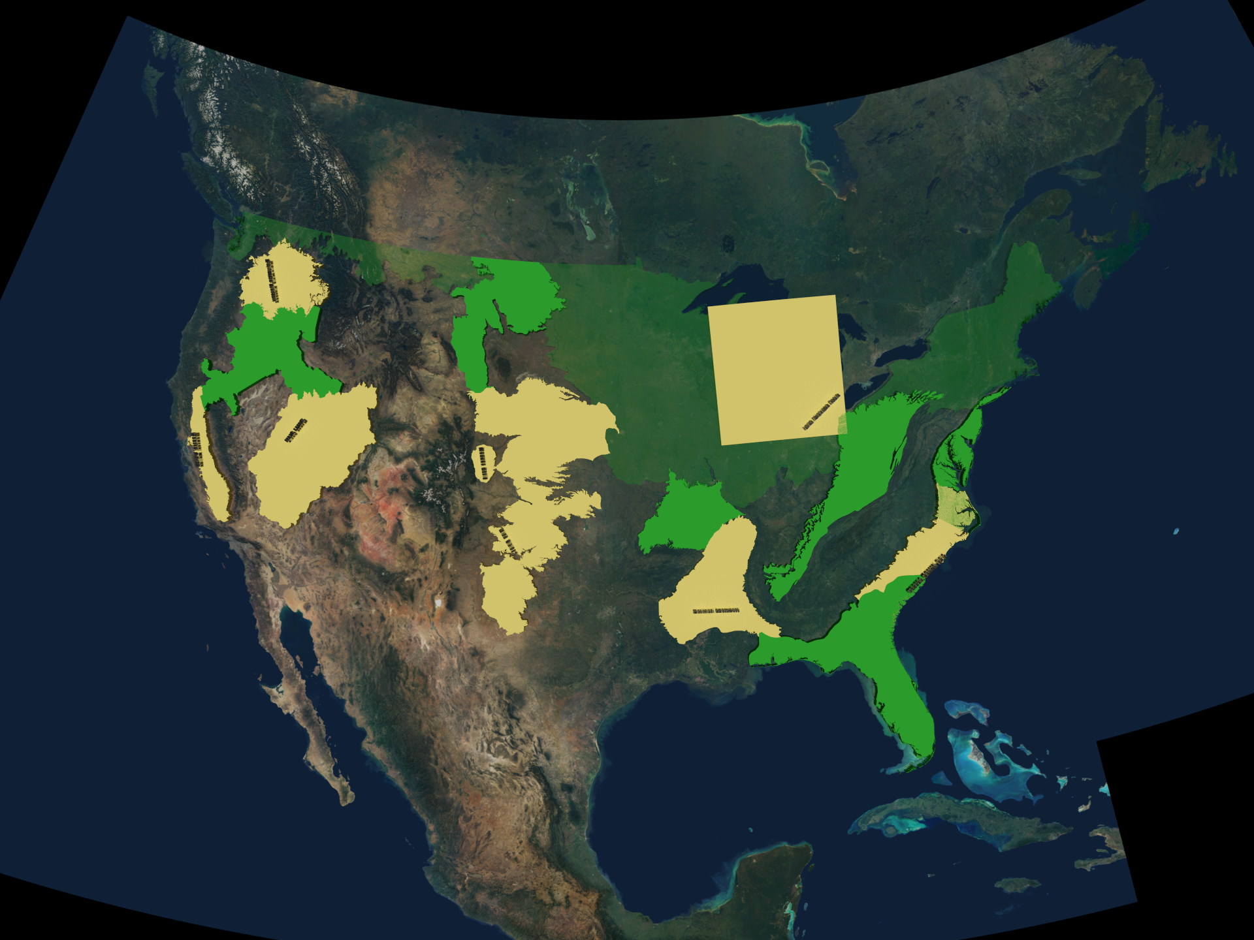

Back cover of SIR 2016-5130 – Artistic concept of transition from well borehole data to a three-dimensional gridded hydrogeologic unit surface:
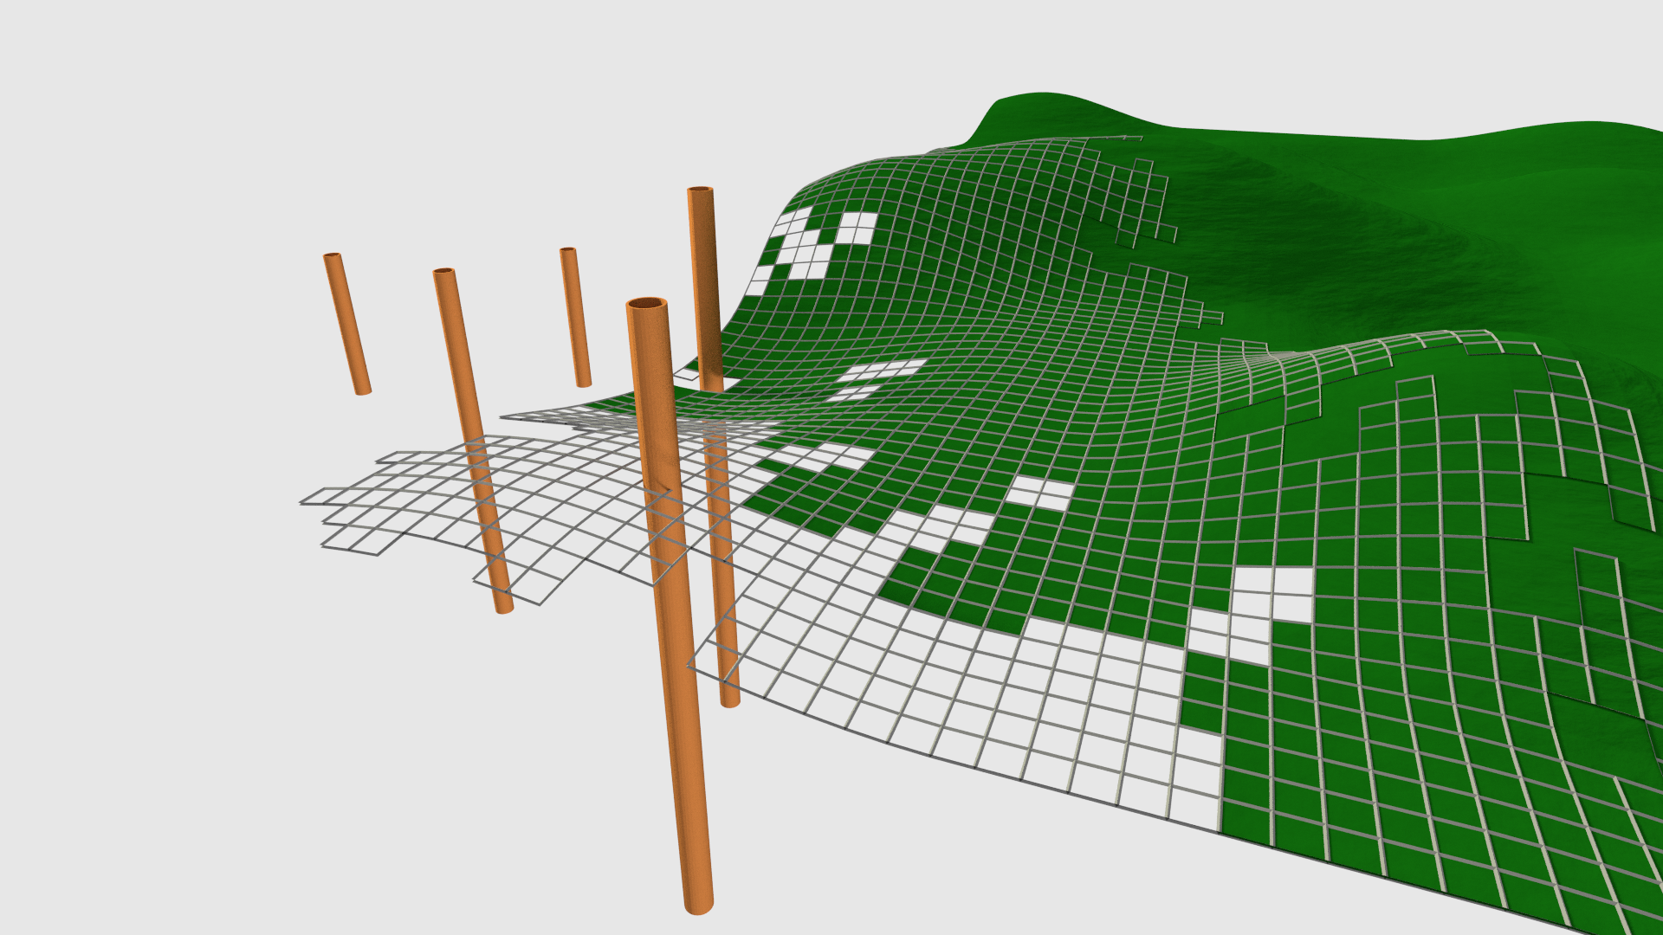

Front cover of SIR 2016-5130 – Hydrogeologic unit surfaces displayed in three-dimensional view with vertical exaggeration.