Water Availability and Use Science Program
Training Modules
FY 2017 End-of-Year Report
November 20, 2017

- PROJECT ACCOMPLISHMENTS/CONTRIBUTIONS (FY 2017)

Water use pertains to human interaction with and influence on the hydrologic cycle, and water-use data and information adds the human component to more accurately reflect the complex interactions within the water budget. There are many challenges to collecting water-use data, and understanding the guidelines and data model structure for the USGS 5-year compilations is complex. There is a need for self-paced online instructions that will enable water-use specialists to learn, or refresh their understanding of water use for the compilations.
A training matrix was developed to scope out the training modules for various topics and students at different learning levels. Beginning in FY2016 and finishing in FY2017, this project has developed 16 online, self-paced training modules, including one for concepts of water use and an introduction to the 5-year compilation. Two modules cover the site-specific and the aggregate databases that store water use at USGS. All categories of water use are provided, with instructions on how to store data in the USGS databases. As of late FY2017, 5 modules are live, with the remaining modules soon to be loaded.

USGS Water Use – Introduction to the 5-year Water-Use Compilation (DOILearn module USGS-H-17-127)
USGS Water Use – Water-Use Concepts (DOILearn module USGS-H-17-126)
USGS Water Use – Public Supply (DOILearn module USGS-H-17-094)
USGS Water Use – Thermoelectric Power (DOILearn module USGS-H-17-129)
USGS Water Use – Irrigation (DOILearn module USGS-H-17-128)

A training team with alias email address to answer specific water-use questions has been formed, and tipsheets that are used to give instruction on focused, condensed topics have been constructed as well.
(2) PROJECT WORKPLAN AND BUDGET FOR FY 2018

Future training plans include onsite, hands on training for the community of scientists in USGS that are collecting and reporting water-use data for various project needs. A national water-use conference is planned for early FY2019, with will include training on water-use data collection.

Project Activities and timelines:
- TOTAL:
- Salary $150,000
- Equipment/supplies (list only major items)
- Contracts (identify)
- Publications
- Travel
- NOTEWORTHY COLLABORATIONS, MEETINGS, TECHNICAL TRANSFER ACTIVITIES, SPIN-OFF PROJECT DEVELOPMENTS, AND ACKNOWLEDGEMENTS

- Report Products, Bibliographic Update, Data Releases, and Groundwater-Model Archives

(5) PROJECT TEAM DIRECTORY –
Kristin Linsey, New York WSC, Troy; 518-285-5636; kslinsey@usgs.gov; Krissi is lead for the OED on-line training.
Kathleen Rowland, Bismark, ND, 701-250-7418; krowland@usgs.gov

(6) PHOTOS, ANIMATIONS, AND GRAPHICS –
Total population and public-supply withdrawals by state and source, 2015.
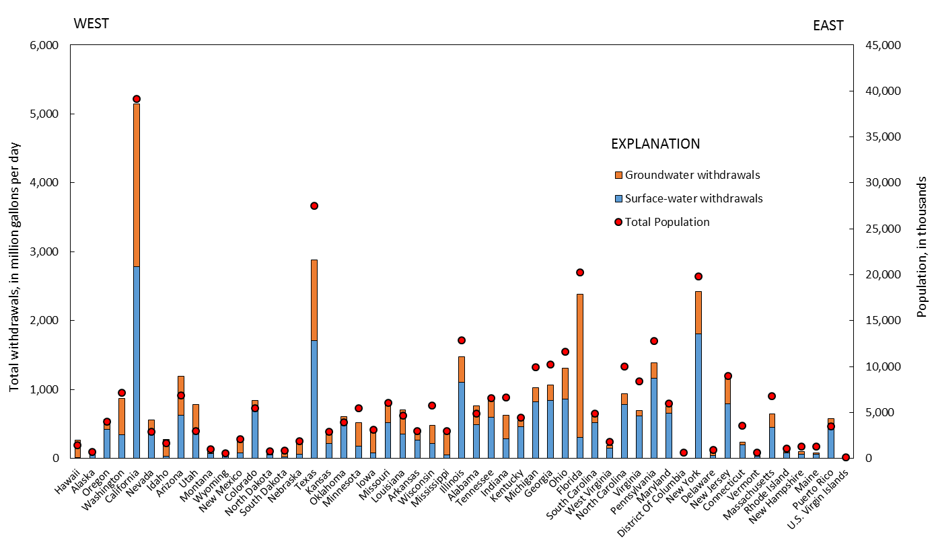
Total domestic water use by state, 2010 and 2015.
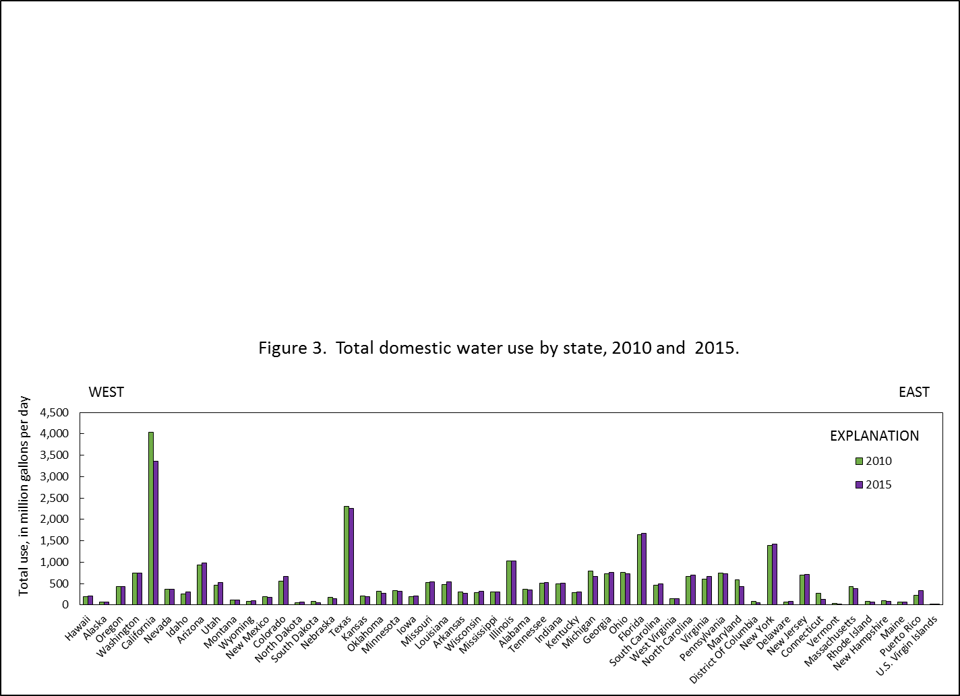
Total domestic per capita water use by state, 2010 and 2015.
