Phase 2 (FY2018-2020): Characterization of the Hydrogeologic and Geothermal Conditions of the Northwest Volcanic Aquifer Study Area

Introduction
This workplan is divided into a general background section, a summary of activities accomplished under Phase 1, and proposed activities under Phase 2 (including anticipated products, personnel, timeline, and budget).

General Background on Study Area
The USGS Regional Aquifer Systems Analysis (RASA) program covered many of the nation’s principal aquifers and has provided a springboard for subsequent studies under the Groundwater Resources Program, and more recently, the Water Availability and Use Science Program (WAUSP). Some areas, such as the Pacific Northwest basaltic-rock aquifer terrain (Reilly and others, 2008), however, have yet to be quantitatively assessed as part of a regional aquifer system. The workplan described herein summarizes Phase 1 activities that have been completed or are underway, and describes Phase 2 activities for FY2018 and beyond.
The study area (which we refer to as the Northwest Volcanic Aquifer Study Area [NVASA], (Figure 1) lies in the middle of a broad volcanic region of the Northwest we refer to as the Northwest Volcanic Aquifer Province (NVAP). This larger region includes multiple geologic provinces such as the Columbia Plateau, the Cascade Range, the Modoc Plateau, the High Lava Plains of Oregon, the volcanic Snake River Plain (east to and including the Yellowstone Plateau volcanic field), and the northwest corner of the Basin and Range Physiographic Province. The boundary between the NVAP and the Basin and Range Province is not sharp, and is defined for our purposes as the transition in northwestern Nevada from the volcanic dominated areas to the predominant basin and range structures of the Great Basin to the south.
Virtually all regional groundwater flow in the NVAP occurs in volcanic deposits (largely lava flows) or volcanic-derived basin-filling sediments. Although volcanic deposits of the region span the entire Cenozoic Era, significant groundwater flow is largely restricted to Miocene and younger deposits. Pre-Miocene volcanic deposits, for example the Clarno and John Day Formations, and rocks of the western Cascade Range, tend to have extremely low permeability due to weathering, hydrothermal alteration, and secondary mineralization (Lite and Gannett, 2002, Gannett and others, 2007).
Parts of the NVAP have been extensively studied under previous USGS efforts. For example, the Columbia Plateau, which occupies much of central and eastern Washington and north-central Oregon was studied under both the RASA and Groundwater Resources Program Groundwater Availability studies (Vaccaro, 1986; Kahle and others, 2011; Ely and others, 2014). The upper Deschutes and Klamath Basins, which include the eastern flanks of the Cascade Range and adjacent drainage basins in Oregon and northern California, have been studied and modeled under Cooperative Water Program projects (Gannett and others, 2001, 2007). The Snake River Plain was studied under the RASA program (Lindholm, 1986) and many subsequent regional and local investigations. There remain, however, large tracts of the NVAP that have never been part of any regional groundwater assessment. Parts of these areas have been included in earlier studies by USGS or individual states, however most of those studies were published more than 20 years ago, and none constitute a systematic coverage of the proposed study area. For example, the most recent groundwater assessment of the Harney Basin in Oregon, an area of emerging groundwater issues, was conducted by Art Piper during the tenure of Oscar Meinzer as Chief of the USGS Ground Water Branch (Piper and others, 1939).
The proposed Northwest Volcanic Aquifer Study Area (NVASA) occupies the largely unstudied parts of the broader NVAP. The study area boundaries (Figure 1) were defined to minimize overlap with previous regional assessments (for example the Columbia Plateau, Oregon Cascade Range, and the Snake River Plain), follow natural hydrogeologic boundaries where possible, and include most of the volcanic aquifers of the original Pacific Northwest basaltic-rock aquifers map (Unit 58) of Reilly and others (2008). Where there is overlap with or proximity to previous regional studies, results of those studies will be used to inform the proposed investigation, no new work is anticipated in those areas. The general study area boundaries proposed extend from the Blue Mountain Anticline on the north (which defines the southern boundary of the Columbia Plateau), and the eastern flank of the Cascade Range on the west (extending south into the active volcanic arc in northern California). The southern boundary generally corresponds with the transitional area at the northern edge of the Basin and Range Province as previously described, and the southern edge of the Owyhee Region of southwestern Idaho. The eastern boundary aligns with the eastern edge of the Owyhee volcanic region and follows the extent shown by Reilly and others (2008). The exact boundaries are not yet defined.
While the National Groundwater Atlas (Whitehead, 1994) excluded (or otherwise differentiated) basin-fill aquifers form the Northwest basaltic-rock aquifers, Reilly and others (2008) combined them into a single principal aquifer unit (their figure 23). Depicting these as a single principal aquifer is plausible because unlike some areas, such as parts of the Basin and Range Province where permeable basin-filling deposits are surrounded by impermeable bedrock, basin-filling deposits in the NVASA are likely to be hydraulically connected with permeable rock in the surrounding uplands. Basin-filling deposits in the study area are probably integral to regional flow systems, and will be included in the proposed study.
The volcanic terrain of the Northwest not only hosts substantial groundwater flow systems, but geothermal systems as well. The USGS Geothermal Resource Investigations Project, which is supported by the Energy Resources Program, is actively interested in the region. Recent collaborative efforts among scientists in the Water Mission Area and Energy and Minerals Mission Area in the Columbia Plateau have demonstrated the importance of regional groundwater flow in understanding the surface manifestation of regional crustal heat flow patterns (Burns and others, 2014). Therefore, there is considerable alignment of interests and opportunity for synergistic advances in hydrogeologic and geothermal science in the NVASA. A Groundwater Resources Program Groundwater Availability study in the NVASA will provide a unique opportunity for interdisciplinary collaboration, and leveraging of funds and other resources. The approach outlined in this proposal assumes a jointly-funded collaborative effort in which programs from both the Water, and Energy and Minerals Mission Areas will provide resources and staff. In this way, efforts can be combined where interests and information needs overlap, thereby optimizing time and resources for discipline-specific areas of inquiry. Though interests and information needs overlap, the exact geographic scopes may not. The Water Mission Area effort will be focused on the “understudied” parts of the region, while the Energy and Minerals Mission Area effort will have a slightly larger geographic scope, inclusive of the Snake River Plain.

Phase 1 Activities, Accomplishments, and Implications
As part of Phase 1, a series of tasks were accomplished to assess the NVASA region, with the primary goal of developing a fundamental understanding of the hydro-physiography of the region and its implications for geothermal resources. Broadly, the WAUSP-funded Phase 1 goals were to:
- Develop a geologic map interpretation that would act as the foundation of both hydrogeologic and geothermal frameworks.
- Develop some preliminary estimates of groundwater recharge for the region.
- Develop hydrologic datasets and geostatistically analyze correlations between geology and hydrology that explain how water is stored and transmitted within the study area.
A brief summary of major study components is below, but in summary: Goal 1 is complete with the publication in review (Sherrod and Keith, 2017); Goal 2 has been accomplished, and results are being used as part of Goal 3 analyses (which depend on Goal 1 finalization). Goal 3 progress is substantial (see Figures 3-6), but the available datasets are proving richer than anticipated, allowing the identification of Phase 2 activities. Partial results from Goals 2 and 3 are in review (Burns et al, 2017a), with the full analysis manuscript anticipated to be in review by the end of FY2017. In addition to the primary goals above, an additional manuscript on the topic of climate change effects on groundwater temperature with implications for habitat was just published (Burns et al., 2017b).

New Thematic Interpretation of Existing State-level Geologic Maps
A new thematic interpretation of existing state-level geologic maps (Ludington et al., 2005) has been constructed, providing an updated and refined distribution of the composition and age of the volcanogenically dominated terranes of southeast Oregon, northeast California, and southeast Idaho, USA. This interpretation has been developed for the purposes of better understanding geothermal and hydrologic resources of the region. Sherrod and Keith (2017) have constructed a digital mosaic of the volcanogenic terranes of the northwestern U.S. This digital mosaic has similarities thematically to 1970s geologic maps that depicted age and composition of volcanic rocks at regional scale (Luedke and Smith, 1982, 1983; scale 1:1,000,000), but the 0-5 Ma age bin has been further divided to give improved temporal resolution of more recent volcanism. Unlike the map of Luedke and Smith that included only volcanic rocks, the new compilation has been expanded to include all types of geology. While the Luedke and Smith maps provided a clear picture of the age and compositional progression of volcanics in the region, the new more-refined map allows a more comprehensive analysis of the hydrology and geothermal heat flow.

Stream Gage Hydrograph Separation & Expert Systems Classification
Automated baseflow separation, using the USGS Groundwater Toolbox (Barlow et al., 2015), was conducted on 285 stream gages within the study area, and metrics of hydrograph disturbance were considered to remove hydrographs that do not represent natural processes of interest (e.g., dam operations), resulting in a set of 145 stream gages with some years of data that were representative of undisturbed stream response (a total of 3,087 gage-years). Most of the final 145 gages are moderately or strongly affected by snow storage and release of spring snowmelt discharge (Figure 2).
Stream hydrograph separation techniques separate measured flow at a stream gage, into fast and slow components of response to rainfall and snowmelt, and are not based on physical representation of processes contributing to streamflow. Water that runs off the land surface directly into streams arrives at the stream gage shortly after precipitation or snowmelt events. Water that infiltrates to groundwater flows along a much slower path, and therefore is lagged and diffused relative to water that runs off immediately. Fast-response-time water is assumed to be surface water runoff, but groundwater can have many different time scales of response, corresponding to the myriad of groundwater flow paths that can exist within a natural geologic system. Because snommelt processes operate on timescales similar to groundwater, the hydrograph separation incorrectly identifies snowmelt as groundwater discharge. For these reasons, quantification of the snowmelt discharge effect is part of our proposed Phase2 efforts.
Hydrograph-separation was accomplished by downloading ~7,000 gage years of data from NWIS for the basins that are small enough (<500 sq.miles) to be examined with the Groundwater Toolbox, then analyzing each gage year with the six different baseflow separation algorithms, resulting in ~42,000 plots that six experienced hydrogeologists examined and classified, with each gage-year being evaluated by a minimum of two hydrogeologists. Hydrographs were scored on their value as being representative of natural rainfall/runoff/infiltration conditions, the degree to which snow is an important storage mechanism, and scores for how well each baseflow separation method worked. The 145 final gages with 3,087 high-value gage-years are those where all reviewers rated the gage-year at a value of 7 or greater (with 10 being maximum score). These gage-years are those that are being used for the statistical analysis.
After a comparison of the baseflow separation techniques, the consistently highest ranked methods were the BFI methods, with BFI-modified barely outperforming BFI-standard. BFI tended to provide the highest estimates of runoff and the lowest estimates of groundwater component of the stream hydrograph. Most other methods included much more of the hydrograph under the groundwater component, with PART being the favorite method. The distinction between BFI and PART is mostly what the rater is willing to accept as “groundwater”. It was acknowledged that true runoff might be best estimated by PART, “regional” groundwater flow might be best estimated by BFI-modified, and some temporal frequency of interflows is represented by the difference in baseflow between PART and BFI (i.e., PART baseflow minus BFI baseflow).

Soil Water Balance Modeling for the Period 1980-2013
To estimate groundwater recharge, we used distributed predicted precipitation (1-km DayMet gridded daily precipitation for the period 1980-2013 (Thornton et al., (2015))) as input to a soil water balance model (SWB (Westenbroek et al., 2010)) to estimate evapotranspiration (ET), runoff, and infiltration for the period 1980-2013 for the 285 stream-gage basins used for the Groundwater Toolbox analysis, assuming constant curve numbers (CNs) of 20 (low runoff), 65 (typical runoff for typical NVASA terrains), and 80 (high runoff). The purpose of exploring the range of CNs was to assess the range of groundwater recharge that might occur. A primary finding of this analysis is that ET varies by <2% for all CNs, indicating that DayMet-estimated precipitation minus SWB-estimated ET equals an estimate of available water (i.e., water that is available to flow into streams or groundwater) that is independent of CN (i.e., the most uncertain parameter in SWB for controlling groundwater recharge).
The Phase 1 SWB analysis was aimed at providing a range of groundwater recharge estimates (e.g., for CN = 20, 65, and 80), and a SWB model has been constructed and run for the entire NVASA area that contains the 285 gage basins. However, because the Groundwater Toolbox provides an independent estimate of runoff, as part of Phase 2, we will investigate calibrating CNs as a function of geologic age and composition (i.e., new thematic maps), providing an improved estimate of groundwater recharge. Further, for agencies that regulate groundwater and surface water as a single resource, we can provide estimates of available water (i.e., groundwater + surface water) to aid in allocation of the resource.

Categorization of Hydrogeologic Character of the Geologic Terrains of the NVASA
The statistical analysis of hydrograph response as a function of the new thematic geologic map (which just finished peer-review) is ongoing, but the NVASA can be broadly divided into three scenarios dependent on permeability and groundwater recharge rate: [1] highly permeable young volcanogenic deposits with high recharge transmit water over long distances, discharging at a few high-volume springs with low seasonality in flowrate variation (Figure 3A); [2] lower permeability older terrains with high recharge, discharging in many small springs all across the landscape, with high variability in seasonality of flowrate (Figure 3B); and [3] lower permeability older terrains with low recharge, discharging at few low-volume springs, with low seasonality (Figure 3C).
The conceptual model of Figure 3 translates to the entire NVASA. Figure 4 shows the fraction of available water that infiltrates to groundwater (estimated for 145 high-quality gages using Groundwater Toolbox and SWB output) overlaying average annual precipitation. The pattern of groundwater infiltration corresponds to the conceptual model (Figure 3) with high precipitation in the west (Figure 4) corresponding to high groundwater recharge into permeable young volcanogenic deposits (Figure 5), whereas high precipitation in the northeast has less groundwater recharge, resulting from the lower permeability of the older rocks. Figure 6 shows spring density as a function of geologic age (spring markers are colored by geologic unit age), matching the conceptual model well, except where quaternary faults have likely created secondary permeability associated with fracture flow. This conceptual model will be further investigated during Phase 2, possibly using thermal infrared (TIR) imagery or other methods to rapidly detect and estimate groundwater flow to streams.

Potentiometric Surface Maps
Available head data has been compiled and generalized potentiometric surface maps have been created for areas with sufficient data. These maps will be published overlaying an appropriate categorization of the thematic categorization of Sherrod and Keith (2017). The hydrogeologic categorization will be the result of the ongoing statistical analysis of hydrology as a function of geologic age and composition.

Creation of a Hydrogeologic Framework Based on the Geostatistical Analysis of Hydrology and Geologic Age and Composition
Now that the geologic map (Sherrod and Keith, 2017) is in review, the statistical analysis of the geology and hydrology can be completed. As implied by the above Phase 1 accomplishments, the available datasets and modeling products are providing a richer set of data than anticipated. While much of the remainder of FY2017 will be devoted to statistical analysis, it is anticipated that some of the derivative products will motivate Phase 2 research, and will evolve based on new findings.

Geothermal Database Compilation
A geothermal database for the NVAP has been compiled for Oregon and Washington, with ongoing work to compile data for California, Idaho, and Nevada. This task is mostly for geothermal project goals, but the final dataset will be examined to identify the depth of thermal perturbation of conductive heat flow due to the transport of heat by groundwater flow (i.e., thermal profiles will be examined to estimate the bottom of the aquifer system where possible).

Phase 2 Activities
Phase 2 activities are based on Phase 1 findings, and can be broadly divided into two main groups: [1] continued analysis of regional data with new tools, and [2] focused efforts to quantify groundwater and heat flow in the northern California part of the study area (hereafter called the Cascade Area Modoc Plateau = CAMP). Cumulatively, springs and groundwater seeps within the CAMP area contribute approximately half of the annual average flow (~140 m³/s) to the Pit River, which is the largest tributary to Shasta Lake, the largest reservoir in California. The tributary groundwater-fed springs, driven by high precipitation in the Cascade Range, provide a relatively cool and drought-resistant source of water for fisheries and agricultural, municipal, and industrial use (Burns et al., 2017b), so water availability and use are of prime considerations for this part of the NVASA.
Phase 2 regional analysis builds upon findings of Phase 1. In particular, the correlations between geology and groundwater flow will continue to be examined, and new tools will be developed to separate and estimate direct runoff and shallow and deeper groundwater flow components. High primary permeability exists in young volcanogenic terrains, and high secondary permeability exists near some structurally controlled open fractures. More detailed statistical analyses of young volcanic deposits will seek to refine understanding of which types of deposits result in high primary permeability. A slip and dilation tendency map will be developed to identify which quaternary folds and faults are correlated with high secondary permeability. New data collection will include efforts to support our understanding of snow hydrology and potential uses of heat as a tracer to identify geologic controls on groundwater discharge.

Task 1: Refined and Continued Statistical Analysis, Coupled with Process-Based Models
The combination of Phase 1 products (e.g., Figure 7) is a rich dataset that Phase 2 efforts will continue to develop.

Subtask 1.1: Evaluate and Quantify the Influence of Snow Hydrology
Because most stream hydrographs in the study area are moderately to significantly snow-affected, future efforts will seek to better understand: (1) the role of snow as a storage mechanism, (2) snowmelt as a process that partitions available water into groundwater and surface water, and (3) implications of persistent drought and climate change on the effect of snow storage on late-season stream flow. Baseflow separation strategies will be considered, plus extraction of snowmelt from SWB (and other models such as BCM) will be considered to develop improvements in estimates of snowmelt-derived runoff and recharge. Further, we are investigating the development of metrics that provide a quantitative score for the degree of importance of snow on the stream hydrograph.

Subtask 1.2: Develop Refined Groundwater Recharge Estimates
Preliminary statistical analysis shows that curve numbers are correlated with geologic age and composition. For Phase 1, a range of CNs (spanning expected variability) was used to evaluate a range of recharge estimates. Under this range of CNs, simulated ET did not vary much (<2% variation in ET for the full range of CNs). Using the observation that SWB runoff should equal groundwater toolbox runoff (Figure 7), we will estimate CN as a function of geologic age and composition, providing a much narrower range of groundwater recharge estimates for NVASA, tightening the groundwater budget. We will evaluate the recently updated version of SWB for potential value added by new functionality, and if warranted, we will move our existing model into the new version.

Subtask 1.3: Develop One or More Hydrogeologic Thematic Interpretations of the Study Area
The combination of Figures 4, 5, and 6 can be used as the foundation for delineation of the study area into hydrogeologic sub-provinces, but completion of Phase 2 will allow further refinement of the hydrogeologic map of the region. Additionally, this map (or these maps, if more than one is constructed) will include generalized head maps where sufficient data are available. The head maps are substantially complete under Phase 1, and we will evaluate whether or not head data also support permeability patterns from the statistical analyses.

Subtask 1.4: Use Geothermal Data to Refine Hydrogeologic Interpretation
Where possible, the newly compiled geothermal database will be compared to hydrologic patterns to improve understanding of regional hydrogeology. For example, comparing depth at which thermal profiles transition from advectively perturbed to conductive can be used to identify the bottom of the regional aquifer system, which can be coupled with water-well construction data to estimate aquifer thickness.

Subtask 1.5: Hydrologic Disturbance Index Refinement
As part of the stream hydrograph analysis, a disturbance index (based on NHD and other available GIS data) was developed to pre-screen hydrographs during preliminary analyses. Because all hydrographs were examined by a team of experts, we can statistically evaluate how well the Index worked, and possibly propose better screening tools or ways to improve estimates of time of regulation.

Task 2: CAMP Study Area Analysis
Due to its importance as a drought-resistant water supply for much of California, much of the Phase 2 efforts are focused on better-understanding the CAMP sub-area of the NVASA (Figure 8). The CAMP sub-area is representative of high-recharge high-permeability conditions, in contrast to the Harney Basin (a cooperative study by the Oregon Water Science Center and the Oregon Water Resources Department), which is a low-recharge low-permeability part of the NVASA. Including the CAMP area ensures that we more-closely examine the range of conditions occurring in the NVASA, allowing us to strengthen our understanding of the entire region.

Subtask 2.1: Construction of 3D Geologic Framework for Highly Productive Aquifers within the CAMP Study Area
In cooperation with USGS Geologic Division geologists, a graduate student will be employed to create 3D interpretations of subsurface geology that can be used to understand the groundwater and heat flow in the region.

Subtask 2.2: Groundwater and Heat Flow Simulation that is Concurrent with Subtask 2.1
Groundwater and heat flow simulations, using SUTRA (or similar), will be conducted using alternate geologic interpretations generated under Subtask 2.1. The purpose of these simulations will be to identify testable hypotheses that can be used to differentiate between alternate models, thereby improving our understanding of how the system works, and providing feedback to geologic mapping efforts.

Subtask 2.3: Data Collection
Measurements will be made that allow differentiation between competing geologic, hydrologic, and heat flow models. Sampling will provide feedback into geologic mapping and modeling efforts. Most data are anticipated to be flow and temperature, but we will evaluate the role of targeted tracers of travel time and interaction with hydrothermal fluids or volcanic gases.

Subtask 2.3.1: Snow Hydrology
The U.S. Forest Service and the University of Nevada – Reno have an active research program investigating the role of snow in recharge processes as a function of forest treatments. As part of this work, the USFS has a staff hydrologist and seasonal student interns to collect data. We will coordinate with USFS to use CAMP as a testing area to refine our understanding of snow hydrology within the NVASA.

Subtask 2.3.2: Role of Geology on Groundwater and Surface Water Flow Patterns
The rate of groundwater and heat flow will be measured at locations that have been identified as hydrologically significant. Further, new locations may be measured, based on geologic and modeling evidence, to differentiate between competing models.
The role of geologic structures on groundwater discharge patterns will be investigated to improve our understanding of how lithology and structure work together to create flow paths and barriers. Mechanisms will be explored within the Hat Creek drainage, where faults offset relatively young lava flows and a series of large springs emerge, allowing inference of how these mechanisms control groundwater flow throughout the study area.

Subtask 2.3.3: Development and Implementation of Monitoring Plan
Based on what is learned during the study of the CAMP, a monitoring plan will be developed and implemented (to the extent that project resources can support) for the purpose of long-term evaluation of system dynamics, and with the expectation that these data may be used during future model development for the CAMP area. The value of adding monitoring locations will be assessed during simulation analyses and discussed with basin partners.

Task 3: Synergistic Activities between Regional Efforts and CAMP and Harney Basin Study
This task is intrinsic to Tasks 1 and 2, but we wanted to explicitly state that regional NVASA efforts will provide input to study of the CAMP and Harney areas. Further, findings within both CAMP and Harney Basin will be used to improve the understanding of regional hydrology. When appropriate, new statistical relations can be evaluated for the region, based on local findings. Findings in local areas may guide the compilation of new data layers for the region to improve the understanding of regional hydrology.

Products/Report Plan and Timeline
All activities will continue, starting with resources remaining for FY2017, including geologic mapping during the summer 2017 field season.
The following products are expected to be published as individual (or combined, if analyses are contingent upon each other) reports or journal articles as appropriate.
- NVASA regional baseflow analysis – Jenny Curtis (lead author) – first draft ~Jan 2018
- NVASA regional SWB estimates of Recharge – Erick Burns (lead author) – first draft ~Jan 2018
- NVASA statistical analysis of geology and climate’s role in controlling hydrology – Erick Burns (lead author) – first draft ~Oct 2017
- Analysis of snowmelt – Will use CAMP and Harney results, so by end of FY2020
- CAMP 3D geologic model development – Student/Burns&Sweetkind (lead author) – FY2020
- CAMP hydrologic analysis, including monitoring – Burns or Curtis (lead author) – FY2019
- CAMP Heat and fluid flow simulations using the 3D geologic model, including discussion of how simulations were used to constrain the geologic model – Erick Burns (lead author) – FY2020
- Summary of NVASA hydrologic analysis, including regional implications of lessons learned from CAMP and Harney Basin work – Erick Burns (lead author) – FY2020
If results are sufficiently interesting, the following topics will be published as part of the above manuscripts or stand-alone, as appropriate:
- Evaluation of the utility of thermal-infrared image data for determining the location and magnitude of preferential groundwater discharge patterns – Jenny Curtis (lead author) – FY2020

Personnel
Personnel listed below are divided into two groups: (1) persons receiving support from WAUSP and (2) persons that are funded under the Energy Resources, Hazards, or Geologic Mapping Programs. A brief description of Group 2 personnel expertise and contributions is given. Erick Burns will coordinate and be involved with all aspects of the study, but John Engott and Jenny Curtis will be in substantial control of field work and data collection activities within the CAMP study unit. Jenny Curtis has been principal developer of the Groundwater Toolbox methods employed during Phase 1, and has done preliminary BCM analysis of snow hydrology, so will continue working on Phase 2 Task 1 activities.
In addition to the new Phase 2 tasks defined in this workplan, USGS Geothermal Project staff (including Erick Burns who is listed below under the WAUSP group) will have additional complementary ERP-funded tasks aimed at assessing regional geothermal resources within the larger NVAP. These resources are not shown below.

Task 1: Refined and Continued Statistical Analysis, Coupled with Process-Based Models

WAUSP Funded Personnel
- Erick Burns – ORWSC (FY2018-2020; 4 PP/yr from WAUSP and 2 PP/yr from ERP)
- Jenny Curtis – CAWSC (FY2018-2020; 2 PP/yr)

Personnel Funded by Other Programs
- Drew Siler [Research Geologist] – Geology, Minerals, Energy, and Geophysics Science Center (FY2018-??) Role: Structural geologist that will develop slip and dilation tendency maps for Quaternary faults for analysis of correlations between structure and secondary permeability.
- Jonathan Glen [USGS Geothermal Project Chief; Research Geophysicist] – Geology, Minerals, Energy, and Geophysics Science Center (FY2018-2020) Role: Assess the use of regional geophysical surveys to act as predictors for permeability and heat flow.
- Colin Williams [GMEGSC Director; Regional Assessment of Geothermal Resources] – Geology, Minerals, Energy, and Geophysics Science Center (FY2018-2020) Role: Expert on statistical methods of prediction of energy and mineral resources.
- Jacob DeAngelo [GIS Specialist] – Geology, Minerals, Energy, and Geophysics Science Center (FY2018-2020) Role: GIS tools for predicting resources, and spatial database compilation.
- Steve Ingebritsen [Research Hydrologist] – California Volcanoes Observatory (FY2018-2020) Role: Hydrothermal systems expert; Cascade Range expert.

Task 2: CAMP Study Area Analysis

WAUSP Funded Personnel
- Erick Burns – ORWSC (FY2018-2020; 4 PP/yr from WAUSP and 2 PP/yr from ERP)
- Jenny Curtis – CAWSC (FY2018-2019; 6 PP/yr)
- John Engott – CAWSC (FY2018-2019; 4 PP/yr)
- Student – ORWSC (FY2018-2020; 13 PP/yr = 0.5 FTE/year)

ERP or Other Geologic Division Funded Personnel
- Don Sweetkind [Research Geologist] – Geosciences and Environmental Change Science Center (FY2018-2020) Role: Work with the student to develop geologic maps and 3D geologic models of the CAMP study area.
- Vicki Langenheim [Research Geophysicist] – Geology, Minerals, Energy, and Geophysics Science Center (FY2018-2020) Role: Work with the student to interpret existing geophysical datasets to develop 3D geologic models of the CAMP study area.
- Colin Williams [GMEGSC Director; Regional Assessment of Geothermal Resources] – Geology, Minerals, Energy, and Geophysics Science Center (FY2018-2020) Role: Expert on assessment of geothermal resources, and experience measuring heat flow within the CAMP study area.
- Steve Ingebritsen [Research Hydrologist] – California Volcanoes Observatory (FY2018-2020) Role: Hydrothermal systems expert; Cascade Range expert.

Budget Summary
The following budget is a total by year for the Water Availability and Use Science Program only. Detailed Net-to-Gross spreadsheets for each cost center are available on request. The OR WSC will be lead on all tasks. During the project, Burns or GMEG staff will travel quarterly for half-day meetings (meetings in Portland, OR, or Menlo Park, CA) to allow frequent exchange of ideas between the WAUSP and Geothermal Program (costs split equally between the programs). The student will need to be recruited to begin fieldwork the summer of 2017, and is anticipated to be a Portland State University geology student, stationed at the ORWSC. However, the student will have intensive field seasons with Don Sweetkind, Patrick Muffler (emeritus), and Jenny Curtis. As necessary, the student will accompany Burns to Menlo Park to work with Vicki Langenheim, and other regional experts as needed (e.g., Julie Donelly-Nolan, Jake Lowenstern, etc.). FY2017 funding for the student will be provided from WAUSP funds previously distributed to startup FY2018 tasks, supplemented by ERP funds.
FY2018 = $270K
FY2019 = $185K
FY2020 = $175K
TOTAL = $630K

References Cited
Barlow, P.M., Cunningham, W.L., Zhai, Tong, and Gray, Mark, 2015, U.S. Geological Survey groundwater toolbox, a graphical and mapping interface for analysis of hydrologic data (version 1.0)—User guide for estimation of base flow, runoff, and groundwater recharge from streamflow data: U.S. Geological Survey Techniques and Methods 3-B10, 27 p., http://dx.doi.org/10.3133/tm3B10.
Bauer, H.H., and Vaccaro, J.J., 1990, Estimates of ground-water recharge to the Columbia Plateau regional aquifer system, Washington, Oregon, and Idaho, for pre development and current land-use conditions: U.S. Geological Survey Water-Resources Investigations Report 88-4108, 37 p., http://pubs.er.usgs.gov/usgspubs/wri/wri884108.
Brooks, L.E., Masbruch, M.D., Sweetkind, D.S., and Buto, S.G., 2014, Steady-state numerical groundwater flow model of the Great Basin carbonate and alluvial aquifer system: U.S. Geological Survey Scientific Investigations Report 2014-5213, 124 p., 2 pl. http://dx.doi.org/10.3133/sir20145213.
Brown, J., Bach, L., Aldous, A., Wyers, A., and DeGagne, J., 2011, Groundwater-dependent ecosystems in Oregon: an assessment of their distribution and associated threats: Frontiers in Ecology and the Environment 9(2): 97-102.
Burns, E.R., Williams, C.F., Ingebritsen, S.E., Voss, C.I., Spane, F.A., and J. DeAngelo, 2014, Understanding Heat and Groundwater Flow through Continental Flood Basalt Provinces: Insights Gained from Alternative Models of Permeability/Depth Relationships for the Columbia Plateau, USA, Geofluids (2014), doi: 10.1111/gfl.12095, 19 p., http://onlinelibrary.wiley.com/doi/10.1111/gfl.12095/abstract
Burns, E.R., Gannett, M.W., Sherrod, D.R., Keith, M.K., Curtis, J.A., Bartolino, J.R., Engott, J.A., Scandella, B.P., Stern, M.A., and Flint, A.L., (2017a, in review, IP-086602) Geothermal Implications of a Refined Composition-Age Geologic Map for the Volcanic Terranes of Southeast Oregon, Northeast California, and Southwest Idaho, USA, GRC Transactions, Vol. 41.
Burns, E. R., Y. Zhu, H. Zhan, M. Manga, C. F. Williams, S. E. Ingebritsen, and J. B. Dunham (2017b), Thermal effect of climate change on groundwater-fed ecosystems, Water Resour. Res., 53, doi:10.1002/2016WR020007.
Ely, D.M.; Burns, E.R.; Morgan, D.S.; and Vaccaro, J.J., 2014, Numerical simulation of groundwater flow in the Columbia Plateau Regional Aquifer System, Idaho, Oregon, and Washington: USGS Scientific Investigations Report: 2014-5127.
Flint, L.E., and Flint, A.L., 2007, Regional analysis of ground-water recharge, in Stonestrom, David A., Constantz, Jim, Ferre, Ty P.A., and Leake, Stanley A., eds., Ground-water recharge in the arid and semiarid southwestern United States: U.S. Geological Survey Professional Paper 1703-B, p. 29-60 [http://pubs.usgs.gov/pp/pp1703/b/].
Gannett, M.W., and Lite, K.E., Jr., 2004, Simulation of regional ground-water flow in the upper Deschutes Basin, Oregon: U.S. Geological Survey Water-Resources Investigations Report 03–4195, 84 p.
Gannett, M.W.; Lite, K.E., Jr.; La Marche, J.L.; Fisher, B.J.; Polette, D.J., 2007, Ground-Water Hydrology of the Upper Klamath Basin, Oregon and California, USGS Scientific Investigations Report: 2007-5050, 85 p.
Gannett, M.W., Wagner, B.J., and Lite, K.E., Jr., 2012, Groundwater simulation and management models for the upper Klamath Basin, Oregon and California: U.S. Geological Survey Scientific Investigations Report 2012–5062, 92 p.
Glen, J.M.G., McKee, E.H., Ludington, S., Ponce, D.A., Hildebrand, T.G., and Hopkins, M.J., 2004, Geophysical Terranes of the Great Basin and Parts of Surrounding Provinces, USGS Open-File Report 2004-1008, 303 p.
Heilweil, V.M., and Brooks, L.E., eds., 2011, Conceptual model of the Great Basin carbonate and alluvial aquifer system: U.S. Geological Survey Scientific Investigations Report 2010-5193, 191 p.
Kahle, S.C.; Morgan, D.S.; Welch, W.B.; Ely, D.M. Hinkle, S.R.; Vaccaro, J.J.; and Orzol, L.L., 2011, Hydrogeologic framework and hydrologic budget components of the Columbia Plateau Regional Aquifer System, Washington, Oregon, and Idaho: USGS Scientific Investigations Report: 2011-5124.
Leavesley, G.H., Lichty, R.W., Troutman, B.M., and Saindon, L.G., 1983, Precipitation-runoff modeling system—User’s manual: U.S. Geological Survey Water-Resources Investigations Report 83–4238, 207 p.
Lindholm, G.F., 1986, Snake River Plain regional aquifer-system study: in Sun, R.J., ed., Regional Aquifer-System Analysis Program of the U.S. Geological Survey--summary of projects, 1978-84: U.S. Geological Survey Circular 1002, p. 88-106.
Lite, K.E., Jr., and Gannett, M.W., 2002, Geologic framework of the regional ground-water flow system in the upper Deschutes Basin, Oregon: U.S. Geological Survey Water-Resources Investigations Report 02-4015, p. 44.
Ludington, S., Moring, B.C., Miller, R.J., Stone, P.A., Bookstrom, A.A., Bedford, D.R., Evans, J.G., Haxel, G.A., Nutt, C.J., Flyn, K.S., and Hopkins, M.J. “Preliminary integrated geologic map databases for the United States; western states California, Nevada, Arizona, Washington, Oregon, Idaho, and Utah”, version 1.3, updated December 2007: U.S. Geological Survey Open-File Report 2005-1305, (2005), accessed March 20, 2017, at http://pubs.usgs.gov/of/2005/1305/.
Luedke, R.G., and Smith, R.L. “Map showing distribution, composition, and age of late Cenozoic volcanic centers in Oregon and Washington.” U.S. Geological Survey Miscellaneous Investigations Map I-1091-D, (1982), scale 1:1,000,000.
Luedke, R.G., and Smith, R.L. “Map showing distribution, composition, and age of late Cenozoic volcanic centers in Idaho, western Montana, west-central South Dakota, and northwestern Wyoming” U.S. Geological Survey Miscellaneous Investigations Map I-1091-E, (1983), scale 1:1,000,000.
Phillips OM, 1991, Flow and Reactions in Permeable Rocks. Cambridge University Press, Cambridge.
Piper, A.M.; Robinson, T.W.; Park, C.F.; and Jessup, L. T,. 1939, Geology and ground-water resources of the Harney Basin, Oregon, with a statement on Precipitation and tree growth: US Geological Survey Water Supply Paper 841.
PRISM Climate Group, 2014, http://www.prism.oregonstate.edu/.
Reilly, T.E.; Dennehy, K.F.; Alley, W.M.; and Cunningham, W.L., 2008, Ground-Water Availability in the United States: US Geological Survey Circular 1323.
Sherrod, D.R., and Keith, M.K. (2017, in review, IP-085787) “Geologic Map Showing Distribution, Composition, and Age of Cenozoic Volcanic Rocks of the Pacific Northwest Volcanic Aquifer System Study Area.” U.S. Geological Survey Data Series 2017-XXXX, XX p., XX sheets, http://dx.doi.org/10.3133/ofr20XXXXXX.
State of Oregon, 2012, Integrated Water Resources Strategy: http://www.oregon.gov/owrd/pages/law/integrated_water_supply_strategy.aspx
Thornton, P.E., M.M. Thornton, B.W. Mayer, N. Wilhelmi, Y. Wei, R. Devarakonda, and R.B. Cook. 2014. Daymet: Daily Surface Weather Data on a 1-km Grid for North America, Version 2. Data set. Available on-line [http://daac.ornl.gov] from Oak Ridge National Laboratory Distributed Active Archive Center, Oak Ridge, Tennessee, USA.
U.S. Geological Survey, 2007, Facing tomorrow’s challenges – U.S. Geological Survey science in the decade 2007-2017: U.S. Geological Survey Circular 1309, 70p.
Vaccaro, J.J., 1986, Columbia Plateau regional aquifer-system study: in Sun, R.J., ed., Regional Aquifer-System Analysis Program of the U.S. Geological Survey--summary of projects, 1978-84: U.S. Geological Survey Circular 1002, p. 141-145.
Westenbroek, S.M., Kelson, V.A., Dripps, W.R., Hunt, R.J., and Bradbury, K.R., 2010, SWB—A modified Thornthwaite-Mather Soil-Water-Balance code for estimating groundwater recharge: U.S. Geological Survey Techniques and Medhods 6-A31, 60 p.
Whitehead, R.L., 1994, Oregon, Washington, and Idaho: in Miller, J.A, ed., Groundwater Atlas of the United States, U.S. Geological Survey, Reston Virginia, 2000.
Williams CF & DeAngelo J, 2008, Mapping geothermal potential in the western United States. Transactions of the Geothermal Resources Council 32, 181–188.
Williams CF & DeAngelo J, 2011, Evaluation of Approaches and Associated Uncertainties in the Estimation of Temperatures in the Upper Crust of the Western United States. GRC Transactions, 35, 1599-1605.

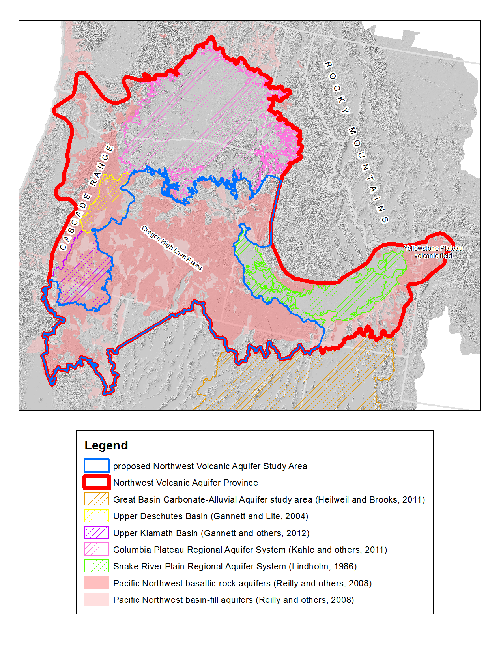
Figure 1: Map showing the extent of the Northwest Volcanic Aquifers Province (NVAP). The proposed Northwest Volcanic Aquifers Study Area (NVASA) is surrounded by previous USGS groundwater study areas (hash-marked polygons). The NVASA covers most of the understudied parts of the Pacific Northwest basaltic-rock aquifers (as shown by Reilly and others (2008)).
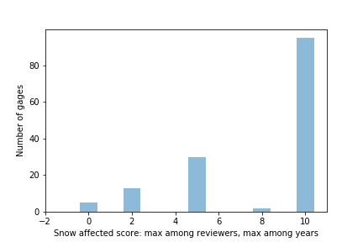
Figure 2: Histogram of the 145 high-quality gages that were rated as snow affected (score = 0 is not affected; score = 5 is moderately affected; and score = 10 is strongly affected).

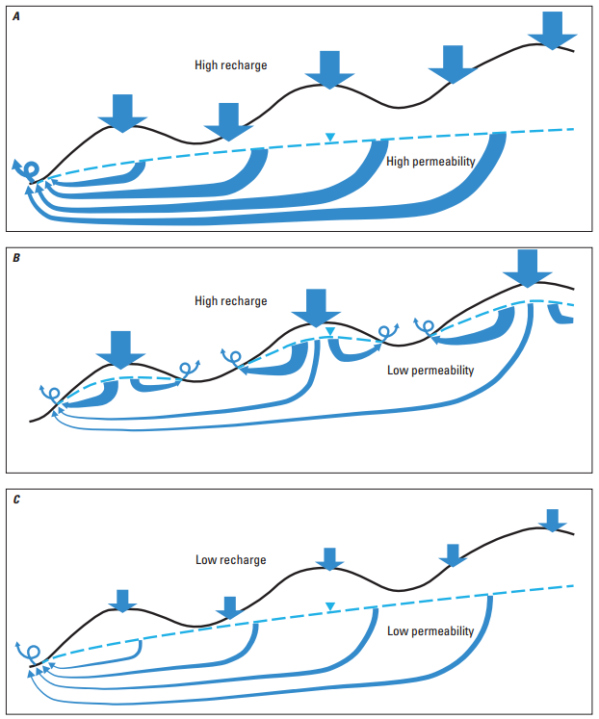
Figure 3: Schematic diagram illustrating why spring density and flow rate is a function of groundwater recharge rate and permeability. (A) For high recharge rates in high permeability terrain, groundwater flows long distances discharging to high volume springs with sustained flows year-round. (B) For high recharge rates and low permeability terrain, most groundwater flow discharges near the recharge area many relatively small springs with high annual variability in stream flow rate. A small fraction of groundwater flow may travel great distances, depending on connectivity in the deeper subsurface (shown by thin deep arrows with question marks to emphasize the possibility that deep connectivity may not exist). (C) For low recharge rates in low permeability terrain, fewer springs occur than under the high recharge condition (i.e., panel (B)) because recharge rate does not exceed the capacity of the aquifer to transmit the lower rate of groundwater flow over long distances, resulting in a lower density of small springs.

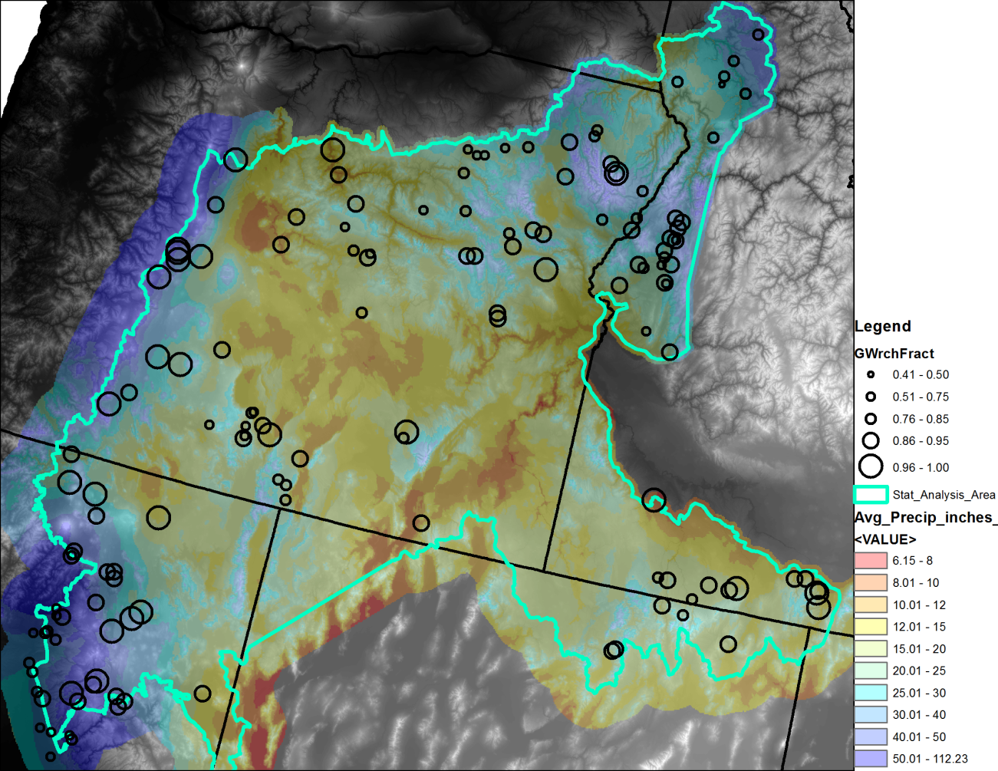
Figure 4: Location map showing the study area extent, average annual precipitation for 1980-2013, and the fraction of available water that infiltrates to groundwater. High precipitation areas of the northwest have a larger fraction of available water infiltrating to groundwater, compared to the northeastern high precipitation areas.
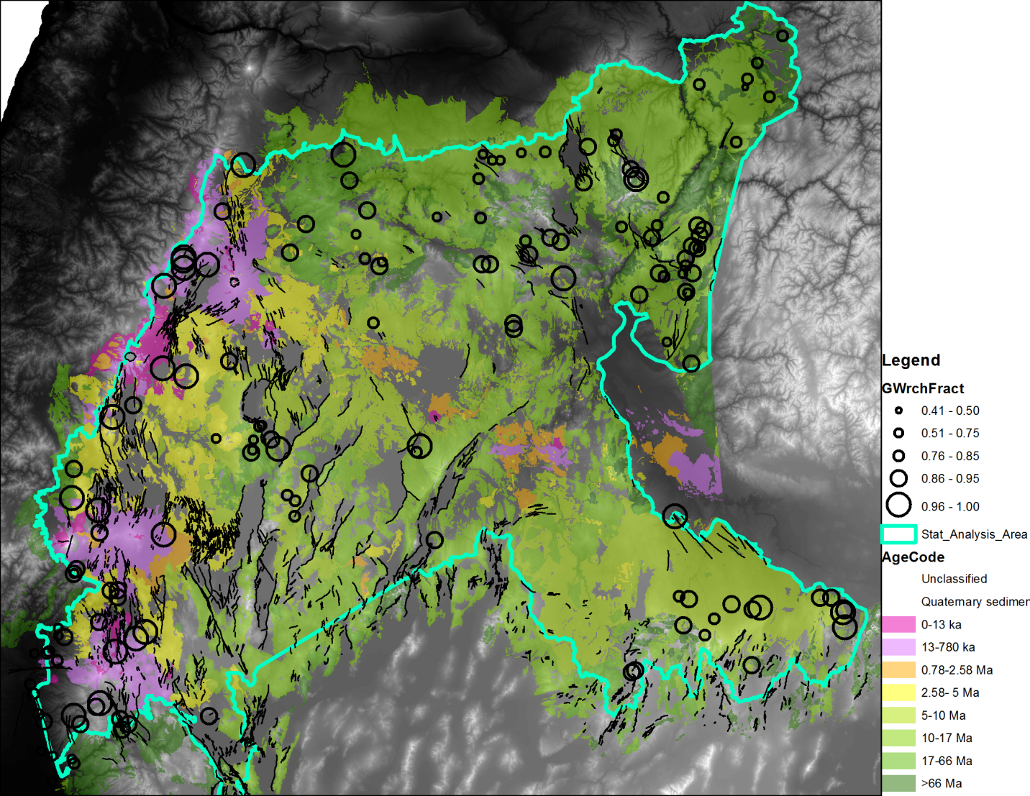
Figure 5: Study area geologic age bins with Quaternary faults, overlain with the fraction of water resources that infiltrates to groundwater. Young volcanogenic terrains (geology with age 0-2.58 Ma) are correlated with a higher fraction of available water infiltrating to groundwater. In the older terrains (>5 Ma), groundwater infiltration is generally less, but there are some exceptions which tend to be nearer quaternary faults.
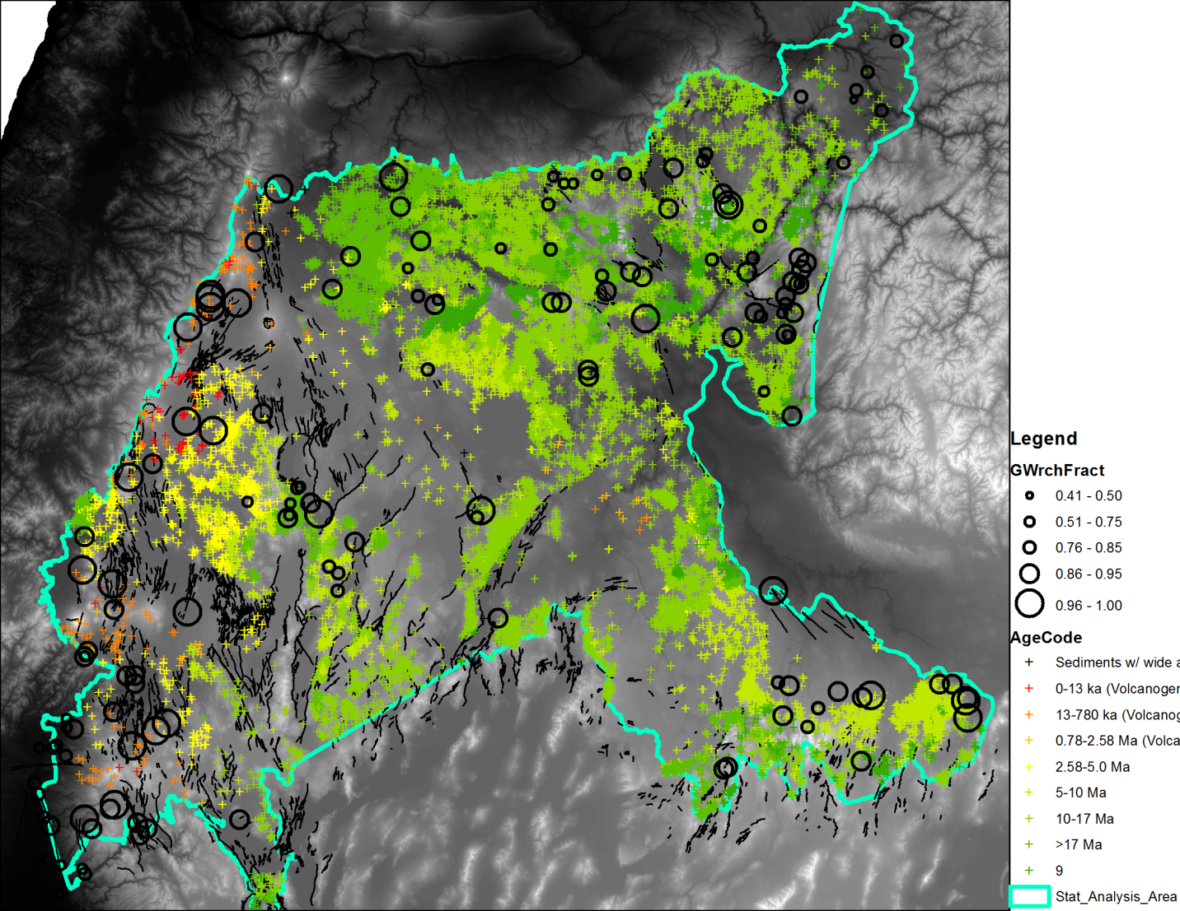
Figure 6: Mapped springs colored by geologic age, overlain with the fraction of water resources that infiltrates to groundwater. Springs fall into three main categories based on physical processes: low density springs in young volcanic terrains (age categories 2-4 in Table 1), and high and low density springs in older terrains (transition from young to old is in the ~2.58-5.0 Ma bin). Springs are most dense in older, less permeable terranes with larger precipitation (Figure 4). These springs tend to have lower flow rates and large seasonal variability. Springs in young terrains tend to be large and lower density, with less seasonality in flow rate, consistent with being fed by permeable regional volcanic aquifers. The lower density of springs in dry parts of the study area underlain by older terrains, is the result of the lower precipitation and groundwater recharge rates. See Figure 3 for schematic cross-sections corresponding to the three spring categories.

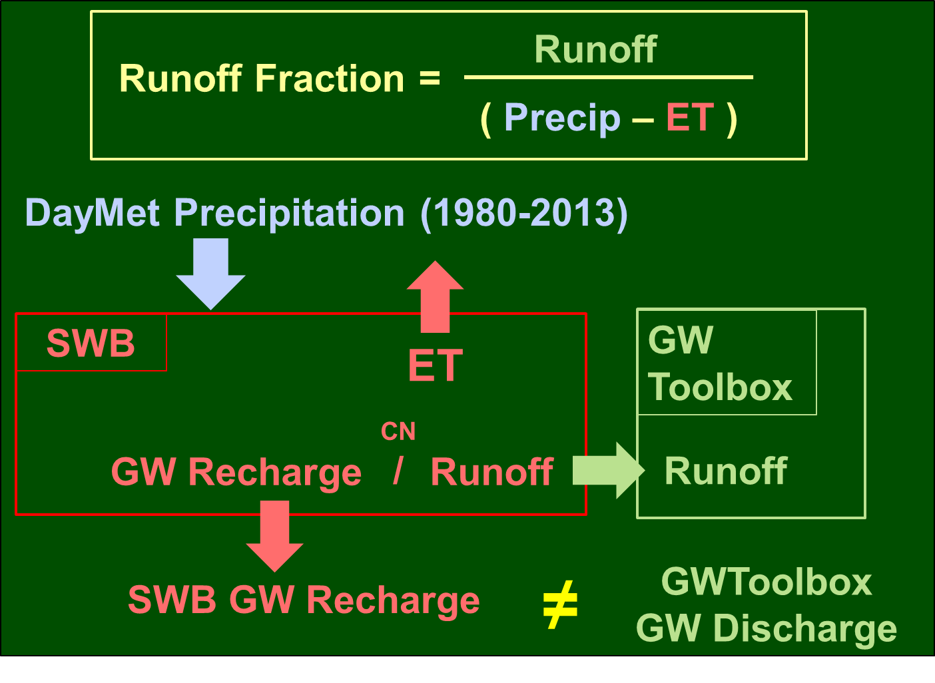
Figure 7: Relationships between datasets and model products from Phase 1 to be used for Phase 2 study. Assuming a large fraction of water does not infiltrate through the stream bottoms above a gage (or that stream infiltration can be estimated), SWB computed runoff should be the same as the runoff component estimated at the stream gage. Because the NVASA has regional groundwater flow components, the same is not true for the SWB groundwater component and the Groundwater Toolbox groundwater component. Because ET is nearly invariant with CN (discovered during Phase 1), SWB CNs could be calibrated to match simulated runoff to Groundwater Toolbox estimated runoff. Preliminary statistical analysis shows that CNs are functions of geologic age and composition.
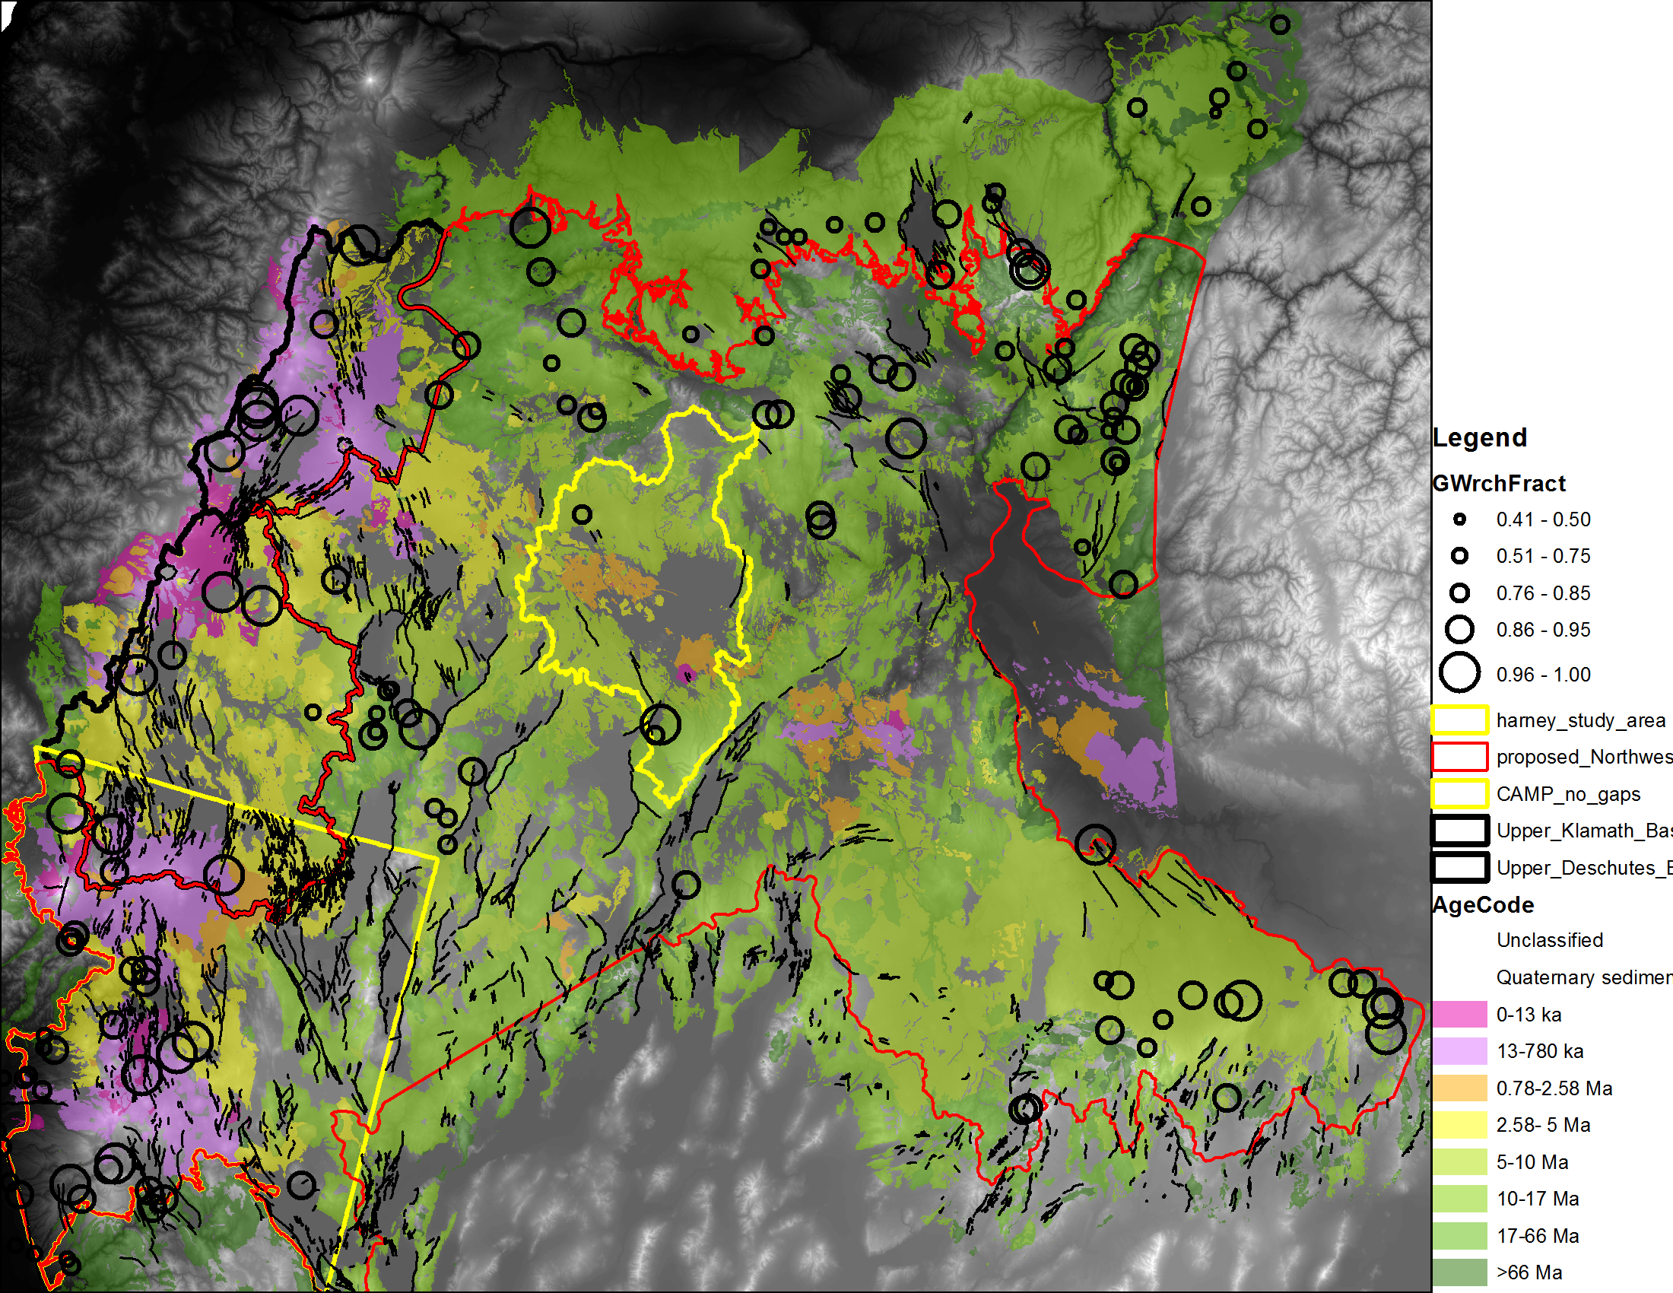
Figure 8: Phase 2 research will continue on the larger NVASA area (red outline), using previous and ongoing research findings from Upper Klamath and Upper Deschutes studies (black outlines), and concurrent research activities in the CAMP area (yellow outline – lower left) and in the Harney Basin cooperative groundwater study area (yellow outline – center).

