Mississippi Alluvial Plain Water Availability Project
Regional Groundwater Availability Projects
FY 2016 End-of-Year Report
(1) PROJECT ACCOMPLISHMENTS/CONTRIBUTIONS (FY 2016)

- Groundwater Level Data Management: A software framework, named visGWSI, to support information query, review, visualization, and statistical analysis of groundwater data was initiated in the last quarter of Fiscal Year 2016 in the R statistical programming language. The visGWSI is a complementary tool to other scripts related to visGWSI needs, the gwtoolbox framework (http://water.usgs.gov/ogw/gwtoolbox/), and local database administrator tools. The visGWSI has a grand objective to process immense full database dumps at combined Water Science Center scales (multiple USGS NWIS-GWSI installations) with anomaly detection capabilities supporting general database cleanup with statistical inference as applicable. Anomalies of primal interest are potentially erroneous water levels in the database. Thus, visGWSI is the major step for rigorous cleanup of the NWIS database. Details are provided below along with background concerning a parallel track of GW Database Informatics.
  - Background and Parallel Path of Code Development: Near exhaustive data table queries (initial data pulls) to GWSI will be made using scripts in R and these tables will be merged into immense rectangular formats for visGWSI processing. A side component of the initial data pulls will be a mixture of site number and location anomaly processing. For example, site numbers not consistent with decimal latitude and longitude position, errors in county name intersection between the spatial location and metadata, and other variants related to cross-reference of spatial information.
  - visGWSI: The visGWSI will not immediately have a graphical-user interface per se, but be designed for full database processing. The visualization is to plot "hydrographs" of the groundwater level data in conjunction with meta data such as total well depth, datum (land surface), screen intervals, and other. The framework will eventually have hooks for insertion of external meta information such as hydrostratigraphic data of the aquifer and preliminary estimates of regional water level surfaces. The framework will help explore potential erroneous metadata as well as potential errors in water level data. The framework will also track attributes of source agency for water level data because multiple cooperators contribute to water level data in the study area. Multiple aquifer codes are also present in the database and the framework should allow for better data exploration than presently available.
Time series processing with visualization and annotation of meta data will be made deliberating on processing master tables of all site ids. For site, anomaly checking of the water levels against available metadata for physical consistency. For example, water levels with altitudes below the bottom opening of a well could be reflective of erroneous data. A host of statistics for the water levels will be computed on yearly, intra- and inter-annual variation, decadal summaries, and trend analyses (Kendall's Tau and other). The trend analyses will be supported by continuous in time regression-like modeling from which outlier detection can be made. Data with extreme residuals to continuous-time trend lines are anomalous and thus more likely to be erroneous or warrant additional scrutiny.
  - Status at End of Fiscal Year 2016: Brian Breaker (Arkansas) with coordination with other personnel has led "background" script development for full database retrieval and packaging into an immense rectangular data structure for the current design needs of visGWSI. Brian has been using a full dump of Ark-GWSI as the test bed. Also a number of cross-referencing elements of spatial location relative to site ids, latitude and longitude, and other spatial metadata has been completed and "log files" of potentially erroneous elements are written for later inspection by local GSWI DB administrators.
William Asquith (Texas) has led visGWSI development with very close coordination with Brian Breaker, Wade Kress (Tennessee), and others. Milestones at end of Fiscal Year 2016 include processing capability against the Ark-GWSI test bed. This includes such milestones as hydrograph visualization for 7,150 wells of some 10,000 wells (wells with one data point or other complications are ignored). In excess of 200,000 measures are processed. Generalized additive model (GAM) with potential seasonal functions (sin/cos) added if sufficient coverage of water-levels within the years provide for a continuous trend line. A second curvilinear trend line is generated by a support vector machine (SVM) statistical approach. Both trend lines have strengths and weaknesses in identify anomalous data. Outliers for both trend types are identified as at or greater than the 99th percentile of the absolute values of the residuals and at least 1 ft absolute deviation from the trend line. visGWSI produces an extensive "log file" of these outliers, and also during the processing by site, "log files" of potentially other erroneous elements are written for later inspection by local GSWI DB administrators. Additional milestones include Kendall's Tau and statistical significance for a monotonic trend in the water levels and host of summary statistics such as counts, means, standard deviations of water levels. Experimental statistical testing of data compatibility between agency source coding of water levels is operational. Further tables of decadal counts, means, and standard deviations of water levels are generated in format suitable for GIS processing.
- Surface water: Development of a science plan for reducing error in the current MERAS model in relation to SW-related components (specifically the SFR module representation of streams in the model). The purpose of this plan is to identify limitations related to the characterization and representation of SW in the current MERAS model and develop a roadmap for addressing limitations in order improve the understanding of groundwater availability. The roadmap consists of four initiatives designed to address four broad scientific questions, primarily using manipulations of existing data. Each initiative includes a write-up describing the problem as well as a list of tasks, presented in order of increasing complexity generally. In addition to the science plan, initial work has been completed regarding draft R-code development for streamflow recession and a dataset representing characterization of streamflow regimes (~200 characteristics) for both period-of-record and decadal periods for streamgages in the MERAS boundary. These initiatives include:
  - Can the number of stream miles be increased and physical characteristics be better described in the SFR network in the MERAS model using existing observations of streams and streamflow?
  - Can error in estimated streamflow and surface-water stage in the MERAS model be constrained using existing surface-water time series?
  - Can existing continuous SW data provide guidance for model calibration related to SW / GW interaction? and
  - Are specific basin categories (certain physical or land-use characteristics) under-represented in the current surface-water dataset?
- Water Budget: This fiscal year, long-term empirical, ground-based estimates of annual average ET, runoff, and recharge were developed within a closed water budget (Figure 1). These estimates and comparisons with remote sensing and field data have been described in submitted publications. Initial comparisons of the ET and recharge data with other methods of estimation for the MAP area have also begun. Having shown the potential for advantageously combining these ground-based estimates with the remote sensing estimates, the process of combination for monthly timescale estimates has begun as well. The monthly timescale work will continue into the next fiscal year.
Preliminary recharge and evapotranspiration (ET) estimates were also obtained from Soil Water Balance model for the period 1980 through 2015. Average recharge over the SWB model area ranged from about 7.5 in/yr in 1981 and 2010 (relatively dry years) to about 16.6 in/yr in 2009 (the wettest year during the period of record. Mean-annual average recharge over the model area (Figure 2) was about 11.4 in/yr, or about 21% of mean-annual precipitation (55.4 in/yr) for the model area during the period of record. Annual ET results varied less during the period of record, ranging from about 20.8 in/yr in 1983 to 23.8 in/yr in 1994, and appear to be less dependent on annual variations in precipitation than recharge. Mean-annual average ET over the model area (Figure 3) was about 22.4 in/yr, about 40% of mean-annual precipitation for the model area during the period of record.
Preliminary mean-annual recharge results from the SWB model were compared to regression-based recharge estimates computed by Meredith Reitz and to the recharge values used in the original MERAS groundwater-flow model (Figure 4). Recent overlapping time periods were used to calculate the mean-annual recharge values from each source: 1980 – 2015 for SWB mean-annual recharge, 2000 – 2013 for the regression-based method, and 1986 – 2007 for the MERAS model. On a mean-annual basis, average SWB-derived recharge results over the model area (11.4 in/yr) are comparable to those derived from the regression-based method (9.8 in/yr), although the spatial distribution of recharge differs between the two methods. However, mean-annual recharge estimates from both SWB and the regression-based method are about 10 times that of the MERAS model (0.9 in/yr average over the model area).
- Data Worth and Uncertainty Analysis: The existing MERAS groundwater model (Clark and others 2013) is being used as a tool to evaluate the uncertainty that exists in our ability to forecast future water levels and surface-water groundwater exchange within the Mississippi Alluvial Plain (MAP) region. This effort includes:
  - Develop initial estimates of model forecast uncertainty using FOSM-based analyses.
  - Identify the major contributions to forecast uncertainty, also known as “data worth” analyses.
  - Develop an ensemble of model inputs that capture nonlinearities in the model and can be used in a “self-updating” model framework (FY17 and FY18)

- Modeling Support: Nebraska WSC (NEWSC) is mapping storage depletions for the MAP area, using MERAS model. Depletions to streams and any other important terms included. NEWSC performed initial sensitivity testing and diagnosis using the MERAS model, folder ‘d-MDEQ-base’ version (last 100 stress periods). Modified model was deployed to NEWSC cluster in FY16 and projected to be ~ 50% completed by 30SEP16.

- Geophysical Surveys:

- Project workplan

(2) PROJECT WORKPLAN AND BUDGET FOR FY 2017

- Surface water model
- Water budget: Accurate assessments of groundwater availability in the MAP area include improved estimates of water-budget components such as groundwater recharge. Recharge in the existing Mississippi Embayment Regional Aquifer Study (MERAS) groundwater-flow model, which includes the MAP area, is distributed as a percentage of precipitation for each stress period across 19 zones based on soil type, geomorphology, or surficial geology (Clark and Hart, 2009). External estimates of recharge from numerical models such as the Soil-Water-Balance (SWB) model (Westenbroek and others, 2010) or regression-based methods could provide improved estimates of recharge that are calculated in a manner independent of groundwater-flow-model calibration. These improved estimates of recharge, along with concurrent updates to the streamflow network used in the MERAS model, could be used to update the groundwater-flow model to more accurately represent the groundwater and surface-water flow system(s). Remote sensing data also has potential to uniquely contribute to MAP water availability assessments, due to its high frequency of measurements (days to weeks) useful for monitoring changes through time and the increasing spatial resolution that enables field-scale measurements of water consumption. This fiscal year, work will focus on improving estimates of recharge for driving groundwater models, improving estimates of evapotranspiration (ET) from both the SWB model and remotely sensed data, and measuring the impacts of water use decisions on ET and resulting recharge. Initial work will also be carried out in assessing remote sensing methods for measuring groundwater storage change.
  - Recharge is the key water budget component that drives the Mississippi Embayment Regional Aquifer System (MERAS) model that simulates groundwater flow under different water use scenarios in the Mississippi Embayment. Accuracy in these recharge estimates translates directly into accuracy in the groundwater flow predictions, so recharge is a major focus in the effort to better understand regional groundwater flow. Recharge is however difficult to measure directly. There are several options for modeling recharge, but uncertainties in theory and in input datasets result in a range of estimates that when used as groundwater model inputs result in differing predictions for groundwater availability. Comparing, refining, and testing estimates of recharge will show significant benefits in the accuracy of these groundwater flow predictions.
The MAP team has expertise in various methods that can contribute and co-operate to improve our understanding of recharge rates and process in the region. The Soil Water Balance model is process-based, and includes modules for incorporating irrigation, soil infiltration, and other relevant water cycle processes. Representations of these processes depend however on coefficients and relationships that can vary from site to site, so that while the SWB model can be a powerful tool for understanding not only bulk water budget numbers, but the contributions of individual processes, it needs to be calibrated and adjusted to site-specific data, and compared with other methods to ensure accurate representation of the various rates of water exchange. It also requires data to be available at a daily timestep, so that it can be run back to 1980, but further extensions require strong assumptions linking recharge directly to precipitation.
The remote sensing-based water budget work will not be process-based, but will rely on independent data from remote sensing and stream gages, and will provide a data-based comparison for the SWB model for the modern time period. Then, SWB results from 1980-2015 and remote sensing results from 2003-2013 will be used to constrain regression-based methods that rely on monthly-timescale data available back to 1895. By iterating between the three methods, we will be able to (1) understand the MAP’s active water cycle processes (and their dependencies) within a SWB model that has been tested and refined through comparison to independent data sources, and (2) develop estimates for recharge that date back to 1895.
  - Back-casting of recharge estimates - The modern timescale estimates developed using remote sensing data sources will then be used to calibrate relationships that rely only on data types for which we have long-term records for the past and eventually also climate projections for the future (such as temperature and precipitation). Applying these regressions to the past will allow us to back-cast groundwater models and test their results against known events such droughts, and also to estimate groundwater availability through the next century. Such estimates will be directly useful for long-term planning for resource sustainability. These estimates will include irrigation estimates through time for the MERAS region back through 1900 that have already been compiled for running the MERAS model, with groundwater pumping records back to the 1920s. An alternate approach involving estimating recharge as a straightforward percentage of precipitation, rather than within the context of a closed water budget, will also be explored. This fiscal year, we anticipate the production of preliminary back-casting predictions, with the results to be published in FY 2018.
  - Water Use Effects on Water Availability - As the sustainability of groundwater resources becomes a matter of concern, more data is needed to understand quantitatively how water use decisions impact the water available for future use. The primary purpose of groundwater pumping in the MAP is agricultural irrigation. Some of the water used for irrigation recycles back into the local water system through runoff and recharge, but the majority of this water is lost from the system to evapotranspiration. Quantifying the rate of evapotranspiration in irrigated areas will be a way to quantify irrigation efficiencies for different irrigation methods and crop types.
Remote sensing ET data are available at 30m resolution, which will allow us to distinguish between individual fields [Allen et al., 2007]. We will compare this remote sensing ET data with USGS water use databases in the MAP, such as the Arkansas database compiled by MAP colleague Drew Westerman, to draw conclusions about efficiencies of different irrigation methods and crop types. Study sites will be preferentially selected in locations where the Agricultural Research Service is establishing ET flux towers, so that field data comparisons or calibrations can be made. This study of the irrigation water loss efficiency of different irrigation methods and crop types will be useful for establishing best practices for irrigation methods, or long-term crop type planning. This work will be initiated this FY, to be completed either late this FY or early in FY2018.
  - Remote Sensing and Groundwater - The GRACE (Gravity Recovery And Climate Experiment) satellites measure fine changes in the Earth’s gravitational field primarily caused by changes in water storage, and have been collecting monthly data since 2002. A significant portion of these water storage changes can be attributed to changes in groundwater storage, and a great deal of recent attention has been paid to the potential for GRACE to be a useful monitor of groundwater storage fluctuations and long-term trends. On a monthly timescale, the data show a strong seasonal signal in water storage, and have the potential to provide a powerful tool for groundwater monitoring. These estimates are available at a coarse scale (hundreds of km), involve extensive processing of the raw data, and have shown mixed results in comparisons with field data in various studies [Rodell et al., 2007; Thomas et al., 2016].
Because the GRACE estimates can show significant uncertainties, more work needs to be done to test and calibrate the estimates with local data and models before GRACE can be used with confidence as a groundwater monitoring tool for the MAP. Dr. Reitz is a co-PI on a USGS Powell Center project to combine and constrain GRACE data with models and field data. The groundwater of the MAP region is one of the focus areas of this project. The Powell Center working group includes MAP colleague Brian Clark, who will help make comparisons to the MERAS groundwater model. Through comparisons of GRACE with MERAS and available field data, the project will assess whether additional local calibrations are needed for the GRACE data to produce reliable estimates of water storage in the MAP. If these calibrations lead to accurate estimates, GRACE will be a helpful monitor of storage changes and trends through time, and could inform the MERAS model and estimates of water availability (Figure 4). This project initiates this fiscal year, and will be completed in FY2018. We anticipate a publication and data release in FY2018 centered on comparisons of GRACE with models and data on groundwater storage change in the MAP.

- Groundwater level data management: The Mississippi Alluvial Plain project encompasses parts of seven states (Illinois, Missouri, Kentucky, Tennessee, Arkansas, Mississippi, Louisiana). These states are part of four USGS Water Science Centers (WSC): Illinois, Indiana-Kentucky, Lower Mississippi-Gulf, and Missouri. Due to the distributed configuration of the National Water Information System (NWIS), data for the MAP project is distributed across 7 NWIS servers in the four centers. Management of new and existing data for the MAP project stored in these databases requires centralized oversight. The Data Manager for the MAP project (Ron Seanor) will coordinate any cleanup tasks with the specialists and DBA’s in each center before committing any changes to the database.
The objectives of this effort are:
  - Create data analytics using visGWSI (described in FY16 accomplishments) to identify inconsistencies in the data from all seven NWIS servers
  - Coordinate and perform updates to the databases to correct missing and inconsistent data
  - Provide a merged dataset from the seven NWIS servers to the principal investigators (PI) for the MAP project
All tasks will focus on sites and data associated with the MAP; however, if the cleanup of identified issues can be automated or completed easily, then changes will be applied to all relevant data. Some, but not all, of the data management activities will include:
- Aquifer Codes – The National Aquifer code can be used as a gross selection criteria for pulling groundwater data specific to the MAP project. However, there were many wells with blank National Aquifer codes identified, along with many that had incorrect National Aquifer codes based on local aquifer codes. In addition, a spatial analysis of well depths and screen intervals against the hydrogeologic framework to further identify incorrect aquifer (both local and national) assignments will be performed.
- Construction and Lithology Data: Well depth, screened intervals, and lithologic descriptions of the primary contributing zone are critical data needed to ensure wells are screened in the Mississippi River alluvial aquifer. An effort will be made to populate missing well depths, screened intervals, and lithologic intervals, if possible.
- Land surface datum altitudes are critical to converting water level, depth, and screen intervals to a common datum for analysis. In 1993, Congress adopted NAVD 88 as the official civilian vertical datum for the United States and instructed all federal agencies to upgrade to the new datum. Currently, within the seven NWIS servers, there are ## wells with land surface datum using NGVD29.
- Water level data, both existing and new data, will be reviewed to identify duplicates and missing metadata, along with a statistical analysis to identify anomalies and outliers. Water levels identified as incorrect or questionable will qualified by setting the water level approval code to “Rejected” to allow PI’s to filter out unusable data.
- Furnished Record - Water level data to be used in the MAP project includes data furnished by state entities (Arkansas, Mississippi, and Missouri). This data has to be formatted and mapped to sites in NWIS, and qualified with the correct metadata before entry into the center databases. In addition, new sites have to be established for the furnished data at sites not currently in NWIS. This data also has to be reviewed and approved.

- Status of the groundwater system: The purpose of this task is to generate water-level and storage changes for the Mississippi River Valley Alluvial Aquifer (MAP) aquifer using generally the same methods as have been used the USGS’s HP Water-Level Monitoring Study. Groundwater withdrawals from the MAP aquifer, like the HP aquifer, are primarily used for irrigation. Tentatively the water-level change maps would be for the period predevelopment (about 1920) to 1970, 1970 to 1980, 1980 to 1990, 1990 to 2000, 2000 to 2010, and 2010 to 2015, but these periods may change and it may not be possible to assemble water-level measurements from the predevelopment period of the MAP aquifer. If it is not possible to assemble predevelopment water levels for the MAP aquifer, a modeled predevelopment water-level surface that was developed for the groundwater availability study of the USGS Mississippi Embayment Regional Aquifer System (MERAS) (Clark and Hart, 2009) may be used to estimate predevelopment water levels.
For this study, one report will be released in Fiscal Year (FY) 2017 and one or more reports will be released in FY 2018. The FY 2017 report will contain one water-level change map and associated estimate of change in storage, in addition to a description of methods used to generate the map and calculate the change in storage; the selected water-level change period for the FY 2017 report will be determined later. In FY 2018, one or more USGS product with the remaining water-level change maps and estimates of storage will be released. All of the water-level data will be prescreened using a method developed by the Will Asquith, Wade Kress, and Ron Seanor.
  - Objectives: To generate maps of water-level changes in the MAP aquifer for specified time periods. The maps will be generated from water-level change data in wells screened only in the MAP Aquifer and measured in the years specified for the map. Water-level data from 1870-1920 and later will be reviewed to determine if sufficient data exists to create develop a predevelopment water-level surface for all or part of the aquifer area. Otherwise the predevelopment water-level surface will be simulated using the groundwater flow model that was developed for the USGS MERAS groundwater availability study (Clark and Hart, 2009) may be used to estimate the predevelopment water level.
The water-level change maps will be generated as rasters, the raster cell size will be determined later, based on well density, but likely will be 50 to 100 meters on each side. Depending on the variation in specific yield over the aquifer area, it may be beneficial to also generate maps of storage change. Another type of map that could be generated is percent change in predevelopment saturated thickness. This proposal includes costs to generate maps of either change in storage or percent change in predevelopment saturated thickness.
  - Deliverables: The study will include a report to be released in FY17 with maps of water-level change and possibly storage change for a period “to be determined” map and one or more reports to be released in FY18 with the maps of water-level and possibly storage change for the remaining periods. The FY17 and FY18 reports will include the maps as figures and requested statistics, which could include area-weighted water-level and storage change by county and in total, as tables. At the same time each report is released, the related datasets as rasters and shape files also will be released. The FY17 report will describe the methods used to generate the maps and statistics. The FY18 report(s) will reference the FY17 report for methodology.
The tentative release date for the FY17 report and datasets is at the end of the 4nd quarter, 2017. The tentative release date for the FY18 report and datasets is at the end of the 3nd quarter, 2018.

- Uncertainty and data worth: The existing MERAS groundwater model (Clark and others 2013) is being used as a tool to evaluate the uncertainty that exists in our ability to forecast future water levels and surface-water groundwater exchange within the Mississippi Alluvial Plain (MAP) region. This effort includes:
  - Develop initial estimates of model forecast uncertainty using FOSM-based analyses (FY17)
  - Identify the major contributions to forecast uncertainty, also known as “data worth” analyses. (FY17)
  - Develop an ensemble of model inputs that capture nonlinearities in the model and can be used in a “self-updating” model framework (FY17 and FY18).

A major task for the MAP project in FY17 is to finalize the FOSM-based uncertainty and data worth analyses started in FY16 and publish the results in a peer-reviewed journal. This publication will describe the procedures and results of the FOSM analyses, including the data worth analysis.

It is anticipated that the results of the FOSM analyses as well as the results of the other investigations that are underway to improve our understanding of the MAP hydrologic system, will culminate in the construction of a new model that will explicitly simulate the relevant features of the MAP. Furthermore, it is expected that this new model will be subjected to uncertainty quantification to provide decision makers with critical information related to the model’s performance. Although the FOSM analyses have provided useful insights into our understanding of potential future conditions of the MAP hydrologic system, the FOSM analyses rely on a linearity assumption. Furthermore, if a new management or climate scenario is to be evaluated, it requires re-completing the entire FOSM process. An alternative approach to uncertainty quantification is to use an ensemble of model inputs to approximate the uncertainty in the model inputs. Once an ensemble of model inputs is found that reproduces the historical hydrologic observations acceptably well, then this ensemble can be used to evaluate any desired scenario that can be codified into the model. Unfortunately, the process of identifying a reasonably-sized ensemble of model inputs that reproduce historical conditions can carry a large computational burden, especially if the model forward run time is long.

To support the new, forthcoming MAP model, we are proposing to develop tools to lessen the computational burden involved in finding an ensemble of “calibrated” model input datasets. We anticipate implementing a new approach to uncertainty analysis borrowed from the petroleum reservoir simulation industry. This new tool will encode a combined Ensemble Smoother (ES)/Ensemble Kalman Filter (EnKF) methodology. The ES approach to uncertainty quantification is a departure from current methods widely used in environmental modeling. Rather than focusing on a single calibration attempt with (occasional) follow-up uncertainty estimation, the ES method propagates an ensemble of several hundred model input datasets simultaneously through the inversion process. At the conclusion of the inversion process, users have a suite of model input datasets that all match the observation data acceptably well. Furthermore, with the ultimate goal of a model that is easily updated, if not “self-updating”, it is anticipated that the ES/EnKF too will facilitate a much lower burden on users and hardware during the update process. Once an ensemble of model inputs is propagated through ES process, the update to the model will only require running the ensemble for the new time period through the EnKF process instead of running the ensemble for the entire period of record (again). This will drastically reduce the effort required to update a model and, if successful, will move the science of modeling at the USGS forward.

We planning to complete initial development of a C++ implementation of the combined ES/EnKF software tool in FY17. This tool will be part of the PEST++ software suite (Welter and others 2015). We anticipate testing and publication will be completed in FY18.

Deliverables: FOSM publication, initial implementation of ES/EnKF tool, presentations as needed, including 2 stakeholder meetings

- Model support:
  - Mapping of storage depletions: for the MAP area, using MERAS model. Continue monitoring / deploying batches of MAP cells to NEWSC cluster until initial batch is complete. QA results and retest cells failing QA as needed (expected less than 20%). Method is primarily to re-run using injection rather than withdrawal. Expecting some QA support from LMGWSC, to be a second set of eyes on the outputs of the model used to do the mapping.
Deliverables: On 20sep16 Steve Peterson, consulted with G. Delin, WSFT, who advised that in accordance with the new memorandum effective 01OCT16, this work could be considered a ‘scenario model’ and in which case the results can be published in a data release. Primary product will a shapefile, with fields containing values to show which layer of the model was tested, and the resulting depletions to storage, MNW, and streams (and possibly the output pumping rate of the cycle test, if desired). Metadata will point to the original source of the model and describe the processing steps (primarily re-running the model for each mapped cells, QA, and re-runs). Barring any unforeseen hurdles, probably can complete primary analysis in October, do the QA runs in November, and it should be reasonable to have a draft of the metadata in the review process by January 2017.
  - Streamflow routing: Input for the SFR package will be developed from GIS layers and attribute information in the National Hydrography Dataset (NHDPlus v2) or similar published hydrography dataset. Construction of the SFR package from the source dataset(s) will be automated using existing python code, in an approach similar to that taken in other current and previous USGS studies. The automation will allow for efficient regeneration of the SFR package if the model grid resolution changes or new stream-related data become available. A suite of diagnostics is also run, to ensure correct specification of routing, streambed elevations, and other common errors.
Deliverables include an SFR package and supporting plots and GIS layers that allow for visualization.
  - Newt solver: Working

- Geophysical surveys:
  - AEM work for FY17 is proposed to be set up so that it can be scaled to match funds as they become available. Study of optimization of the collection of new data for both the groundwater modeling, stakeholder interests, and geophysical characterization has been started in FY16 (Smith and others, 2016) and will be used in FY17 to finalize AEM survey design. Because the total cost of AEM surveys can be high ($50 to $200 per line kilometer depending on area covered), the whole project area of about 78,000 km² cannot be covered in one fiscal year. We propose starting with regional coverage of part of the flood plain supplemented with detailed coverage of the area where augmented recharge is being studied (Figure 1). Ground geophysical studies have already been started in this area. This is a high priority area for the stakeholders since it includes areas of potential enhanced recharge, is located within the zone of depletion, and is in an area of high uncertainty in the groundwater model (White, written comm.). Regional line coverage would either be by blocks as shown in Figure 1 or by a design that covers the whole flood plain with VERY wide line spacing the first year and fill-in lines the subsequent years.
  - Ground geophysics work in FY17 would also include to supplement the existing geophysical coverage, to apply water-borne methods, and to develop a calibration line for AEM surveys to use. Ground geophysical work by the TXWSC and Geophysics Branch would be jointly interpreted and integrated into the AEM survey planning and ultimately interpretation. All of this work would be integrated into the AEM study to develop parameterization of electrical resistivity into hydrologic and lithologic parameters.

- Monitoring: Working

(3) NOTEWORTHY COLLABORATIONS, MEETINGS, TECHNICAL TRANSFER ACTIVITIES, SPIN-OFF PROJECT DEVELOPMENTS, AND ACKNOWLEDGEMENTS
- Lower Mississippi-Gulf Water Science Center participates in Technical Working Group Meeting to update and enhance regional groundwater flow model for the Mississippi Delta. On March 24, LMG WSC Hydrologists, Jeannie Barlow and Connor Haugh participated in a meeting with Mississippi Department of Environmental Quality to review preliminary simulation results for alternative water supply scenarios using an existing regional groundwater flow model developed by the USGS (Mississippi Embayment Regional Aquifer Study). These efforts are part of a project to assess scenarios for conjunctive water management in the Mississippi Delta. For more information, please contact Jeannie Barlow (jbarlow@usgs.gov; 601-933-2984).

- LMG Personnel meet with Local and State Cooperators to roll out New Water Availability Initiative for the Mississippi Alluvial Plain: During the week of April 4, Scott Gain, Bill Wolfe, Richard Rebich, Wade Kress, and Jeannie Barlow met with the Yazoo Mississippi Delta Joint Water Management District, Mississippi Department of Environmental Quality, and Delta Council to discuss a new initiative to assess water availability in the Mississippi Alluvial Plain through coupled monitoring and modeling. The initiative will take advantage of an existing regional groundwater flow model developed by the USGS (Mississippi Embayment Regional Aquifer Study). For more information, please contact Wade Kress (wkress@usgs.gov).

- LMG WSC hydrologist participates in the Blue Stream Task Force Memphis, Tennessee: On April 21, 2016, Michael Bradley, LMG WSC, participated in a meeting of the Environmental Committee of the Memphis Blue Stream Task Force. Michael gave a presentation on the Mississippi Alluvial Plain to the committee, to the staff of Memphis Mayor Strickland, and staff from Memphis Light Gas and Water describing the new investigation evaluating groundwater sustainability. For additional information, contact Michael Bradley at mbradley@usgs.gov.

- Lower Mississippi-Gulf Water Science Center participates in Technical Working Group meeting to develop groundwater flow model scenarios for alternative water supply options in the Mississippi Delta. On April 25, LMG WSC Hydrologists, Jeannie Barlow and Connor Haugh participated in a meeting with Mississippi Department of Environmental Quality and the U.S. Army Corp of Engineers to discuss assumptions for the development of alternative water supply scenarios using an existing regional groundwater flow model developed by the USGS (Mississippi Embayment Regional Aquifer Study). These efforts are part of a project to assess scenarios for conjunctive water management in the Mississippi Delta. For more information, please contact Jeannie Barlow (jbarlow@usgs.gov; 601-933-2984).

- LMG Personnel meet with State of Mississippi Officials to discuss MAP Initiative: On May 3, Wade Kress, Connor Haugh, and Mike Bradley in the Nashville office (via video conferencing), and Richard Rebich in the Jackson office met with officials from the Mississippi Department of Environmental Quality (MDEQ) to discuss the new Mississippi Alluvial Plain (MAP) Initiative. MDEQ personnel included those from both the Office of Land and Water Resources and Office of Pollution Control. Topics discussed included future monitoring plans for both surface water and groundwater systems in the MAP, updates to the Mississippi Embayment Regional Aquifer Study (MERAS), and use of non-traditional data collection techniques such as Electromagnetic Surveys planned for the MAP Initiative. For more information, contact Wade Kress (wkress@usgs.gov).

- LMG Personnel meet with State of Mississippi Officials to discuss Groundwater and Surface-water Datasets for Mississippi Alluvial Plain Water Availability Initiative: On May 16, Richard Rebich, Wade Kress, and Jeannie Barlow met with Mississippi Department of Environmental Quality officials to discuss FY16 data collection efforts and assess available datasets as part of the Mississippi Alluvial Plain initiative. The initiative will take advantage of an existing regional groundwater flow model developed by the USGS (Mississippi Embayment Regional Aquifer Study). For more information, please contact Wade Kress (wkress@usgs.gov; 615-837-4763).

- USGS, MRCTI, UMRBA, and TNC meet to discuss common science interest and collaboration: May 23, 2016, USGS staff from the Midwest Region and the Lower Mississippi Gulf Water Science Center met with representatives from the Mississippi River Cities and Towns Initiative, Upper Mississippi Basin Association, and The Nature Conservancy to discuss collaboration and common interests between the agencies. A brief description of the MAP project was provided to the group. Attending from the USGS were Michael Bradley, Lower Mississippi Gulf Water Science Center, Amy Beussink Director, Missouri Water Science Center, Bob Swanson, Director Nebraska Water Science Center, Scott Morlock, Deputy Regional Director for Science Midwest Region, Dr Leon Carl, Regional Director, Midwest Regions, and Mark Gaikowski and Jeff Houser with the Upper Midwest Environmental Sciences Center. Key areas of common interest include nutrient and sediment monitoring along the Mississippi, ecosystems, drought and water supply, and harmful algal blooms. For more information, contact Michael Bradley, mbradley@usgs.gov

- USGS and USACE Vicksburg: On May 27, 2016, Wade Kress and Jeannie Barlow met with Dave Johnson from the USACE in Vicksburg to discuss the proposed engineering projects in the Delta to provide additional water resources and how the upcoming water-borne resistivity surveys in the Tallatchie, Quiver, and Sunflower Rivers could be used to evaluate these potential projects.

- Lower Mississippi-Gulf Water Science Center Research Hydrologist participates in Mississippi Delta Sustainable Water Resources Task Force Management Meeting: On May 31, Jeannie Barlow attended the Mississippi Delta Sustainable Water Resources Task Force Management meeting and presented an update on the application of a regional groundwater flow model (MERAS) to assess alternative water supply scenarios for the Mississippi Delta as well as an overview of the Mississippi Alluvial Plain Water Use and Availability project. The USGS is presently working in cooperation with the Mississippi Department of Environmental Quality to update and refine an existing regional groundwater flow model in order to assist the Task Force in understanding and managing water resources within the Delta region. For additional information contact Jeannie Barlow (jbarlow@usgs.gov).

- Lower Mississippi-Gulf Water Science Center participates in Mississippi Delta Sustainable Water Resources Task Force meeting: On June 23, Richard Rebich, Wade Kress, and Jeannie Barlow attended the Mississippi Delta Sustainable Water Resources Task Force Management meeting and presented an update on the application of a regional groundwater flow model (MERAS) to assess alternative water supply scenarios for the Mississippi Delta as well as an overview of the Mississippi Alluvial Plain Water Use and Availability project. The USGS is presently working in cooperation with the Mississippi Department of Environmental Quality to update and refine an existing regional groundwater flow model in order to assist the Task Force in understanding and managing water resources within the Delta region. For more information, please contact Wade Kress (wkress@usgs.gov; 615-837-4763).

- Mississippi Alluvial Plain project works with local stakeholders to kick off geophysical field collection effort. On Monday June 19, scientists from the Office of Groundwater, Branch of Geophysics and the New England, Texas, and Lower-Mississippi Gulf Water Science Centers arrived in the Mississippi Delta to kick off a new geophysical data collection effort taking place this summer in the Mississippi Delta as part of the Mississippi Alluvial Plain (MAP) project. Geophysical survey locations were identified by working closely with several stakeholders in the Mississippi Delta, including Delta F.A.R.M, Yazoo Mississippi Delta Joint Water Management District, and Mississippi Department of Environmental Quality. The MAP project is a new initiative designed to assess water availability in the Mississippi Alluvial Plain through coupled monitoring and modeling. The initiative will take advantage of an existing regional groundwater flow model developed by the USGS (Mississippi Embayment Regional Aquifer Study). For more information, please contact Wade Kress (wkress@usgs.gov; 615-837-4763).

- Missouri Water Science Center meets with Southeast Missouri Regional Water District to discuss possible joint groundwater project and brief District on Mississippi River Alluvial Plan study: On July 18 Director Amy Beussink, and John Schumacher attended a board meeting of the Water District. The District provided the USGS an update on their progress toward a possible cooperative groundwater quality study and indicated they were planning on installing dedicated monitoring wells during 2016-17 for groundwater sampling. The USGS provided the District an update on the USGS MAP study and information on a small water-level effort done in southeast Mo for the MAP study during May, 2016. For more information, please contact Amy Beussink (ambeussi@usgs.gov, 573-308-3665) or John Schumacher (jschu@usgs.gov, 573-308-3678).

- Lower Mississippi-Gulf Water Science Center meets with new interim director of the Yazoo Mississippi Delta Joint Water Management District: On July 18, Richard Rebich and Jeannie Barlow met with Jimmy Palmer, recently selected interim director of YMD, along with Mark Stiles (YMD Technical Director) and representatives from USDA-ARS in Oxford, MS. The meeting focused on continued collaboration regarding water availability and quality studies within the Mississippi Delta. For more information, please contact Richard Rebich (rarebich@usgs.gov; 601-933-2928).

- Lower Mississippi-Gulf Water Science Center participates in Delta Council meeting on alternative water supply options for the Mississippi Delta: On July 19, Jeannie Barlow presented an update on modeling and related monitoring activities in the Mississippi Delta at a meeting held by Delta Council in Stoneville, MS. The USGS is presently working in cooperation with the Mississippi Department of Environmental Quality to update and refine an existing regional groundwater flow model (MERAS) in order to help in understanding and managing water resources within the Delta region. For more information, please contact Jeannie Barlow (jbarlow@usgs.gov; 601-933-2984).

- Lower Mississippi-Gulf Water Science Center presents at Yazoo Mississippi Delta Joint Water Management District monthly board meeting: On July 20, Jeannie Barlow attended YMD's monthly board meeting and presented an overview of the Mississippi Alluvial Plain Water Use and Availability project and preliminary results from a recent geophysical data collection effort completed in the Mississippi Delta. For more information, please contact Wade Kress (wkress@usgs.gov; 615-837-4763).

- Lower Mississippi-Gulf Water Science Center participates in Mississippi Delta Sustainable Water Resources Task Force Meeting: On August 11, Richard Rebich, Wade Kress, and Jeannie Barlow attended the Mississippi Delta Sustainable Water Resources Task Force Management meeting. Barlow presented preliminary results from a regional groundwater flow model (MERAS) for several alternative water supply scenarios for the Mississippi Delta. Kress presented preliminary results from a recent geophysical data collection effort completed in the Mississippi Delta as part of the Mississippi Alluvial Plain Water Use and Availability project. The USGS is presently working in cooperation with the Mississippi Department of Environmental Quality to update and refine an existing regional groundwater flow model in order to assist the Task Force in understanding and managing water resources within the Delta region. For more information, please contact Jeannie Barlow (jbarlow@usgs.gov; 601-933-2984) or Wade Kress (wkress@usgs.gov; 615-837-4763).

- LMG Personnel meet with Arkansas Stakeholders to discuss the Mississippi Alluvial Plain Project: On August 26, 2016, Wade Kress, Bill Wolfe, Tim Kresse, Phil Hays, and Billy Justus met with stakeholders from Arkansas to discuss the new USGS groundwater availability project focused on the Mississippi Alluvial Plain (MAP) aquifers. Wolfe opened the meeting with an introduction discussing the newly formed LMG WSC and an overview on how the MAP project was initiated. Kress provided a presentation discussing the 2016 scope of work as well as an overview of the preliminary findings. After the presentation, we opened the floor to discuss local water availability needs within the alluvial plain of Arkansas. Stake holders that attended this meeting were: USACE-LR, ADEQ, USFWS, ANRC, BWD, AGFC, ADH, ASDA-ARS, AGS, and USDA-ASU. For more information, please contact Wade Kress (wkress@usgs.gov; 615-837-4763) or Bill Wolfe (wjwolfe@usgs.gov; 615-837-4756).

- Lower Mississippi-Gulf Water Science Center meets with Yazoo Mississippi Delta Joint Water Management District and Mississippi Department of Environmental Quality to discuss FY17 water availability monitoring plans in the Mississippi Delta: On September 7, Jeannie Barlow attended a meeting with directors from YMD and MDEQ to discuss continued collaboration on the collection of water-level and water-use data within the Mississippi Delta. Data collected in the Mississippi Delta will support ongoing local and regional efforts to better understand and manage water resources within the Mississippi Alluvial Plain. For more information, please contact Jeannie Barlow (jbarlow@usgs.gov; 601-933-2984) or Wade Kress (wkress@usgs.gov; 615-837-4763).

- Lower Mississippi-Gulf Water Science Center meets with U.S. Army Corp of Engineers, Vicksburg District to discuss FY17 groundwater-streamgage network in the Mississippi Alluvial Plain: On September 13, Richard Rebich, Wade Kress, and Jeannie Barlow attended a meeting with USACE, Vicksburg District to discuss plans for the continuation and expansion of the groundwater-streamgage network within the Mississippi Alluvial Plain. Data collected will support ongoing local and regional efforts to better understand and manage water resources within the Mississippi Alluvial Plain. For more information, please contact Jeannie Barlow (jbarlow@usgs.gov; 601-933-2984) or Wade Kress (wkress@usgs.gov; 615-837-4763).

- Lower Mississippi-Gulf Water Science Center meets with Yazoo Mississippi Delta Joint Water Management District and USDA-ARS to discuss FY17 water-level monitoring and analysis plans in the Mississippi Delta: On September 13, Wade Kress and Jeannie Barlow attended a meeting with YMD and USDA-ARS to discuss continued collaboration on the collection and analysis of water-level data within the Mississippi Delta. Data collected in the Mississippi Delta will support ongoing local and regional efforts to better understand and manage water resources within the Mississippi Alluvial Plain. For more information, please contact Jeannie Barlow (jbarlow@usgs.gov; 601-933-2984) or Wade Kress (wkress@usgs.gov; 615-837-4763).

- Missouri Water Center meets with Missouri Department of Natural Resources Water Resources Center to discuss USGS Mississippi River Alluvial Aquifer Study: On September 29, 2016 Center Director Amy Beussink briefed Andrea Collier, Director of Missouri DNR Water Resource Center, on the kick-off meeting for MAP project. For more information, please contact Amy Beussink (ambeussi@usgs.gov, 573-308-3665).
(4) Report Products, Bibliographic Update, Data Releases, and Groundwater-Model Archives

To initiate communication of the MAP project science objectives with our colleagues, members from the MAP project team delivered three presentations at the USGS national groundwater conference. We also have three approved abstracts for the fall meeting of the American Geophysical Union. Several stakeholders indicated that they are very interested in having access to data that are being compiled or collected as a result of this releases

- USGS Groundwater Conference:
Haugh, C.J., and Barlow, J.R.B., 2016, Water availability in the Mississippi River alluvial plain: Scenario modeling for water management. Talk presented by Connor Haugh at 2016 USGS National Groundwater Workshop in Reno, NV.

Ladd, D.E., Reitz, M., Clark, B.R., and Bradley, M.W., 2016, Evaluation of recharge and evapotranspiration estimation methods in the Mississippi Alluvial Plain. Talk presented by David Ladd at USGS National Groundwater Workshop in Reno, NV.

Reitz, M., W. Sanford, and G. Senay (2016, August). Estimating evapotranspiration, recharge, and runoff for the CONUS from remote sensing, climate, and stream gage data. Talk presented at USGS National Groundwater Workshop in Reno, NV.

- American Geophysical Union, Fall Meeting:
Miller, B.V., Wallace, D.S., Kress, W.H. (2016, December), The Use of Waterborne Resistivity Profiling to Quantify Hydraulic Conductivity of 150 Kilometers of Streambed in the Mississippi Alluvial Plain. AGU Fall Meeting 2016. San Francisco, CA. https://agu.confex.com/agu/fm16/preliminaryview.cgi/Paper177587.html

Smith, B.D., White, J.T., Kress, W.H., Clark, B.R., Minsley, B.J., Barlow, J.R. (2016, December), Using FOSM-based data worth analyses to design geophysical surveys to reduce uncertainty in a regional groundwater model update. AGU Fall Meeting 2016. San Francisco, CA. https://agu.confex.com/agu/fm16/preliminaryview.cgi/Paper150272.html

Reitz, M., W. Sanford, G. Senay, W. Kress, and D. Ladd (2016, December). Development of monthly water budget estimates for the CONUS and application to the Mississippi Alluvial Plain. Talk or poster to be presented at American Geophysical Union annual meeting, San Francisco, CA. https://agu.confex.com/agu/fm16/preliminaryview.cgi/Paper187726.html

- Science Base Data Release:
Miller, B.V., Wallace, D.S., Kress, W.H., 2016, Water-borne continuous resistivity profiling data from select streams in the Mississippi Delta region: U.S. Geological Survey data release. (in review)

Westerman, Drew. A., Kresse, Timothy. K., and Kress, Wade H. 2016, Groundwater Quality of the Mississippi Alluvial Plain; Missouri, Tennessee, Arkansas, Mississippi, and Louisiana: U.S. Geological Survey data release. (in review)

(5) PROJECT TEAM DIRECTORY FY16/17
- Project Management
  - Wade H. Kress, Lower Mississippi Gulf Water Science Center, 615-837-4763, wkress@usgs.gov, Hydrologist, MAP Project Manager
- Geophysics
  - Bruce Smith, Crustal Geophysics and Geochemistry Science Center, Geophysicist, bsmith@usgs.gov, 303-236-1399, Geophysicist, Lead scientist for geophysical methods
  - Scott Ikard, Texas Water Science Center, 512-927-3513, sikard@usgs.gov, Geophysicist, Surface geophysical methods
  - Carole Johnson, Office of Groundwater – Branch of Geophysics, 860-487-8802, cjohnson@usgs.gov, Hydrologist, Borehole geophysical logging
  - Eric White, Office of Groundwater – Branch of Geophysics, 860-487-8802, eawhite@usgs.gov, Hydrologist, Surface geophysics
  - Benjamin Miller, Lower Mississippi Gulf Water Science Center, 615-837-4730, bvmiller@usgs.gov, Physical Scientist, Surface geophysics
  - David Wallace, Texas Water Science Center,
- Water Budget
  - Meredith Reitz, National Research Program, 703-648-5834, mreitz@usgs.gov, Research Physical Scientist, Lead Scientist for water budget
  - Rodney Knight, Lower Mississippi Gulf Water Science Center, 615-837-4731, rrknight@usgs.gov, Research Hydrologist, Surface water trends
  - Brian Breaker, Lower Mississippi Gulf Water Science Center, 501-228-3627, bbreaker@usgs.gov, Surface Water Specialist, Surface water trends
  - William Asquith, Texas Water Science Center, 806-392-4148, wasquith@usgs.gov, Research Hydrologist, Statistical analysis of surface and groundwater
  - David Ladd, Lower Mississippi Gulf Water Science Center, 615-837-4773, deladd@usgs.gov, Hydrologist, Water budget analysis
  - Virginia McGuire, Nebraska Water Science Center, 402-416-9836, vlmcguir@usgs.gov, Groundwater level trends and storage change
  - Drew Westerman, Lower Mississippi Gulf Water Science Center, 501-228-3643, dawester@usgs.gov, Hydrologist, Water use
  - Ronald Seanor, Lower Mississippi Gulf Water Science Center, 318-251-9630, rcseanor@usgs.gov, Hydrologic Technician, Groundwater database evaluation and revision
- Modeling
  - Brian Clark, Lower Mississippi Gulf Water Science Center, 479-442-4888, brclark@usgs.gov, Hydrologist, Lead scientist for groundwater flow modeling
  - Steve Peterson, Nebraska Water Science Center, 402-328-4151, speterson@usgs.gov, Hydrologist, Groundwater modeling
  - Jeremy White, Texas Water Science Center, 512-927-3585, jwhite@usgs.gov, Data worth and uncertainty analysis
  - Andrew Leaf, Wisconsin Water Science Center, 608-821-3912, aleaf@usgs.gov, Hydrologist, Streamflow Routing (SFR)
  - Amanda Flynn, Nebraska Water Science Center, 402-328-4144, aflynn@usgs.gov, Physical Scientist, Groundwater modeling
- Hydrogeologic Framework
  - Rheannon Heart, Lower Mississippi Gulf Water Science Center, 501-228-3664, rmhart@usgs.gov, Hydrologist, Hydrogeologic Framework – Aquifer Properties
  - Burke Minsley, Crustal Geophysics and Geochemistry Science Center, 303-236-5718, bminsley@usgs.gov, Research Geophysicist, Geophysical modeling and interpretation
  - John Lane, Office of Groundwater – Branch of Geophysics, 860-487-8802, jwlane@usgs.gov, Hydrologist, Integration of geophysics into groundwater flow model
  - Courtney Killian, Lower Mississippi Gulf Water Science Center, 601-933-2900, ckillian@usgs.gov, Hydrologist, Surface and Groundwater Exchange
  - Dennis Woodward, Emeritus, 303-236-1479, woody@usgs.gov, Hydrologist, Hydrogeologic framework
  - Samantha Wacaster, Lower Mississippi Gulf Water Science Center, 501-228-3639, Student Trainee Hydrology, srwacaster@usgs.gov, GIS support

(6) PHOTOS, ANIMATIONS, AND GRAPHICS
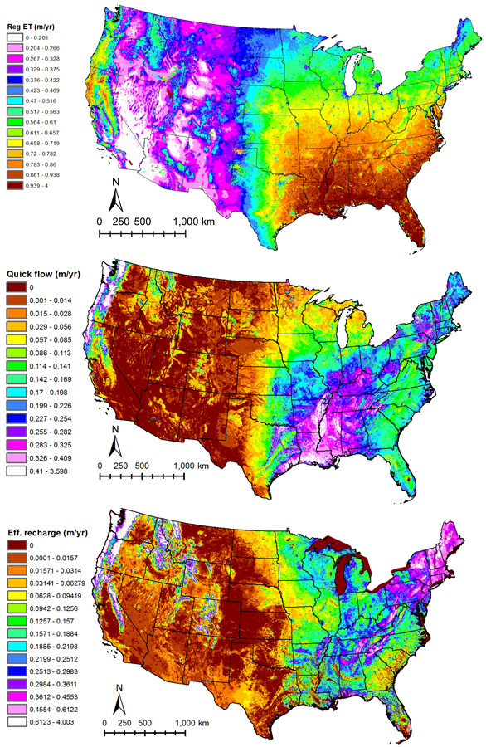
Figure 1. 2000-2013 average annual water budget components for evapotranspiration, quick-flow runoff, and effective recharge (base flow). Preliminary data in review for publication.
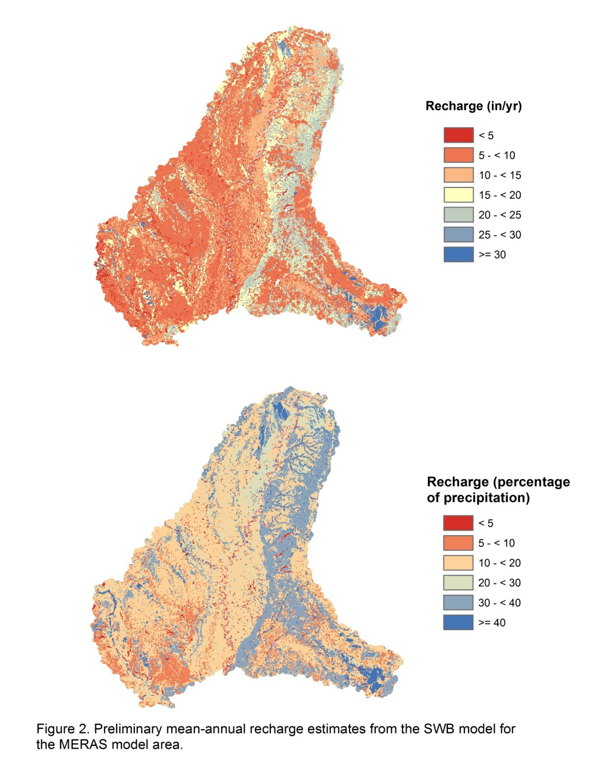
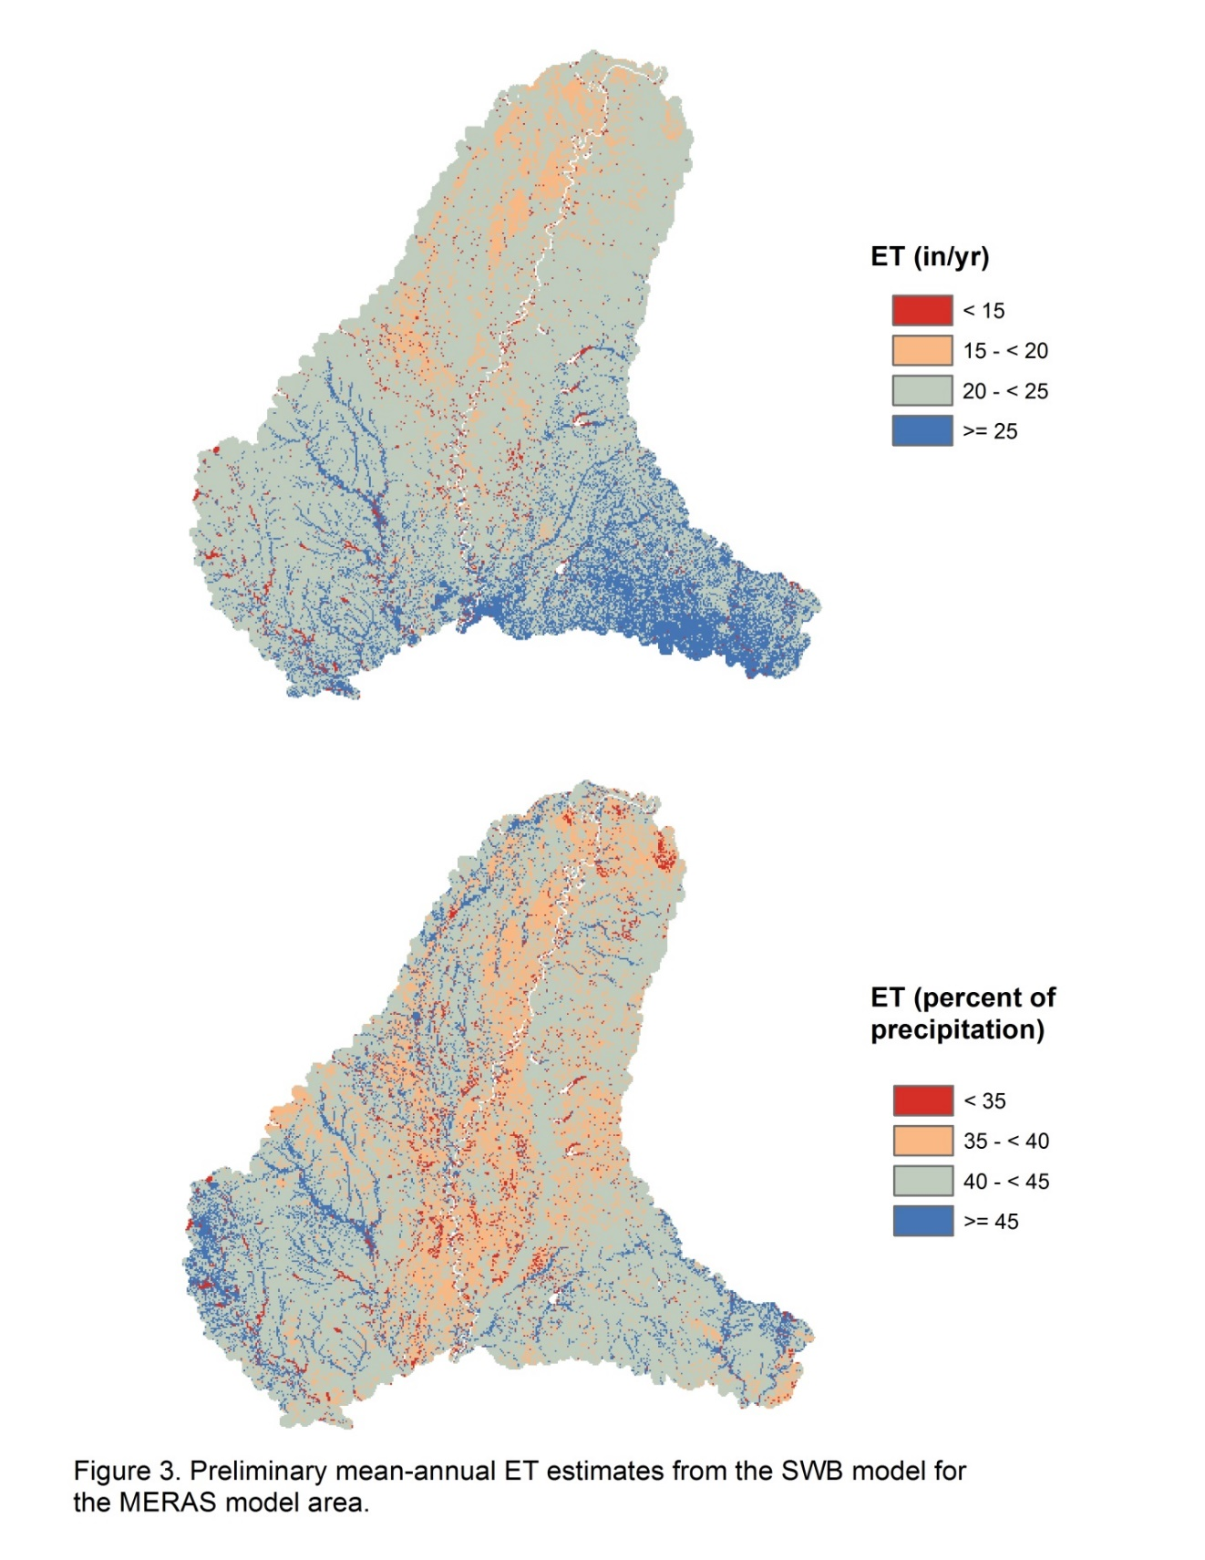
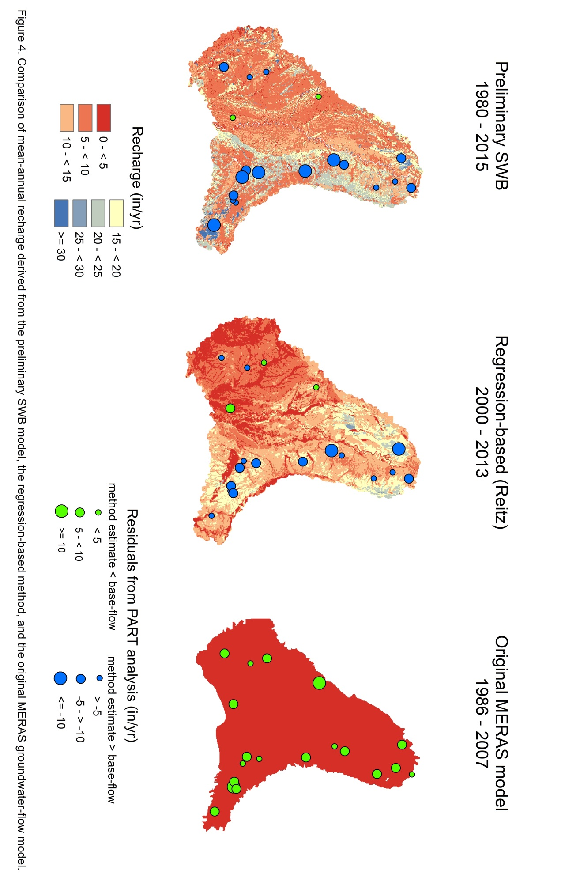
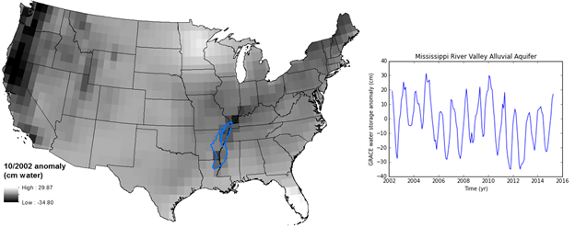
Figure 5. The Mississippi River Valley Alluvial Aquifer outlined against a background of an example GRACE grid from October 2002, using averaged CSR, JPL, and GFZ data sets processed using the scale factors of Landerer and Swenson (2012). To the right are trends in GRACE total water storage change through time within the MRVA area.

