Water Availability and Use Science Program
Hawai‘i Volcanic Aquifer Study FY 2017 End-of-Year Report
Hawaii’s Volcanic Aquifers supply freshwater to 1.4 million people, a large component of the U.S. military in the Pacific, and diverse industries. The objective of the Hawai‘i Volcanic Aquifer Study, one of the regional groundwater availability assessments of the Water Availability and Use Science Program, is to update understanding of groundwater availability in Hawai‘i’s aquifers. The study is being conducted by the United States Geological Survey (USGS) Pacific Islands Water Science Center (PIWSC) in Honolulu, Hawai‘i. Fiscal Year (FY) 2017 was the fifth year of the study.
1. PROJECT ACCOMPLISHMENTS/CONTRIBUTIONS IN FY 2017

USGS Revised Recharge Estimates for Kaua‘i, O‘ahu, and Maui
Accurate recharge
The ultimate source of freshwater to Hawaii’s aquifers is groundwater recharge. USGS has been a leader in providing recharge estimates for the Hawaiian Islands since the 1990s. The Hawai‘i State Commission on Water Resources uses the estimates to set sustainable yields for the islands. Other diverse entities, including municipal water systems, researchers, educators, developers, and conservation groups, also rely on the recharge estimates. In FY 2017, the Hawai‘i Volcanic Aquifer Study revised recharge estimates for Kaua‘i, O‘ahu, and Maui, that had originally been published in FY 2016. The revised estimates include various historically significant time periods, including (1) a predevelopment period before the first modern well was drilled in 1879, (2) 1978-2007 when the islands underwent a significant change in agriculture, and (3) 2001-2010, which represents current conditions. The estimates show how groundwater recharge has changed as a result of human activities on the land surface, such as deforestation, the change from subsistence agriculture to large-plantation agriculture, and the change from large-plantation agricultural to urban and other land uses. Geospatial data sets of the recharge estimates will be made available on the web so that anyone can use them in their analysis or research.

USGS Revised Groundwater Models using revised Recharge
The Hawai‘i Volcanic Aquifer Study initially created computer groundwater models of Kaua‘i, O‘ahu, and Maui in FY 2016; however, because the accuracy of models depends on accurate input data, the models were recalibrated in FY 2017 using the revised groundwater recharge described above. The models are designed to quantify the consequences of groundwater withdrawals. Preliminary model simulations indicate that historical withdrawals have caused various impacts depending on geologic and hydrologic conditions. In some areas, such as the heavily used Pearl Harbor Aquifer, groundwater withdrawals have resulted in saltwater rise (figure 1 in Photos, Animations and Graphics [below]). In windward O‘ahu, groundwater withdrawals have resulted in reduced groundwater discharge to streams (figure 2). Withdrawals have also caused lowering of the water table and reductions in fresh-groundwater discharge along the coast. These impacts can translate to limits on how much water can be withdrawn from Hawai‘i’s aquifers to meet future human needs. The models will also be used to examine how changes in future rainfall, land use, and groundwater withdrawals will affect groundwater availability. These models have the potential to substantially change the way groundwater resources are managed in Hawaii.
2. PROJECT WORKPLAN AND BUDGET FOR FY 2018
The work plan for the Hawai‘i Volcanic Aquifer Study has four major tasks:
1. Describe the hydrogeologic framework, quantify the groundwater budgets, and develop conceptual models of groundwater occurrence and flow. (Completed)
2. Construct and calibrate steady-state numerical groundwater-flow models. (Completed, except report)
3. Use the models to assess groundwater resources—how resources have changed as a result of historical human activities and how impacts from human activity may limit groundwater availability in the future.
4. Disseminate project findings through publications, community outreach, professional meetings, and project web pages.
The following subtasks will be completed in FY 2018:

A. Prepare a Scientific Investigations Report (SIR) describing model construction and calibration
Objective—Prepare an SIR describing model construction and calibration. Archive models.
Planned Activities for FY 2018
- Complete draft report
- Submit draft for peer review; revise
- Archive models and data sets
- Submit report for Bureau approval
- Publish SIR and release related data sets
Planned goals/products for FY 2018—Published SIR; archived models and data sets.

B. Use models to assess groundwater availability
Objective—Use calibrated groundwater models to assess groundwater availability for Kaua‘i, O‘ahu, and Maui. Archive models.
Planned Activities for FY 2018
- For Kaua‘i, O‘ahu, and Maui, simulate current and predevelopment conditions and compare results to quantify the water-table decline, saltwater rise, and reduction in discharge to streams and coastal ecosystems resulting from 150 years of historical groundwater withdrawal by humans.
- For O‘ahu, estimate changes in groundwater recharge that are likely to result from rainfall changes (using the most current information from climate modelers) and land-use changes to about mid 21st century. Simulate these changes in the O‘ahu groundwater model to assess the possible impact of climate change and land use on future groundwater availability.
- Work with the Honolulu Board of Water Supply (HBWS) to project the quantity and location of increases in groundwater withdrawal for O‘ahu to about mid 21st century. Simulate these changes in the O‘ahu groundwater model to assess the impact on future groundwater availability.
- Simulate the combined effect of changes in rainfall, land use, and groundwater withdrawal.
- Prepare a bureau-approved draft Professional Paper describing methods of model creation and calibration.
- Archive groundwater models and data sets used in the analysis.
Planned goals/products for FY 2018—Completion of the numerical-model analyses of groundwater availability. Archived groundwater models.

C. Prepare a Professional Paper and summary Fact Sheet describing the results of groundwater-availability analysis.
Objective—Prepare a Bureau-approved draft Professional Paper describing model construction and calibration.
Planned Activities for FY 2018
- Complete draft report
- Submit draft for peer review; revise
- Archive models and data sets
- Submit report for Bureau approval
Planned goals/products for FY 2018—Bureau-approved Professional Paper and Fact Sheet.
D. Continue communication and outreach with stakeholders and the community
Objective—Disseminate results to stakeholders and other interested parties.
Planned Activities for FY 2018
- Continue communicating and collaborating with stakeholders to ensure project outcomes are relevant to those responsible for managing Hawai‘i’s groundwater.
- Continue informing stakeholders and the community of new information products as they come available.
- Give technical presentations at conferences to engage and benefit from feedback from other hydrologists and water-resources professionals.
- Continue updating project’s website.
Planned goals/products for 2018 —Timely release of information through publications, oral presentations, meetings, and the project website.

E. Budget for FY 2018
The PIWSC requests $106,600 to support the Hawai‘i Volcanic Aquifer study in FY 2018 (only the Pacific Islands Water Science Center will be involved in FY 2018). A budget breakdown is shown in Table 1.

Table 1. Estimated funding for the Hawai‘i Volcanic Aquifer Study in FY 2018.
Item | Cost
Pacific Islands Water Science Center
Estimated labor | 60,300
Equipment and supplies | 200
Travel | 4,000
Subtotal | 64,500
Science support | 12,900
Overhead | 29,200
Total gross funding | 106,600

3. NOTEWORTHY COLLABORATIONS, MEETINGS, TECHNICAL TRANSFER ACTIVITIES, SPIN-OFF PROJECT DEVELOPMENTS, AND ACKNOWLEDGEMENTS
Hawai‘i State Commission on Water Resources Management values USGS products
Estimates of groundwater recharge are among the most highly anticipated products of the Hawaii Volcanic Aquifer Study. This sentiment was expressed recently in a quote from Jeffrey Pearson, the Deputy Director of the Hawai‘i State Commission on Water Resource Management: “The USGS report, “Volcanic Aquifers of Hawai‘i—Hydrogeology, Water Budgets, and Conceptual Models” is a valuable summary of the current knowledge of Hawai‘i’s groundwater, and a source for updated estimates of groundwater recharge and water use. The USGS recharge estimates are an essential component of the aquifer sustainable yields developed by the State of Hawai‘i Commission on Water Resource Management as part of the Water Resources Protection Plan of the Hawai‘i Water Plan.”

USGS presented preliminary results from the Hawai‘i Volcanic Aquifer Study at AGU, GSA, and AWWA
Scientific and professional conferences are an opportunity for USGS hydrologists to share their research and get feedback from colleagues and stakeholders on their study’s methods and findings. The USGS presented methods and preliminary modeling results of the Hawai‘i Volcanic Aquifer Study in a poster at the 2016 Fall meeting of the American Geophysical Union (AGU), and in oral presentations at the 2017 meeting of the Geological Society of America (GSA) Cordilleran Section, and the 2017 conference of the American Water Works Association (AWWA) Hawai‘i Section. These presentations showed how the groundwater models created by the Hawai‘i Volcanic Aquifer Study can be used to quantify the effects of groundwater development and how these effects can limit the availability of groundwater in Hawai‘i.

USGS described how the Hawai‘i Volcanic Aquifer Study can help develop strategies to mitigate climate-change impacts for Honolulu
Predicted climate-change impacts—particularly sea-level rise and diminished rainfall—portend threats to the water supply and infrastructure of the City and County of Honolulu, which serves drinking water to more than 70 percent of Hawai‘i’s population and most of its industries. Starting in 2016 and continuing in 2017, USGS hydrologists contributing to the Hawai‘i Volcanic Aquifer Study Assessment have served on the Technical Advisory Committee for Impacts of Climate Change on Honolulu Water Supplies and Planning Strategies for Mitigation, a project funded by a grant from the Water Research Foundation to develop strategies to mitigate the impacts of climate change for the HBWS. USGS hydrologists met with the engineers and researchers to discuss the Hawai‘i Volcanic Aquifer Study’s objectives, approach, and timelines, and the possibility of collaboration to help the HBWS cope with climate change.

USGS discusses potential collaboration with the University of Hawai‘i to use models and data sets from the Hawai‘i Volcanic Aquifer Study
The University of Hawai‘i has received an EPSCoR grant for ‘Ike Wai, a multidisciplinary project to research water resources in Hawaii. ‘Ike Wai project leaders have sought a collaborative relation with the USGS to gain from the PIWSC’s extensive experience and data on the hydrology of Hawai‘i. ‘Ike Wai project leaders also recognize that the PIWSC has developed an understanding, though the USGS cooperative studies program, of the needs of stakeholders in Hawai‘i’s water-resource community. In FY 2017, the USGS met often with the University of Hawaii to discuss ways in which products of the Hawai‘i Volcanic Aquifer Study—such as groundwater models and recharge estimates—could be made more accessible to the stakeholders and the public. For example, the University’s high-performance computer could house the groundwater models, and members of the University’s Information Technology Services department can work with USGS to create a web interface to allow stakeholders to run scenarios of their own design on the models. Visualization and animation tools could also be developed to help stakeholders understand model results, as well as for educational purposes. Collaboration would allow synergistic coupling of USGS hydrogeologic expertise with the University’s expertise in information-technology and high-performance computing. The product could advance the way groundwater resources are managed in Hawai‘i, and will reflect positively on the USGS and University of Hawai‘i.

USGS continued collaboration with the Honolulu Board of Water Supply to discuss future groundwater pumping projections
One of the objectives of the Hawai‘i Volcanic Aquifer Study is to determine how future demands for water will impact the groundwater resources of O‘ahu. The USGS met with the HBWS initially in 2015 and again in 2016 to review the Hawai‘i Volcanic Aquifer Study and discuss future groundwater pumping projections that can be simulated in the O‘ahu groundwater model. In FY 2017, the Hawai‘i Volcanic Aquifer Study team continued to collaborate with the HBWS to develop future pumping scenarios. The collaboration ensures that the Hawai‘i Volcanic Aquifer Study’s simulation of future pumping will be plausible and relevant.

4. Report Products, Bibliographic Update, Data Releases, and Groundwater-Model Archives
Hawaii volcanic-rock aquifer study—Water Availability and Use Science Program, Regional Groundwater Availability Studies: Project website, http://hi.water.usgs.gov/studies/GWRP/index.html.
Rotzoll, K., Oki, D.S., and El-Kadi, A.I., 2013, Development of a Hydrogeologic Framework Using Tidally Influenced Groundwater Levels, Hawai‘i: Abstract and poster, H11H–1248, American Geophysical Union Fall Meeting, AGU San Francisco, California, December 9–13, 2013. http://hi.water.usgs.gov/studies/GWRP/Rotzoll_etal_2013_AGU_Poster.pdf
Rotzoll, K., Oki, D.S., and El-Kadi, A.I., 2014, Up and Down—How Can We Assess Hydraulic Properties from Tidal Fluctuations in Coastal Aquifers?: Abstract and poster H53B-0845, American Geophysical Union Fall Meeting, San Francisco, California, December 15–19, 2014. http://hi.water.usgs.gov/studies/GWRP/Rotzoll_etal_2014_AGU_Poster.pdf
Johnson, A.G., Engott, J.A., and Bassiouni, M., 2014, Spatially distributed groundwater recharge estimated using a water-budget model for the Island of Maui, Hawai‘i, 1978–2007: U.S. Geological Survey Scientific Investigations Report 2014–5168, 53 p., http://dx.doi.org/10.3133/sir20145168.
Rotzoll, K., Izuka, S.K., Fienen, M.N., Nishikawa, T., and El-Kadi, A.I., 2015, Modeling Effects of Humans and Climate on Groundwater Resources of Hawai‘i's Volcanic-Rock Aquifers: Abstract and poster H31G-1506, American Geophysical Union Fall Meeting, San Francisco, California, December 14–18, 2015. http://hi.water.usgs.gov/studies/GWRP/Rotzoll_etal_2015_AGU_Poster.pdf
Engott, J.A., Johnson, A.G., Bassiouni, Maoya, and Izuka, S.K., 2015, Spatially distributed groundwater recharge for 2010 land cover estimated using a water-budget model for the Island of O‘ahu, Hawai‘i: U.S. Geological Survey Scientific Investigations Report 2015–5010, 49 p., http://dx.doi.org/10.3133/sir20155010.
Rotzoll, K., S.K. Izuka, T. Nishikawa, M.N. Fienen, and A.I. El-Kadi, 2015, Quantifying effects of humans and climate on groundwater resources through modeling of volcanic-rock aquifers of Hawaii: Abstract and oral presentation, Second Conference on Water Resource Sustainability Issues on Tropical Islands. Honolulu, Hawai‘i, December 1–3, 2015.
Izuka, S.K., 2015, Assessing groundwater availability in Hawai‘i’s diverse hydrogeologic settings: Abstract and oral presentation, Second Conference on Water Resource Sustainability Issues on Tropical Islands. Honolulu, Hawai‘i, December 1–3, 2015.
Izuka, S.K., Engott, J.A., Bassiouni, Maoya, Johnson, A.G., Miller, L.D., Rotzoll, Kolja, and Mair, Alan, 2016, Volcanic aquifers of Hawai‘i—hydrogeology, water budgets, and conceptual models: U.S. Geological Survey Scientific Investigations Report 2015-5164, 158 p., http://dx.doi.org/10.3133/sir20155164.
Izuka, S.K., Rotzoll, K., and Nishikawa, T, 2016, Challenges of modeling groundwater in the volcanic-island aquifers of Hawai‘i: Abstract and poster, USGS National Groundwater Workshop, Reno, Nevada, September 29–October 4, 2016.
Rotzoll, K., Izuka, S.K., Nishikawa, T., Fienen, M.N., and El-Kadi, A.I., 2016, Quantifying effects of humans on groundwater resources of Hawaii through sharp-interface modeling: Abstract and poster H23E-1594, American Geophysical Union Fall Meeting, San Francisco, California, December 12–16, 2016.
Rotzoll, K., Izuka, S.K., 2017, Quantifying effects of historical groundwater development on water resources of Hawaii through sharp-interface modeling: Abstract and oral presentation, American Water Works Association / Hawai‘i Section Hawai‘i Water Environment Association 2017 Pacific Water Conference, Honolulu, Hawai‘i, February 14–16, 2017.
Rotzoll, K., Izuka, S.K., 2017, Impacts of groundwater withdrawals in Hawai‘i: Abstract and oral presentation, Geological Society of America Cordilleran Section, 113th Annual Meeting, Honolulu, Hawai‘i, May 23–25, 2017.

5. PROJECT TEAM DIRECTORY
Scot K. Izuka
Hydrologist
U.S. Geological Survey
Pacific Islands Water Science Center
1845 Wasp Blvd, Bldg. 176
Honolulu, Hawai‘i 96818
808-690-9586
skizuka@usgs.gov
Roles: Project lead, principal workplan author, development of hydrogeologic framework, development of conceptual model, groundwater modeling.
Kolja Rotzoll
University of Hawai‘i, Mānoa
Water Resources Research Center
Currently located at:
U.S. Geological Survey
Pacific Islands Water Science Center
1845 Wasp Blvd, Bldg. 176
Honolulu, Hawai‘i 96818
808-690-9565
kolja@usgs.gov
Roles: Hydrogeologic framework, groundwater-recharge revisions, and groundwater modeling.
Adam G. Johnson
Hydrologist
U.S. Geological Survey
Pacific Islands Water Science Center
1845 Wasp Blvd, Bldg. 176
Honolulu, Hawai‘i 96818
808-690-9583
ajohnson@usgs.gov
Roles: Groundwater-recharge computations.
Delwyn S. Oki
Hydrologist
U.S. Geological Survey
Pacific Islands Water Science Center
1845 Wasp Blvd, Bldg. 176
Honolulu, Hawai‘i 96818
808-690-9598
dsoki@usgs.gov
Roles: Work-plan development, advisor for groundwater modeling, PIWSC groundwater specialist.

6. PHOTOS, ANIMATIONS, AND GRAPHICS
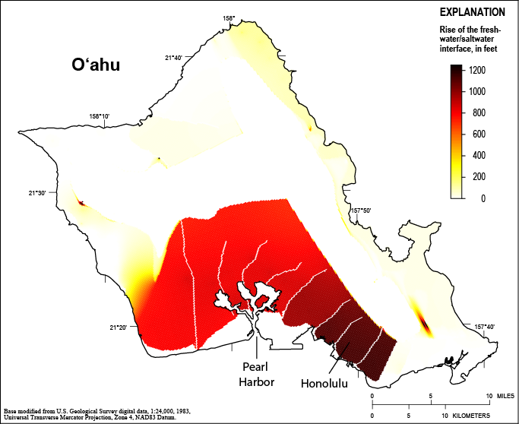
Figure 1. O‘ahu’s most extensive fresh groundwater resources exist as lenses floating on saltwater. This map shows how groundwater withdrawals from 1870 to the present have caused the interface between freshwater and saltwater to rise. The rise is particularly evident in the heavily pumped aquifers of Honolulu and surrounding Pearl Harbor.

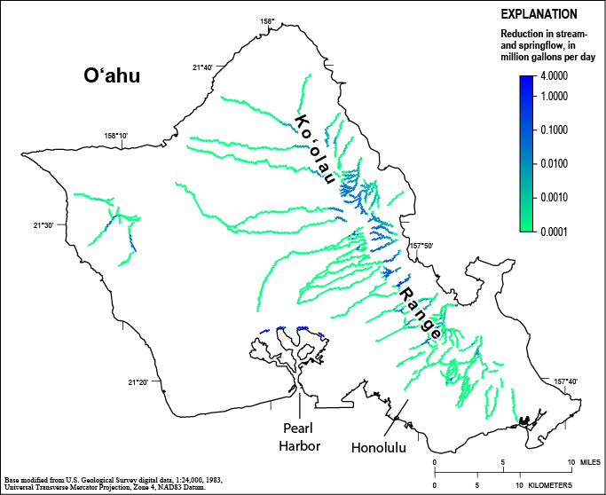
Figure 2. Many streams and springs on O‘ahu receive groundwater discharge that maintains flow during periods of no rainfall; this flow supports aquatic habitats, taro cultivation, and other beneficial uses of stream water. This map shows how historical groundwater withdrawals have reduced groundwater discharge to streams and springs, particularly those in the Ko‘olau Range and near Pearl Harbor.

