Coastal Carolinas Focus Area Study
FY 2018 End-of-Year Report Request
September, 2018

(1) PROJECT ACCOMPLISHMENTS/CONTRIBUTIONS (FY 2018)

Landscape and Hydrologic Change Study Component
- Based on continued stakeholder input, models and maps of two scenarios of predicted future land-use in the study area were designed and finalized for annual time steps from 2020-2065. The two modeled scenarios represent: 1) “status-quo” development that continues the same general patterns (urban form, conservation practices, units/acre, etc) given projected population growth, and 2) “Water-Smart” growth scenario, which allows for population growth (more densification and less sprawl) while conserving groundwater recharge areas and stream buffers, reduce probability of wetland development, keep conservation land protected and reduce water-use/capita. These land-use scenarios are being incorporated in to the FAS’s groundwater, surface-water and ecological-response models for simulation of future water-use and availability scenarios.
- A journal article on the land-use change-modeling study component is complete and in the colleague review process.
- Based on stakeholder input, future water-demand models have been developed for South Carolina and North Carolina using population growth projection, future climate model output and the future land-use scenario models. A geographically weighted regression approach was used with domestic, public and industrial water use being the dependent variables and social-economic (income, age), environmental (temp, precip) and urban form (number of urban “patches”, landscape shape index and aggregation index) were the independent variables. The model performed very well in our focus study area, with R-squares of 0.6 – 0.8, using water-use data from 2000-2010.
- A journal article on the future-water demand modeling has been published on this work in the Water Resources Research journal (see “Report Products…” section at the end of this report for the link to the published article).
- Worked with the USGS Southeast Climate Science Center to conduct a statistical analysis of Global Climate Models (GCMs) to define a wet, dry and a median condition models for our future simulations.
Water Use Study Component
- Water-use and NPDES discharge data compilation and disaggregation to HUC-8s through 2015 has been completed including the disaggregation of irrigation and domestic self-supplied to the surface-water model catchments (much smaller than HUC-8s, ~ 2 mi²). This database is the basis of the Data Release to accompany the groundwater modeling report.
- All surface-water use and discharge information was compiled into single database that allows the data to be more easily incorporated to the models and the data releases. A companion database for groundwater-use data used in the groundwater model has been compiled as the basis of the Data Release to accompany the groundwater modeling report.
- All 2015 water-use data have been approved and published in the 2015 compilation. HUC8 water-use for 2000, 2005, 2010, 2015 have been entered to AWUDS and are awaiting approval by the WAUSP team.
- The following Data Releases and metadata have been compiled and are ready for review by WAUSP staff or other colleague reviewer:
  - HUC8 Aggregates Compiled to one text file (PS, IN, PO,PC,MI, LI,IC,IG, WW)- 2000,2005,2010,2015)
  - Surface-water model withdrawals from SWAT model sub-basin (by use category)
  - Wastewater input to SWAT model sub-basin (by use category)
  - Groundwater withdrawals from ModFlow model cell (by aquifer and use category)
Surface Water Study Component
- Surface-water models of the Cape Fear and Yadkin/PeeDee basins using the Soil and Water Assessment Tool (SWAT) model, including dynamic water-use data, have been calibrated and future water-demand, land-use and climate data are being simulated with the calibrated models.
- A journal article and data release are being drafted to document the model calibration and application for future scenarios.
Ecological Response Study Component
- Ecological response modelers have completed working Bayesian network models for invertebrates and fish using modeled streamflow data from the SWAT models for both the Cape Fear and Yadkin/PeeDee watersheds.
- Initiated simulation of ecological response to future climate, land-use and streamflow data using the Bayesian network models based on modeled streamflow.
- Initiated evaluation of the Bayesian network models for invertebrates and fish using streamflow surrogate data (precipitation and temperature).
Groundwater Study Component
- An unsteady groundwater model (predevelopment to 2015), which includes all the water-use data (more than 8,000 wells) has been calibrated.
- A draft USGS SIR documenting the groundwater model is approximately 65% complete.
- Future land-use and climate data are being modeled in the Soil-Water Balance (SWB) model of the study area to develop future recharge values for the groundwater model scenarios.
Study Results and Outreach
- The project webpage updated to reflect the change in schedule and include the publication on water-demand modeling.
- Presentations on the study have been made to various stakeholders and partners inside and outside of the study area in FY18.
- Initiated planning with the Geospatial Science + Cyber Innovation Branch of the TXWSC for developing a product visualization and delivery portal. The plan is to develop a decision support system (DSS)/user interface to allow users to retrieve a predefined library of modeled in-stream, aquifer, and ecological response to the range of population, land-use, water-demand and climate-change scenarios we are modeling.
(2) PROJECT WORKPLAN AND BUDGET FOR FY 2019

Overall Study Objective and Approach
- The focus area of this study includes the lower, coastal regions of the Yadkin/Pee Dee and Cape Fear River Basins in South Carolina and North Carolina from Wilmington, NC down to Georgetown, SC.
- The objective of the study is to develop tools that will help to effectively manage groundwater and surface-water supplies in this coastal area to meet societal and ecological uses, by providing water-resource managers estimates of how potential changes in population growth, water-use, land-use, and climate will impact aquifer water levels, streamflow and ecology. The following are the major activities associated with the study:
  - Compile refined water-use data and disaggregate from County to the HUC-8 level.
  - Develop a refined groundwater-flow model of the surficial, carbonate and deeper sand aquifers to simulate results of historic and future stresses on the groundwater system in the coastal areas.
  - Develop surface-water models to simulate watershed response to various scenarios of climate, land-use and water-use change to evaluate future streamflow and water availability.
  - Develop empirical ecological response models relating fish and macroinvertebrate metrics to streamflow metrics and land use to forecast community changes associated with the various water-use, land-use, and climate change scenarios.

FY19 Work Plan

- Publish land-use change modeling journal article with NC State University collaborators. (Value-added product)
- Depending upon turnaround time of WAUSP Water-Use Team review, may need to finalize publication of some of the Data Releases for HUC8 AWUDS data (2000 – 2015) for Public Supply, Domestic, Industrial, Thermoelectric, Golf Course, Mining, Livestock, Aquaculture, Ag Irrigation and Wastewater Returns. (In original Work Plan)
- Publish Data Releases for surface-water withdrawals and wastewater returns summarized by SWAT-model HRUs. Publish Data Release for groundwater withdrawals summarized by ModFlow model grid cell. (Value-added product)
- Route through FSP and publish a SIR or journal article (and accompanying data release) titled “A modeling framework to assess the long-term sustainability of surface-water resources in the Coastal Carolinas”, which documents the SWAT models for both the Cape Fear and Yadkin/PeeDee basins (In original Work Plan).
- If time and budget permit, publish a journal article (and associated data release) on SWAT models titled “Predicting surface-water availability under climate and land-use change in the Coastal Carolinas, 2018-2065” (Value-added product).
- Finalize ecological response models for future conditions using:
  - Forecast land-use and simulated flow data from the SWAT models. (In original Work Plan); and
  - Forecast land-use, temperature and precipitation data (Value-added product)
- Route through FSP and publish the following journal articles on ecological response modeling:
  - Invertebrate response model to modeled streamflow metrics and land use (In original Work Plan)
  - If the standard errors of the fish model are small enough, a paper on fish response to modeled streamflow metrics and land use (In original Work Plan)
  - Depending upon the performance of the two model approaches (see approaches a) and b) in item 6) above) and time and resources, a third journal articles may be produced comparing predictive sensitivity of SWAT streamflow data and the climatic surrogates approach (Value-added product).
- Finalize saltwater-intrusion groundwater model (SEAWAT) from the calibrated MODFLOW model for a least one localized area (ie. Wilmington, NC and Georgetown, SC) and simulate future scenarios (In original Work Plan).
- Route through FSP and publish an SIR titled “Simulation of groundwater flow in the Atlantic Coastal Plain, South Carolina and parts of North Carolina and Georgia, predevelopment to 2065”, which documents the groundwater model (In original Work Plan).
- Continue working with staff in the TX WSC to develop the Decision Support System (DSS)/user interface to allow users to retrieve a predefined library of modeled streamflow, aquifer, and ecological response to a range of population, land-use, water-demand and climate-change scenarios (In original Work Plan)
CC FAS FY19 Budget Request Summary

Below is a table with the estimated additional FY 2019 gross funding needed to wrap up the products for the CCFAS, itemized by Science Center and project component.

Science Center  Project Component | Salary | Travel | Total
South Atlantic WSC  Project Management,  (Dianna Hogan, 100 hrs)  Water Use, Data Management  (Jaime Painter, 240 hrs)  Groundwater Modeling  (Jason Fine, 320 hrs)  (Greg Cherry, 80 hrs)  (Bradley Huffman, 160 hrs)  Surface-water Modeling  (Ana Garcia, 360 hrs)  (Laura Gurley, 464 hrs)  (Cassandra Pfeifle, 120 hrs)  Ecological Response Modeling  (Tom Cuffney, 40 hrs)  (Song Qian, U of Toledo, CESU agreement)  Publications (SPN)  Conference | $155,000  $9,000  $18,000  $41,000  $75,000  $12,000  --  -- | $5,000  --  --  --  --  $5,000  --  -- | $160,000
California WSC  Ecological Response Modeling  (Jason May, 700 hrs) | $65,000 | -- | $65,000
TOTAL | $220,000 | $5,000 | $225,000

(3) NOTEWORTHY COLLABORATIONS, MEETINGS, TECHNICAL TRANSFER ACTIVITIES, SPIN-OFF PROJECT DEVELOPMENTS, AND ACKNOWLEDGEMENTS

Presented an overview of the project to and interacted with stakeholders at multiple informal meetings and a formal meeting of the Cape Fear Sustainable Rivers Program on October 27, 2017 in Moncure, NC.
Two “spin-off” projects related to the Focus Area Study have been developed to address local stakeholder needs so far:
- Extension of the CC FAS groundwater model to include the entire SC coastal plain and portions of the coastal plain in GA and NC. Funded by the State of SC.
- Assessment of aquifer vulnerability (to climate and anthropogenic-induced water-level declines, contamination) study of New Hanover County, NC that will utilizing the CC FAS Soil-Water Balance and groundwater models. Funded by New Hanover County, NC.
Another new project leveraging the land-use change and water-demand modeling work and general groundwater modeling approach from this FAS is in the final stages of securing funding from Wake County, North Carolina.
Our project has been included in the NOAA NIDIS Coastal Carolinas Drought Early Warning System Draft Strategic Plan document (page 25-26).

(4) Report Products, Bibliographic Update, Data Releases, and Groundwater-Model Archives
Sanchez, G. M., Smith, J. W.,Terando, A., Sun, G., & Meentemeyer, R. K. (2018). Spatial patterns of development drive water use. Water Resources Research, 54. https://doi.org/10.1002/2017WR021730

(5) PROJECT TEAM DIRECTORY –
- Chad Wagner (Program Coordinator, Groundwater and Streamflow Information Program, Raleigh, NC; 919-571-4021; cwagner@usgs.gov; Outgoing Project manager)
- Dianna Hogan (Science Advisor, Southeast Region, Reston, VA; 703-648-7240; dhogan@usgs.gov; Incoming Project manager)
- Georgina Sanchez (PhD candidate/Post-Doc, Center for Geospatial Analysis, NC State University, Raleigh, NC; (517) 755 – 0264; gmsanche@ncsu.edu; Land-use change modeling)
- Adam Terando (Research Ecologist, USGS Southeast Climate Science Center, Raleigh, NC; 919-515-4448; aterando@usgs.gov; Climate-change modeling and data)
- Doug Smith (Hydrologist, South Atlantic Water Science Center, Raleigh, NC; 919-571-4011; dgsmith@usgs.gov; Water-use)
- Jaime Painter (Hydrologist, South Atlantic Water Science Center, Norcross, GA; 678-924-6676; jpainter@usgs.gov; Water-use and GIS)
- Ana Maria Garcia (Research Hydrologist, South Atlantic Water Science Center, Raleigh, NC; 919-571-4058; agarcia@usgs.gov; Surface-water modeling)
- Laura Gurley (Hydrologist, South Atlantic Water Science Center, Raleigh, NC; 919-571-4014; lgurley@usgs.gov; Surface-water modeling)
- Cassandra Pfeifle (Hydrologist, South Atlantic Water Science Center, Raleigh, NC; 919-571-4078; cmendoza@usgs.gov; Surface-water modeling)
- Tom Cuffney (Research Ecologist - NDAA, South Atlantic Water Science Center, Raleigh, NC; 919-571-4019; tcuffney@usgs.gov; Ecologic-response modeling)
- Jason May (Biologist, California Water Science Center, Sacramento, CA; 916-278-3079; jasonmay@usgs.gov; Ecologic-response modeling)
- Song Qian (Professor, University of Toledo, Department of Environmental Sciences, Toledo, OH; 419-530-4230; song.qian@utoledo.edu; Ecologic-response modeling)
- Mary Freeman (Research Ecologist, USGS Patuxent Wildlife Research Center, Athens, GA; 706-583-0978; mcfreeman@usgs.gov; Ecologic-response modeling)
- Bruce Campbell (Groundwater Specialist, South Atlantic Water Science Center, Columbia, SC; 803-750-6161; bcampbel@usgs.gov; Groundwater modeling)
- Jason Fine (Hydrologist, South Atlantic Water Science Center, Raleigh, NC; 919-571-4034; jmfine@usgs.gov; Groundwater modeling);
- Greg Cherry (Hydrologist, South Atlantic Water Science Center, Norcross, GA; 678-924-6632; gccherry@usgs.gov; Groundwater modeling)
- Bradley Huffman (Hydrologist, South Atlantic Water Science Center, Columbia, SC; 803-750-6129; bhuffman@usgs.gov; Groundwater modeling and general programming/automation)
(6) PHOTOS, ANIMATIONS, AND GRAPHICS
We have animations of simulated changes in land-use (urban growth) and water-demand for the focus area that can be provided. Static images of the land-use change area around Conway, SC and change in water-demand for NC and SC are included below for reference.
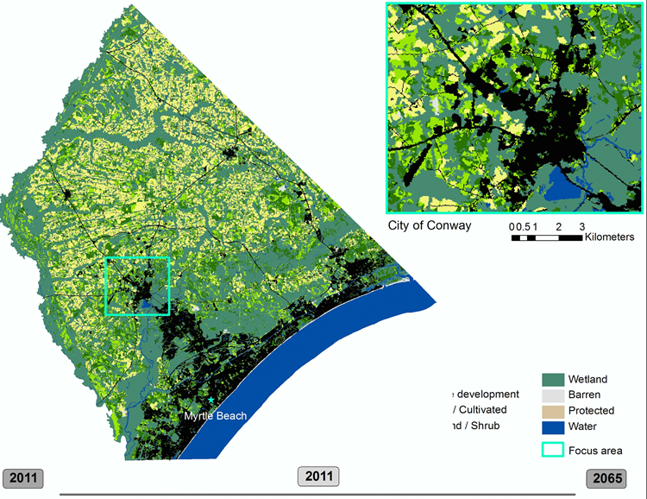
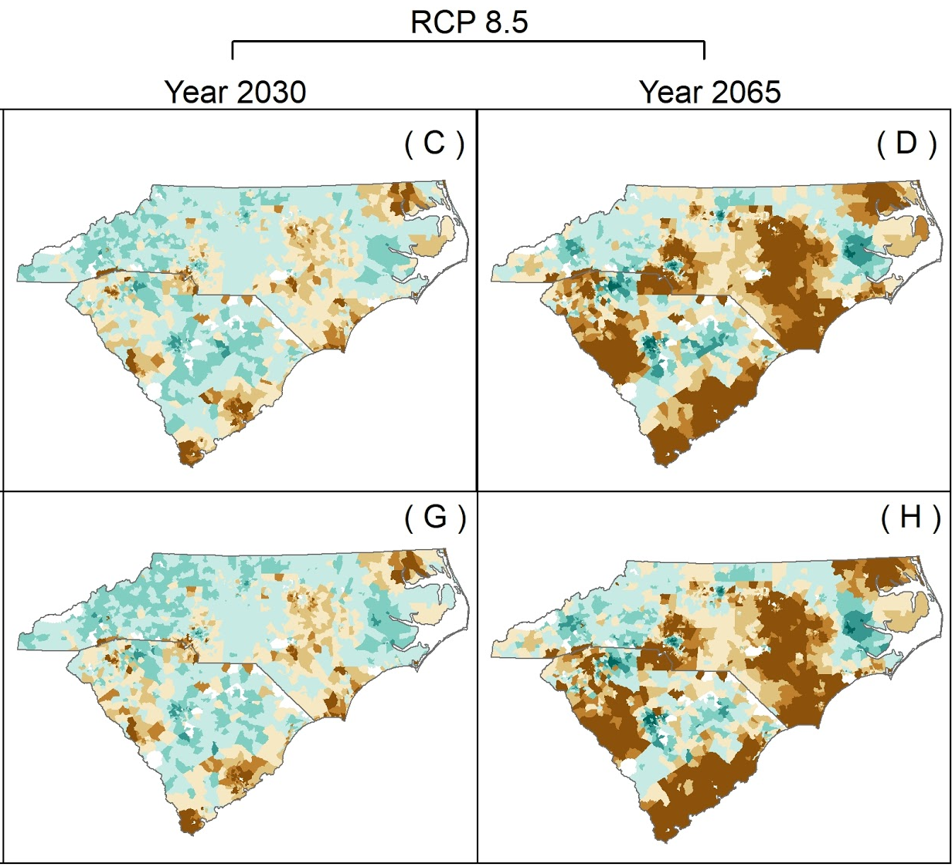
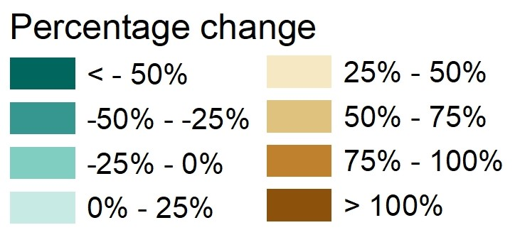
Water-demand change estimates at census tract spatial unit by 2030 and 2065.
WaterSmart
Status-Quo

