Coastal Lowlands Aquifer System (CLAS)
Regional Groundwater Availability Project
FY 2017 End-of-Year Report
August 22, 2017

(1) FY 2017 Project Accomplishments & Contributions
- Convert RASA model to MODFLOW: In FY17, the USGS reached into the archive of the Regional Aquifer System Analysis (RASA) work of the 1980s and 90s. The RASA work contains multiple groundwater-flow models of the Coastal lowlands aquifer system, at varying resolutions (typically individual model cells of five or ten miles on a side). Though the RASA models tend to be coarse in both time and space, the information contained in the archive was useful in reconstructing the models in more recent software architecture (MODFLOW-NWT), and allowed for initial downscaling to one-mile cell dimensions. An initial steady-state model was developed.
- Convert steady-state model to transient model: The steady-state model was then combined with recent estimates of recharge and compared to processed NWIS observations of water levels throughout the period of record. Next, a simplistic transient model was developed simulating conditions from 1985-2010 with AWUDS withdrawals in a version 1 WEL package (distributed over all model layers) to begin assessing transient stresses on the system. Active simulation with the new information provides a preliminary evaluation of uncertainty of the various inputs (recharge, hydraulic conductivity, water use, etc.), and will be used to guide further input development. Also, a beginning SFR package has been developed, and Reitz and others effective recharge datasets are being incorporated into the transient model.
- Compile framework and aquifer property data: The RASA framework (layering) is not consistent with more recently-developed understanding of the CLAS. Therefore, aquifer information from recent studies, groundwater-flow models, and other data sources have been compiled and a new aquifer-specific framework is currently in development.
- Compile water-use data: Available water-use information is also being compiled and organized into consistent data formats for implementation into a MODFLOW WEL package. Surface-water water use data are being compiled for processing in SFR diversions.
- Begin development of the prior: The prior is quantified as the expected value, variance, and range of a particular hydraulic property or boundary condition. In FY 2017, we are beginning to develop our understanding of the prior of properties like hydraulic conductivity, transmissivity, specific storage, as well as groundwater withdrawals, as we compile data.
- Compile dataset for model history-matching: NWIS water levels for the period of record for the CLAS have been pulled and processed into PEST compatible data files. Non-NWIS data is being compiled.
- Beginning development of new subsidence package for MODFLOW 6: A working beta version of the new subsidence package for MODFLOW 6 has been completed and is being tested.

(2) FY 2018 Project Workplan & Budget

Workplan: The objectives of the study in FY18 consist of:
- Completion of new subsidence package for MODFLOW 6 with journal article completed in FY 2018
- Continued development of transient model with improved SFR and RCH packages, including hindcasting. Conversion of MODFLOW-NWT model into MODFLOW 6 framework within new national water model grid with MAP & MERAS.
- Completion of water use compilation/extrapolation
- Completion of framework compilation and expected data release in FY18 (original workplan was FY19)
- Compilation and processing of model targets (water level, surface water, subsidence)
- Finish development of prior
- Development of formal QOIs and predictive models
- Departures from original
  - Conversion to National Grid -- The national grid is a departure from the original workplan, but allows for consistency and close collaboration with the Mississippi Alluvial Plain study.
  - Recharge: utilization of Reitz datasets for consistency with MAP instead of SWB model
  - Use of iES (iterative Ensemble Smoother) technique in combination with PEST++
  - The framework for the CLAS will be closely coupled to the MAP.

Budget:
Center | Task | Name | Salary (Net) | Salary (Gross)
TX | modeling & proj management | Linzy Foster | $45,148 | $66,819
TX | framework | Andy Teeple | $28,386 | $42,011
TX | water use | Natalie Houston | $21,732 | $32,163
TX | water use | Sam Wallace | $18,270 | $27,040
LMG | modeling & proj  management | Brian Clark | $62,803 | $89,772
LMG | model support | Leslie Duncan | $31,956 | $45,679
WI | SFR | Andy Leaf | $9,001 | $11,881
 |  | Salary Totals | $217,296 | $315,365

Other Expenses | Cost (Net) | Cost (Gross)
Contract (Jeremy White) from HQ | ? | $10,000
Travel (TX) | $5,000 | $7,400
Travel (LMG) | $5,000 | $7,147
Publication Cost (SUB journal article) | $4,000 | $5,718

Breakdown | Total (Gross)
TXWSC | $175,433
LMGWSC | $148,316
WIWSC | $11,881
Contracts (Jeremy White, from HQ) | $10,000
Total | $345,630

(3) Noteworthy Collaborations, Meetings, Technical Transfer Activities, Spin-off Project Developments, & Acknowledgements
Stakeholder webinar:
(RESCHEDULED due to Hurricane Harvey - TBD) Texas Water Science Center Brown Bag webinar series, August, 2017, Austin, Texas, A New Regional Investigation of Groundwater Availability of the Coastal Lowlands Aquifer System: An Overview of Objectives and Approach

Other meetings:
2017 MWRC, Mississippi Water Resources Conference, April, 2017, Jackson, MS, Guest speaker during luncheon session, provided overview of regional modeling efforts that included the Coastal Lowlands, Mississippi Alluvial Plain, and Ozarks
11th Annual Louisiana Groundwater, Surface Water, and Water Resources Symposium, April 11-12, 2017, Baton Rouge, LA
Alabama Water Resources Conference and Symposium, September 7-9, 2016, Orange Beach, Al, Investigation of the Coastal Lowlands aquifer system
(Abstract submitted) National Groundwater Association Groundwater Summit, December, 2017, Nashville, TN, Developing a Regional Model of the Coastal Lowlands Aquifer System--Using Uncertainty Quantification as a Guide
(Abstract submitted) American Geophysical Union Fall Meeting, December, 2017, New Orleans, LA, Using Uncertainty Quantification to Guide Development and Improvements of a Regional-scale Model of the Coastal Lowlands Aquifer System, spanning Texas, Louisiana, Mississippi, Alabama, and Florida

Noteworthy collaborations:
- The CLAS project is working with the MAP project to join into one model grid consistent with the national water model. The goal in this collaboration is to have improved boundary conditions and consistent datasets and processing.
- A project to develop the “Hydrogeologic Structure of Southwestern Louisiana” by John Lovelace and Maxwell Lindaman is currently underway in the LMG WSC and we are collaborating with Max to assist his project while also utilizing his datasets within our CLAS framework dataset.
- Linzy Foster worked on a pre-proposal with Dr. Krishna Paudel (LSU Agricultural Center), Dr. Z. George Xue (LSU), and Dr. Frank Tsai (LSU) on “Groundwater availability and economic analysis of the Coastal Lowlands Aquifer System” for submittal to the USGS-NWIR National Competitive Program. The pre-proposal was unfortunately not selected for a full proposal but there is ongoing interest in continued development of models of the Chicot aquifer in southwestern Louisiana for predictive purposes in investigating climate change and saltwater intrusion.

Stakeholder input:
“Montgomery County (TX) is one of the fastest growing regions in the state of Texas, with the population of the county expected to double by the year 2040. With that increase in population, an enhanced understanding of groundwater availability in our region will be a valuable tool in the District’s on-going efforts to protect and preserve the groundwater resources of Montgomery County. Thus, the District is very supportive of a project that will include development of a numerical groundwater model that will encompass all of the coastal aquifer from the Mexico-Texas border to the Florida Panhandle.”
-- Kathy Turner Jones, General Manager, Lone Star Groundwater Conservation District
“I am writing on behalf of the Mobile Bay National Estuary Program in support of your Water Availability and Use Science Program work plan for the Coastal Lowlands Aquifer System Groundwater Availability Study. … This project supports goals and objectives of the CCMP [Comprehensive Conservation and Management Plan] and promotes monitoring of ecological services delivered by protection of critical habitats. We look forward to … employing project results in outreach efforts. Again, MBNEP wholeheartedly supports this proposal.”
-- Roberta Arena Swann, Director, Mobile Bay National Estuary Program

(4) Report Products, Bibliographic Update, Data Releases, and Groundwater-Model Archives
No reports or data releases at this time.
The CLAS project website has been developed as is located here: https://www2.usgs.gov/water/lowermississippigulf/lmgweb/clas/

(5) Project Team Directory
Texas Water Science Center:
Linzy K. Foster; 512-927-3529, lfoster@usgs.gov, co-PI, modeling and project management
Andrew Teeple, 512-927-3560, apteeple@usgs.gov, model framework
Jonathan Thomas, 682-316-5036, jvthomas@usgs.gov, model framework
Daniel Tebo, 512-927-3537, dtebo@usgs.gov, water use, model support
Natalie Houston, 512-927-3565, nhouston@usgs.gov, water use
(David) Sam Wallace, 682-316-5037, dswallace@usgs.gov, water use
Jeremy White, 512-927-3585, jwhite@usgs.gov, subsidence/uncertainty

Lower Mississippi-Gulf Water Science Center:
Brian Clark, 501-352-1864, brclark@usgs.gov, co-PI, modeling and project management
Leslie Duncan, 615-837-4700, lduncan@usgs.gov, model support
Wade Kress, 615-674-0702, wkress@usgs.gov, model framework
Angela Collier, 225-298-5481 x3214, acollier@usgs.gov, water use
Courtney Killian, 601-933-2900, ckillian@usgs.gov, model framework
Amy Gill, 334-850-0995, acgill@usgs.gov, water use
David Ladd, 615-837-4773, deladd@usgs.gov, model framework

Wisconsin Water Science Center:
Andrew Leaf, 608-821-3912; aleaf@usgs.gov, SFR package, streamflow data processing

(6) Photos, Animations, & Graphics

A video of a snapshot of NWIS water levels in the CLAS study area.
https://drive.google.com/a/doi.gov/file/d/0B7PTvJSGF5o3MWFRVGJwMjE5aEE/view?usp=sharing

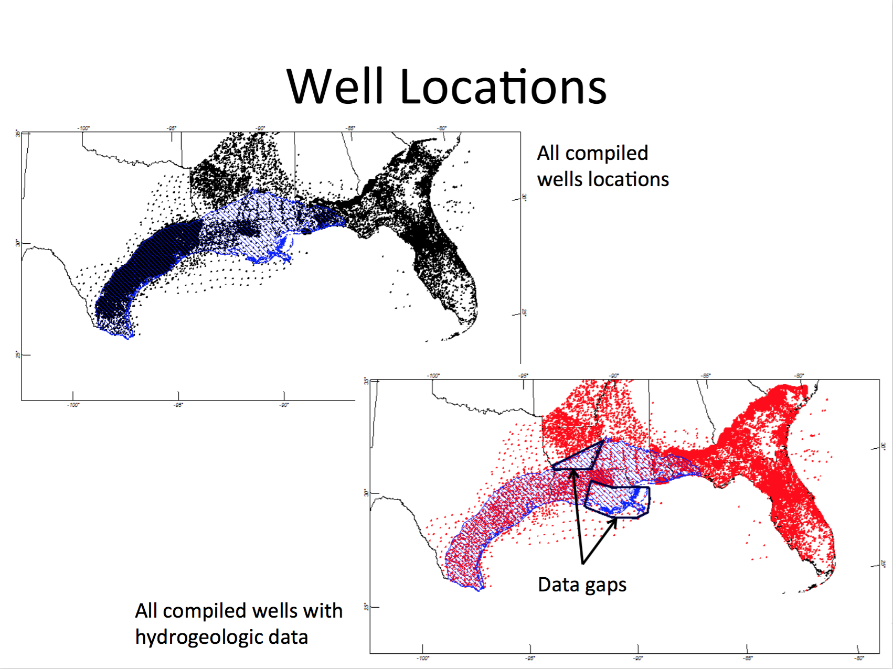
Locations of wells and location of wells with hydrogeologic data, as well as locations of data gaps.
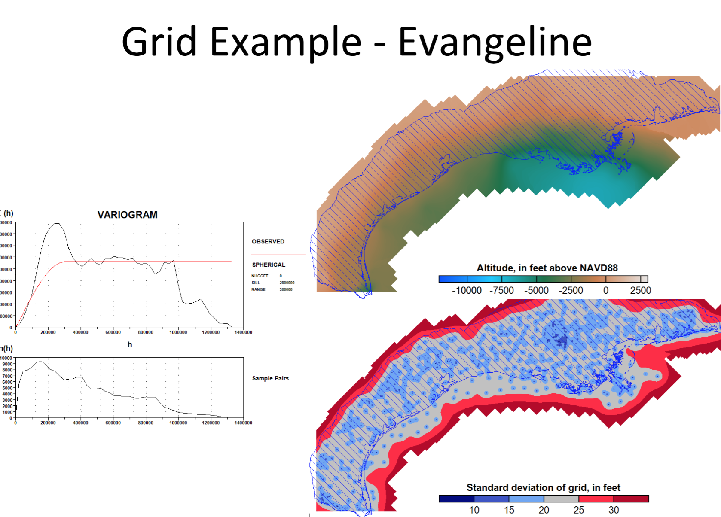
Experimental and model variogram, as well as interpolated grid of the Evangeline aquifer from well picks and kriging.

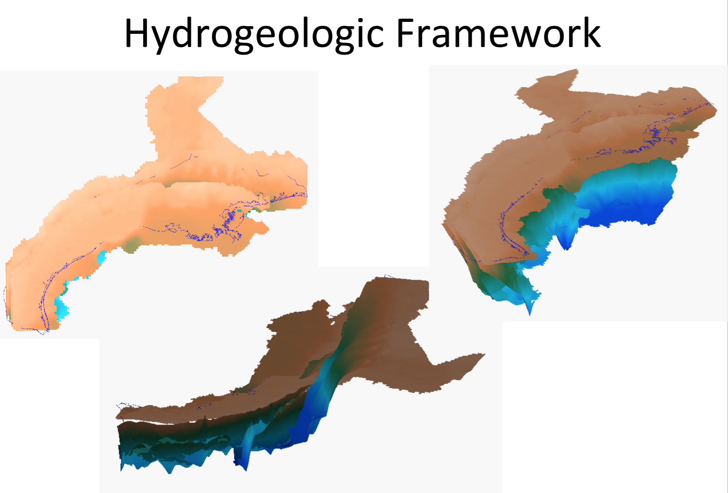
Some interpolated beginning layers of the Chicot, Evangeline, Burkeville, and Jasper aquifers for the CLAS model.

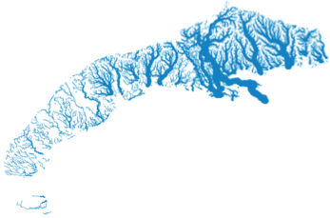
Beginning glance at stream network for SFR package.

