Project Accomplishments

Metamodel has been constructed to approximate model output of an integrated hydrologic model
- A metamodel was developed from a transient groundwater flow model. Developing metamodels from transient groundwater flow models has not been documented and advances the current state of groundwater science.
- The metamodeling methods have been developed using the Santa Rosa Plain model and the methodology has been documented and scripted to start executing in other representative basins.
- The metamodels predicted the response of multiple hydrologic model outputs to changes in pumping stresses.
- The metamodeling exposed trends and correlations between model inputs and outputs that were otherwise unknown within a complex nonlinear flow model.

Initial model for North Coast region was developed for the Eel River Valley
- In the Eel River Valley, a series of increasingly complex hydrogeologic framework models are being developed as separate versions with the value of added information. Versions 1 and 2 have been completed and Version 3 is underway.
- Grid and simple flow budget data have been compiled. BCM data have been extracted to characterize the predevelopment recharge and runoff in and to the valley.
- A model of the Eel River Valley was built based on hydrogeologic framework version.
- Model-building scripts have been developed and are general enough to build a groundwater flow model for another similar basin. This work expands upon the recent USGS publications related to general model building for groundwater residence time distributions (Starn and Belitz, 2018).

Model visualization, results, and dissemination tools
- Initial meetings were held with USGS - Wetland and Aquatic Research Center (WARC) to develop tools and scripts to visualize water budget data from an existing model and various zonal output. The initial web page and tool design layout was developed.
- Several discussions have taken place with Texas Water Science Center (TXWSC) to try and enhance and build on their groundwater model dash board to include more water budget information. A mock-up on how this initially be structured was developed.

References
Starn, J. J. and Belitz, K. (2018), Regionalization of groundwater residence time using metamodeling. Water Resour. Res.. Accepted Author Manuscript. doi:10.1029/2017WR021531

Project Work Plan and Budget for FY19
The majority of focus in FY 19 will be finalizing several products related to work in the previous phases of the project. Ongoing work will continue with geodatabase design, water-budget compilation, groundwater flow modeling, metamodeling, visualizing water budgets, and developing a website with tools to analyze model and metamodel output. The tasks summarized for FY19 are those originally submitted to WAUSP in the project proposal. Specific items for each task that will be executed in FY19 are as follows:

Task 1: Evaluation of Existing Data and Models
The strategy for this task has evolved into creating a geodatabase out of the ArcHydro Groundwater Data model and populating it with data for each coastal basin. The methods for incorporating data into modeled regions is different than that for unmodeled regions. The geodatabase is being designed to be able to export datasets in a consistent format to construct a new groundwater flow model or to provide inputs to a metamodel application.
- Complete a geodatabase design that streamlines hydrogeologic data collection and preparation for each coastal basin.
- Prepare datasets for general model development and metamodel application.
- Prepare datasets for updates to existing models.

Task 2: Water-Budget Estimation
The water-budget compilation is an aspect of the project that will be emphasized in FY19. Estimates for evapotranspiration, surface runoff, and groundwater recharge will be collected for each basin from the most recent BCM and existing numerical flow models. These estimates will provide a baseline to compare similar estimates from metamodels. The recharge estimates will be vitally important for the groundwater flow models that will be constructed or updated as a part of this project.
- Compile BCM and existing model data for each basin for preliminary water budget estimates.

Task 3: Hydrogeologic framework modeling
The methods for developing a hydrogeologic framework model for CA coastal basins has been designed to include several versions of increasing complexity. These methods are currently being applied to the Eel River Valley. An analysis of information gained, or the value of added data, will help guide the choice of framework model complexity for any additional basins.
- Complete version 3 of Eel River Valley hydrogeologic framework model.
- Perform cost-benefit analysis for each version of the framework.
- Publish geologic report documenting a hydrogeologic framework development strategy.

Task 4: Determine appropriate core, representative models and update as needed
The main objective of this task is to leverage the models that have already been constructed. These models can be used as representative models for each region of the CA coast and can thus be sampled to develop metamodels. There are updated and recently completed models for each coastal region except for the north coast. In order to sample these models, they need to be modified. Modifications are in progress for some models (e.g., Pajaro, central coast region) and completed for others (e.g., Santa Rosa Plain, SF bay region). Additionally, there are existing models that are out-of-date and they need to be made current (e.g., Santa Clara).
- Complete modifications and updates to existing models that will be used for metamodel development.
- Begin updating models that are out of date.

Task 5: Complete Eel River Valley model (representative of Northern Coastal Basins)
The Eel River Valley model is being developed in stages (versions) and will serve as the representative model for this region. Water budget estimates will be developed and simulated, and the calibrated model will be sampled to develop metamodels. It will also serve as a numerical test of the performance of the model with increasing hydrogeologic framework complexity in the versions. The reduction in model output uncertainty (obtained through calibration) will help quantify the value of added information.
- Complete construction and calibration of Eel River Valley groundwater model with general model-building scripts for each version of the hydrogeologic framework model.
- Perform thorough analysis of information gained (with respect to quantifying SGMA’s undesirable results) in the simulation with each framework version.

Task 6: Develop metamodels to extrapolate core models to areas where models are unavailable
In the proof-of-concept phase1, metamodels were developed and tested. The metamodel result show: a) substantial new methods; and b) promising results that can be used to develop metrics useful to water managers. From FY19 and onward, metamodels will continue to be developed and applied in various coastal basins as needed.
- Test transferability of metamodels developed in Santa Rosa Plain.
- Develop metamodels for Pajaro Valley using the same methods used for Santa Rosa Plain.
- Publish journal article detailing the metamodeling methods and applications.

Task 7: Develop graphical model visualization, results, and dissemination tools of factors affecting groundwater availability
- Complete design of visual representation of water budget components to be viewed from a dashboard for various groundwater models. In the end, each coastal basin will have it’s own dashboard.
- Begin work in earnest with other groups developing web-based tools to visualize and disseminate model information and results. This will move forward with two parallel efforts –
  - WARC will develop tools and scripts to visualize water budget data from an existing model and various zonal output.
- TXWSC will enhance and build on their groundwater model dash board to include more water budget information. This will be designed to highlight the components of SGMA and build on the CAWSC SGMA tools and CADWR water budget modeling tools. Work will also begin to allow the web-based tool and metamodels for real-time user interactions.

FY19 Workplan Schedule
Also see attached spreadsheet

General FY19 Budget by name and task
Note: about $50,000 of carryover funds from FY18 will be suballocated to TXWSC and WARC for Task 7 in October 2018 (Early FY19). This work was planned for FY18 but the receiving groups were unable to initiate the work in FY18. An additional $30k from FY19 funds will be suballocated for the same task.
Row Labels | Sum of Hours | Sum of Total (Net) | Sum of Total (Gross)
1. GIS datasets | 1080 | 45401.74 | 68315.09
GS 09/01 estimated salary | 1000 | 39898.08 | 60033.84
GS 13/01 estimated salary | 80 | 5503.66 | 8281.25
2. Water-Budgets | 360 | 22764.65 | 34253.51
GS 11/01 estimated salary | 160 | 7722.53 | 11619.93
GS 12/10 estimated salary | 200 | 15042.12 | 22633.58
3. Hydrogeologic Framework | 320 | 58510.34 | 67852.13
GS 12/01 estimated salary | 320 | 18510.34 | 27852.13
Suballocation |  | 40000.00 | 40000.00
4. Core model updates | 720 | 36896.08 | 55516.80
GS 09/01 estimated salary | 240 | 9575.54 | 14408.12
GS 11/01 estimated salary | 240 | 11583.79 | 17429.90
GS 12/05 estimated salary | 240 | 15736.75 | 23678.78
5. Eel River Valley Model | 520 | 22420.55 | 33735.75
GS 07/01 estimated salary | 240 | 7828.33 | 11779.13
GS 11/01 estimated salary | 240 | 11583.79 | 17429.90
GS 12/10 estimated salary | 40 | 3008.42 | 4526.72
6. Metamodeling | 480 | 48094.77 | 62273.65
GS 11/01 estimated salary | 240 | 11583.79 | 17429.90
GS 13/01 estimated salary | 240 | 16510.98 | 24843.74
Suballocation |  | 20000.00 | 20000.00
7. Visualizations & Web tools | 320 | 58232.71 | 72481.20
GS 11/01 estimated salary | 40 | 1930.63 | 2904.98
GS 12/01 estimated salary | 80 | 4627.58 | 6963.03
GS 15/05 estimated salary | 200 | 21674.50 | 32613.18
Suballocation |  | 30000.00 | 30000.00
All |  | 15450.00 | 23247.31
Equipment |  | 10300.00 | 15498.20
Travel |  | 5150.00 | 7749.10
Grand Total | 3800 | 307770.84 | 417675.43

* $50k Suballocation for Task 7 is not included in any FY19 totals. It is carryover from FY18.

Noteworthy Collaborations
Several interested groups have invested resources to explore collaboration. The collaboration with USGS Geologic Division and Wisconsin Science Center has been ongoing. In FY19 more formal consultation with State agencies (CA DWR and SWRCB) will begin. Additional meetings will be planned with various stakeholders at the water agency level to get feedback on how various modeling efforts might help plan for SGMA compliance.

USGS Geologic Division (Don Sweetkind)
The Geologic Division is developing a range of framework models (from simple to complex) and evaluating the value of added complexity. Funds had been suballocated in Phase 1 to develop a framework model for the Eel River Valley. Additional work is required to produce datasets for the more complex hydrogeologic framework models.

USGS Wisconsin Science Center (Mike Fienen)
The Wisconsin Science Center has been instrumental in successfully running thousands of model realizations on their computational cluster. The availability of hundreds of cores and the ease with which we were able to get jobs up and running with Condor made this the best choice for running our experiments. Local resources (San Diego and Sacramento) were insufficient in number of cores and availability. The national USGS cluster resource (Yeti) was available but difficult to modify all the model components to work on the Linux environment.

CA Department of Water Resources
The California Department of Water Resources (DWR) has held several meetings on the topic of the Sustainable Groundwater Management Act (SGMA) that were attended by Steve Phillips and/or Claudia Faunt. DWR is concurrently exploring ways to develop water budgets in basins along CA’s central coast and recognizes that collaboration with this project would be mutually beneficial.

CA State Water Resource Control Board
The California State Water Resource Control Board (SWRCB) is the regulatory agency for state water supply. Meetings will be attended by members of this project to present developments and to obtain feedback on what methods will be most useful from a regulatory perspective.

USGS Wetland and Aquatic Research Center (WARC)
The WARC leverage USGS computer science expertise to address technical challenges surrounding data management, visualization, and complex computations for a variety of Gulf of Mexico, State, and Federal partners such as the Louisiana Coastal Protection and Restoration Authority and the Comprehensive Everglades Restoration Program. The WARC Advanced Applications Team is a 30-person staff that includes 25 computer scientists, 2 engineers, 1 GIS/metadata person, and 2-3 students. They are a SOFTWARE shop, hosting their own data center with hundreds of servers and an active presence in the Amazon Cloud. Their Web apps services include everything from web code (html, php, css js) to web-server side code (C#.NET, python). Database driven forms, maps, visualizations, story maps, and custom GIS apps. Additional expertise in modeling or computationally intense apps, distributed modeling frameworks, and ecological models that run via GUI or headless.

USGS Texas Water Science Center (TXWSC)
The TXWSC has developed a groundwater web interface for MODFLOW models, GWWebFlow. GWWebFlow is a browser-based groundwater model viewer designed to allow users to easily explore model inputs and outputs for published and approved USGS models. It currently supports the MODFLOW family of models, including MODFLOW2005, MODFLOW-NWT, MT3DMS and SEAWAT. GWWebFlow relies on a THREDDS data server to host the model inputs and outputs that have been stored in NetCDF4 files. The NetCDF4 files used in GWWebFlow are generated using the FLoPy Python package. The CAWSC is currently working with them on various projects to help enhance our web presence and leverage existing technology.

Report Products: FY19
- Journal Article on metamodel development & application (draft by end of Nov 2018, completed by end of Feb 2019).
- Journal Article on hydrogeologic framework and quantification of complexity, an example from the Eel River (draft by end of Dec 2018, completed by end of Mar 2019).
- Data versions of Eel River Valley groundwater model (Apr 2019).
- Data model updates to Pajaro Valley (Jul 2019)
- Website prototype with GUI tools, visualizations of water budgets, and model/metamodel results (End of FY19).

Project Team Directory
The following team comprises the main workforce in FY19

Zachary Stanko
Hydrologist
USGS CA Water Science Center
San Diego, CA
Phone: (619) 225-6448
Email: zstanko@usgs.gov
Role: lead modeler, project co-chief

Claudia Faunt
Supervisory Hydrologist
USGS CA Water Science Center
San Diego, CA
Phone: (619) 225-6142
Email: ccfaunt@usgs.gov
Role: project co-chief

Steven Phillips
Groundwater Specialist
USGS CA Water Science Center
Sacramento CA
Phone: (916) 278-3002
Email: sphillip@usgs.gov
Role: project advisor

Ayman Alzraiee
Hydrologist
USGS CA Water Science Center
Sacramento, CA
Phone: (916) 278-3256
Email: aalzraiee@usgs.gov
Role: statistical modeling

Geoffrey Cromwell
Geologist
USGS CA Water Science Center
Santa Maria, CA
Phone: (805) 928-9539 x11
Email: gcromwell@usgs.gov
Role: hydrogeologic framework

Michael Fienen
Research Hydrologist
USGS Wisconsin Water Science Center
San Diego, CA
Phone: (608) 821-3894
Email: mnfienen@usgs.gov
Role: metamodeling specialist

Meghan Dick
Student Hydrologist
USGS CA Water Science Center
San Diego, CA
Phone: (619) 225-6159
Email: mdick@usgs.gov
Role: GIS datasets/database

Sally House
Information and Reports Specialist
USGS CA Water Science Center
San Diego, CA
Phone: (619) 225-6133
Email: shouse@usgs.gov
Role: Web-based tools

Don Sweetkind
Research Geologist
USGS Southwest Region
Denver, CO
Phone: (303) 236-5349
Email: dsweetkind@usgs.gov
Role: hydrogeologic framework

Multimedia Materials

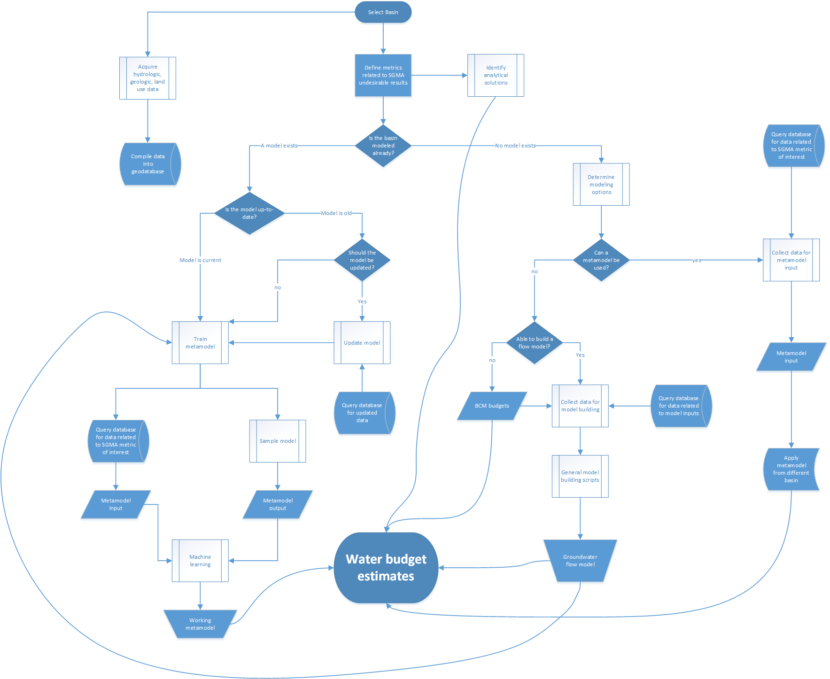
Figure 1: Workflow design for obtaining water budget estimates for the 40 California Coastal Basins. Since there are many ways to approximate water budget components, this project will quantify these components using various methods and compare them. This figure is also included separately as a higher quality PDF for zooming in on specific component.
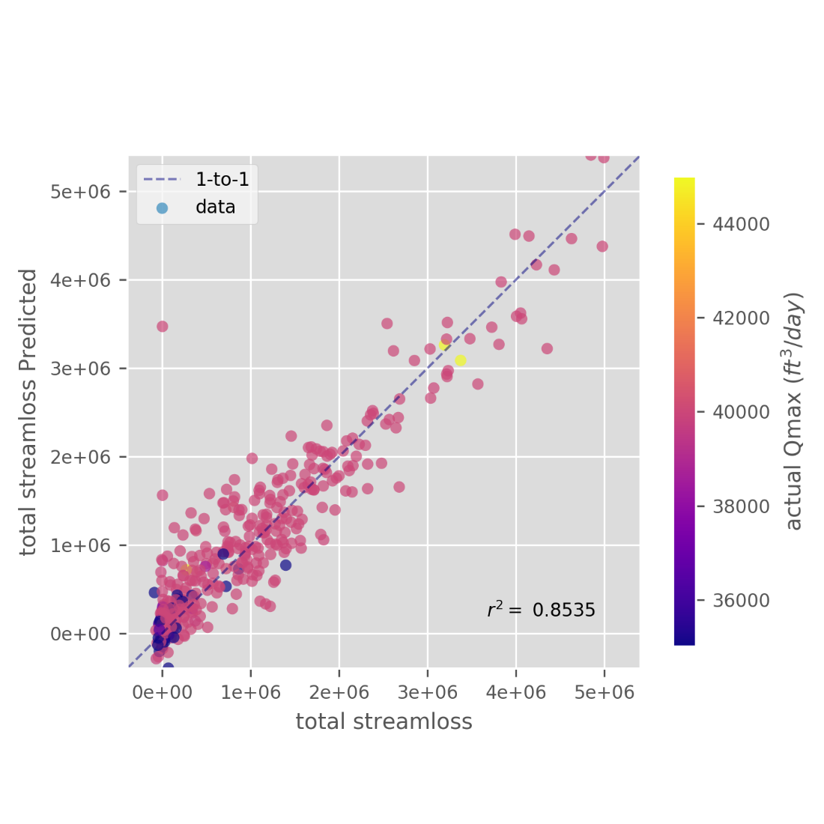
Figure 2: This figure shows the performance of one metamodel to estimate total streamloss as a result of adding a production capacity pumping well. Each point represents an additional well placed in a unique location in the model domain. The total streamloss response (x-axis) is calculated as the difference between a baseline streamloss and that with an additional well over a 10-year simulation period of the GSFlow model. The predicted streamloss (y-axis) is the same output metric predicted by the metamodel.

