Project Accomplishments
Objectives of Phase 1 of the Regional Groundwater Availability Study of the California Coastal Basins are to 1) develop a framework for modeling the groundwater issues identified by California’s Sustainable Groundwater Management Act (SGMA) and 2) determine the viability of metamodels to help assess groundwater availability in modeled and unmodeled coastal basins.
During the first seven months, significant progress has been made toward these objectives. We have been approaching this problem in three parallel tracks: 1) developing a simple to complex framework to determine necessary complexity; 2) using theoretically based models to test moving from steady-state to transient type problems; and 3) simplifying existing complex models. The three approaches can be summarized as follows:
- A multi-staged conceptual hydrogeologic framework model has been designed which offers flexibility in developing a groundwater flow model for an unmodeled basin. Instead of beginning a modeling project with the assumption that a complex hydrogeologic framework model will be constructed, a range of increasing complex models has been designed. This structure is being tested in several basins to see where (in terms of simulating phenomena) and how much a numerical flow model is sensitive to the increasing complexity affects the results. This is particularly important in this study as it is not possible to build complex models for all of California’s coastal basins.
- A transient test-case metamodel has shown good statistical performance for predicting water levels of a transient groundwater flow model. Previous work had only developed metamodels for steady-state groundwater flow models. This advancement is essential in order to use metamodels as a new tool for predictions of SGMA issues that depend on dynamic climate and water use patterns.
- A complex, coupled groundwater and surface-water flow model of the Santa Rosa Plain was modified to run 1000 times in order to compile a dataset of model inputs and outputs. The modifications were necessary to be able to run a large model many times on a cluster with limited memory and storage.
By using these three approaches, we are well on our way to completing the 5 tasks in Phase 1:
- Determine representative models;
- Update existing models to use
- Develop a preliminary integrated hydrologic model representative of the northernmost part of the North Coast hydrologic region
- Develop a metamodeling framework for representative groundwater models
- Develop preliminary pro-type web-based tools for hydrologic analyses
Task 1 and 2 are complete; Tasks 3 and 4 are nearing completion 4; and Task 5 has just begun. The following status updates are derived from the tasks of the Phase-1 proposal:

Task 1: Determine representative models (Complete)
- The Santa Rosa Plain (SRP) hydrologic model (built in GSFLOW) was chosen as the first representative model for the metamodel development process for the following reasons:
  - The SRP model was recently completed and published; therefore minimal updating was required.
  - It is the only existing hydrologic model for the North Coast hydrologic region.
  - The stream network is sufficiently modelled to meet goals of the Sustainable Groundwater Management Act (SGMA) with respect to undesirable results involving surface-water depletion. Additional issues with related to groundwater levels are also being modelled.
  - The model has high complexity with long runtimes, which represents both a challenge and need for metamodeling.
- Additional representative models for the other hydrologic regions have been identified
  - San Francisco Bay: Petaluma Valley (MODFLOW-OWHM)
    - SGMA issues: water quality, seawater intrusion
  - Central Coast: Pajaro Valley (MODFLOW-OWHM)
    - SGMA issues: seawater intrusion, groundwater levels, groundwater storage
  - South Coast: Los Angeles Region (MODFLOW -USG)
    - SGMA issues: water quality, seawater intrusion, groundwater levels
- The four representative models span all of the undesirable results of interest to SGMA and cover a range of groundwater modeling software.

Task 2: Update existing representative models (Complete for 1 model)
The model updating involves tailoring the selected models specifically for metamodel testing. Since Phase 1 was meant to show proof of the overall strategy, The SRP model was selected as the first model to modify. Modifications to other representative models will be made in Phase 2.
- The SRP model was modified to significantly reduce the computational demand, which enabled full parallelization of model runs:
    - The model horizon was trimmed to a representative period (1990-2000) to reduce overall runtime yet still capture wet and dry periods
    - Model input files were significantly reduced in size to enable efficient use of CPU memory when sampling the model
Despite these simplifications, the model still provides the needed results to calculate the analytics needed for SGMA.

Task 3: Develop a preliminary integrated hydrologic model representative of the northernmost part of the North Coast hydrologic region (in progress, on schedule)
The new model is being built in stages of increasing complexity. With each stage, the value of the added complexity is being quantified by metamodel performance. The simplest MODFLOW-based model is on schedule to be completed by 12/30/2017.
- A team of geologists, geophysicists, and hydrologists from several science centers has been assembled to study the geology of the Eel River Valley and construct stages of a hydrogeologic framework model:
    - Simple, coarse geologic model -> single-layer flow model
    - Adding moderate complexity to basin fill and stream network -> two-layer flow model
    - Complex , fine scale hydrogeologic resolution -> multi-layer flow model
- A numerical groundwater-flow-modeling framework is being developed to incorporate the various stages of the hydrogeologic framework. Mike Fienen and Jeff Starn have been consulted to determine the potential for applying some of the NAWQA modeling strategies to the California coastal basins.

Remaining work for FY18 Q1
- Implement the various stages of framework model construction.
- Compile GIS datasets for framework and numerical models.
- Complete the numerical model for the simplest stage.

Task 4: Develop a metamodeling framework for representative groundwater models (in progress)
To date, this task has focused on developing the framework from which future metamodels could be developed once representative models are prepared. An example of the framework is presented in Figure 1.
- A machine-learning workflow has been designed to sample a groundwater model by running it many times with variations in the inputs to construct a dataset (called a ‘training set’) of the model inputs/outputs needed for metamodel development. Because the Freyberg model is a simple and well-studied groundwater flow model, it was chosen as a tool for testing a range of groundwater modeling strategies. The first sets of training sets from this model have been routed into the machine-learning routine.
- Results of the preliminary metamodel construction and evaluation using the workflow and a test model (Freyberg) were presented this past spring at MODFLOW and More 2017, in Golden Colorado. Some results from the Freyberg metamodel design and analysis are shown in Figures 2-4.
- In addition to the simple model, the more complex SRP model has been run 1000 times and key model outputs have been collected for variations in model inputs. The training set had been compiled for a surface-water depletion metamodel.

Remaining work for FY18 Q1
- Continue building training sets for SRP metamodels.
- Compare metamodel performance from a different machine learning techniques.
- Validate and evaluate metamodel performance.
- Summarize results in progress report.

Task 5: Develop preliminary pro-type web-based tools for hydrologic analyses
- Continue researching web-based tools for hydrologic analyses.
- Develop prototype web pages that show water-budget components and analyses of model results.

Summary of remaining Phase 1 deliverables
- A preliminary integrated hydrologic model representative of the North Coast hydrologic region is currently being developed and will be completed by December 2017
- Flow chart and infographic summarizing a streamlined metamodeling approach from initial model characterization to metamodel results and analysis. An over view of this is presented in Figure 1 and will be finalized and delivered by September 30, 2017.
- A written progress report to the WAUSP will be produced to summarize the findings of the metamodeling and recommend modeling strategies for the remainder of the project near the completion of phase 1 (December 30, 2017).
- A suite of preliminary post-processing tools to present an interpretable collection of model and metamodel results will be summarized (December 30, 2017).
- An updated proposal to complete the remainder of the CCB study (December 30, 2017).

Project Work Plan and Budget for Phase 2, FY18
Based on the current success of Phase 1, we propose initiation of Phase 2. Phase 1 has shown that a range of modeling options are needed to determine the groundwater availability of the California Coastal Basins, one of which is metamodels. The feasibility for metamodel use will be location dependent. In addition to metamodel development, simple groundwater flow models will be built in several modeled and unmodeled basins and compared to existing complex models, metamodels, water budget analysis, and analytical solutions.
The objectives for the FY18 portion of Phase 2 are to 1) Compare stages of hydrogeologic framework complexity in the Eel River Valley to the application of metamodels; 2) Assess the transferability of metamodels developed in the Santa Rosa Plain to other coastal basins; and 3) present web-based GUI tools for examining water budgets and groundwater model results. This phase will identify what tools will be used where for a synopsis of groundwater availability for the California Coastal Basins.
This work plan is a continuation of ongoing work and the proposed budget maintains current levels of commitment from the project team with an additional amount of funds for computational resources. The Tasks of Phase 2 are modified from the originally proposed work plan.

Summary work plan of FY18 Phase 2 activities
The FY18 Q2-Q4workplan is derived from the original proposal assuming Phase 1 is completed. Because Phase 1 is scheduled to be completed the end of FY18 Q1, Phase 2 work will begin in FY18 Q2. The following Phase 2 activities are proposed.

Task 1: Evaluation of Existing Data and compiling GIS datasets
This task will include evaluating existing datasets and models that are relevant to this study. A detailed compilation and analysis of climatic, land-use, geologic (geologic maps, well logs, and geophysical logs), hydrologic (streamflow, water levels, and spring locations), water-quality, water use, and geodetic data will be assembled into a Geographic Information System (GIS). Although much of the development of the GIS will occur in this phase for specific basins being developed, it will be used, updated, and revised throughout the study.

Task 2: Begin Water-Balance Modeling
Estimates of long-term transient water-balance components associated with recharge and runoff will be developed for all the CCBs using the BCM (Flint and others, 2013). The model has been developed at a fine spatial scale of approximately 270-m grid size for all watersheds contributing flows to the CCBs. Preliminary estimates of natural recharge and runoff are currently available, but require refinement and local calibration to accurately calculate water budgets for all CCBs.

Task 3: Develop a preliminary integrated hydrologic model representative of the northernmost part of the North Coast hydrologic region
Several hydrogeologic framework models of increasing complexity will be developed for the Eel River Valley. These framework models will be used to determine the improvement of model fit (benefit) associated with additional work (cost). As levels of complexity are added, the model’s ability to predict certain SGMA issues will be evaluated by:
- Compile all available data and options for assimilation
- Quantify the reduction in uncertainty with additional model features
- Compare numerical flow model results with metamodel predictions

Task 4: Develop a metamodeling framework for representative groundwater models
This task involves enhancing the metamodeling workflow to accommodate a range of hydrogeologic complexities, as determined in the previous task.
- Run additional sampling to develop metamodels for other SGMA issues
- Assemble robust metamodel validation techniques
- Design experiment to test metamodel transferability
- Classify modeling options for each SGMA issue in each coastal basin

Task 5: Begin work on web-based GUI to visualize metamodel results
The goal of this task is to provide a user-friendly interface to groundwater model results that includes controls for running metamodels and visualizing water budgets.
- Assemble graphics that convey important aspects of groundwater availability
- Develop interactive controls for viewing model and metamodel results

General FY18 Budget

Task | Name | Net Cost | Gross Cost
1 | GIS Datasets | $ 23,022.77 | $ 34,870.05
 | Seymour, Whitney | $ 20,165.04 | $ 30,541.77
 | Dick, Meghan | $ 2,857.73 | $ 4,328.29
2 | Wate-Balance Modeling | $ 17,365.25 | $ 26,301.23
 | Engott, John | $ 10,251.98 | $ 15,527.55
 | Stanko, Zachary | $ 7,113.26 | $ 10,773.68
3 | Eel River Hydrologic Model | $ 83,396.40 | $ 105,727.76
 | Stanko, Zachary | $ 27,474.98 | $ 41,613.33
 | Suballocation | $ 40,000.00 | $ 40,000.00
 | Cromwell, Geoffrey | $ 11,506.23 | $ 17,427.23
 | Dick, Meghan | $ 4,415.19 | $ 6,687.20
4 | Metamodeling | $ 80,538.14 | $ 101,398.67
 | Stanko, Zachary | $ 27,474.98 | $ 41,613.33
 | Suballocation | $ 40,000.00 | $ 40,000.00
 | Alzraiee, Ayman | $ 13,063.16 | $ 19,785.33
5 | Web-Based Tools | $ 24,441.27 | $ 37,018.50
 | GS 07/01 estimated salary | $ 10,437.77 | $ 15,808.95
 | House, Sally | $ 8,503.53 | $ 12,879.36
 | Martin, Donald | $ 5,499.97 | $ 8,330.19
all |  | $ 33,601.54 | $ 50,892.56
 | Faunt, Claudia | $ 16,055.76 | $ 24,317.89
 | Phillips, Steven | $ 7,245.78 | $ 10,974.39
 | Equipment | $ 5,150.00 | $ 7,800.14
 | Travel | $ 5,150.00 | $ 7,800.14
Grand Total |  | $ 262,365.37 | $ 356,208.77

Noteworthy Collaborations
Several interested groups have invested resources to explore collaboration. Additionally, work concurrently being executed for the NAWQA General Models project has been used and future collaboration on the modeling framework is likely.

USGS Geologic Division
The Geologic Division expressed interest in developing a range of framework models (from simple to complex) and evaluating the value of added complexity. Funds had been suballocated in Phase 1 to process gravity data for the Eel River Valley. Additional work is required to produce datasets for the more complex hydrogeologic framework models.

USGS Wisconsin Science Center
The Wisconsin Science Center has been instrumental in successfully running thousands of model realizations on their computational cluster. The availability of hundreds of cores and the ease with which we were able to get jobs up and running with Condor made this the best choice for running our experiments. Local resources (San Diego and Sacramento) were insufficient in number of cores and availability. The national USGS cluster resource (Yeti) was available but difficult to modify all the model components to work on the Linux environment.

CA Department of Water Resources
The California Department of Water Resources (DWR) has held several meetings on the topic of the Sustainable Groundwater Management Act (SGMA) that were attended by Steve Phillips and/or Claudia Faunt. DWR is concurrently exploring ways to develop water budgets in basins along CA’s central coast, and recognizes that collaboration with this project would be mutually beneficial.

The Intelligent Systems in Geosciences
The Intelligent Systems in Geosciences (IS-GEO, https://is-geo.org/) is a cross-disciplinary research coordination effort funded by the National Science Foundation (NSF). Zachary Stanko, participated in the 2017 IS-GEO Summer Institute, which provided a unique opportunity to consult with the intelligent systems (IS) community about machine learning as it applies to groundwater modeling. Several techniques for workflow design and machine learning execution have been incorporated into our work.

NAWQA General Model
A NAWQA modeling team that has a similar objective and a similar framework design has been developed. We are pursuing collaboration with the modelers on this project to determine what work may have crossover potential.

Report Products: Phase 2
- Data Release on Eel River GIS datasets (July 2018)
- Article on hydrogeologic framework and quantification of complexity, an example from the Eel River (Draft by July 2018)
- Article/report on metamodel development & application (September 2018)
- Website prototype with GUI tools, visualizations of water budgets, and model/metamodel results (September 2018).

Project Team Directory
The following members have been working on this project during FY17 and will continue during FY18

Zachary Stanko
Hydrologist
USGS CA Water Science Center
San Diego, CA
Phone: (619) 225-6448
Email: zstanko@usgs.gov
Role: lead modeler, project co-chief

Claudia Faunt
Supervisory Hydrologist
USGS CA Water Science Center
San Diego, CA
Phone: (619) 225-6142
Email: ccfaunt@usgs.gov
Role: project co-chief

Steven Phillips
Groundwater Specialist
USGS CA Water Science Center
Sacramento CA
Phone: (916) 278-3002
Email: sphillip@usgs.gov
Role: project advisor

Ayman Alzraiee
Hydrologist
USGS CA Water Science Center
Sacramento, CA
Phone: (916) 278-3256
Email: aalzraiee@usgs.gov
Role: statistical modeling

Geoffrey Cromwell
Geologist
USGS CA Water Science Center
Santa Maria, CA
Phone: (805) 928-9539 x11
Email: gcromwell@usgs.gov
Role: hydrogeologic framework

Don Sweetkind
Research Geologist
USGS Southwest Region
Denver, CO
Phone: (303) 236-5349
Email: dsweetkind@usgs.gov
Role: hydrogeologic framework

Michael Fienen
Research Hydrologist
USGS Wisconsin Water Science Center
San Diego, CA
Phone: (608) 821-3894
Email: mnfienen@usgs.gov
Role: metamodeling specialist

Meghan Dick
Student Hydrologist
USGS CA Water Science Center
San Diego, CA
Phone: (619) 225-6159
Email: mdick@usgs.gov
Role: GIS datasets/database

Sally House
Information and Reports Specialist
USGS CA Water Science Center
San Diego, CA
Phone: (619) 225-6133
Email: shouse@usgs.gov
Role: Web-based tools

Multimedia Materials

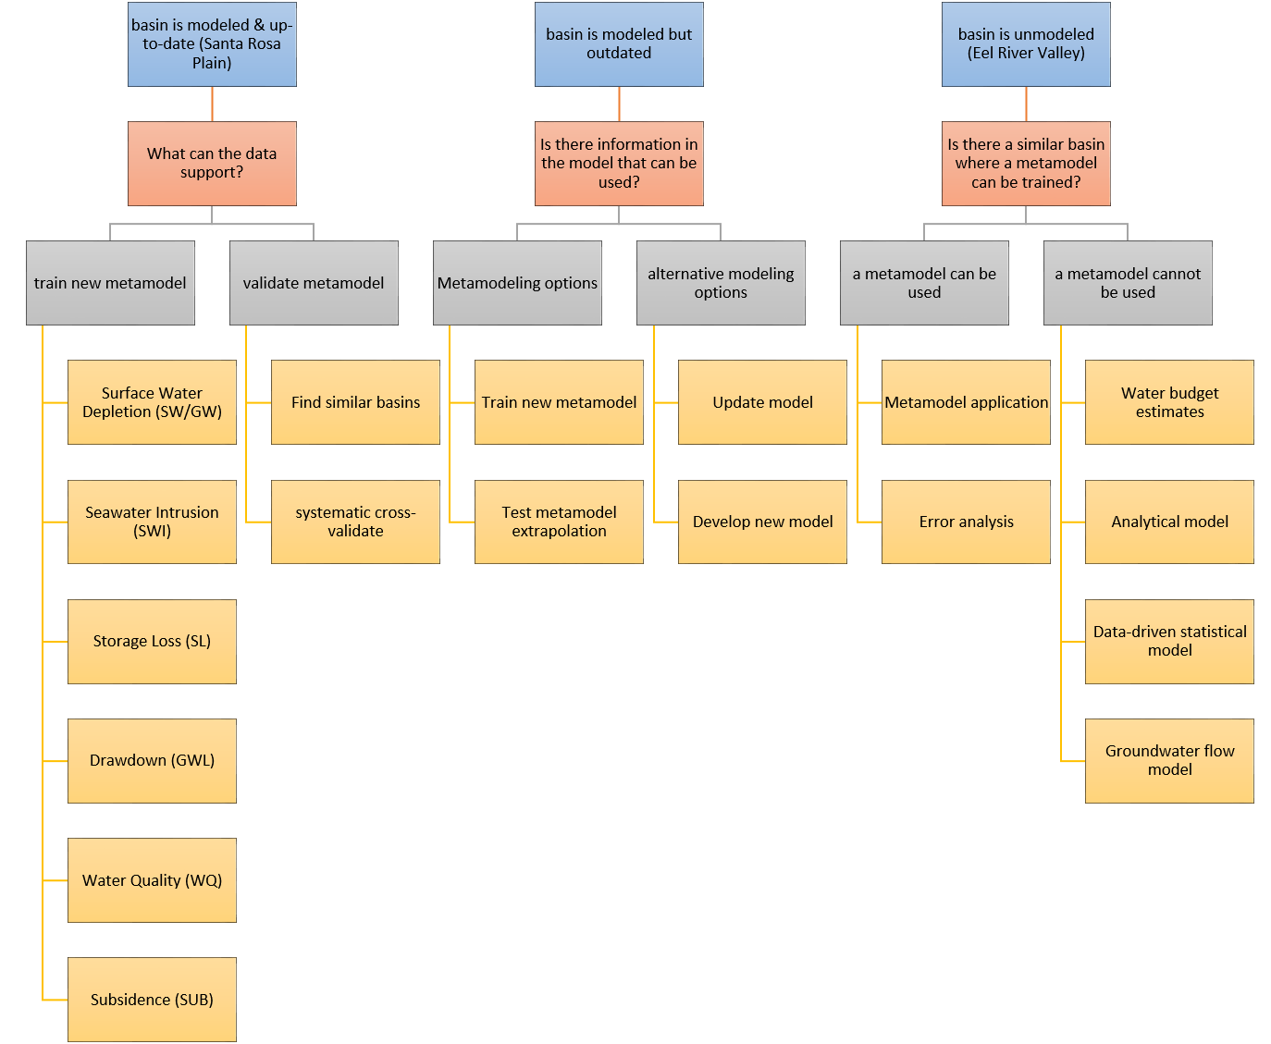
Figure 1: A flowchart that describes the modeling and/or metamodeling options available for a given basin depending on the status of an existing model.
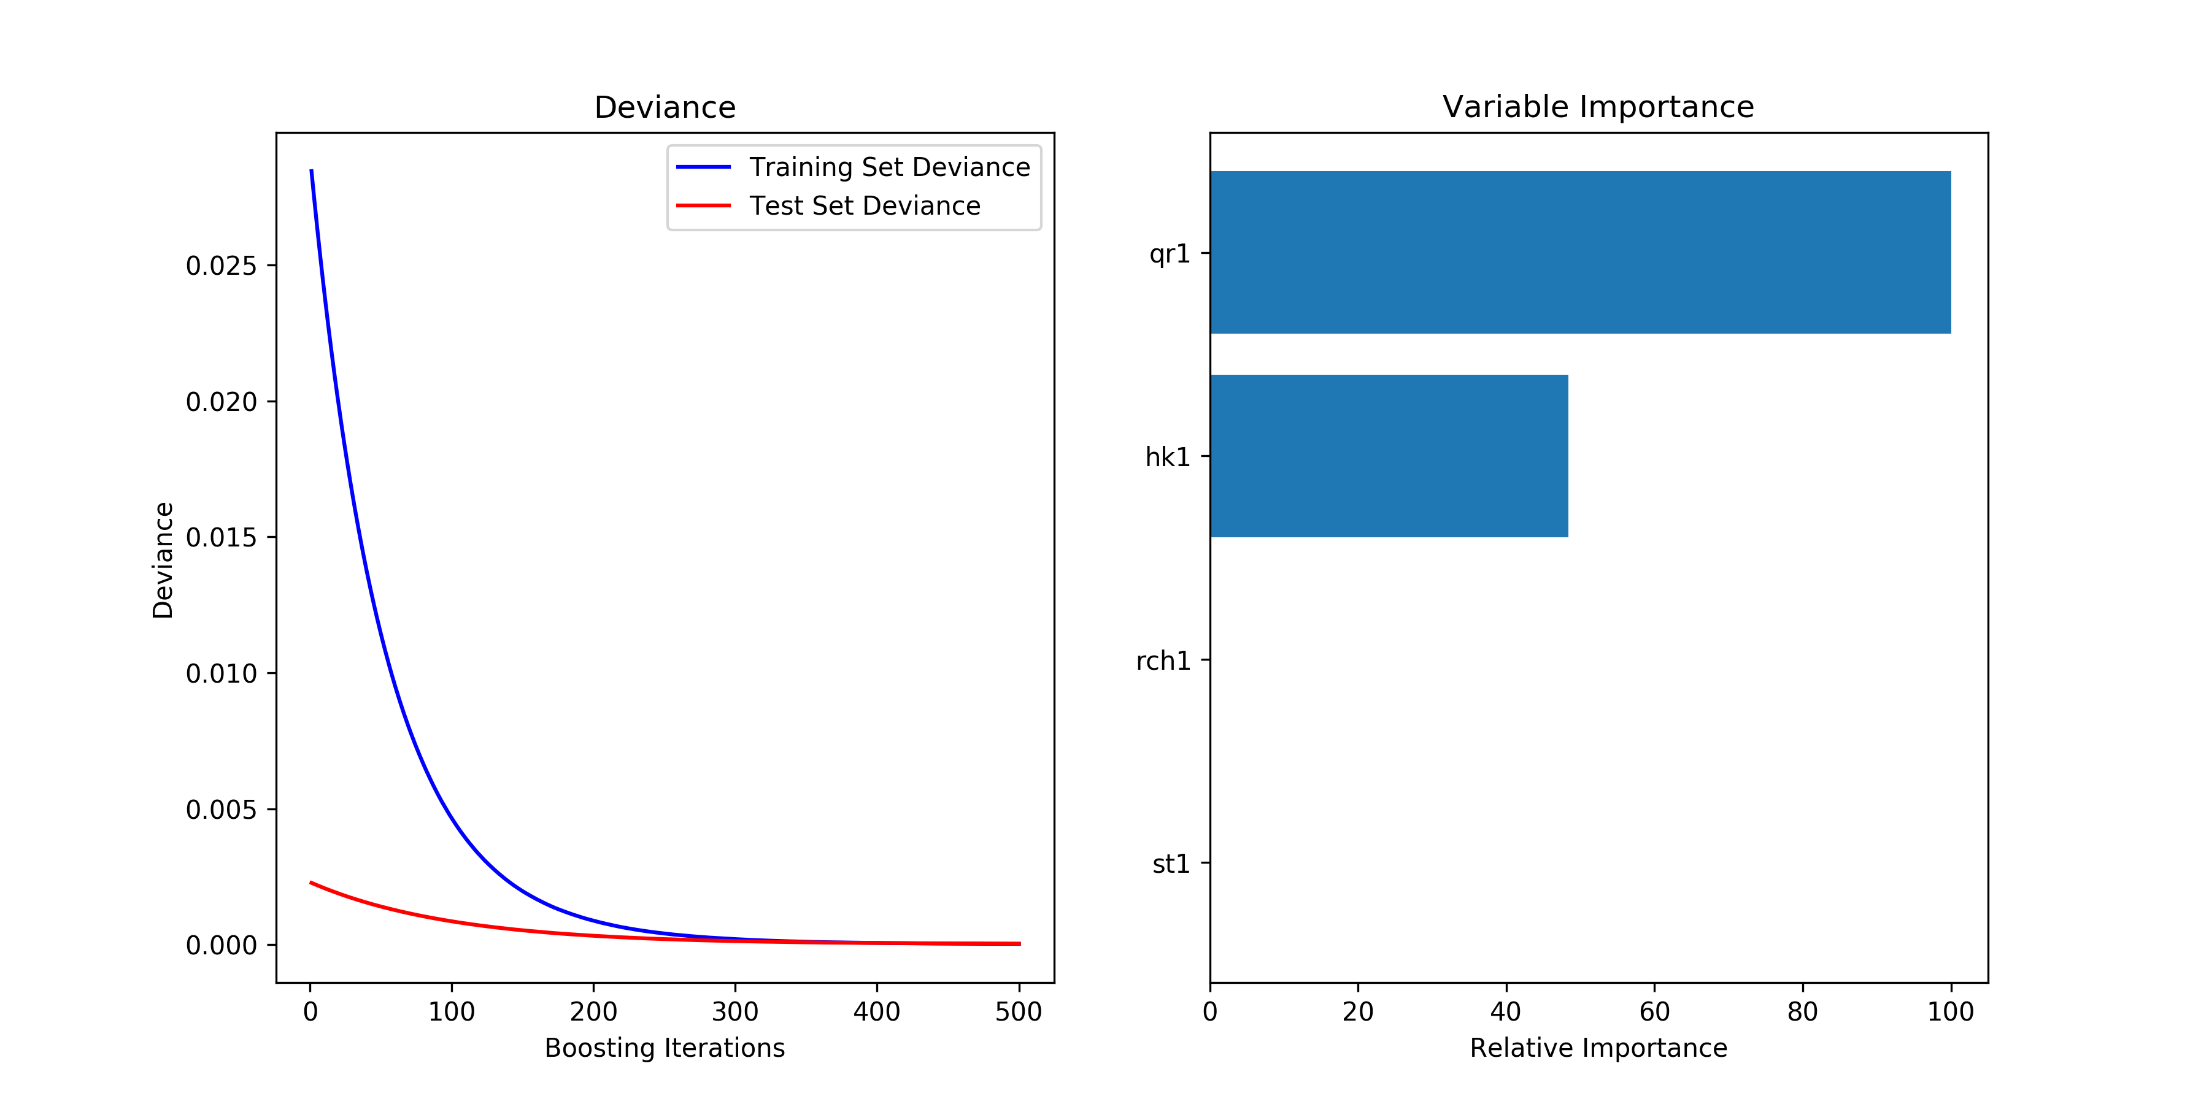
Figure 2: The number of boosting iterations for the Freyberg GBRT metamodels and the relative variable importance.
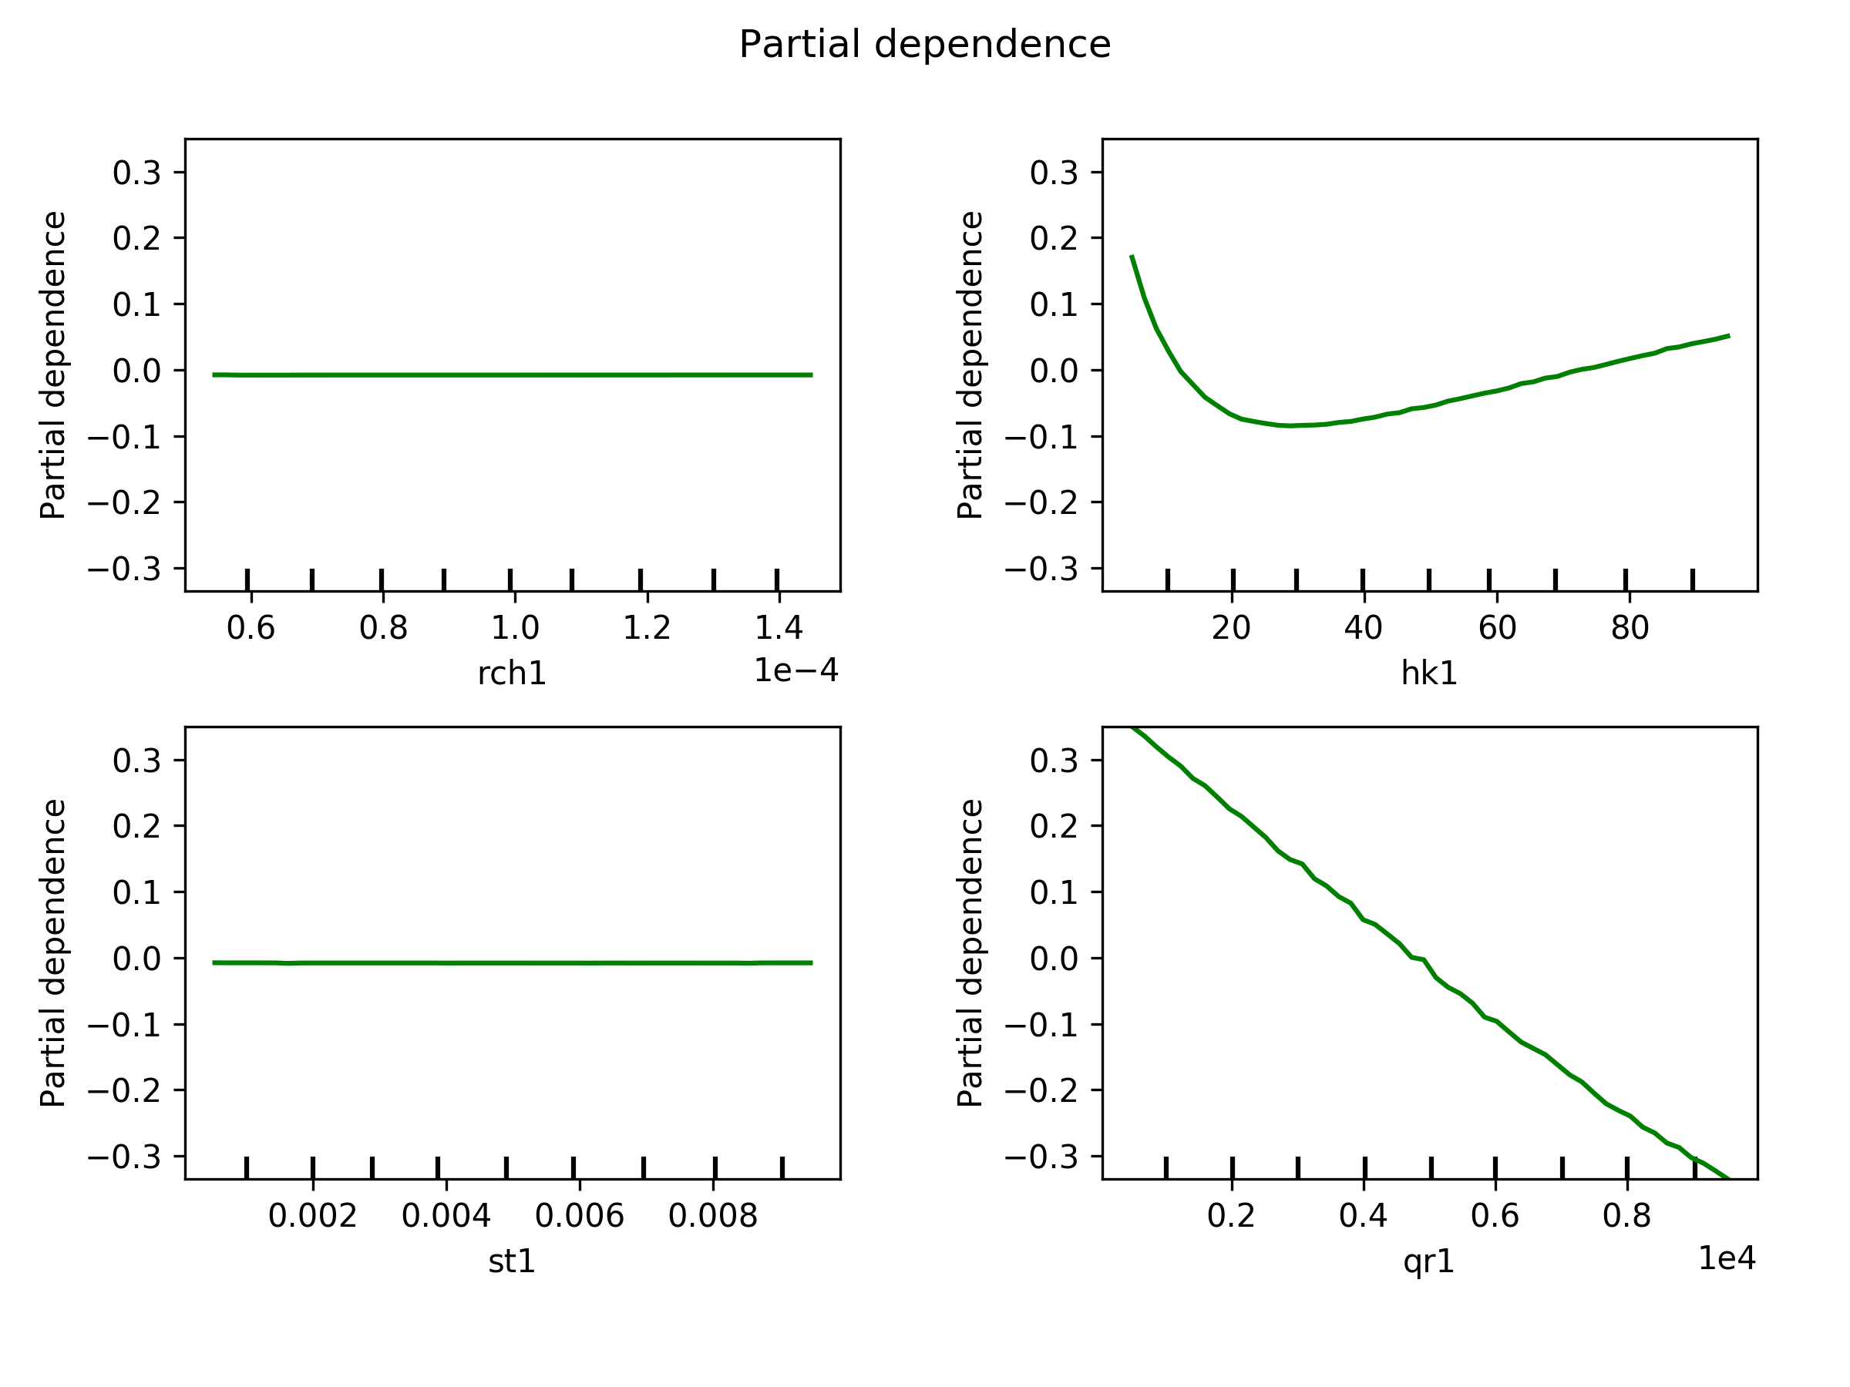
Figure 3: The partial dependence of the metamodels on the input parameters for the Freyberg metamodel. Here, recharge and storage are shown to have no effect. Pumping rate and hydraulic conductivity are shown to have a linear and nonlinear relationship, respectively, to the metamodel output.
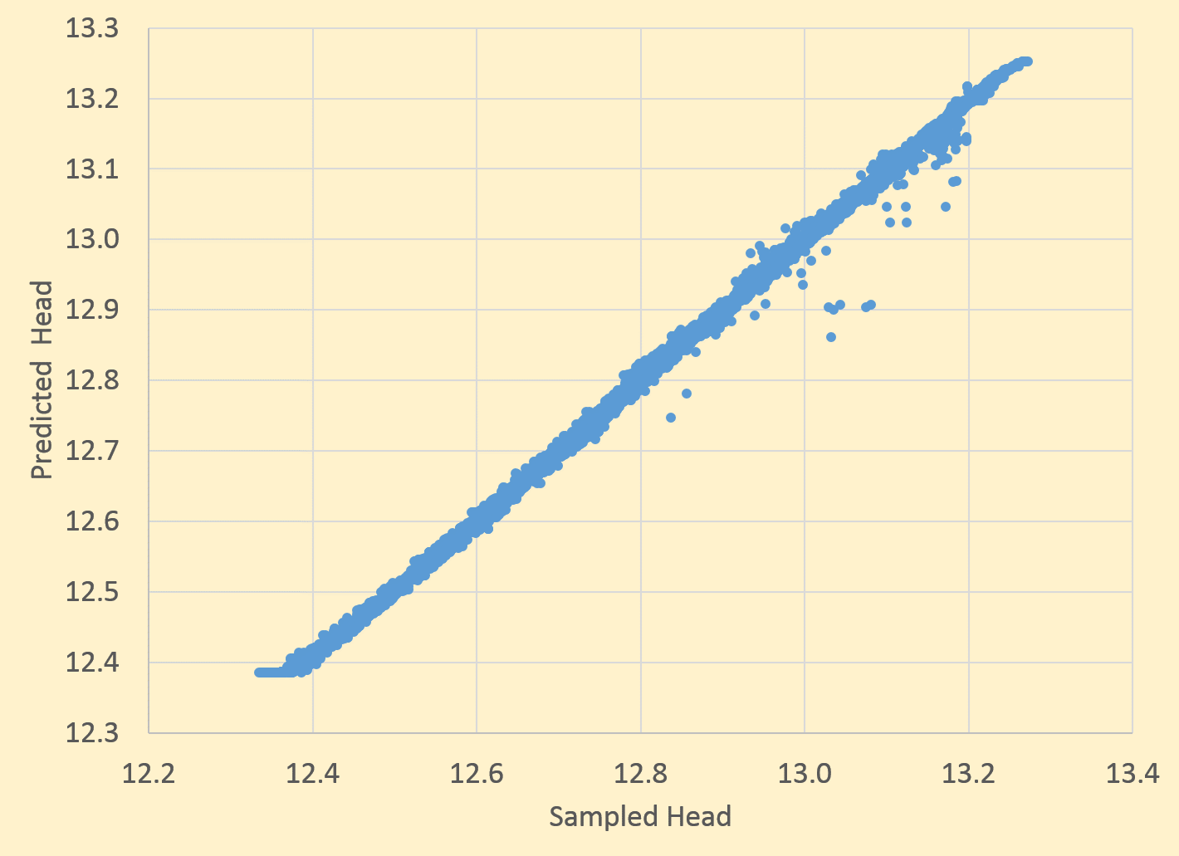
Figure 4: The first test of the trained Freyberg metamodels shows very good performance for the output variable of groundwater head at an observation location.

