National Brackish Groundwater Assessment: FY2016 End-of-Year Report

Prepared by Jennifer Stanton

- Project Accomplishments/Contributions (FY 2016)

Work tasks in FY 2016 were primarily related to:
- Completing the geochemical modeling and analyses,
- Revising the regression analysis to predict the probability of brackish groundwater occurrence,
- Preparing data and metadata for public release,
- Writing and editing the Professional Paper, and
- Writing and editing the Fact Sheet.

Assessing Brackish Groundwater as a Resource for the Nation
For some parts of the Nation, the large-scale development of groundwater has caused declines in the amount of groundwater in storage and in the amount of groundwater that discharges to surface-water bodies. Water supply in some areas, particularly in arid and semi-arid regions, is not adequate to meet demand, and severe drought currently is affecting large parts of the United States. Future water demand is projected to heighten the current stress on groundwater resources. The combination of factors has led to concerns about the availability of freshwater to meet domestic, agricultural, industrial, mining, and environmental needs. To ensure the water security of the Nation, untapped sources of water will need to be developed. Brackish groundwater is an unconventional source of water that may offer a partial solution to the water challenges of today and the future.
The USGS has conducted a national brackish-groundwater assessment to gain a better understanding of the occurrence and distribution of brackish groundwater as well as the geochemical and hydrogeologic character of the resource. As part of this study, updated national-scale maps of dissolved-solids concentrations and chemical-water types were created using data from about 380,000 sites compiled from more than 30 national, regional, and state sources. These data were used to assess the three-dimensional occurrence of brackish groundwater to a depth of 3,000 feet below land surface. A conservative estimate for the volume of brackish groundwater using available data is more than 900 times the amount of brackish groundwater currently used each year, and more than 40 times the amount of fresh groundwater used. Consequently, it is reasonable to consider brackish groundwater as a substantial water resource available for potential use by the Nation.
In addition to use limitations caused by large dissolved-solids concentration, other chemical constituents can affect the feasibility and cost of using brackish groundwater. The chemical composition of brackish groundwater across the Nation can be very different depending on the geologic setting and associated hydrologic and geochemical processes. Data compiled for this assessment indicated that concentrations of arsenic, barium, boron, fluoride, iron, nitrate, selenium, or uranium in brackish groundwater could limit the usefulness of the resource for drinking water, livestock or irrigation use. Because brackish groundwater will usually be treated prior to use for drinking water, many of the chemical constituents that exceed benchmark standards for that use will be removed during desalination. However, large amounts of those constituents present in the concentrated brine created as a byproduct of desalination can pose a challenge for disposing those waste products. In addition, some constituents, such as boron and arsenic, are not removed as easily as other constituents with common desalination methods. The potential for brackish groundwater to form mineral deposits (scale) was evaluated. Brackish groundwater samples commonly were oversaturated with respect to calcite, barite, or chalcedony, indicating that those minerals are more likely to cause scaling problems.

- Project Work Plan and Budget for FY 2017

Work planned for this study includes the following tasks:

Task 1 Objective: Locate, evaluate, organize, and compile relevant data for evaluating brackish aquifers

Approach: Review relevant literature and compile key datasets and interpretations related to: dissolved-solids concentrations and chemical characteristics. Develop a database of water chemistry and ancillary data from all well information compiled for this study.

FY17 Activities: None (completed)

Task 2 Objective: Create national-scale maps of brackish groundwater

Approach
- Synthesize data from Task 1 into a three-dimensional, grid-based spatial data set. ArcGIS will be used to accomplish this subtask.
- Create a dissolved-solids concentration map for each layer in the grid-based spatial data set and a map showing depth to shallowest brackish groundwater. Use the three-dimensional grid to define generalized vertical and horizontal extents of brackish groundwater.
- Create a generalized chemical water type map for each layer in the grid-based spatial data set (see maps below).
- Conduct statistical analyses to determine relations between dissolved-solids concentrations and hydrogeologic characteristics and to explain the presence or absence of brackish groundwater.

FY17 Activities: None (completed)

Task 3 Objective: Describe major brackish aquifers

Approach
- Evaluate the water-yielding capacity of each brackish zone using qualitative aquifer sediment descriptions or quantitative measures of hydraulic conductivity, permeability, porosity, percent sand content, or well discharge (see example graph below).
- Delineate the horizontal extent and, if possible, the vertical extent of important brackish zones.
- Summarize dissolved-solids concentrations by aquifer using concentration percentiles or distribution graphs.
- Describe current use of brackish and saline groundwater using data from USGS Water Use Program.
- Contact USGS experts in each state that can provide local geologic experience to verify or refine our understanding of brackish resources in that area.

FY17 Activities: None (completed)

Task 4 Objective: Produce products

Approach and FY17 Activities
- Update and maintain the study website
- Finish writing and publish the Professional Paper
- Publish a project summary Fact Sheet
- Publish data and metadata
- Write a press release
- Collaborate with MIT to examine the influence of water chemistry on the energy requirements of treating brackish groundwater by reverse osmosis.

Proposed 2017 Budget

Staff Hours* Cost
Jennifer Stanton (GS12) 440** $52,300
Sharon Qi (GS11) 160 $14,000
Rich Moore (GS13) 159 $17,700
JK Bohlke (RGE) 80 $19,000
Peter McMahon (GS15) 240 $37,700
Travel $15,000
PSC $8,800
Total $164,500***

* 18% of hours shown are for leave and holidays
** Some of these hours may be provided to Dave Anning or others on the team, depending on the type of report revisions that are needed
***This is an increase over previously agreed upon budget targets because the report got into the review process 1.5 months behind schedule, the review process is taking longer than expected, and for additional hours to collaborate with MIT on new work.

- Noteworthy Collaborations, Meetings, Technical Transfer Activities, and Spin-Off Project Developments

Presentations:

“USGS National Brackish Groundwater Assessment”
USGS Saline Water Resources Workshop, November 18, 2015

“USGS National Brackish Groundwater Assessment”
Nebraska Association of Resource Districts Legislative Conference, January 27, 2016

“Assessing the Nation’s Brackish Groundwater Resources”
University of Rhode Island Dept. of Geoscience Graduate Seminar, April 20, 2016

“Importance, Distribution, and Character of the Nation’s Brackish Groundwater Resources”
National Groundwater Association Groundwater Summit, April 27, 2016

“Assessing the Nation’s Brackish Groundwater Resources”
Eastern Nebraska Water Resources Assessment Spring Technical Meeting, May 6, 2016

“Methods to Assign Principal Aquifers to Wells for the Brackish Groundwater Assessment Study”
USGS Groundwater Workshop, September 2016

Collaborations:
We are pursuing a collaboration opportunity with several researchers at the Center for Clean Water and Clean Energy at MIT. The study will examine the influence of water chemistry on the energy requirements of treating brackish groundwater by reverse osmosis. We expect that there will be at least one journal article that will be produced as part of this collaboration. This collaboration will be a good way to get some additional benefit from the work we did to compile the comprehensive geochemical database for the study.

We’ve also been in contact with the Bureau of Reclamation throughout the life of this study with the hopes that we could eventually work together to answer some questions about how brackish groundwater treatment strategies can be optimized with geochemical modeling approaches. We recently got word that there will be some funding available to pursue this effort and have begun making plans to get a group of scientists together to develop a formal proposal.

- Report Products and Bibliographic Update

Abstracts:

Stanton, J.S., Anning, D.W, Moore, R.B., McGuire, V.L., and Degnan, J.R., 2016, Distribution and Character of the Nation’s Brackish Groundwater Resources: National Groundwater Association Groundwater Summit, Denver, Colo., April 24-27, 2016, Meeting Program: available at https://ngwa.confex.com/ngwa/2016gws/webprogram/Paper10884.html.

- Acknowledgements and Testimonials

None to report.

- Project Team Directory, FY2016

Jennifer Stanton, Hydrologist
Nebraska Water Science Center
Phone: (402) 261-0458
jstanton@usgs.gov
Project Manager

Rich Moore, Research Hydrologist
New England Water Science Center
Phone: (603) 226-7825
rmoore@usgs.gov
Geochemical statistics: regression analysis

Dave Anning, Hydrologist
Arizona Water Science Center
Phone: (928) 556- 7139
dwanning@usgs.gov
Geochemical statistics: regression analysis and national grid-based mapping

Ginny McGuire, Hydrologist
Nebraska Water Science Center
Phone: (402) 328-4126
vlmcguir@usgs.gov
Geology: Documenting aquifer boundaries and hydrogeologic characteristics

Alta Harris, Ecologist
USGS-Biology
Klamath Falls Field Station
Phone: 541-273-8689 x205
aharris@usgs.gov
Database Administrator

Sharon Qi, Physical Scientist
USGS-WRD
Colorado Water Science Center
Phone: (360) 993-8977
slqi@usgs.gov
GIS Support

Julian Heilman, Geographer
USGS-WRD
Arizona Water Science Center
Phone: (520) 670-6671 x281
jahr@usgs.gov
GIS Support

Jim Degnan
USGS-WRD
New England Water Science Center
Phone: (603) 226-7826
jrdegnan@usgs.gov
Geology: Aquifer-scale 3-D mapping with Oasis-Montaj software

Pete McMahon, Research Hydrologist
USGS-WRD
Colorado Water Science Center
Phone: (303) 236-6899
pmcmahon@usgs.gov
Geochemistry: Chemical characterization of brackish aquifers

JK Böhlke, Research Hydrologist
USGS-WRD
National Research Program
Phone: (703) 648-6325
jkbohlke@usgs.gov
Geochemistry: Chemical characterization of brackish aquifers

Craig Brown, Research Hydrologist
New England Water Science Center
Phone: 860-291-6766
cjbrown@usgs.gov
Geochemistry: Chemical characterization of brackish aquifers

- Photos of Field Activities, Animations, and Graphics

Recently created preliminary graphics:

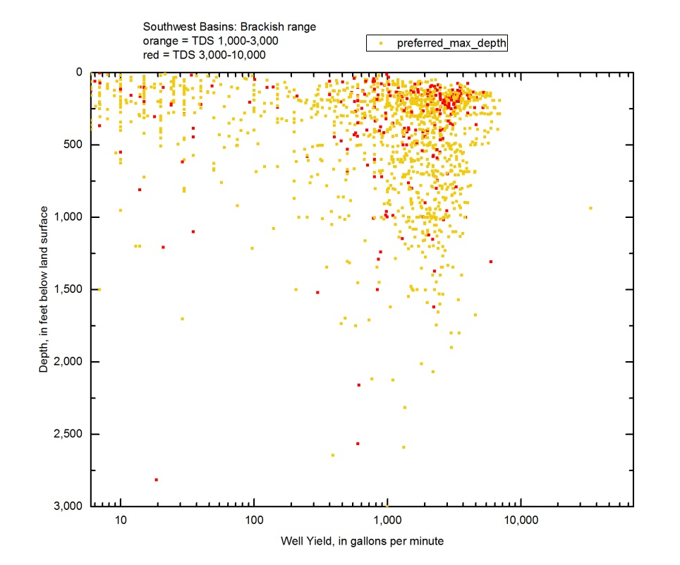
Graph showing relation between well depth and well yield in the Southwest Basins region.

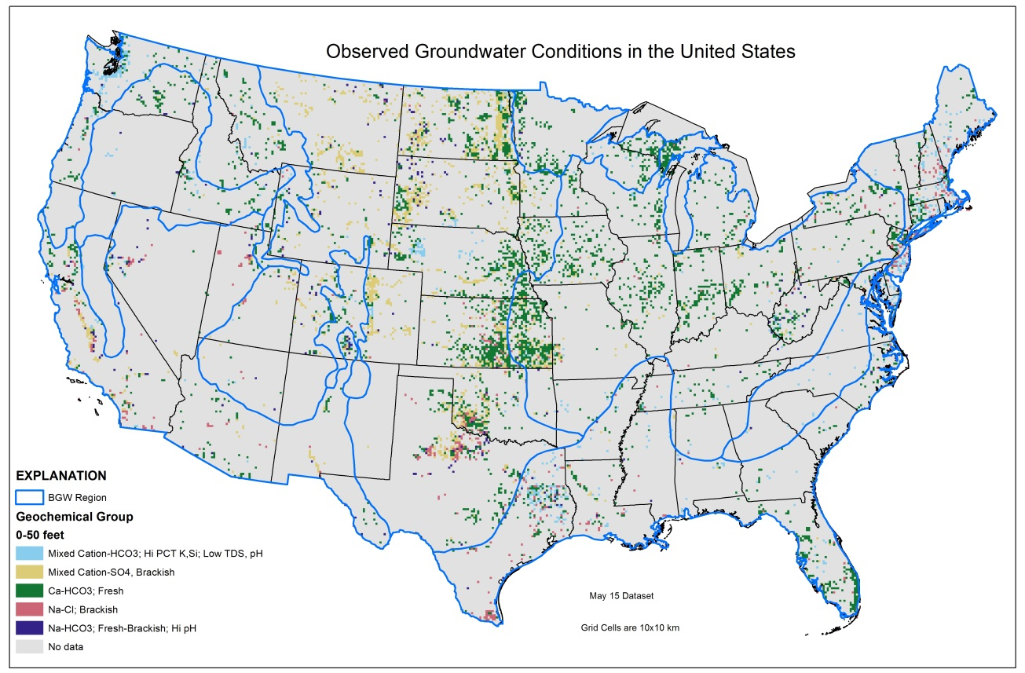
Map showing most frequent geochemical group observed in grid cells for 0 to 50 ft depth (blue lines are brackish groundwater region boundaries).
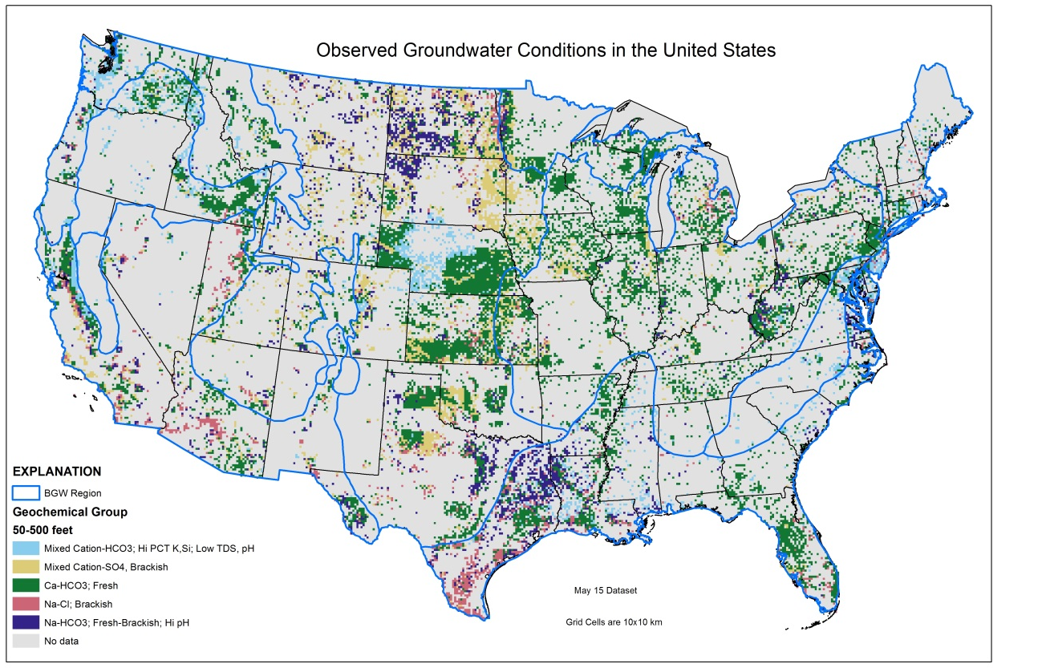
Map showing most frequent geochemical group observed in grid cells for 50 to 500 ft depth (blue lines are brackish groundwater region boundaries).
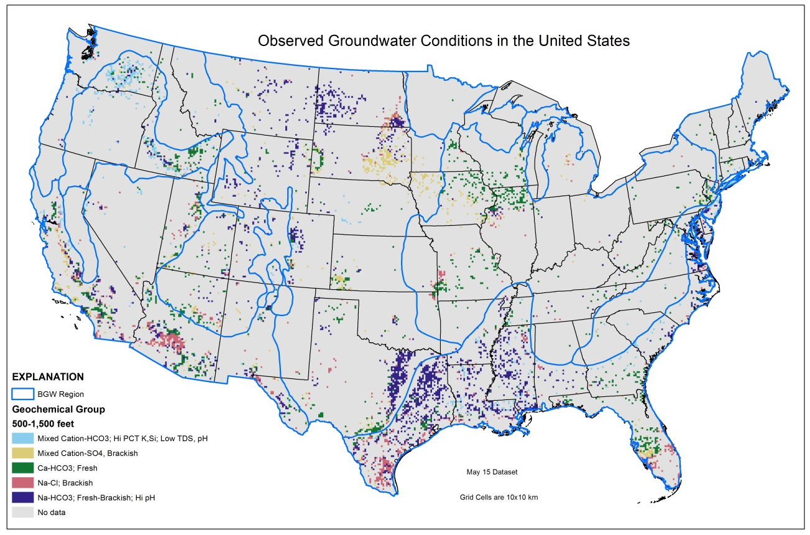
Map showing most frequent geochemical group observed in grid cells for 500 to 1,500 ft depth (blue lines are brackish groundwater region boundaries).
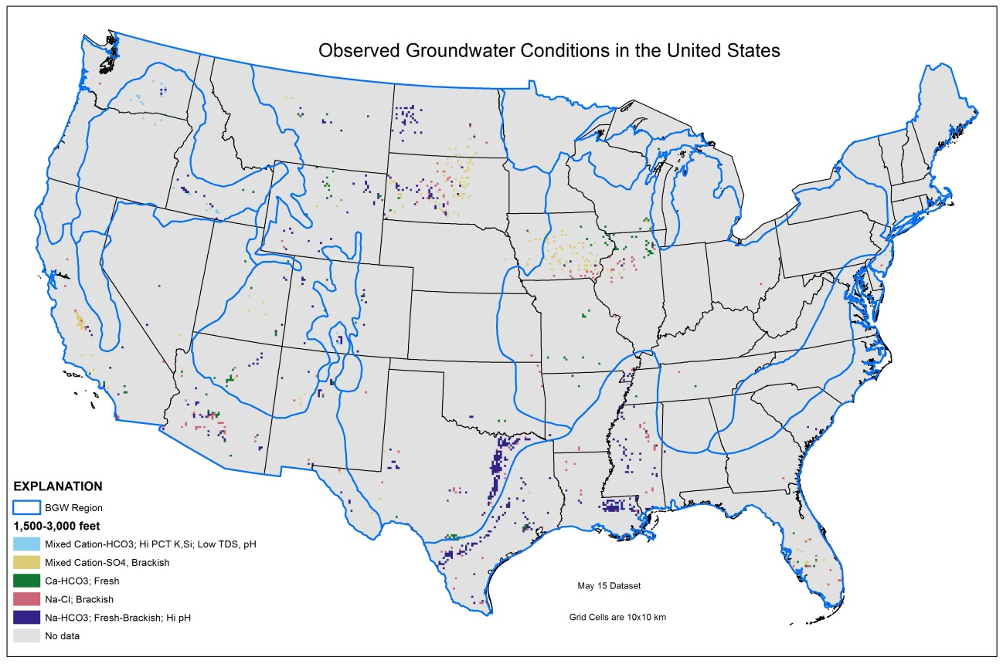
Map showing most frequent geochemical group observed in grid cells for 1,500 to 3,000 ft depth (blue lines are brackish groundwater region boundaries).

