*c_USGSidUPDATING PCFF 7.1 to PCFF 7.2*

Conventions used in this document:

Bold type indicates something you should type such as

**ftp hqwiftp.er.usgs.gov**

Italics text indicate a computer prompt such as

* ***Enter your password*** click on the SYSTEM DSN tab . A node for ORACLE\_SRC must be present! if the node doesn't exist perform the following steps..

<CR> indicates the carriage return key.

**\_\_\_\_\_\_\_\_\_\_\_\_\_\_\_\_\_\_\_\_\_\_\_\_\_\_\_\_\_\_\_\_\_\_\_\_\_\_\_\_\_\_\_\_\_\_\_\_\_\_\_\_\_\_\_\_\_\_\_\_\_\_\_\_\_\_\_\_\_\_**

**PCFF 7.2 is compatible with a PCFF 7.1 database.**

# INSTALL PCFF 7.2

In order to upgrade from PCFF 7.1 to PCFF 7.2 the computer administrator should perform an initial install of PCFF 7.2 as per the PCFF72Install.docx instructions.

Once PCFF 7.2 is installed, copy the following files from the PCFF 7.1 install dir to the PCFF 7.2 install dir

* pcff7.ini
* the active PCFF database (typically named “pcff7\_db.accdb”)

# CONFIGURE PCFF TO USE NWIS DATABASE CONNECTION

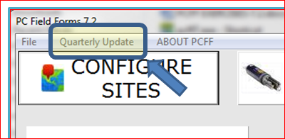Start PCFF 7

* Press the Quarterly Update

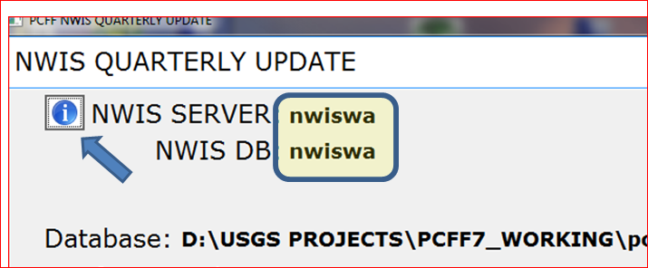

Screenshot: Information Button

* Press the Button
* Select the correct NWIS server and NWIS DB for your site (nwiswa shown for example purposes).
* Save the selection

PCFF 72 is now installed and is ready to use

# DELETE PCFF 7.1

Once PCFF 7.2 is installed and the PCFF 7.1 database copied over, delete the PCFF 7.1 installation as it’s no longer required.

# Questions or comments should be directed to:

## Frank Crenshaw (970) 628-7144 [fccrensh@usgs.gov](mailto:fccrensh@usgs.gov)