*c_USGSidGETTING STARTED*

INSTALL PCFF 7.2

Conventions used in this document:

Bold type indicates something you should type such as

**ftp hqwiftp.er.usgs.gov**

Italics text indicate a computer prompt such as

* ***Enter your password*** click on the SYSTEM DSN tab . A node for ORACLE\_SRC must be present! if the node doesn't exist perform the following steps..

<CR> indicates the carriage return key.

**\_\_\_\_\_\_\_\_\_\_\_\_\_\_\_\_\_\_\_\_\_\_\_\_\_\_\_\_\_\_\_\_\_\_\_\_\_\_\_\_\_\_\_\_\_\_\_\_\_\_\_\_\_\_\_\_\_\_\_\_\_\_\_\_\_\_\_\_\_\_**

**The latest version of PCFF can connect directly to the users NWIS server . This functionality is used to help configure the software as well as allow the user to obtain the most recent NWIS lookup lists.**

**Install Microsoft Office 2010 32 bit software**

PCFF7.2 requires that Microsoft Office 2010 32 bit be installed. PCFF 7 will not be fully functional with any other version of office (including all 64 bit versions) at this time.

**IF 32 bit office is not installed PCFF 7 SHOULD NOT BE USED AS THE QUARTERLY UPDATE FEATURE WON’T WORK!!**

If PCFF 7.2 is going to be used using a different Office product (such as Office 2013 or any 64 bit versions office) then download and install the following. However the quarterly update feature will cease to function. This means that it will be impossible to install NWIS coding updates. It’s not recommend that PCFF be used without this feature as over time the NWIS changes will not be reflected in PCFF, making PCFF not usable in some cases.

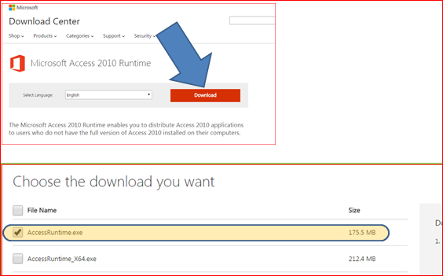

<http://www.microsoft.com/en-us/download/details.aspx?id=10910>

**Install ORACLE Client software**

NOTE:  these two products are pre-requisites to other NWIS applications and may already be installed on the system.  **If they are already installed, no further action is required, proceed to the next step.**

If not already present, a user with administrator privileges needs to perform the following installations:

* Install the Oracle client as per <http://nwis.usgs.gov/IT/ORACLE/Oracle.client.installation.htm>
* Install Keberos as per http://nwis.usgs.gov/IT/ORACLE/Setting.up.Oracle.Kerberos.Windows.htm

**Obtain the PCFF software**

Obtain the base software [http://water.usgs.gov/usgs/owq/PCFF/PCFF72.zip](http://water.usgs.gov/usgs/owq/PCFF/PCFF72.zip" \t "_blank)

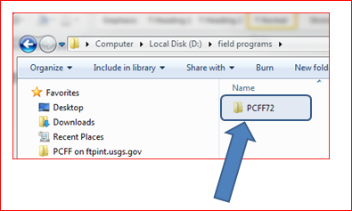

Place the files some place the user will have full access (such as c:\field\_apps\PCFF72 for example). **NOTE: Ensure that all users of the PCFF7 software have full access to the PCFF7 install directory**

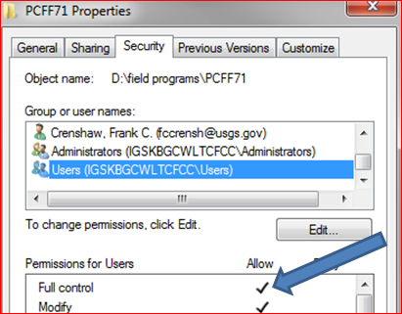

## **(64 Bit OS) If the computer is running Windows 7 x64 do the following steps as a user with Administrative Privileges.**

In the PCFF install directory, locate the directory labeled SETUP/ODBC SETUP X64

1. **Register the ChilkatSsh.DLL to allow for upload of field sample data to the NWIS server.**

***NOTE: if this step fails see the steps to manually register the DLL’s at the end of this document.***

**For 32 bit systems (Windows 7 and Windows XP)**

* + **Run the from the main install directory locate and run the RegisterTeclipse32.exe program as shown. Press the button to register the DLL.**

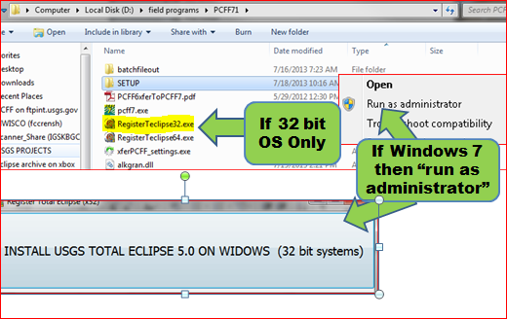

* + **Run the from the main install directory locate and run the RegisterTeclipse32.exe program as shown. Press the button to register the DLL.**

**For 64 bit systems (Windows 7) do the following**

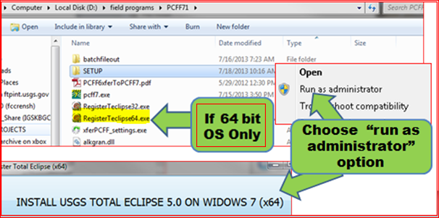

* + **Run the from the main install directory locate and run the RegisterTeclipse64.exe program as shown. Press the button to register the DLL.**

***(ONLY NECESSARY IF REGISTRY FAILED IN STEPS ABOVE!)***

**If the DLL’s failed to register in the above steps, then Register the ChilkatSsh.dll to allow SSH xfer or batch filed from the field.**

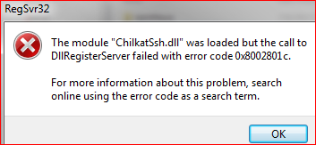

***NOTE: if running windows 7 you must first right click then choose run as administrator option even if logged in as an administrator!***

* Open a command window and navigate to the directory that has the PCFF files in it.
* IF WINDOWS 7 (64 Bit) then enter

**C:\Windows\SysWOW64\regsvr32 ChilkatSsh.dll**

* IF WINDOWS 7 (32 bit ) or Windows XP enter :
* **regsvr32 ChilkatSsh.dll**

# CONFIGURE PCFF TO USE NWIS DATABASE CONNECTION

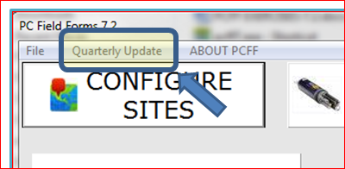Start PCFF 7

* Press the Quarterly Update

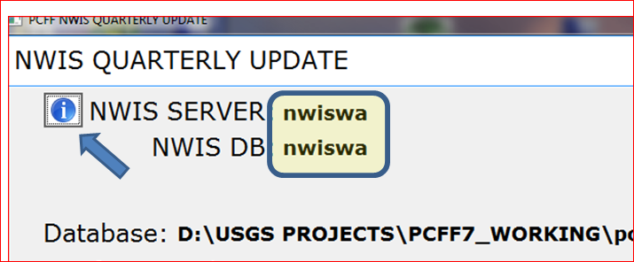

Screenshot: Information Button

* Press the Button
* Select the correct NWIS server and NWIS DB for your site (nwiswa shown for example purposes).
* Save the selection

PCFF 7 is now installed and is ready to use

# Questions or comments should be directed to:

## Frank Crenshaw (970) 628-7144 [fccrensh@usgs.gov](mailto:fccrensh@usgs.gov)