RESSED – An Online Reservoir Sedimentation Survey Database for the United States

National Interdisciplinary Conference, “From Dust Bowl to Mud Bowl”
September 14-16, 2009, Kansas City, MO

J.R. Gray¹, J.M. Bernard², D.W. Stewart¹, G.E. Schwarz¹, and K.T. Ray¹

¹ U.S. Geological Survey
² Natural Resources Conservation Service

The U.S. Geological Survey (USGS) and Natural Resources Conservation Service have created the Reservoir Sedimentation Survey Information database (RESSED). RESSED is the most comprehensive compilation of data from reservoir bathymetric and dry-basin surveys in the U.S. As of January 2009, the RESSED contained results from 6,617 surveys at 1,822 reservoirs in the conterminous United States and one in Puerto Rico (figure 1). The data span the period 1755-1993, with 95 percent of the surveys performed between1930-90. The reservoir surface areas range from sub-hectare-scale farm ponds to 658-square-kilometer Lake Powell. The data in the RESSED can be useful for a number of purposes, including calculating changes in reservoir storage characteristics, quantifying sediment budgets, and estimating erosion rates in a reservoir’s watershed.

The online, publically available RESSED application uses the updated Reservoir Sediment Survey Information System (RESIS-II) developed by the USGS as its base. RESIS-II, in turn, emanated from the original RESIS database developed by the Soil Conservation Service (since 1993, the Natural Resources Conservation Service). The RESIS-II relational database contains more precise and demonstrably reliable location coordinates than RESIS for the majority of the reservoirs.

The RESSED application is anticipated to be the focus for enhancements and improvements to the RESIS-II database. Current plans for future enhancements include: Refinement of coordinates for reservoirs lacking reliable location information; addition of survey data for reservoirs in the January 2009 database; and addition of survey data for other reservoirs.

Users of the RESSED are encouraged to provide demonstrably reliable reservoir coordinates as necessary. Additionally, an online RESSED form enabling entry of survey information is being developed, along with protocols for collection and storage of reservoir-bathymetric information. New reservoir coordinates and additional survey data submitted for storage in the RESSED will be quality-assured by the Subcommittee on Sedimentation of the U.S. Water Information Coordination Program’s Advisory Committee on Water Information before being entered into the publically available database. The RESSED, which was developed under the auspices of the Subcommittee on Sedimentation, can be accessed via: http://ida.water.usgs.gov/RESSED/.

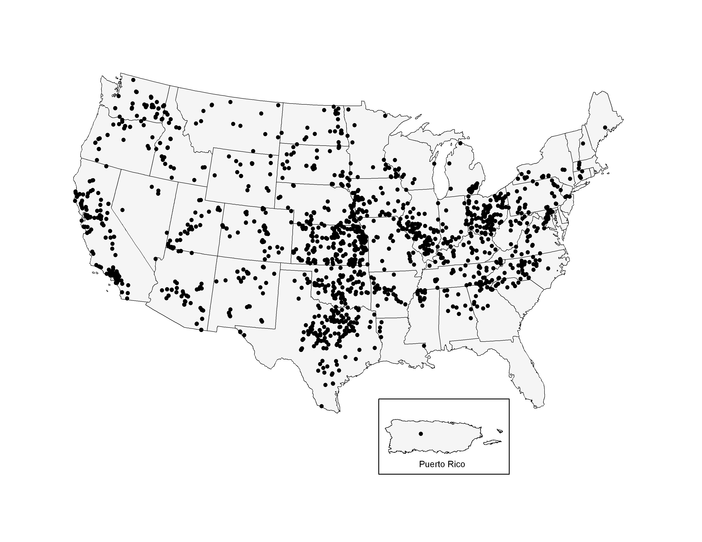
Figure 1. Map of RESSED reservoir locations (January 2009).

