Sampling Design for the Northeast Stream Quality Assessment – 2016
November 18, 2015
The following is a description of the design and approach of the 2016 Northeast Stream Quality Assessment (NESQA). It is intended to provide the Water Science Centers (WSCs) with enough information about our objectives, approach, and sampling plans to complete detailed planning and budgeting for the study. A spreadsheet with timeline and a proposed sampling budget for work carried out by the WSCs also is provided. The budgeting spreadsheet is modified from what was used by the Regional Stream Quality Assessment (RSQA) leaders for developing budgets with WSCs in the previous three regional studies: Pacific Northwest (PNSQA, 2015), Southeast (SESQA, 2014), and Midwest (MSQA, 2013). A separate memo (“NESQA Tasks and 2016 Budgets”) outlines the proposed division of tasks between the WSCs and the RSQA team and describes the budgeting process we are following.
Objectives and Scope
The broad objectives of the NAWQA Cycle 3 Regional Stream Quality Assessment studies are to:
- Determine the status of stream quality – contaminants, nutrients, toxicity, sediment, flow, habitat, and ecological communities – across a region
- Evaluate relations between stressors and ecological condition at sampled locations
- Evaluate relations between the environmental settings of the watersheds and the measured stressors and ecological condition in streams
- Develop regional models and management tools to make spatially-explicit predictions of stressors and ecological responses across the region
On the basis of conversations with USGS and external scientists, resource managers, and stakeholders in the region, we have adapted the general RSQA design to address the dominant stressors and partly address locally-important issues in the region. The RSQA design targets gradients in urban and agricultural land uses with the assumption that by doing so we are sampling the most important in-stream chemical and physical stressors. During the NESQA planning process, we also considered five specific stressors: streamflow alteration, mercury, road salt, unconventional oil and gas development (UOG), and acid deposition. Our design calls for the majority of sites to be selected across a gradient of urban land use, a smaller number of sites selected in light- and moderate-intensity agricultural settings, and a number of reference sites selected across the region. Although not explicitly factored into site selection, the distribution of sites covers variations in the four of the five specific stressors listed above (excluding for the most part, acid deposition).
The NESQA region is defined as the combination of EPA level 3 ecoregions (ECO3) 5.3.1, 8.1.1, 8.1.3, and 8.1.7 (Fig. 1). The region includes the Atlantic Highlands ecoregion (5.3.1) where 66 gaged stream sites affected by a range of hydrological alteration (from unaltered to highly altered by upstream dams) have been monitored for air and water temperature since 2013, and were sampled by NAWQA in 2014 for macroinvertebrates, algae, habitat, and limited water and sediment chemistry. Although for the NESQA study, only sites in the southern parts of the Atlantic Highlands will be sampled, roughly below a line from Manchester, NH, to Syracuse, NY (Fig. 2). To the extent possible, those data will be combined with NESQA data for interpretations.
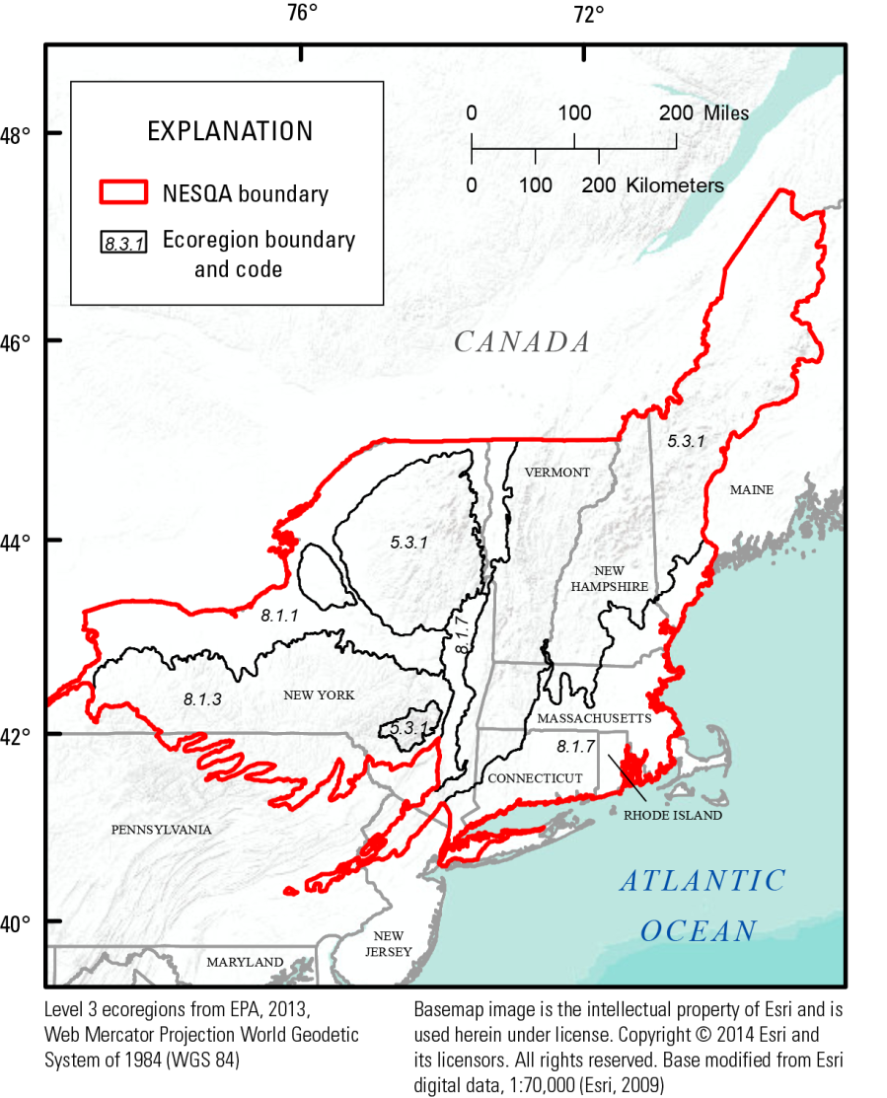
Figure 1. NESQA region showing ECO3 boundaries.
The most intensive urban land use occurs in the lowland ecoregions (8.1.7 and 8.1.1), in particular the New York Metro area—Boston corridor, and around the cities of Albany, Syracuse, Rochester, and Buffalo (Albany—Buffalo corridor) (Figs. 1 and 2). Fairly intensive agriculture is found in parts of New York State, in particular in Central and Western NY, as well as the Southern Tier, and in northern Pennsylvania portion of the study area. Because of the extent of urban land use across the region (the population of ecoregion 8.1.7 is 18,000,000) and continuing urban sprawl around many cities, urban land use will be a greater focus than agriculture. Relatively few sites and effort will be directed at the Atlantic Highlands ecoregion (5.3.1), where sampling at 66 sites representing a range in flow alteration was completed in 2014. This ecoregion is dominated by forest with relatively little urban or agricultural land (Fig. 2) but is generally subject to greater anthropogenic stresses than other US forested uplands because of atmospheric deposition of mercury, application of road salt, and exurban development. For these reasons, 16 sites in settings ranging from forested reference to light urban will be sampled in the Atlantic Highlands.
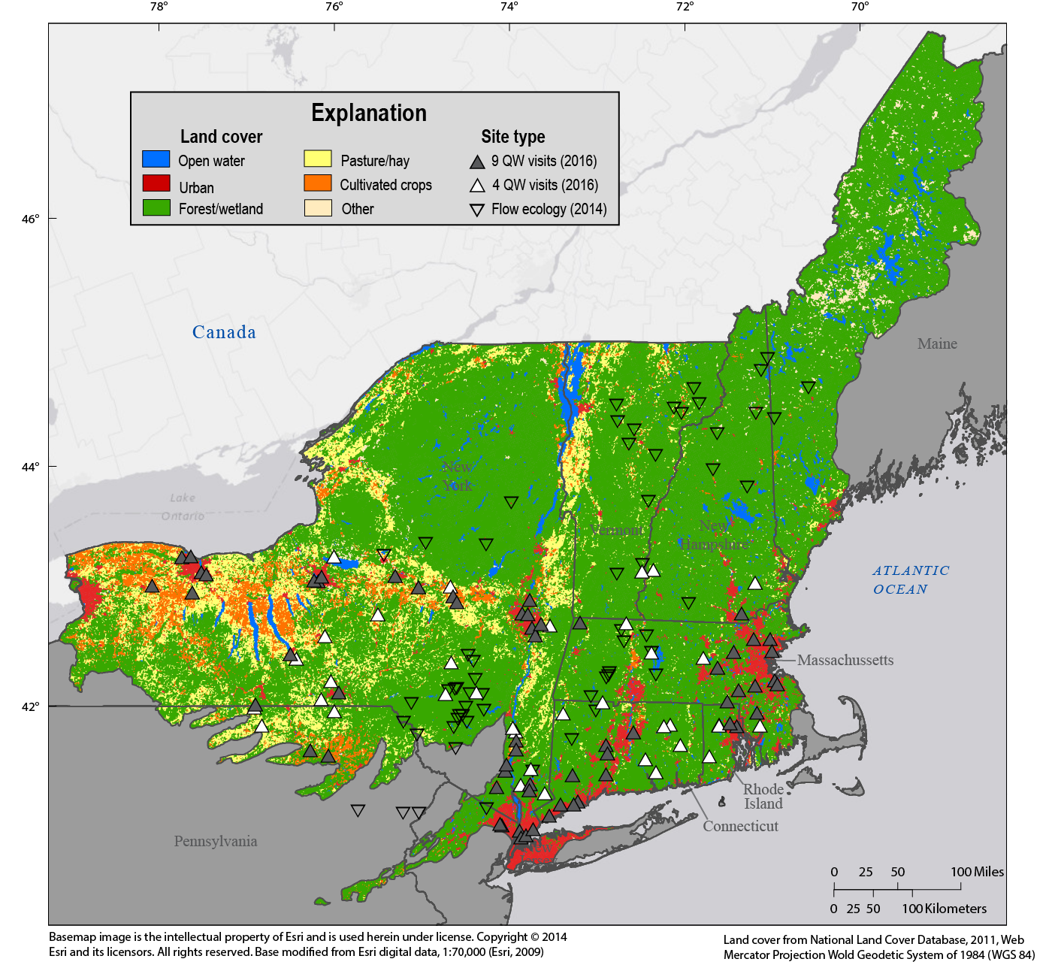
Figure 2. Site distribution and type and land use in the NESQA region.
Site Distribution and Sampling
In total, 97 sites are planned for sampling by the NESQA (using current projections of funding and costs) (Figure 2; Table 1). Sites were selected to span the urban and agricultural gradients in the region (Figure 3). Water sampling will start on June 6, 2016 (Table 2) and will be done weekly for 9 weeks at 61 sites: 53 urban sites across the full urban gradient and 8 agricultural sites. Thirty-six sites, spanning undeveloped (largely forested) reference to light-urban/rural/light-ag land use across the upland and lowland ecoregions will be sampled 4 times during the last 4 weeks of the 9-week sampling period. Time-integrating Polar Organic Compound Integrated Samplers (POCIS) will be deployed during the last 6-7 weeks of the sampling period at all 61 of the 9-sample sites and some of the 4-sample sites. Sediment sampling and ecological surveys will be done once per site at the end of the 9 week water-quality sampling period and two additional sediment samples will be collected at about 14 of the more intensely developed sites during the 9-week period. Because mercury bioaccumulation is an important stream quality condition indicator in this region, fish samples of selected species will be retained for mercury analysis from most sites, providing bioaccumulation data across ranges in source condition and methylation potential. All sites are gaged or will have pressure transducers installed to provide a stage record. All sites will have temperature thermistors installed to provide a continuous water temperature record for up to a year preceding sampling.
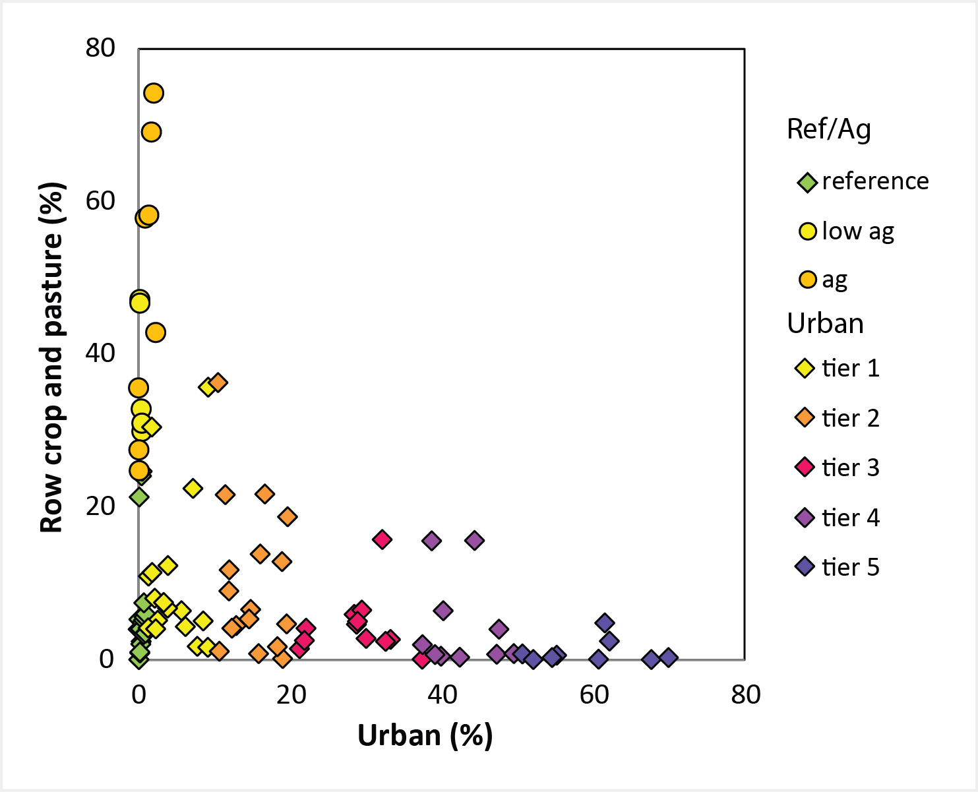
Figure 3. Site distribution in relation to urban and agricultural land-use gradients.

General  landscape setting | Number of sites visited 9 or 4 times for QW sampling |  |  | Number of sites located in each WSC |  |  |  | Dominant Ecoregion type
General  landscape setting | 9 QW visits | 4 QW visits | Total sites | NEWSC  (9x,4x) | NYWSC  (9x,4x) | NJWSC  (9x,4x) | PAWSC (9x,4x) | Lowlands | Highlands
Urb Tier 5 | 9 | - | 9 | 5  (5,0) | 4  (4,0) | - | - | 9
Urb Tier 4 | 10 | - | 10 | 4  (4,0) | 6  (6,0) | - | - | 10
Urb Tier 3 | 12 | - | 12 | 7  (7,0) | 5  (5,0) | - | - | 11 | 1
Urb Tier 2 | 17 | - | 17 | 6  (6,0) | 9  (9,0) | 2  (2,0) | - | 15 | 2
Urb Tier 1 | 5 | 12 | 17 | 10  (2,8) | 7  (3,4) | - | - | 13 | 4
Ag high | 8 | - | 8 |  | 6  (6,0) | - | 2  (2,0) | 8
Ag mod | - | 5 | 5 | - | 3  (0,3) | - | 2  (0,2) | 5
For/ref | - | 19 | 19 | 9  (0,9) | 9  (0,9) | - | 1  (0,1) | 10 | 9
Totals | 61 | 36 | 97 | 41  (24,17) | 49  (33,16) | 2  (2,0) | 5  (2,3) | 81 | 16

Table 1. Target site distribution by landscape type, sampling frequency, water science center, and dominant ecoregion type (highlands denote 5.3.1; lowlands denote 8.1.1, 8.1.3, 8.1.7, and 8.4.1).

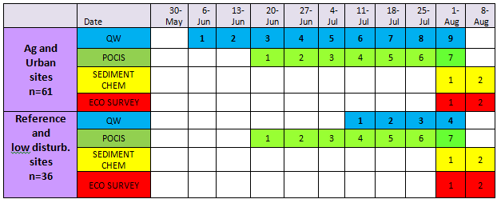
Table 2. Sampling timeline.

Water Quality
Water-quality sampling will be done for either a four or nine-week “index period” at each site to characterize antecedent conditions prior to conducting ecological surveys (algae, invertebrate, and fish communities; habitat), bed sediment sampling, and fish tissue collection for Hg analysis. Water-quality sampling frequency and parametric coverage will vary depending on site type (Table 1). Current plans call for:
- Regular Sites: Higher density urban sites (tiers 2-5 and a few higher density tier1 urban sites), and higher intensity ag indicator sites. Sample water-quality nine times (weekly) during the 9 week index period, with analyses of pesticides, nutrients (incl. glyphosate by immune assay), major ions, DOC, and suspended sediment in all weekly samples; and analyses of organic wastewater indicators (OWIs), pharmaceuticals, glyphosate (by GC/MS), and total and methyl Hg, in selected samples collected from each site during the 9 week period. Deploy POCIS time-integrating samplers during the last 6-7 weeks of the index period and analyze them for pesticides, OWI, pharmaceuticals, and the YES (yeast estrogen screen) assay. Bed sediment sampling will be done by the ecology sampling crews and is described below.
- Reference/rural sites: Light urban, moderate ag, and forested /reference sites. Sample weekly for the last 4 weeks of the 9-week index period with similar parametric coverage as regular sites. Bed sediment sampling is similar to the regular sites but will not include some of the organic contaminants in some or all sites.
Ecological sampling will be done at all sites during the first two weeks of August (tentatively, weeks of Aug 1 and Aug 8). Algae (periphyton), invertebrate, and fish communities, and habitat will be sampled at all sites following NAWQA protocols. Periphyton samples also will be collected for chlorophyll and ash-free-dry mass, and for stable isotope (C&N) analysis. Bed sediment will be sampled by the ecological survey crew for analyses of organohalogen (OH) compounds, polycyclic aromatic hydrocarbons (PAHs) and semi-volatile organic compounds (SVOCs), metals (including total Hg and methyl Hg), OWIs, current-use pesticides (CUPs), and hormones (not all parameters will be analyzed at all sites). Splits of bed sediment from about one-half of the sites will be tested for toxicity at the Columbia Environmental Research Center (CERC). Three to five samples of several targeted fish species (including top predator) will be retained for Hg and stable isotope (C&N) analysis from each site. Fish and bed sediment from 10-30 selected sites (depending on funding and laboratory capacity) will be analyzed for Hg isotopes to assess the relative importance of atmospheric versus local Hg sources.
Ecological sampling crews will be assembled from the Regional Studies team (RSQA) and WSCs in and outside the region. Planning will be handled by RSQA and Ecological Synthesis personnel and funding for support for this work will be handled separately from the water quality sampling.
Continuous data will be used extensively in the NESQA. All sites will be gaged or will have pressure transducers deployed. All sites will have continuous temperature thermistors (water temperature thermistors are being deployed fall 2015; pressure transducers will be deployed spring 2016).
Additional focused work will be done at a few sites; this work is described below in Special Studies.
Timing
The planned timeline for sampling is shown in the Table 2. Pre-sampling efforts include:
1) Brief other potential partners; explore opportunities for collaboration (soon)
- States, EPA, USGS Programs, Tribes, River Basin Commissions, Water Resource Research Centers, NGOs (e.g., TNC, Scenic Hudson), others
2) Develop detailed sampling plans (Oct-Dec 2015)
- RSQA team will provide detailed site-by-site plans
- Coordinators and WSCs will develop staffing plans and field schedules
3) Finalize budgets with WSCs (Dec 2015)
4) Install thermistors (fall 2015) and pressure transducers (spring 2016)
5) Conduct 2-day webex and 1-day face-to-face training for field crews (March and May 2016, respectively)
6) Arrange for special studies support, and install equipment (Spring 2016)
- Pankow training ~March; installation of samplers in April; begin test runs in May
- Walling tube installation ~April 2016 (Allen Gellis is lead)
- Continuous monitor installation ~April 2016 (Mark Munn is lead)

Sampling
Water chemistry
Water chemistry samples will be collected weekly over 9 weeks at regular sites and over 4 weeks at forested/reference/rural sites. Water chemistry sampling will be done by WSC crews with logistical and database support from the RSQA team. Detailed sampling schedules will be developed and ASRs and bottle kits and other sampling supplies will be provided by the RSQA team to help ensure consistency and simplify preparation for the field crews. Coordination between the RSQA team and the WSCs will be the responsibility of Karen Murray and Jim Coles. They will be evaluating sampling equipment availability (we do have some equipment available, e.g., several Teflon churns) and vehicle and staffing needs in collaboration with the WSC management teams. More detail on roles is provided in the NESQA Tasks and 2015 Budgets memo.
The protocol for each water-quality sampling visit is as follows:
- Record stage and field parameters. Check the thermistor or pressure transducer (which has a thermistor) and record field-measured temperature nearby for a field calibration check. Download the thermistor early in the sampling period (to verify that it is working) and at the end of the sampling period;
- Collect a grab sample from channel center for DOC and Hg (selected visits);
- Collect a cross-sectional composite sample in the Teflon churn (8- or 14-L churn);
- Take samples from the churn (in appropriate order) for:
  - pesticides (NWQL) and immunoassay sample for glyphosate (2 20-ml vials filtered using cartridge filter),
  - OWI compounds and pharmaceuticals (regular sites for 3 of the 9 weeks),
  - suspended sediment concentration (note that this is the old NAWQA protocol, not the protocol now being used at fixed stations),
  - nutrients (one bottle whole water and one bottle filtered water),
  - nitrogen and oxygen isotopes (2 of the 9 weeks), and
  - major ions (filtered).
POCIS Samplers
At all sites, deploy a POCIS during the last 6-7 weeks of the sampling period (tentatively, deploy the week of June 20 and recover the week of Aug 1). A POCIS is typically attached to rebar driven into the stream bed. Deployment and retrieval should be quick, taking only about 15 minutes in most cases, and training on this will be provided by Dave Alvarez from Columbia Environmental Research Center (CERC). Deployments and retrievals can be done during regular water-sampling visits.
Bottom Sediment
A bed sediment sample will be collected from each site by the ecological sampling teams during the ecological survey. Analyses will include (regular sites and some reference sites) major and trace elements, radionuclides, grain size, CUPs, halogenated compounds, PAHs, OWIs, and hormones. Samples from about one-half of the sites will have toxicity tests run at CERC (Chris Ingersoll).
Ecological Survey
An ecological survey will be done at each site. The survey will be done following NAWQA protocols. Because of the scope and complexity of conducting ecological surveys at nearly 100 sites during 2 weeks, the ecological surveys are being coordinated by NAWQA Ecological Synthesis and RSQA personnel with support and collaboration from the WSCs depending on staff availability. The RSQA ecological survey coordination team is being led by Daren Carlisle (Ecological National Synthesis Chief) and includes Amanda Bell, Mike Meador, and Sarah Spaulding with input from Karen Murray and Jim Coles. Planning will be done in collaboration with the WSCs and we anticipate providing funding to some biologists, ecologists, and others in the region to participate in the ecological sampling.
Special Studies:
Several special studies will be done at all or some of the sites. Most field work associated with these studies is incorporated into the sample collection described above or will be done by personnel on the regional studies team and collaborators in the WSCs with additional funding to be determined. At present, the following special studies are being planned. Each of these is designed to gain additional insight into the sources or effects of a key stressor.
Automated Samplers
Automated pesticide samplers will be deployed at seven sites. The “Pankow” samplers (developed by Jim Pankow’s team at Portland State University (PSU)) collect daily and weekly composite pesticide samples into 40 ml vials which will be analyzed by the USEPA Office of Pesticide Programs. Splits from weekly composite and spike samples also will be analyzed at NWQL. Installation of the samplers will be coordinated by RSQA team members and training and support will be provided for two or three people in the WSCs to service the samplers. Because of the extra work involved in running these sites, they are budgeted at 1.5 times the site-visit rate used for the regular sites. Final site selection will be done in consultation with EPA personnel, and it is anticipated that two groups of 3-4 sites each will be established; one in the NY WSC and one in the New England WSC. Pete Van Metre is the primary contact for this effort.
Continuous Nutrients
This special study is being let by Mark Munn and is using continuous monitors to assess water quality and nutrient-biota interactions. The study will deploy continuous monitors that include nitrate probes at 6 sites and will include sampling for periphyton algae and nutrients on a monthly basis for up to 6 months (approximately April through September).
Glyphosate
Samples for laboratory analysis of glyphosate by the KS WSC will be collected during 2 of the 9 visits to regular sites. Samples for immunoassay analysis of glyphosate will be collected and analyzed at all urban and ag sites and some reference sites during every visit. These assays will be run at the TX WSC. Barbara Mahler is leading this effort.
Sediment/Geomorphology
The overall objective of this special study is to determine how sediment and the geomorphic structure of channels may impact ecosystem health. To meet this objective, three general approaches will be applied:
- Source evaluation of fine-grained sediment bed and suspended sediments, on the basis of elemental and radionuclide analyses,
- Assessment of channel morphology and channel change, and
- Analyses of suspended sediment concentrations in streams.
As part of this effort, about 14 sites will have Walling tubes (passive suspended sediment samplers) deployed and serviced every few weeks. Samplers will be deployed by RSQA team members prior to the start of regular sampling (to try and capture sediment during spring runoff) and will be visited approximately every 3 weeks during the 9-week sampling period. Sampling associated with this work will be done by members of the RSQA team and/or by special arrangement with WSC personnel in the region. Allen Gellis is leading this effort.
Urban PAHs and metals
Synoptic bed-sediment surveys will be conducted in four urban watersheds for metals (GD lab) and PAHs using a low-cost method available through the NWQL contract laboratory RTI. About 15 samples will be collected in each of the four urban watersheds to better define PAH contributions for urban sources with an objective of better quantifying the contribution of pavement sealers. Barbara Mahler is leading this effort.
Methane in streams
Methane in streams can indicate the effects of unconventional oil and gas development (i.e., ‘hydrofracking’). A reconnaissance sampling effort will be done to collect methane and ₁₃C isotopes in methane at about 12 NESQA sites that overly the Marcellus shale. Vic Heilweil is leading this effort.

