Bridge no. 539

Knik River, Old Glenn Highway

Step-Backwater Model and

Bridge Scour Analysis

Station 15281000

U.S. Geological Survey Water Resources Division
4230 University Drive, Suite 201
Anchorage, Alaska 99508-4664
(907)-786-7041
Alaska District

Location
6820100N, 391900 E, UTM zone 6, latitude 61° 30’ 18”, longitude 149° 01’ 48”, NE ¼ , SE ¼ of section 2, T 16 N, R 2 E, Anchorage C-6 quadrangle, Matnuska Susitna Borough, at the Knik River bridge, mile point 8.9 Old Glenn Highway.

Type of Measurement
Six-section step-backwater measurement and HEC-18 (Richardson and Davis, 1995) bridge scour analysis.

Survey
D. F. Meyer and E. G. Neal surveyed the site July 13, 1999. A Wild T1600 (F. Nr. 362423) total station with a Wild DI 1600 Distomat was used, and data were recorded by a Wild GRE4 data logger and transferred to a computer. The survey was run using an arbitrary datum of 100 ft with arbitrary coordinates of 10,000 ft north and 10,000 ft east with north aligned approximately upstream. Four instrument setups were needed to complete the survey (figure 1). The survey was tied to the bridge datum by surveying the low steel elevation of the bridge and a Corps of Engineers benchmark on the upstream side of the left abutment. Coordinates were not transferred to the as-builts. To correct survey datum to the bridge datum adjust by –24.33 ft.

A gage (station 15281000) was operational at this site from 1958-1988 and from 1991-1992. Gage datum is tied to a Corps of Engineers benchmark (elevation 62.67 ft above MSL) on the upstream side of the left abutment of the old bridge. Elevation to gage datum for this point is 32.50 ft. To correct elevations to gage datum adjust by 30.17 ft.

A discharge measurement was taken at the APPR3 cross section using a boat and a 50 lb suspended weight with a AA current meter. Fathometer data were gathered for all of the cross sections.

Six cross sections were surveyed at the site, three downstream and three upstream of the bridge (figure 1). The survey data from the banks of section APPR1 were projected upstream and added to the fathometer data from APPR2 because the bank data were lost for this section. A bridge section was templated from sections APPR1 ( left bank and channel data), EXIT1 (embankment points), as-built data (bridge geometry), and survey points along the road on the right bank. This section was added because when a bridge is input RAS interpolates bridge sections from the nearest upstream and downstream cross sections. This composite section was input as the upstream and downstream bridge section. Adding this templated section immediately upstream and downstream of the bridge cross section is a more accurate representation of the area at the bridge than having RAS interpolate between EXIT1 and APPR1.

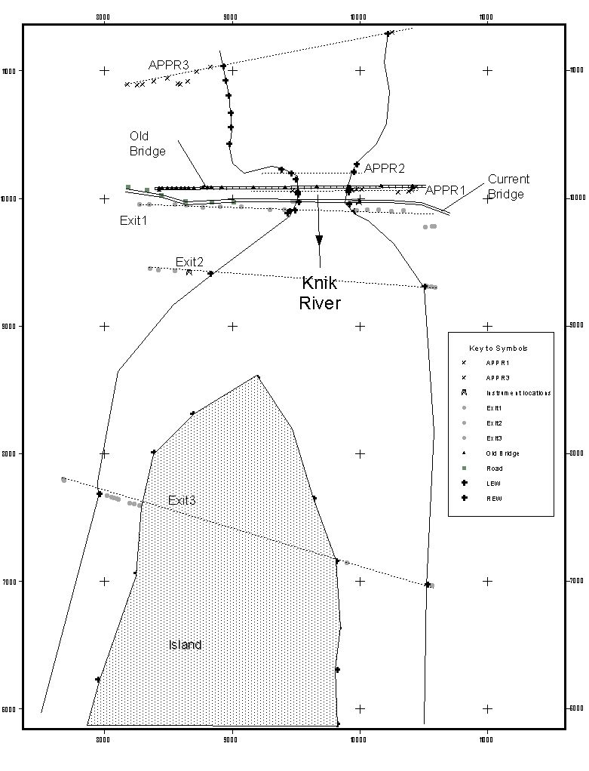
Figure1: Schematic of survey data for bridge 539 at Knik River near Palmer. Coordinate system is arbitrary.
The original survey points were projected in ArcView to determine accurate distances between sections. This plot file was exported as a bitmap to HECRAS to create the geometric plan. Survey data are presented in Appendix H.

Bridge Geometry
Two bridges are included in the model, bridge 539 and an older structure approximately 100 ft upstream. Bridge geometry was taken from the as-built plans for bridge 539 and interpreted from the survey data for the older structure. The bridge and piers are aligned relatively perpendicular to flow for both bridges.

Model Parameters
The model was run as subcritical using the standard step energy method. Initial boundary condition for the present water surface (PWS) was a known water surface elevation of 39.92 ft. at the location of the EXIT3 cross-section, while the initial condition for the Q100 and Q500 events was a normal depth with a slope of 0.0005. This is the slope of the energy gradient at the downstream cross section for the calibration discharge. Discharge estimates for the 100- and 500-year events were taken from the Phase 1 analysis that determined the magnitude using methods outlined by Jones and Fahl (1994). High volume (up to 359,000 ft³s⁻¹ ) glacial outburst floods occurred annually on the Knik River up until 1966. Due to recession of the Knik glacier these flows no longer occur and were therefore not included in the calculations of the Q100 and Q500 discharges. Levees were input in the model on the tops of the spur dikes to avoid split flow calculations in those sections (sections APPR1, APPR2, APPR3, and EXIT1). Model variables are summarized in Table 1.

Roughness values of 0.08 for the overbanks and 0.03 for the channel were initially selected and the channel values were adjusted to as low as .027 and as high as 0.037 to calibrate the modeled water surface elevation to the observed. Using these values the modeled water surface elevations are equal to the observed for sections EXIT2, EXIT1, and APPR1. Section APPR2 has a modeled elevation of 41.3 ft and an observed of 41.57 ft and section APPR3 has a modeled elevation of 42.0 ft with an observed water surface at 42.53 ft. The discrepancy between modeled and observed water surfaces for the approach sections could be attributed to templating survey data upstream. This may present a situation in which the templated elevations are lower than actual elevations. This would result in modeled water surfaces that are lower than observed. These data are presented in Appendix B.

The Q100 and Q500 discharges have two hydraulic jumps through the bridge sections. These jumps are the result of the contraction in the channel through this section of the reach. A plot of the water surface profiles is presented in Appendix C.

The model errors indicate the need for more cross sections to reduce velocity head drops and conveyance ratios between sections. Addition of interpolated cross sections would eliminate these errors, but not significantly affect the water surface profiles or the scour computations.

Reach Conditions
The step-backwater reach is 4,000 ft long and fell 2.61 ft at 23,000 ft³s⁻¹. The overall slope of the water surface between the uppermost section and the lowermost section was 0.0007 at 23,000 ft³s⁻¹, 0.0058 at 79,400 ft³s⁻¹, and 0.0062 at 104,000 ft³s⁻¹.

The channel is fairly uniform throughout the reach. It does significantly contract through the bridge sections and expand downstream of the bridges. At low flows a sand bar is exposed at the downstream cross section. Spur dikes extend from the left and right banks of the channel creating a “hydraulic pillow” that directs the flow under the bridges.

The bridge approach has a low point on the right bank that would allow overflow during extreme (>Q500) discharges. These discharges were common during annual outburst floods from the glacially dammed Lake George. The glacier has receded and outburst floods have not occurred since 1966.

Table 1: Select values used in model
Variable | Value | Notes
Manning’s roughness | .027-.037 (channel), 0.08 (overbank) | Calibrated to observed water surface elevation
PWS discharge | 23,000 ft³s⁻¹
Q100 | 79,400 ft³s⁻¹
Q500 | 104,000 ft³s⁻¹
Elevation of PWS | 39.92 ft | At downstream cross section
Slope of water surface | 0.0007 | Determined from surveyed WS
Slope of energy gradient | 0.0005 | At downstream cross section for calibration discharge
D50 | 1.08 mm or 0.0035 ft. | Leveen scour report
Water temperature | 45° Fahrenheit | Estimated
Pier dimensions for scour calculation | 4.3 ft wide, 26 ft long
Pier Shape | Sharp nosed
Bed condition | Medium dunes (K3=1.1) | Leveen scour report

Scour Calculations
Using the methodology from HEC-18 (Richardson and Davis, 1995) contraction (live-bed) and pier scour were calculated using HEC-RAS for bridge 539. Leveen (unpublished U.S. Geological Survey administrative report, 1967) determined a D50 of 1.08 mm and measured dunes up to 4 ft in height and 10 ft in wavelength at the Knik River crossing on the new Glen Highway. Although these data were downstream of bridge 539 they are thought to be representative and were used in the scour calculations.

Pier scour was computed using the CSU equation. Water temperature used for the calculations was 45° Fahrenheit. Angle of attack was left at zero because the piers are aligned to the direction of flow.

The results of the scour computations are presented in Appendix D and Table 2. Plots of scour at the bridge for all three discharges are presented in Appendix E.

Table 2: Summary of scour results for bridge 539. All scour values are in feet.
 | PWS Q=23,000 ft³s⁻¹ | Q100=79,400 ft³s⁻¹ |  | Q500=104,000 ft³s⁻¹
Bridge 539 | channel | channel | channel
Contraction | 0.26 | 0.55 | 0.77
Pier 1 (left bank) | 7.61 | 11.65 |  | 12.91
Pier 2 (right bank) | 7.61 | 11.65 |  | 12.91
Total scour | 7.87 | 12.20 |  | 13.69

References Cited

Jones, S.H., and Fahl, C.B., 1994, Magnitude and frequency of floods in Alaska and conterminous basins of Canada: U.S. Geological Survey Water-Resources Investigations Report 93-4179, 122 p.

Richardson, E.V., and Davis, S.R., 1995, Evaluating scour at bridges (3d ed.): U.S. Federal Highway Administration, FHWA-IP-90-017 HEC-18, 204 p.

Appendix A

Description of files

File name | File description and software
539_knik_ics.txt  539_knik_printed | Raw data files from the data logger in Northing, Easting, Elevation (ics) and full information formats.
539_knik_survey.xls | Excel spreadsheet containing transformation of points, surveyed cross sections, interpolated cross sections, and data exported to HEC-RAS
539_knik_writeup.doc | This document
539_knik.g02 | Final HEC-RAS geometry file
539_knik.h01 | Final HEC-RAS hydraulic design file
539_knik.f02 | Final HEC-RAS flow file
539_knik.p02 | Final HEC-RAS plan file
539_knik.prj | Final HEC-RAS project file (details of files used, units, default parameters, etc.)
539_knik.r02 | Final HEC-RAS run file

Appendix B: Flow data
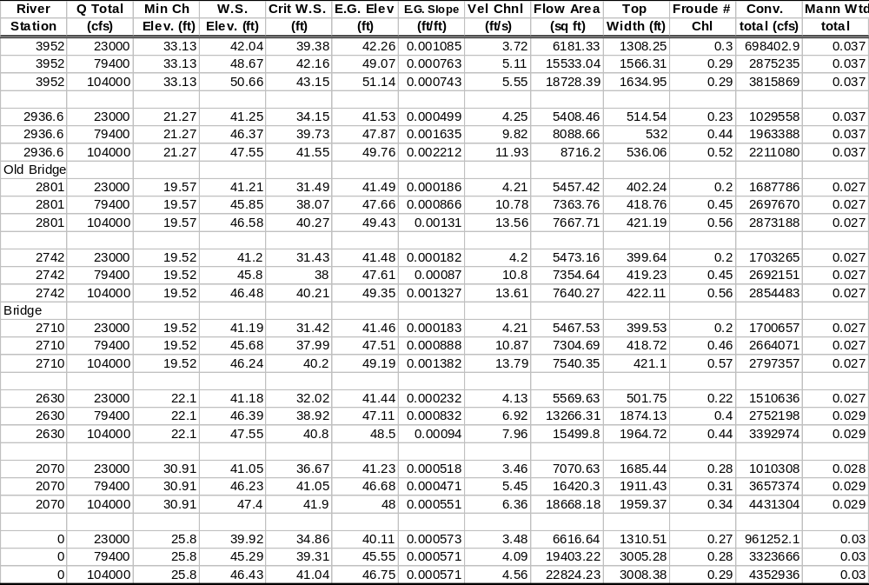
Appendix C: Plot of water surface profiles
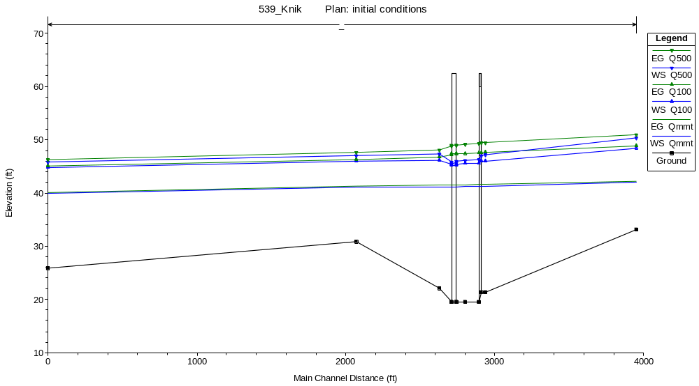
Appendix D: Scour calculations
Scour calculations for Qmmt where Q = 23,000 ft3s-1
Contraction Scour
 |  | Left | Channel | Right
Input Data
 | Average Depth (ft): |  | 13.57
 | Approach Velocity (ft/s): |  | 4.21
 | Br Average Depth (ft): |  | 13.56
 | BR Opening Flow (cfs): |  | 23000
 | BR Top WD (ft): |  | 390.89
 | Grain Size D50 (ft): |  | 0.008
 | Approach Flow (cfs): |  | 23000
 | Approach Top WD (ft): |  | 402.24
 | K1 Coefficient: |  | 0.64
Results
 | Scour Depth Ys (ft): |  | 0.26
 | Critical Velocity (ft/s):
 | Equation: |  | Live
Pier Scour
 | All piers have the same scour depth
Input Data
 | Pier Shape: | Sharp nose
 | Pier Width (ft): | 4.33
 | Grain Size D50 (ft): | 0.008
 | Depth Upstream (ft): | 21.34
 | Velocity Upstream (ft/s): | 5.38
 | K1 Nose Shape: | 0.9
 | Pier Angle: | 0
 | Pier Length (ft): | 26
 | K2 Angle Coef: | 1
 | K3 Bed Cond Coef: | 1.1
 | Grain Size D90 (ft):
 | K4 Armouring Coef: | 1
Results
 | Scour Depth Ys (ft): | 7.58
 | Froude #: | 0.21
 | Equation: | CSU equation
Combined Scour Depths
 | Pier Scour + Contraction Scour (ft):
 |  | Channel: | 7.84
Scour calculations for Q100 where Q = 74,900 ft3s-1
Contraction Scour
 |  | Left | Channel | Right
Input Data
 | Average Depth (ft): |  | 17.58
 | Approach Velocity (ft/s): |  | 10.78
 | Br Average Depth (ft): |  | 17.28
 | BR Opening Flow (cfs): |  | 79400
 | BR Top WD (ft): |  | 409.97
 | Grain Size D50 (ft): |  | 0.008
 | Approach Flow (cfs): |  | 79400
 | Approach Top WD (ft): |  | 418.76
 | K1 Coefficient: |  | 0.64
Results
 | Scour Depth Ys (ft): |  | 0.54
 | Critical Velocity (ft/s):
 | Equation: |  | Live
Pier Scour
 | All piers have the same scour depth
Input Data
 | Pier Shape: | Sharp nose
 | Pier Width (ft): | 4.33
 | Grain Size D50 (ft): | 0.008
 | Depth Upstream (ft): | 25.94
 | Velocity Upstream (ft/s): | 13.37
 | K1 Nose Shape: | 0.9
 | Pier Angle: | 0
 | Pier Length (ft): | 26
 | K2 Angle Coef: | 1
 | K3 Bed Cond Coef: | 1.1
 | Grain Size D90 (ft):
 | K4 Armouring Coef: | 1
Results
 | Scour Depth Ys (ft): | 11.51
 | Froude #: | 0.46
 | Equation: | CSU equation
Combined Scour Depths
 | Pier Scour + Contraction Scour (ft):
 |  | Channel: | 12.05
Scour calculations for Q500 where Q = 104,000 ft³s⁻¹

Contraction Scour
 |  | Left | Channel | Right
Input Data
 | Average Depth (ft): |  | 18.21
 | Approach Velocity (ft/s): |  | 13.56
 | Br Average Depth (ft): |  | 17.72
 | BR Opening Flow (cfs): |  | 104000
 | BR Top WD (ft): |  | 412.24
 | Grain Size D50 (ft): |  | 0.008
 | Approach Flow (cfs): |  | 104000
 | Approach Top WD (ft): |  | 421.19
 | K1 Coefficient: |  | 0.64
Results
 | Scour Depth Ys (ft): |  | 0.74
 | Critical Velocity (ft/s):
 | Equation: |  | Live
Pier Scour
 | All piers have the same scour depth
Input Data
 | Pier Shape: | Sharp nose
 | Pier Width (ft): | 4.33
 | Grain Size D50 (ft): | 0.008
 | Depth Upstream (ft): | 26.62
 | Velocity Upstream (ft/s): | 16.79
 | K1 Nose Shape: | 0.9
 | Pier Angle: | 0
 | Pier Length (ft): | 26
 | K2 Angle Coef: | 1
 | K3 Bed Cond Coef: | 1.1
 | Grain Size D90 (ft):
 | K4 Armouring Coef: | 1
Results
 | Scour Depth Ys (ft): | 12.75
 | Froude #: | 0.57
 | Equation: | CSU equation
Combined Scour Depths
 | Pier Scour + Contraction Scour (ft):
 |  | Channel: | 13.49

Appendix E: Plots of Scour
Scour plot for Qmmt where Q = 23,000 ft³s⁻¹
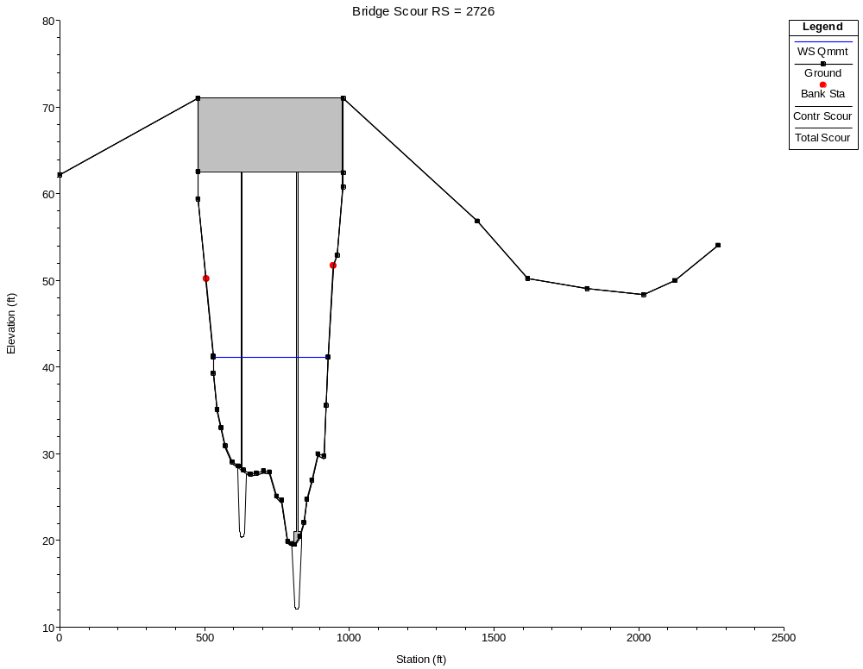
Scour plot for Q100 where Q = 79,400 ft³s⁻¹
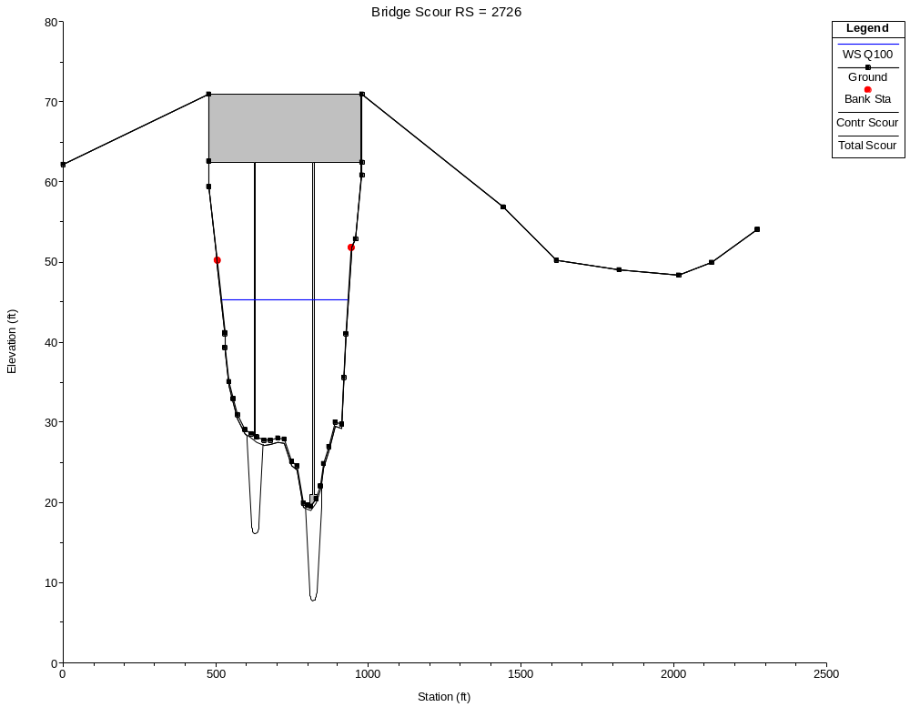
Scour plot for Q500 where Q = 104,000 ft³s⁻¹
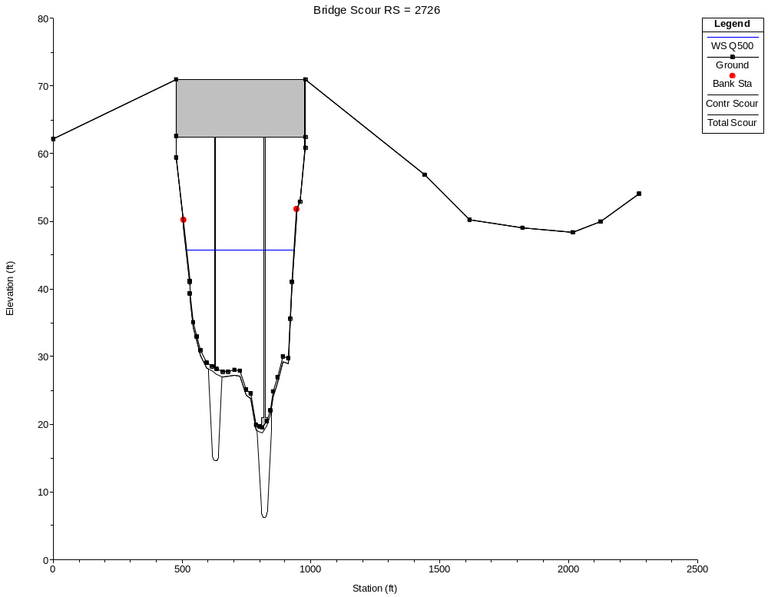
Appendix F: Cross section plots with modeled water surfaces.
APPR3
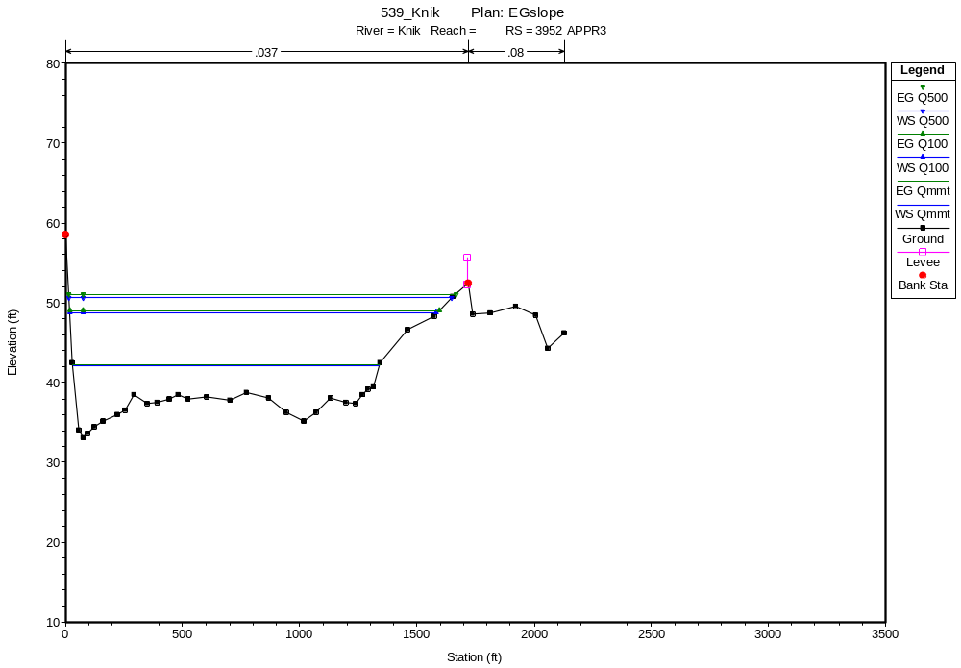
APPR2
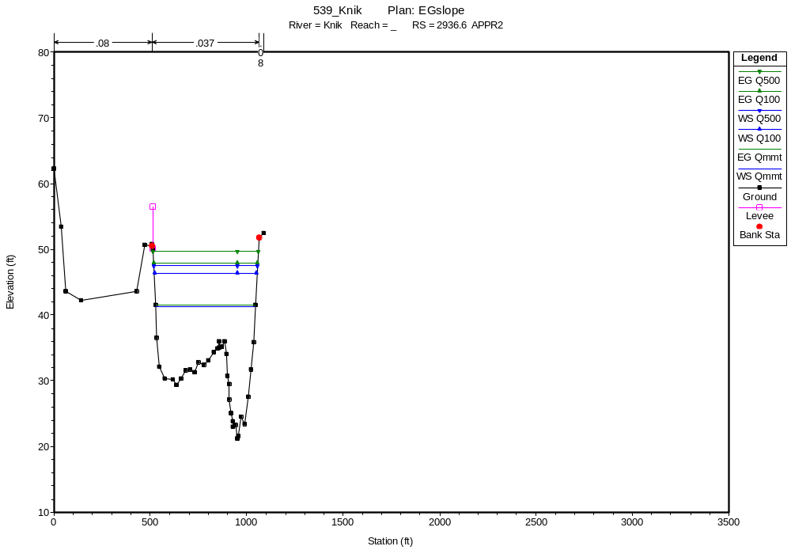
Old Bridge Up
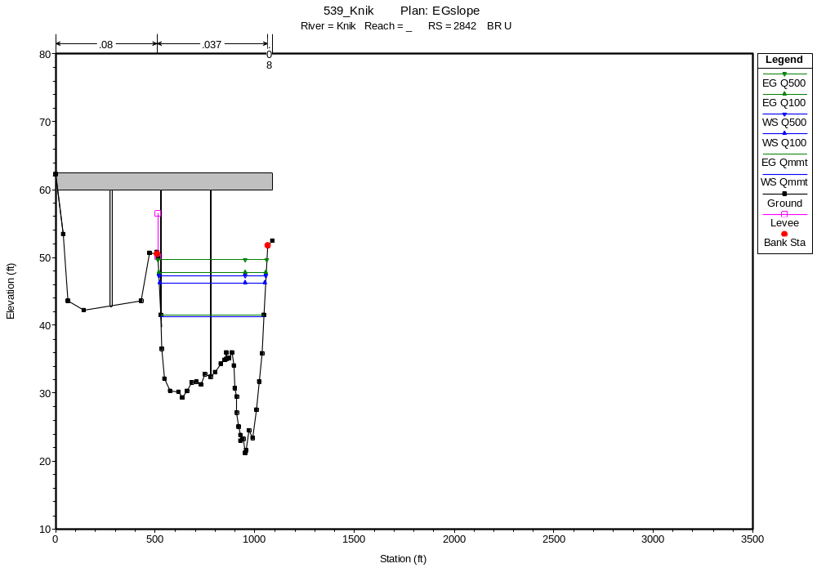
Old Bridge down
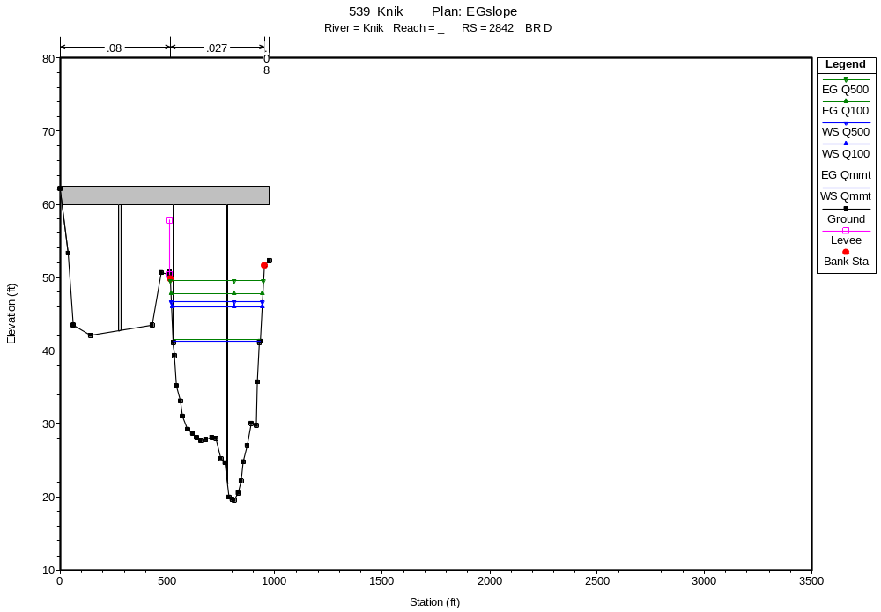

APPR1
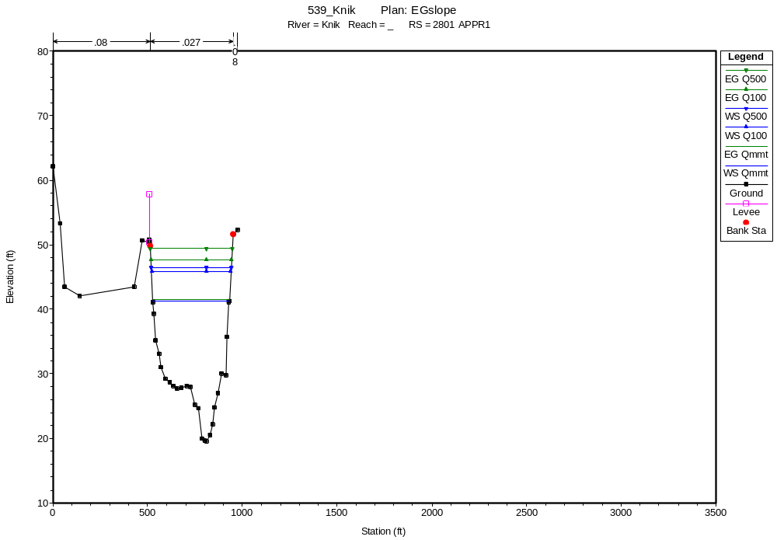
USBRIDGE
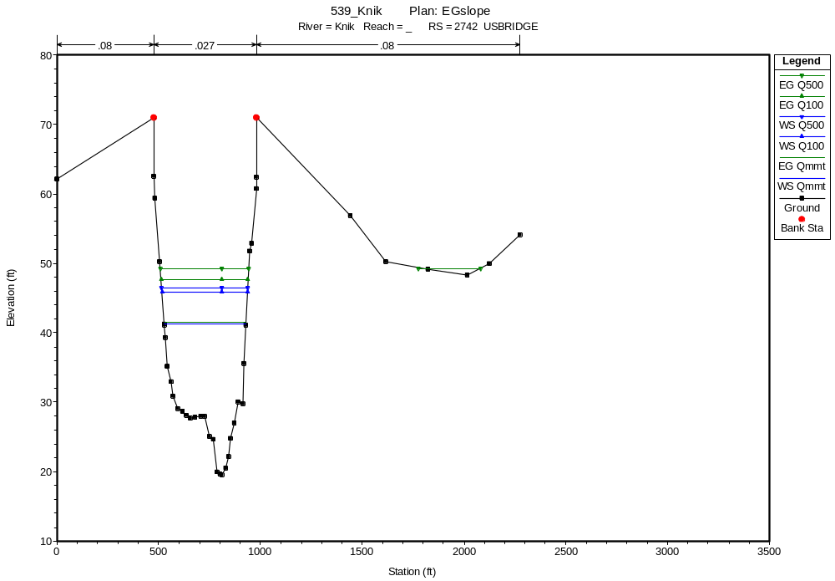

New BRIDGE up
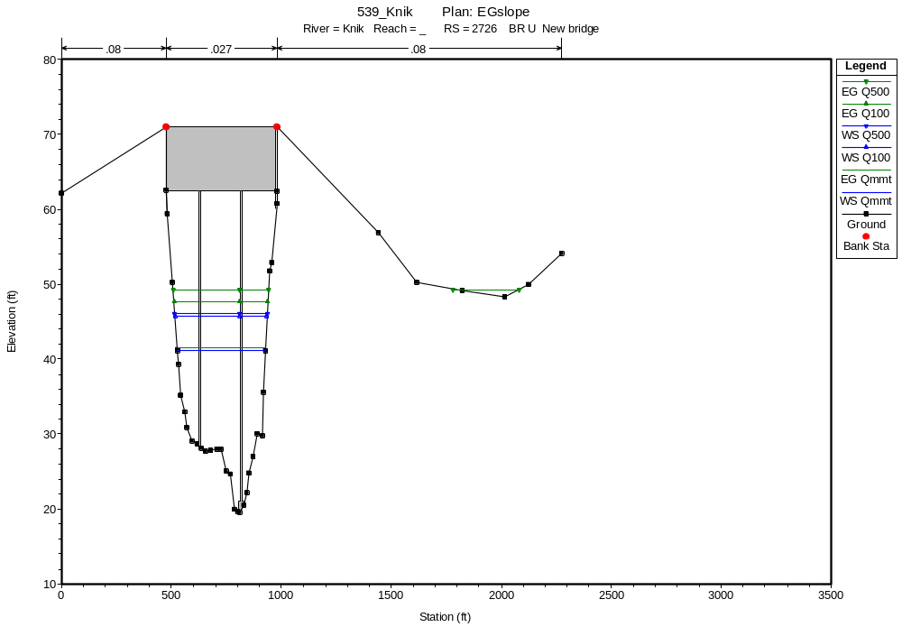
New Bridge down
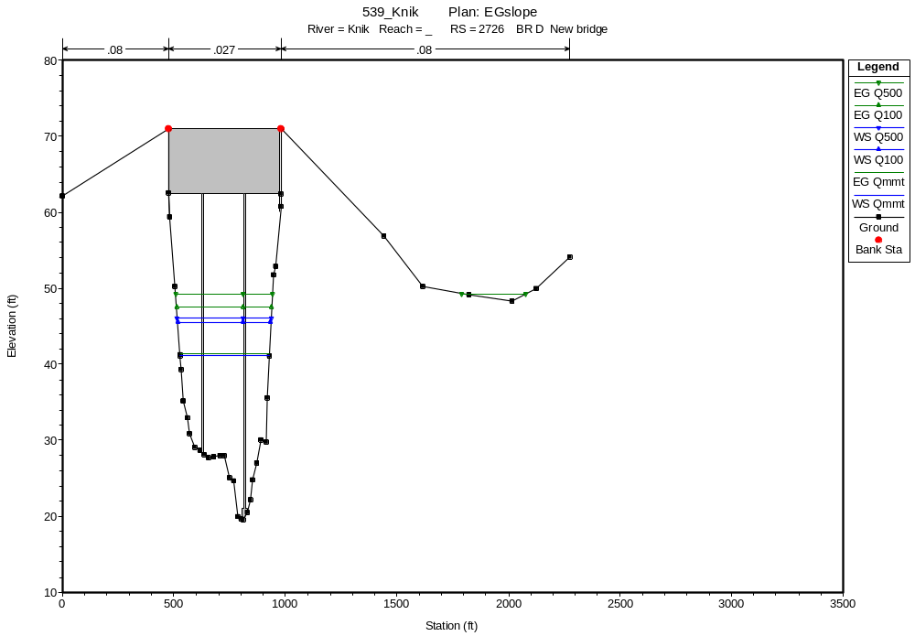

New DSBRIDGE
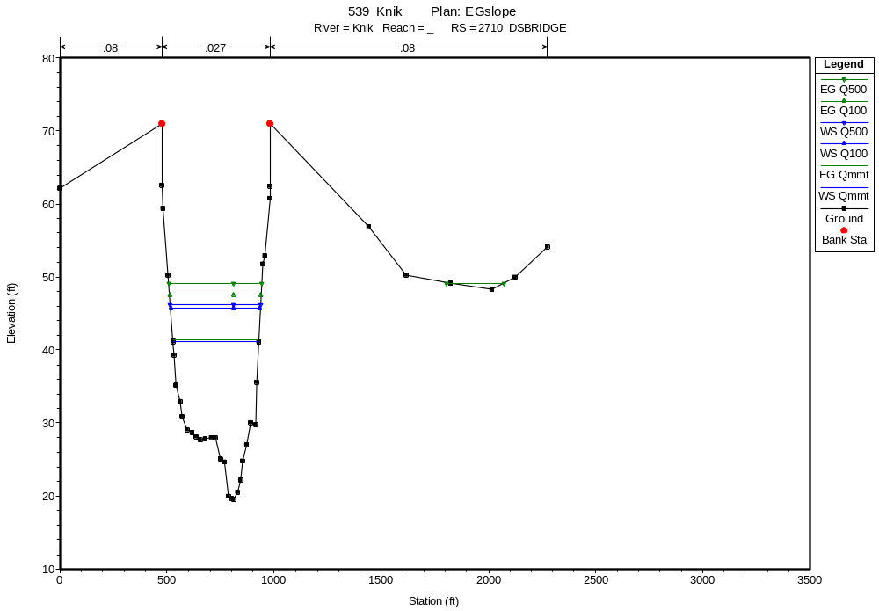
EXIT1
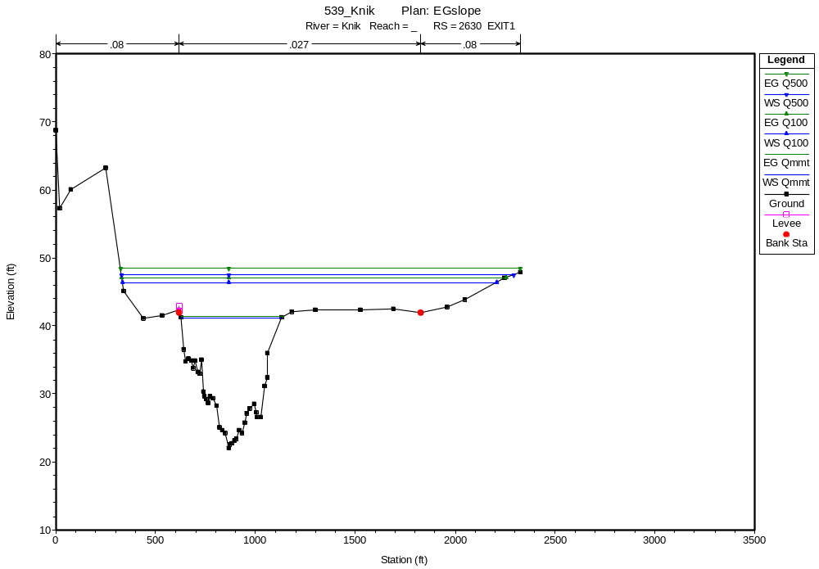

EXIT2
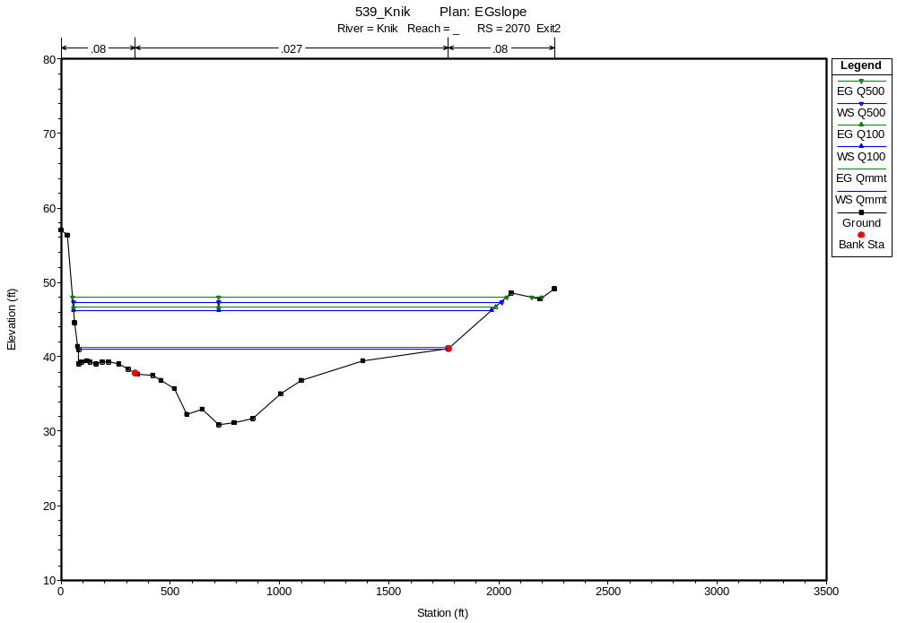
EXIT3
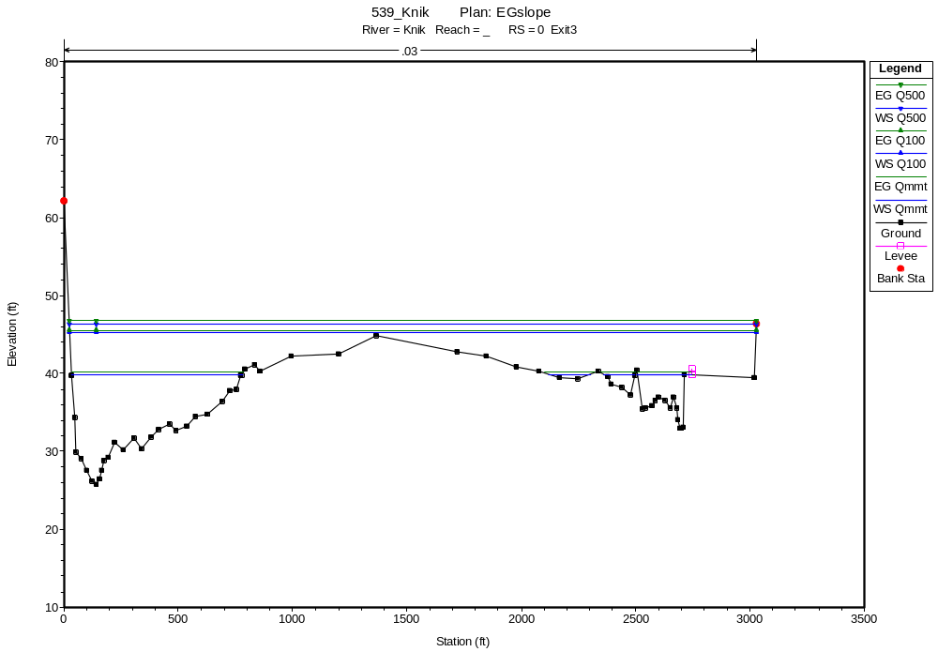

Appendix G: Select site photographs

View upstream from bridge.
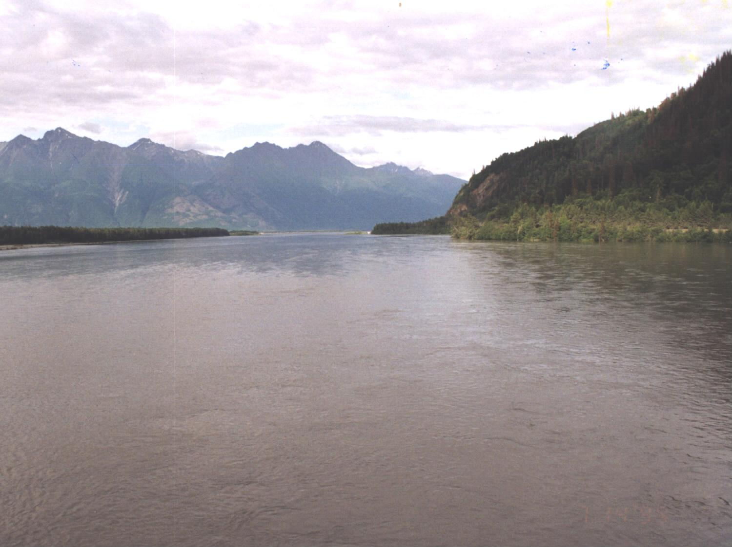

View upstream to bridge.
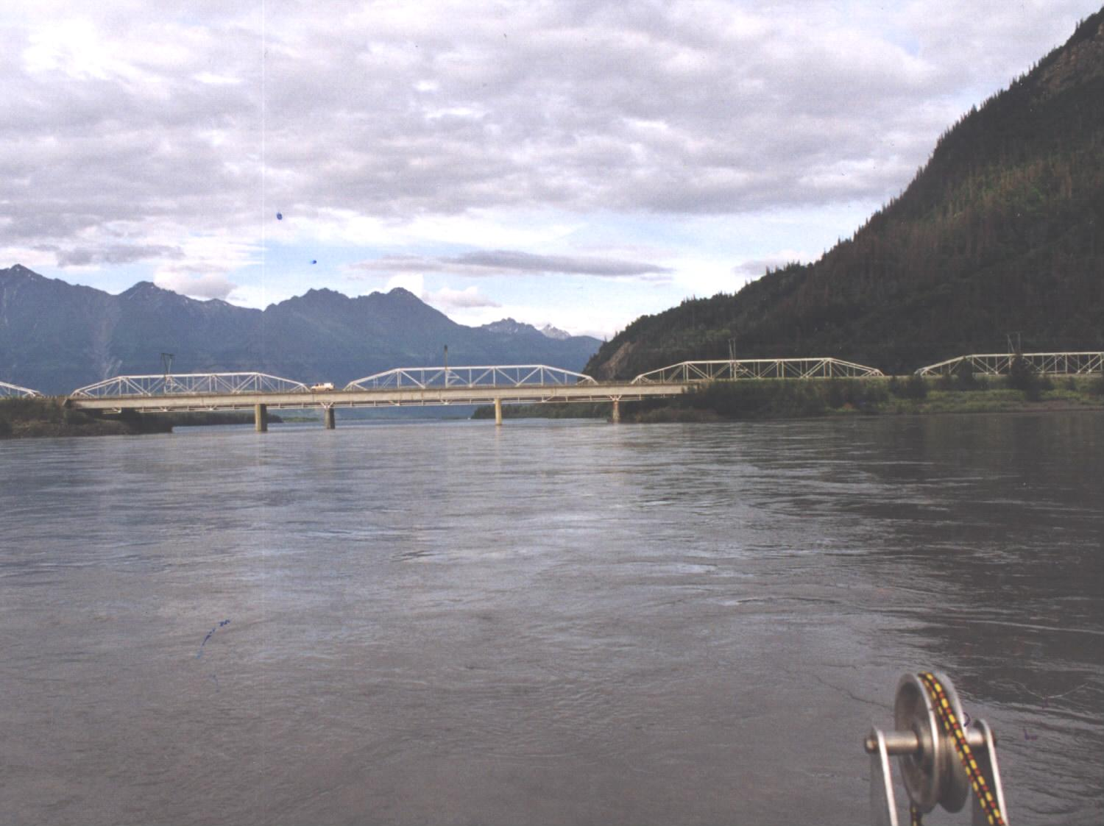

Knik River right bank downstream of the bridge from the left bank.
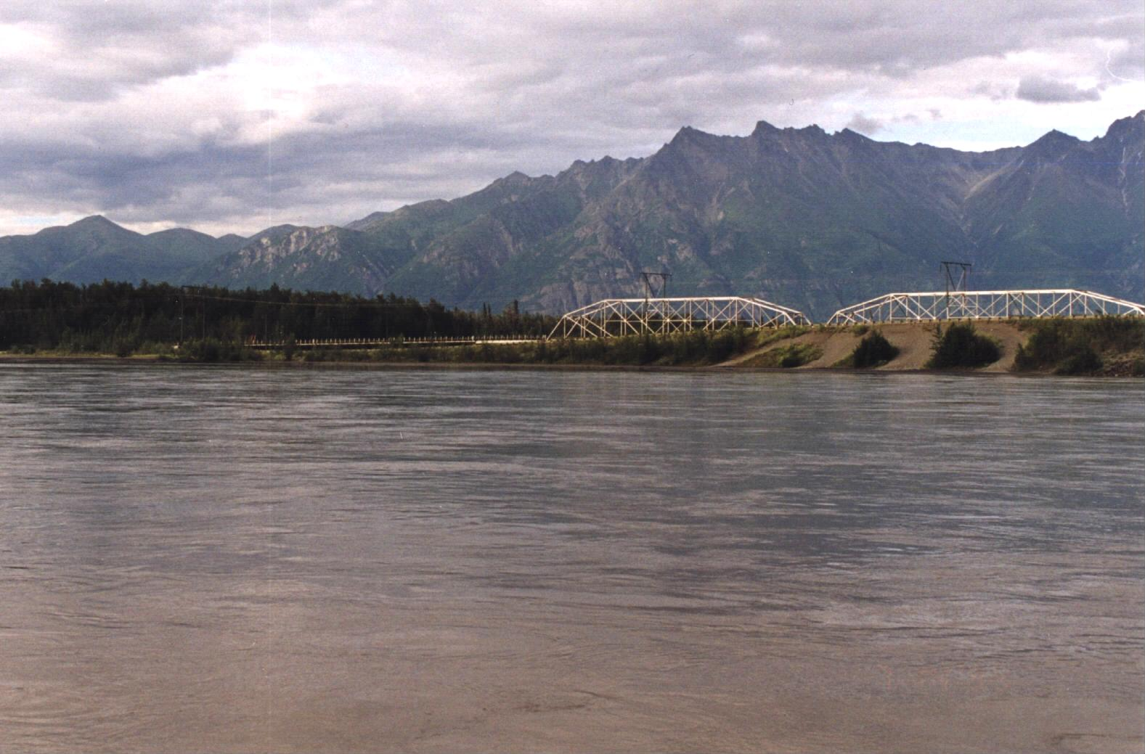

Looking downstream at pier on Bridge 539.
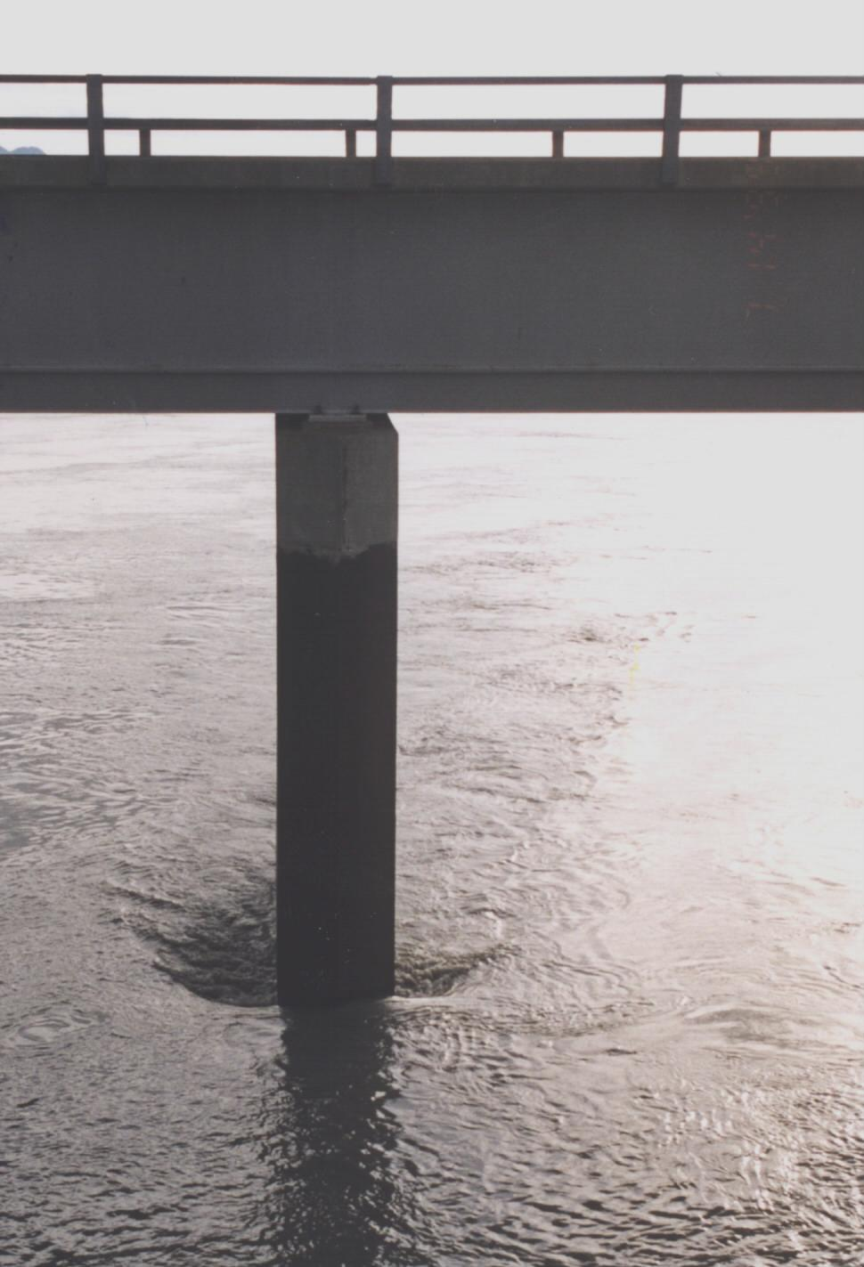
Appendix H: Cross section data


