247th Street Bridge over the James River near Mitchell, SD

Site Overview
The study site is located on the James River approximately 6 miles north of the town of Mitchell, South Dakota and east of State Highway 37 on 247th street. The site is approximately 21 miles downstream from the USGS gaging station near Forestburg (06477000). The USGS National Bridge Scour Team in cooperation with NCHRP and the University of Louisville was deployed to the site to collect real-time bridge scour measurements during the flood in April of 2001. Boat access at the site was unavailable therefore all scour measurements were collected from the bridge deck. 247th street and the bridge were closed at the time of the measurements due to overtopping of the roadway on the left floodplain.

The site is located in a highly rural/agricultural landscape with very little topographic relief, especially in the left floodplain. The bridge is a concrete girder, three span structure supported by two groups of cylindrical piers (2 in each group) which are both founded on timber piles. The channel bed is comprised of a silty-clay with a narrow horizontal clay wedge. The James River has a great deal of meander in the vicinity of the bridge. The left floodplain is expansive at the bridge and the right overbank consists of bluffs rising relatively steeply from the edge of channel.

Hydrologic Conditions
Greater than normal precipitation starting with late fall rains in 2000, greater than normal snowfalls, a delayed snowmelt, and above average rains in April, all contributed to the upper Midwestern flooding in the spring of 2001. The James River basin received a surplus of 10 inches of precipitation through the winter of 2000-2001 and the early part of spring 2001. The temperatures in February, March and the first part of April were 10-15 degrees below normal, which delayed the typical period of snowmelt enough to coincide with a period of above average rainfall associated with a series of cyclonic weather systems characteristic of early spring.

Data-Collection Methods
Scour measurements were collected with by floating an echo sounder attached to a knee-board across the river while being controlled by a hand line from the bridge. The board was allowed to float downstream and streambed elevations were collected as far as 50 feet downstream from the bridge. Data collected upstream of the bridge was restricted to the upstream edge of the bridge deck. Additional bathymetry data was collected in the floodplains and throughout the channel upstream and downstream from the bridge after the flood during a low-water site visit on October 25, 2001.
Water-surface elevations were collected at the upstream and downstream bridge faces by taping down from reference marks which were later surveyed and tied into bridge elevations.

Discussion of Contracted Site
The bridge contraction was asymmetrical with a large majority of the contracted flow coming from the left floodplain. The bridge did receive some relief by a section of road overtopped by the flood flow approximately 625 feet west (on the left floodplain) of the bridge at the time of the scour measurements. There was evidence that the road overflow extended approximately 100 feet further towards the bridge. The overtopped section is shown in figure 1.

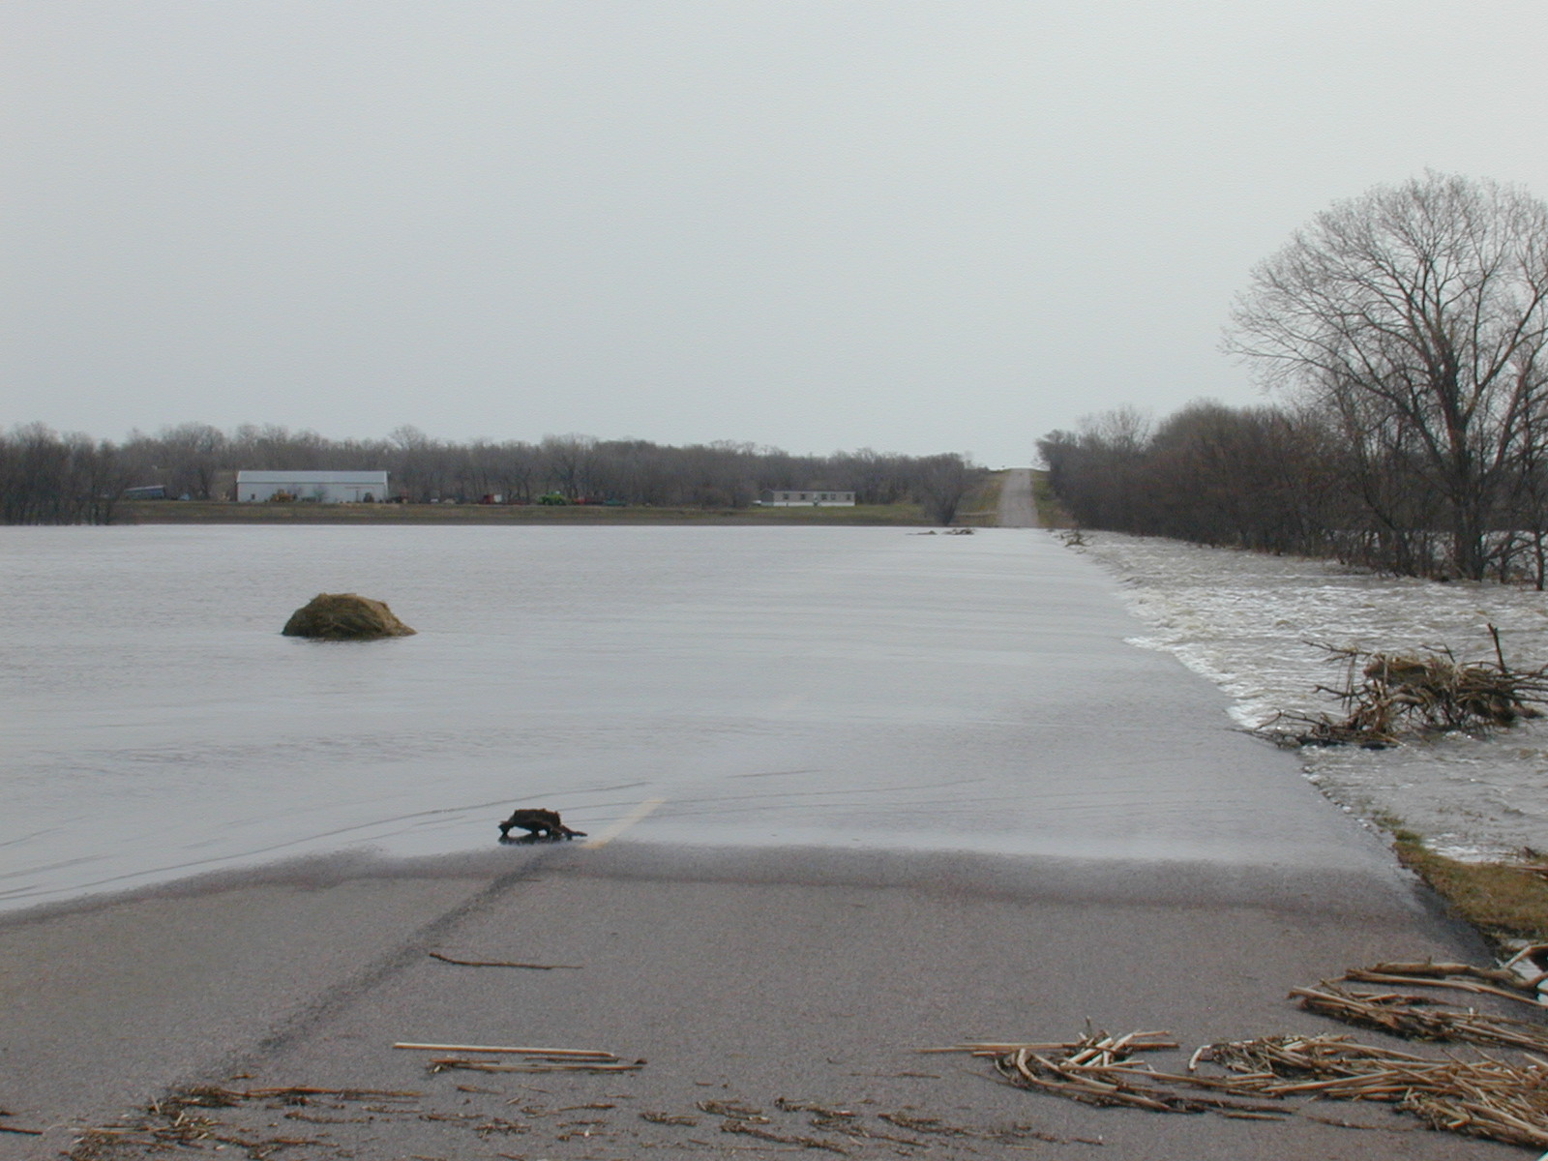

Figure 1. – Looking east from bridge at road overflow on left floodplain.

Although the flow in the left floodplain overtopped the roadway, the floodplain flow on the channel side of the roadway flow was moving towards the bridge opening. A strong area of reverse flow was observed between the left-most pier and the left abutment. The area immediately downstream of the left-most pier was active with boils and eddies, making measurements in this region difficult. The flow angle of attack at the left pier was 40 degrees and was affected by the eddy along the left abutment.

Bridge Info
The structure (#18-153-030) is a 30 ft wide, 262 ft long pre-stressed girder bridge supported by two piers, both located in the main channel of the James River. Pier #1 is on the left, looking downstream, and consists of 2 separate 3 ft diameter cylindrical piles. Pier 2 is on the right and also consists of 2 separate 3 ft diameter cylindrical piles. The bridge has a type III contracted opening, meaning it has sloping embankments and sloping spillthrough abutments. The bridge has a 30-degree skew to the James River and a downhill grade in the eastbound direction. The low-chord elevation is 1224.6 ft above sea level.

Geomorphic Setting
The geomorphic setting and channel alignment of the James River at the 247th street bridge is depicted in figure 2 as well as a graphical representation of the roadway overflow section. A plot of the channel bathymetry collected during the April 2001 flood and subsequent low-flow survey can be found in figure 3.
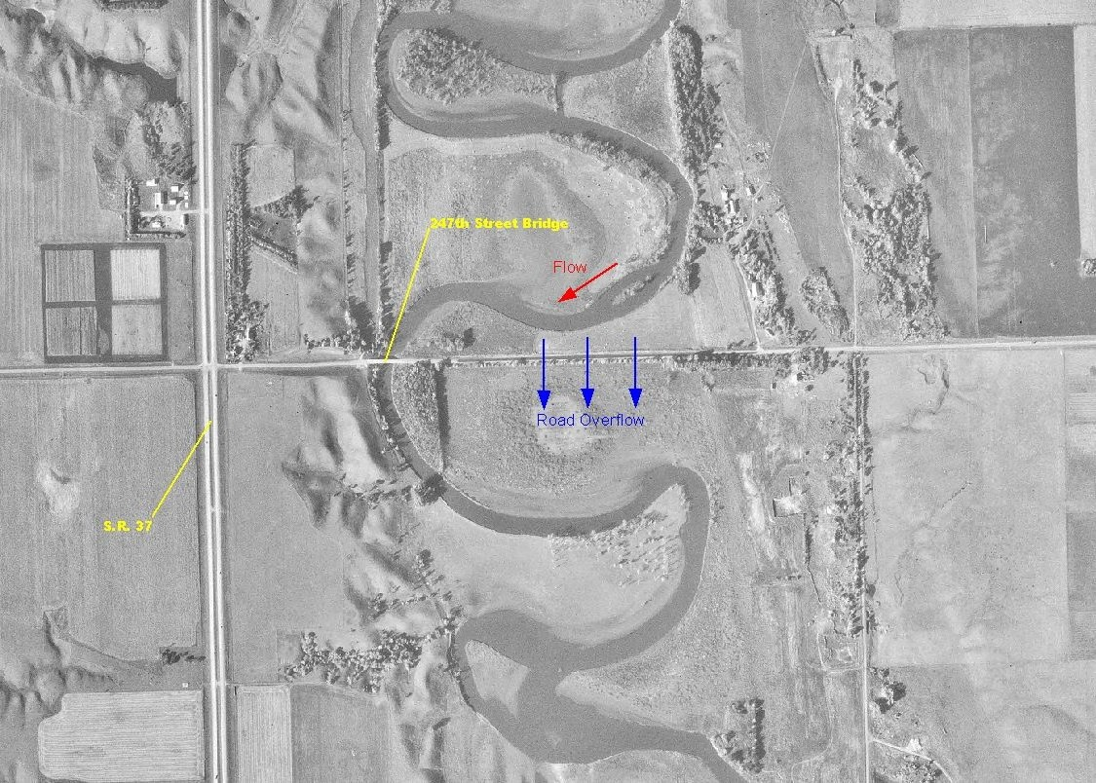

Figure 2. – Geomorphic setting and channel alignment for the James River at 247th street bridge near Mitchell, SD

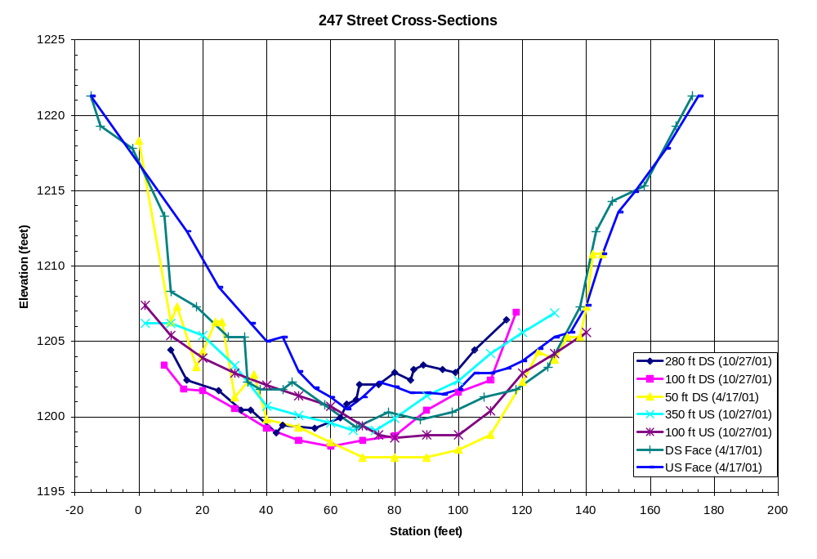
Figure 3. – Surveyed cross-sections in the 247th street bridge reach collected during the April, 2001 flood and subsequent low-flow survey in October, 2001.

Flood Photos
Additional photos taken during the flood in April 2001 are shown in figures 4 – 7.

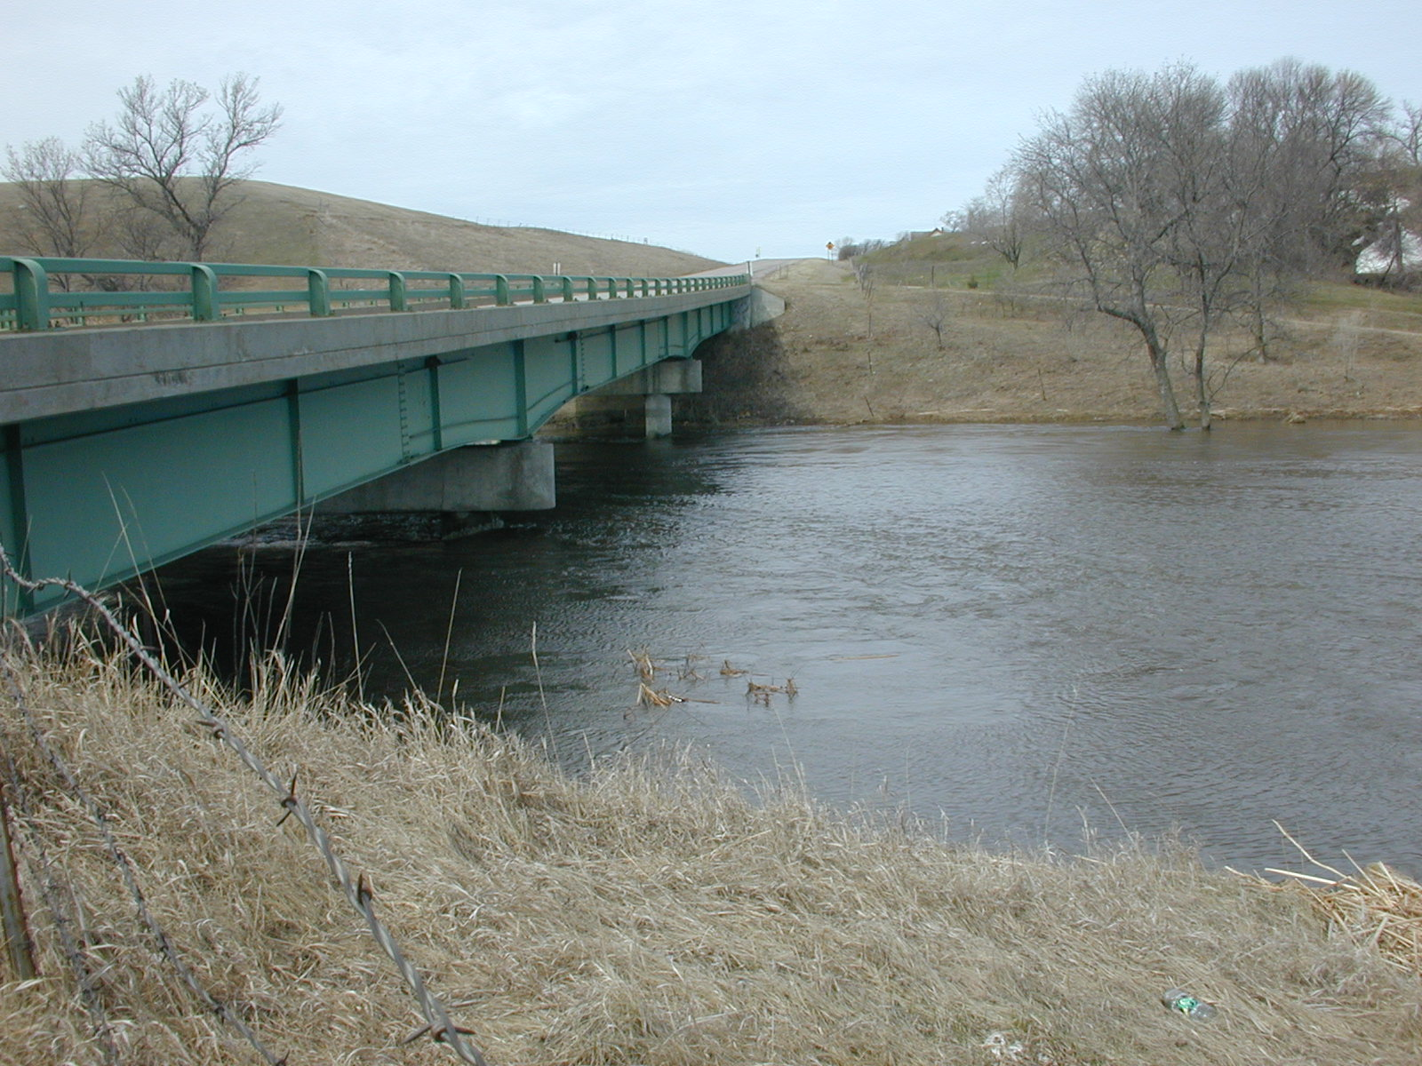
Figure 4. – Looking at upstream bridge face from left embankment

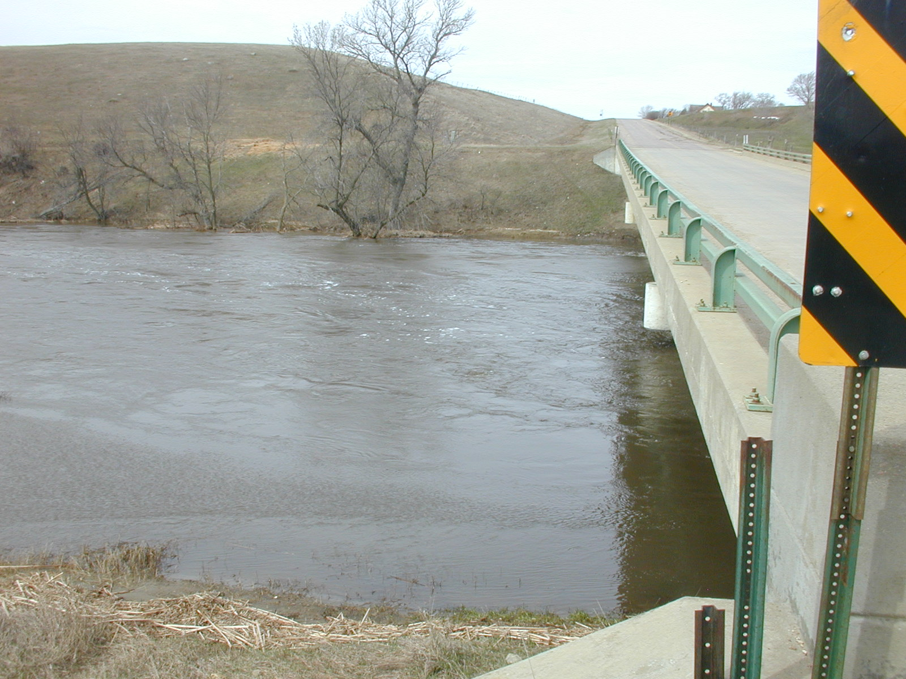
Figure 5. – Looking at downstream bridge face from left wingwall

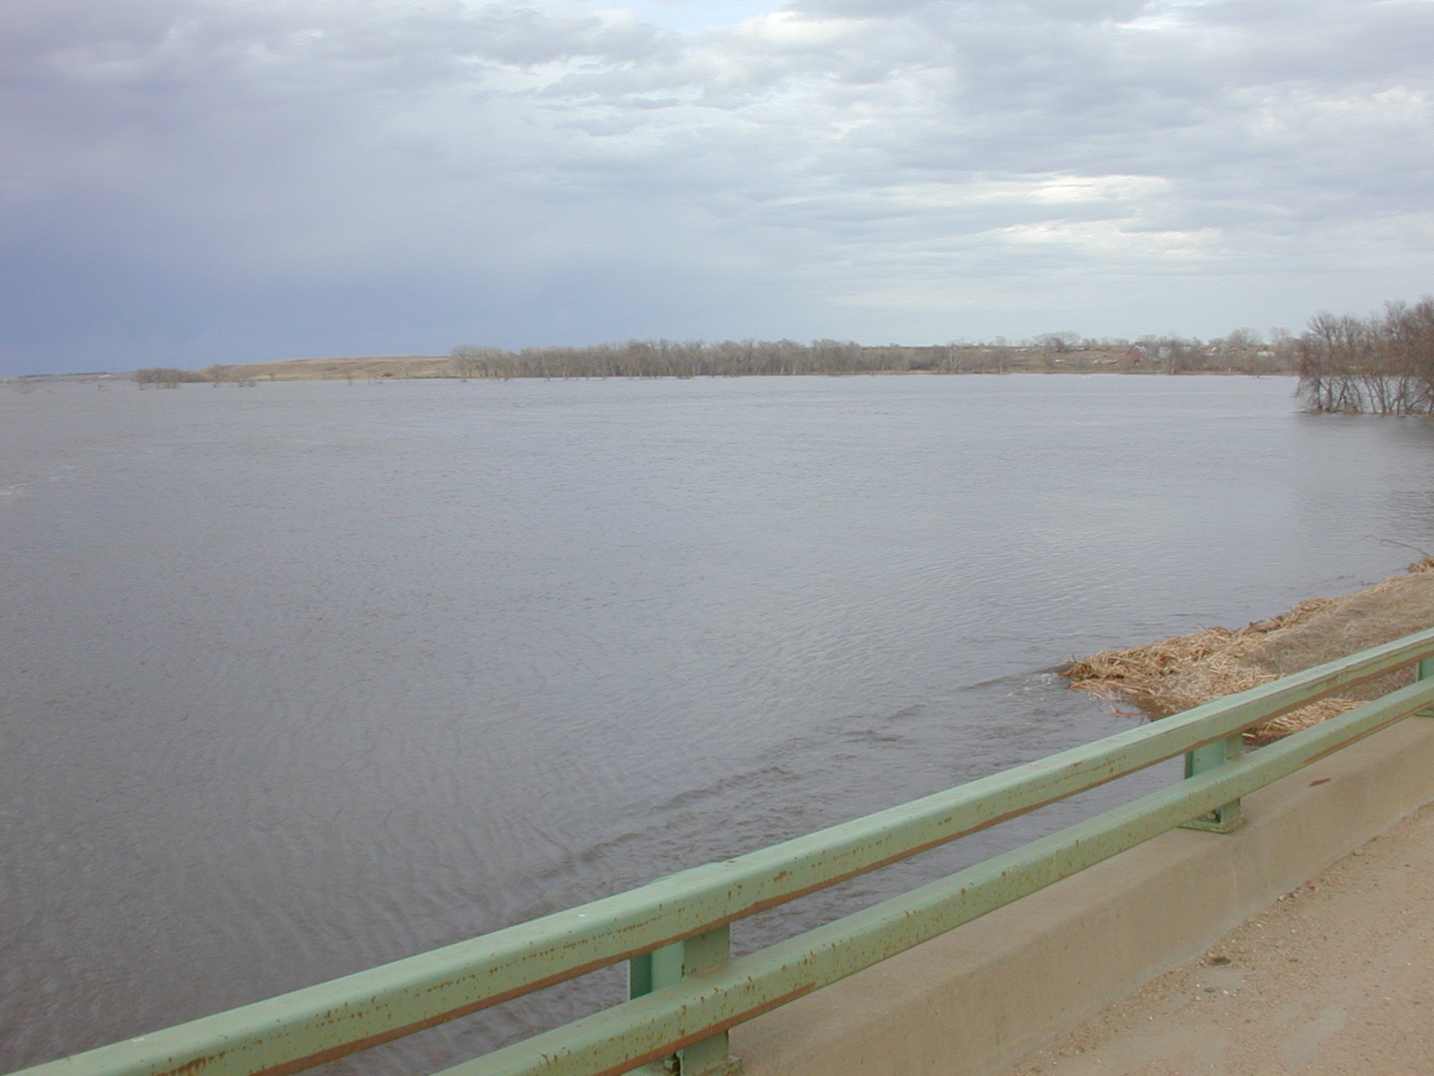
Figure 6. – Looking at upstream left floodplain from bridge deck

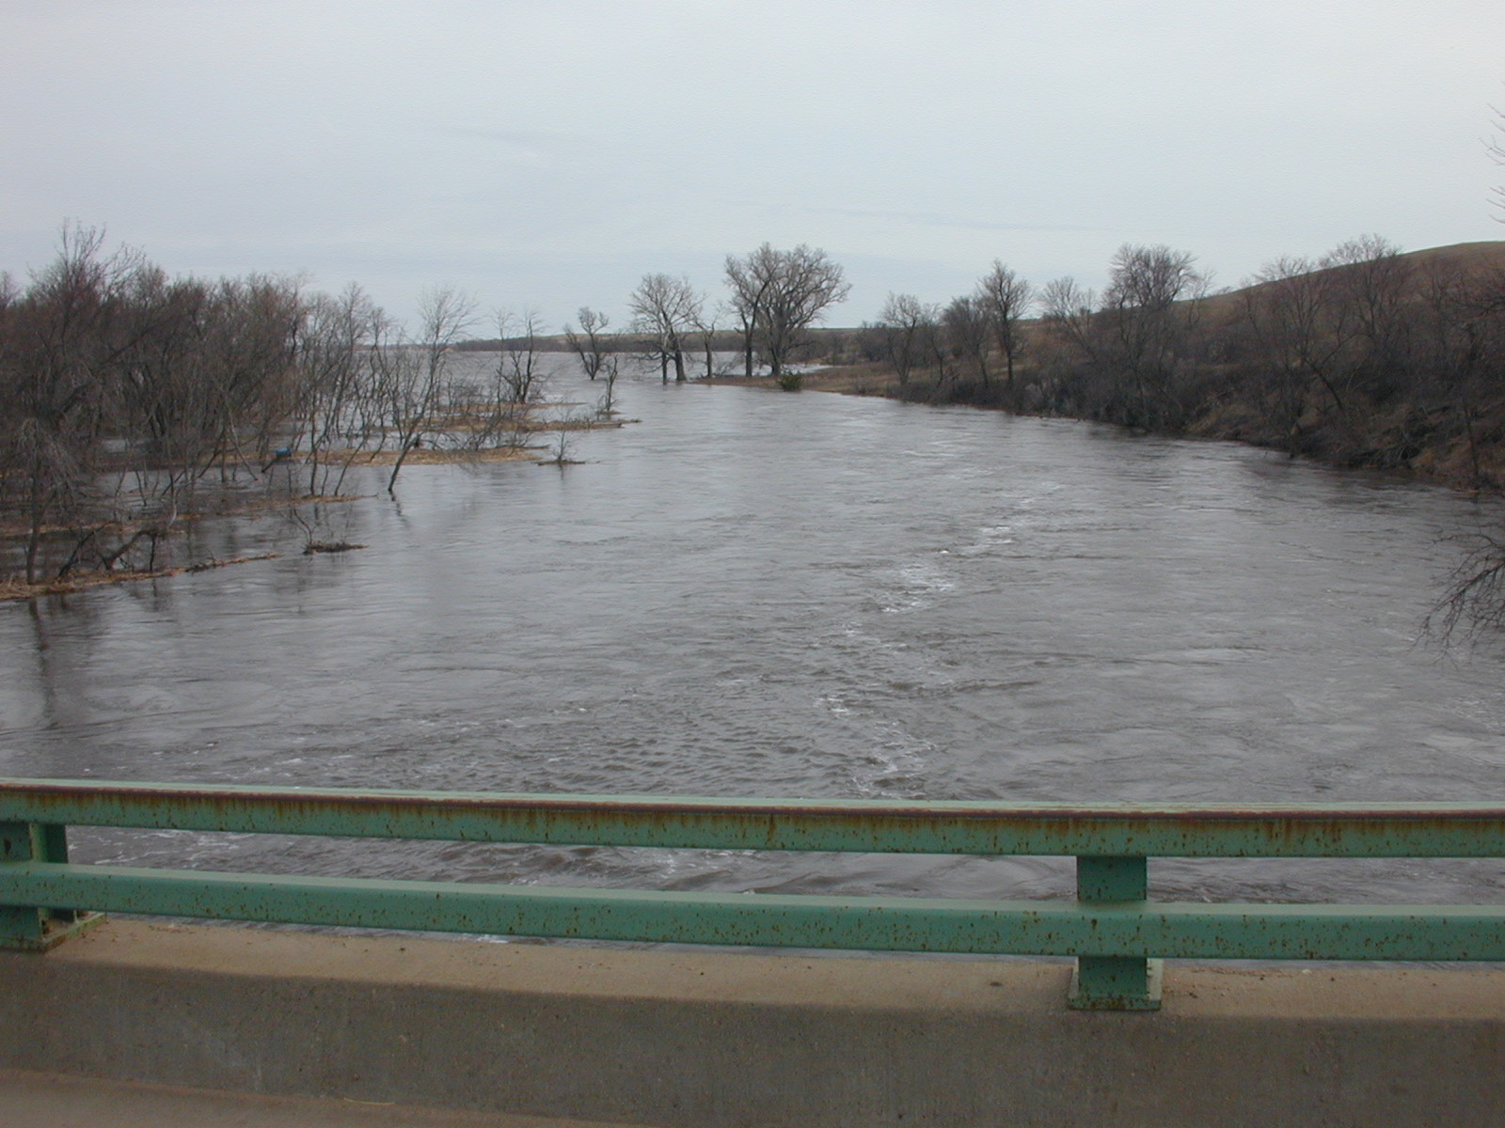
Figure 7. – Looking downstream from bridge deck

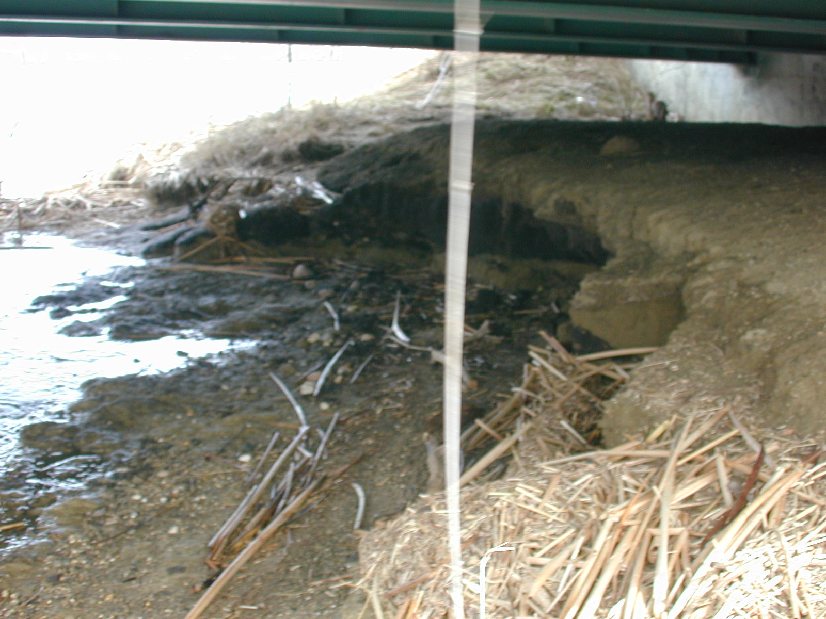
Figure 8. – Looking upstream at left abutment from under bridge

Measurement of Contraction Scour
Without measurements of the uncontracted channel sections, it was difficult to establish an ambient bed from which to estimate contraction scour. The post-flood surveys were used to estimate the contraction scour that occurred during the April 2001 flooding.
Analysis of the data revealed that remnants of an old bridge at the site appear to be influencing the bathymetry and amount of scour through the bridge section. The surveyed data shows the upstream bridge face section to be 3-4 feet higher than the downstream bridge face section as well as other sections collected further upstream of the bridge. It is believed that the foundation or deck from the old bridge is providing a form of scour protection at the upstream bridge face, which would also explain the inability to collect bed material samples at the upstream bridge face. The measured live-bed contraction scour was estimated to be 1 feet with accuracy of +/- 1 foot (see figure 3).

Measurement of Abutment Scour
No abutment scour was observed during the April 2001 flooding.

POST-FLOOD SURVEY
A post-flood survey of the site was conducted October 25-26, 2001 during low-flow conditions to collect more detailed topography data in the floodplains, bed material samples, and more refined Manning’s n estimates. The following photos (figures 9-13) reveal the channel alignment relative to the bridge as well as the scour remnants of the April, 2001 flood.

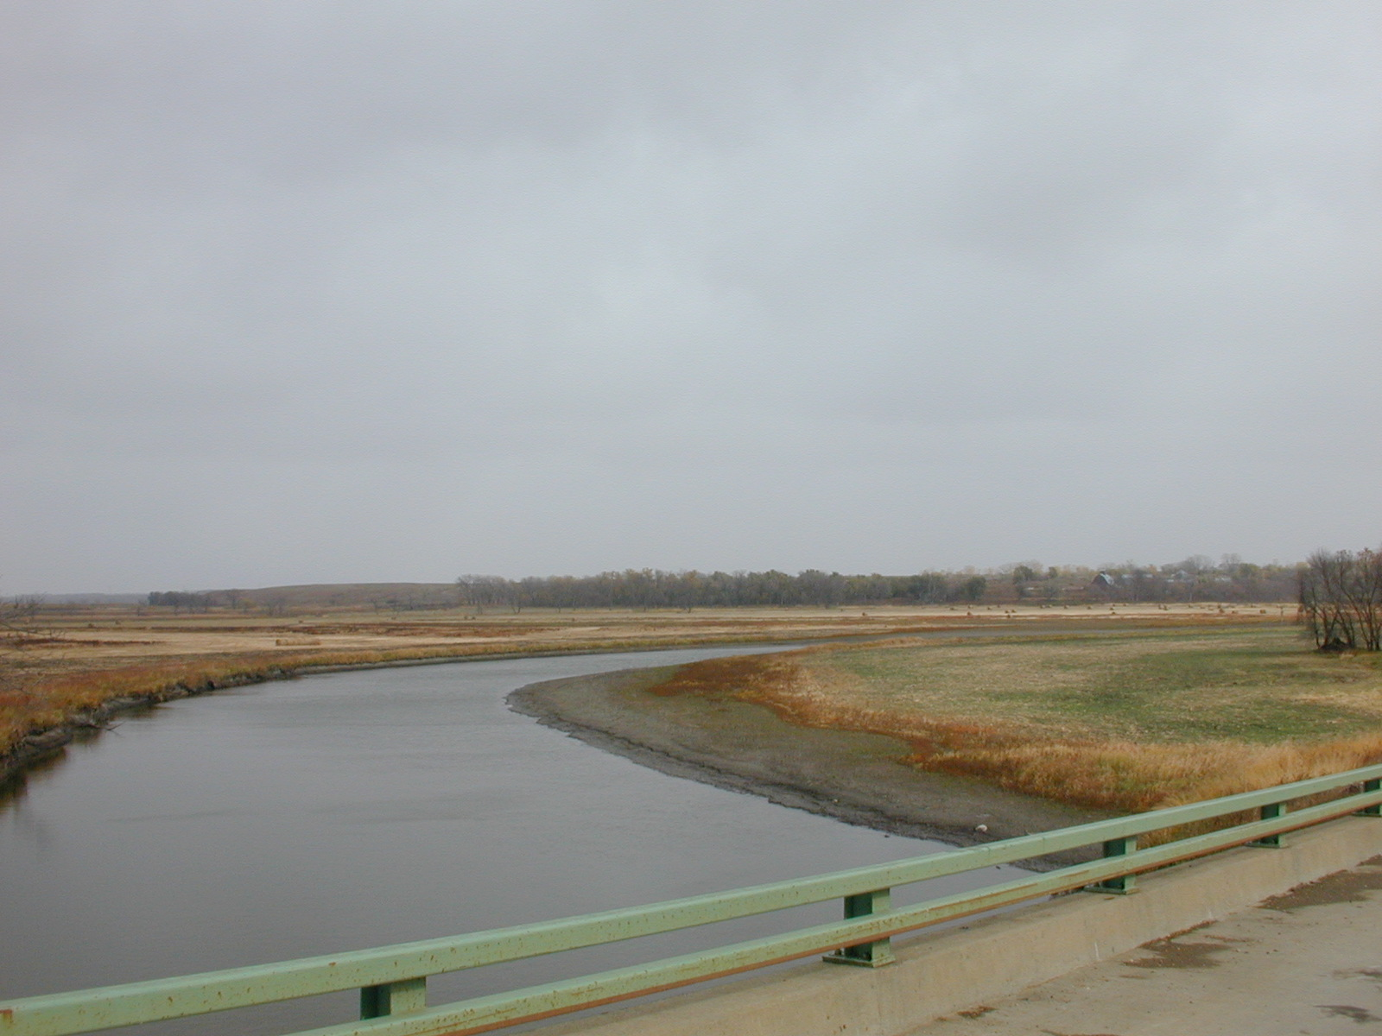
Figure 9. – Post-flood conditions, looking upstream from bridge deck

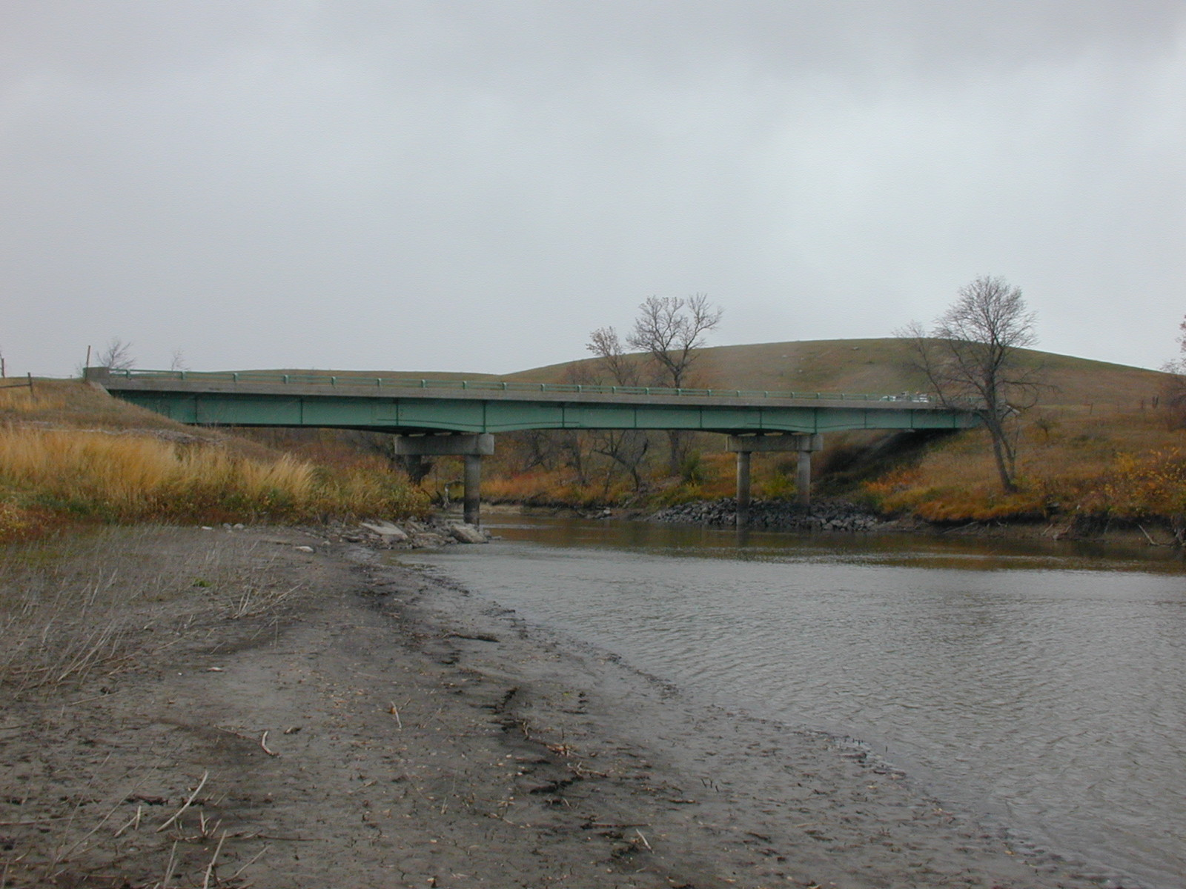
Figure 10. – Post-flood conditions, downstream at bridge from upstream left bank

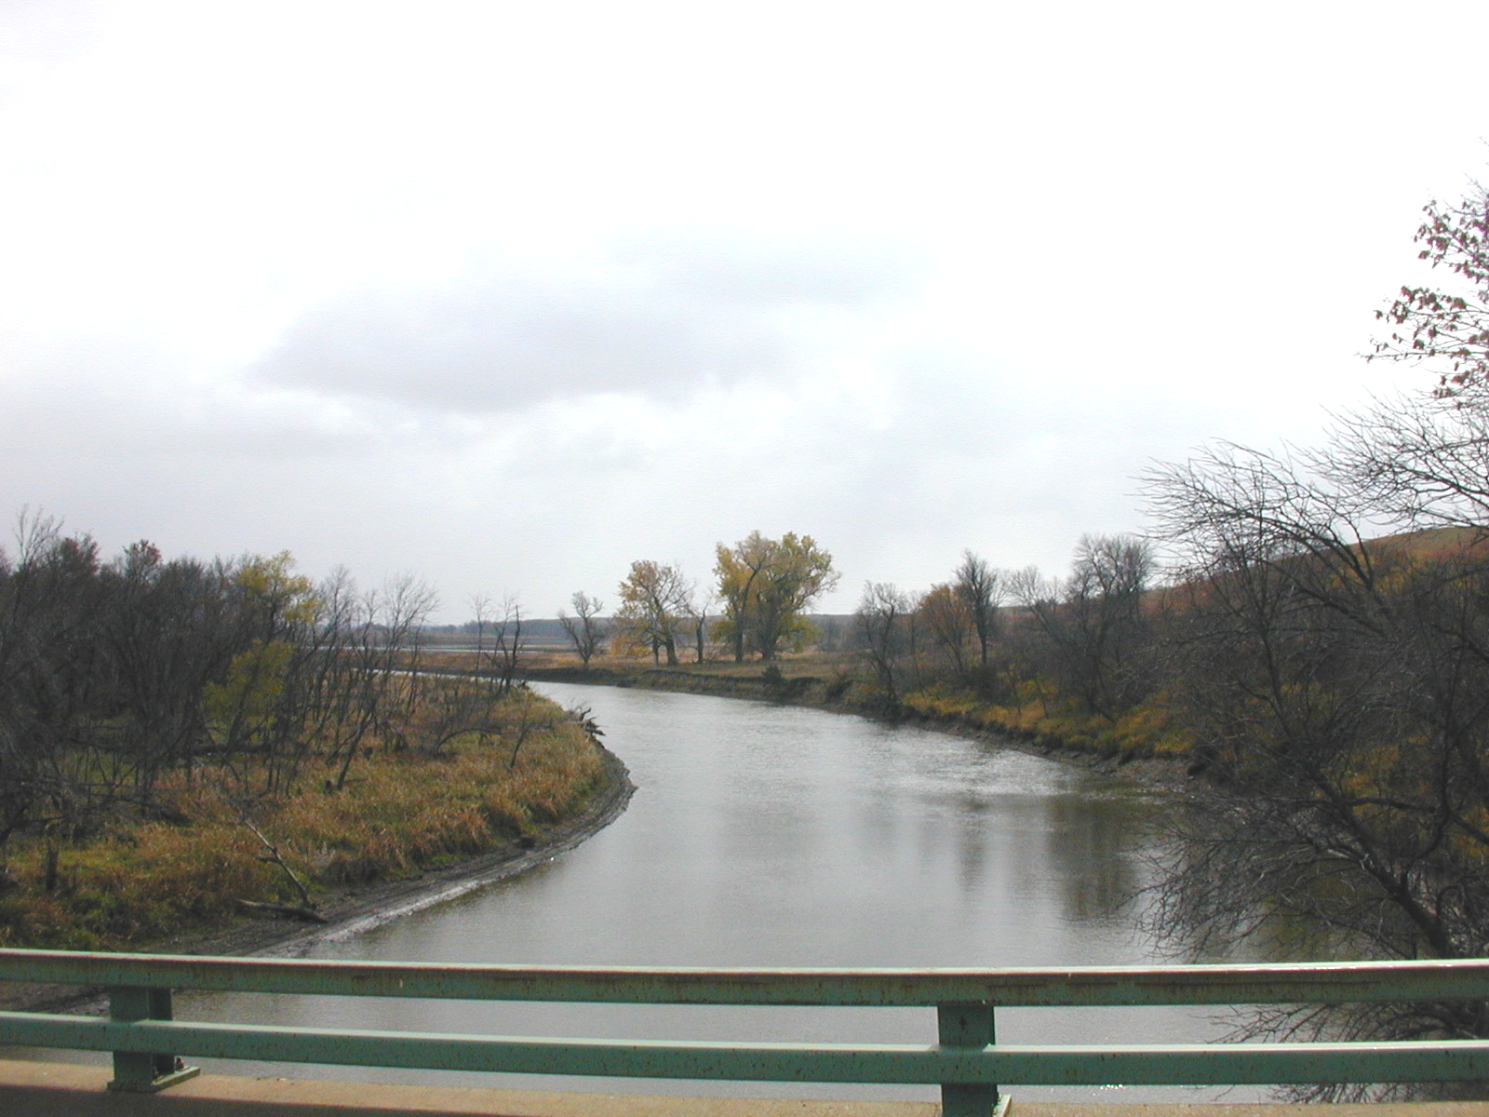
Figure 11. – Post-flood conditions, looking downstream from bridge deck

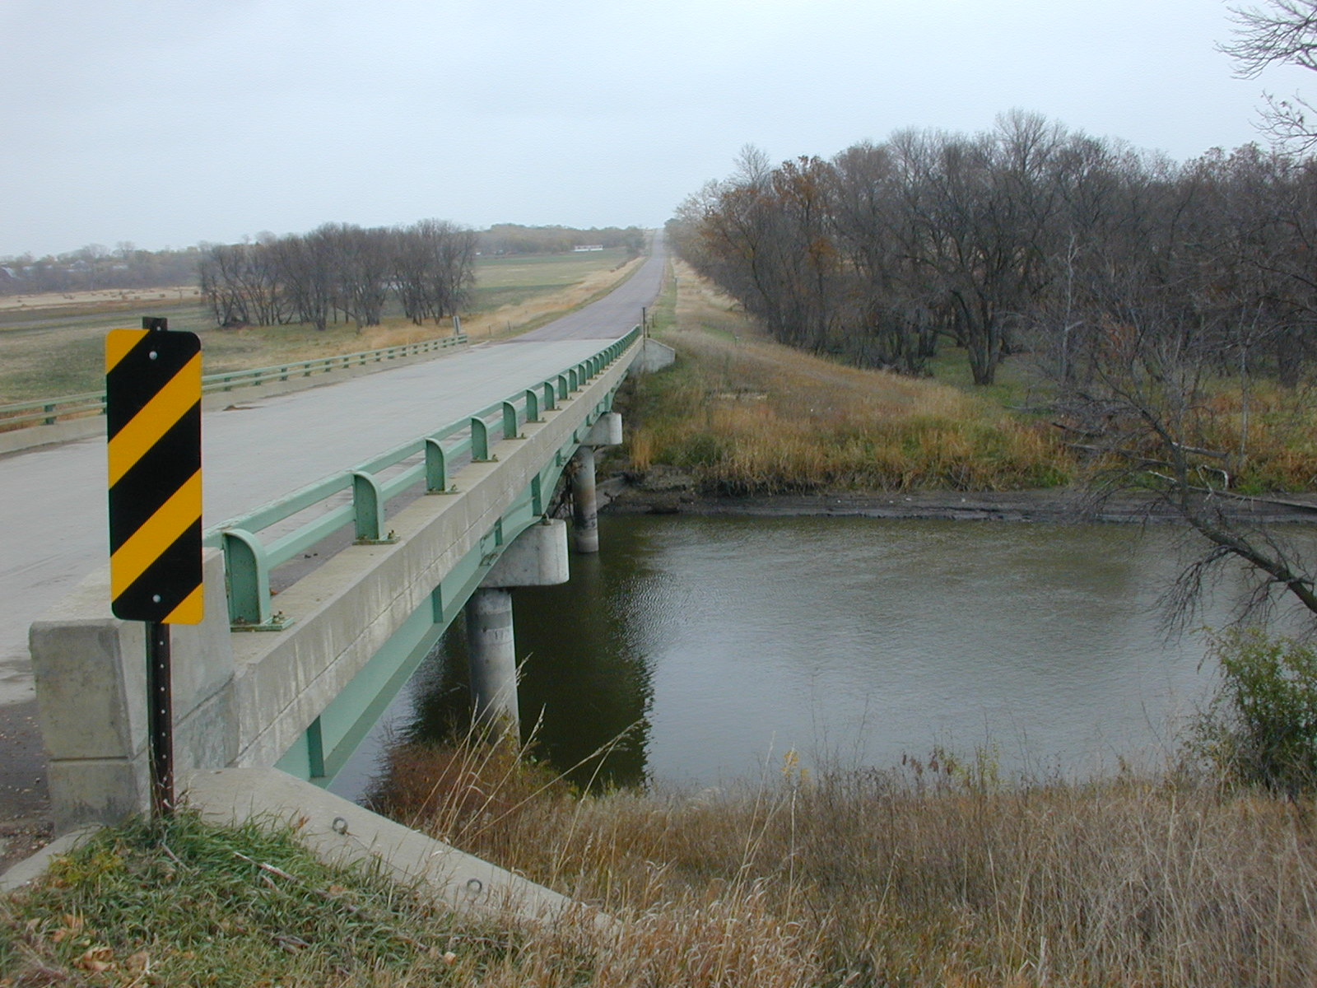
Figure 12. – Post-flood conditions, looking eastbound at downstream face, left floodplain, and section of roadway overflow.

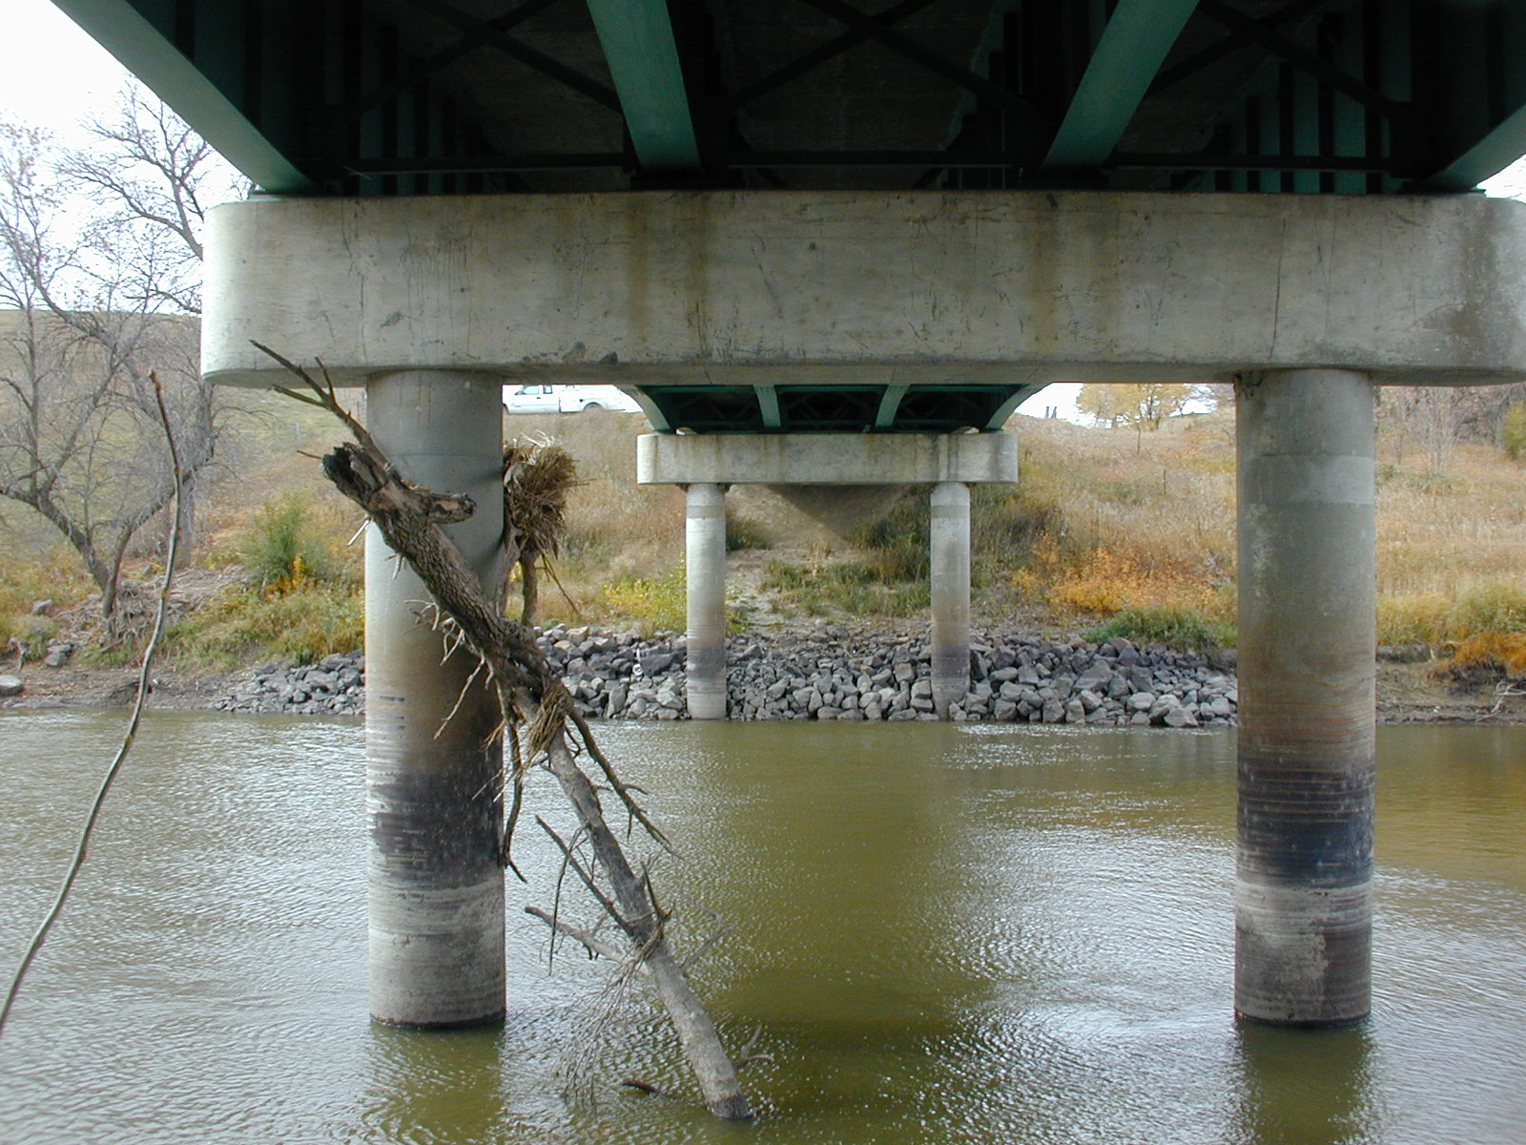
Figure 13. – Post-flood conditions, looking under bridge from left abutment.

Bed Material Data
Bed material samples were collected at three locations in the main channel; 200 feet upstream of the bridge, adjacent to the bridge opening, and 350 feet downstream of the bridge. The samples consisted primarily of a mildly cohesive clayey-silt and had a D₅₀ ranging from .02 mm to .04 mm. No material collected under bridge, due to the presence of rocks and/or concrete from the old bridge. Three samples were collected from boat just downstream of the bridge along the left bank at a depth ~ 4 ft. The grain size distributions for the three sample locations are shown in figures 14-16.

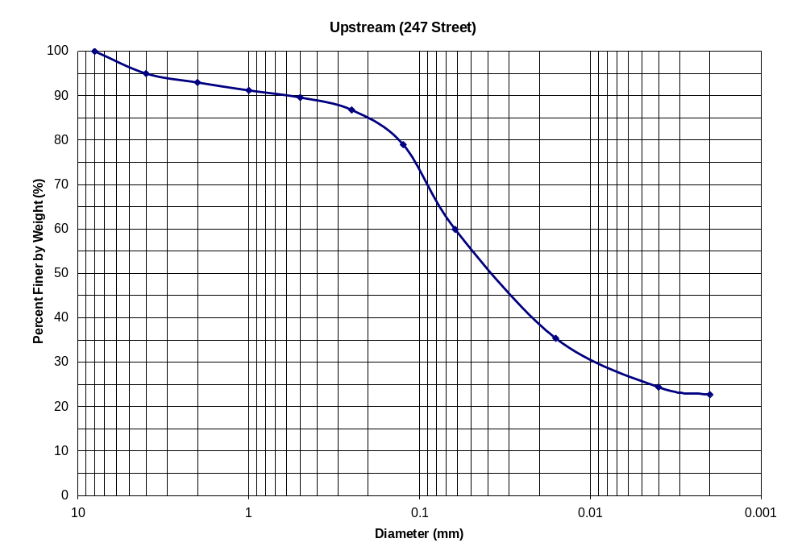
Figure 14. – Grain size distribution for the bed material sample collected upstream of the 247th Street bridge

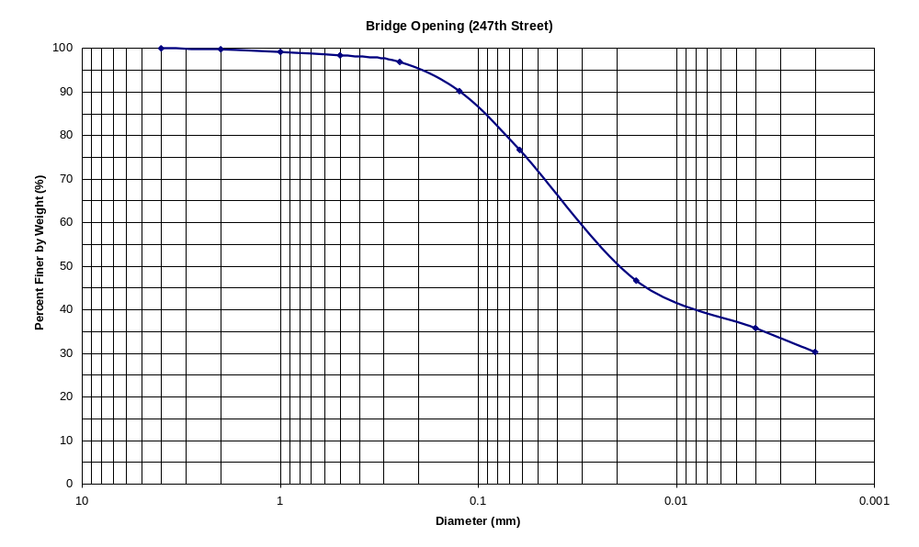
Figure 15. – Grain size distribution for the bed material sample near the 247th street bridge opening.

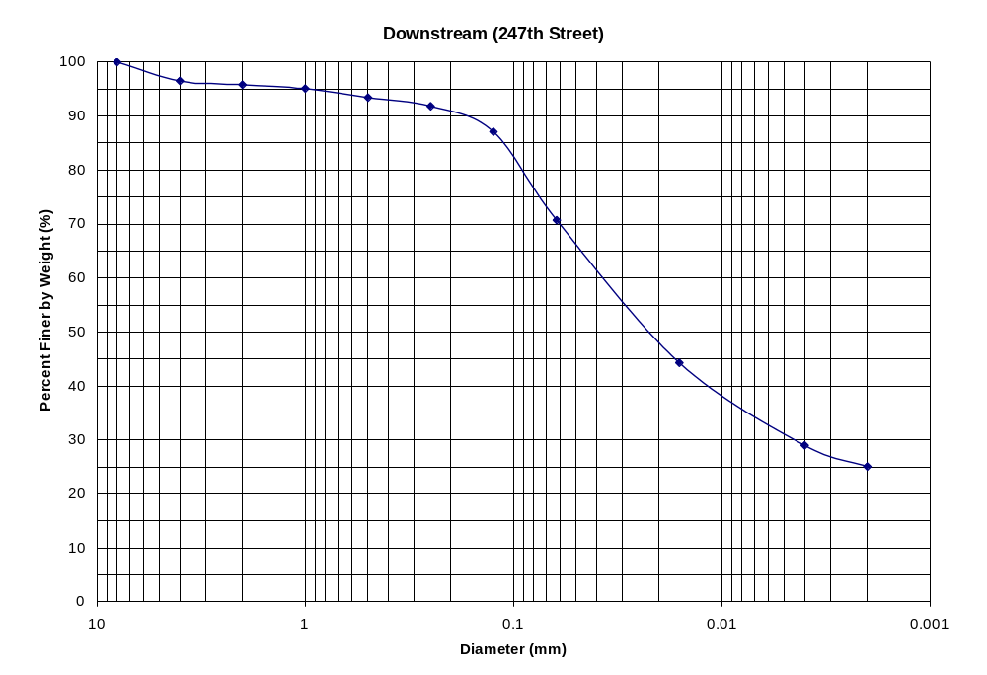
Figure 16. – Grain size distribution for the bed material sample collected downstream of the 247th street bridge.

