Cranberry River near Richwood, WV 03187500
Gauley River Basin
Flood of June 23, 2016

TYPE OF MEASUREMENT: Three section slope area.

LOCATION OF SITE: The streamgage is located at Lat 38°17’43” Long 80°31’36” NAD1927, Nicholas County, WV and is on the left descending bank 30 feet downstream of the U.S. Forest Service bridge. This location is approximately 5.0 miles north of Richwood, WV.

The slope area reach is adjacent to the location of the stream gage. The slope area reach was selected and flagged by members of the VA/WV Water Science Center in the days immediately following the June 23, 2016 flood.

SURVEY OF SITE:
- Site was selected by James Scott, Fred Brogan, Wes Justice, and Katherine Gindel on June 28, 2016. Flagging was conducted at that time.
- Site surveyed by James Scott (Rod), Matt Baker (Rod), AJ Griese (Rod) and Robert Holmes (Instrument, notes); survey conducted on July 26-27, 2016.
- Datum: X,Y position for HUB-1 established by handheld GPS to be: 0541399 m Easting, 4238742 m Northing which converted to survey-feet units is 1776239.86 survey-feet Easting and 13906602.76 Northing. An arbitrary elevation datum of 100 feet was assumed at HUB-1. RM-5 (gage datum 7.090) and RM-2 (gage datum 5.919) were surveyed as part of the indirect. Zero gage datum corresponds to 96.91 feet in the arbitrary datum. A compass head of magnetic north was used to set the azimuth of the survey.
- The survey closed on HUB-2 with an error of +0.001 feet.
- Peak Stage from HWM. LH-1-P was 15 feet upstream of the gage and LH-2-P was 15 feet downstream. Using gage datum corresponding to 96.91 feet, LH-1-P corresponds to 11.91 feet and LH-2-P corresponds to 11.71. An approximate interpolated value of the peak stage from HWM is 11.8 feet stage. The peak stage from the recorder was 11.72.
- Instrument: A Nikon Nivo 2 Total Station (2 second instrument) serial number S/N C050791 was used for the survey. Calibration was ran on the instrument and found to be within tolerances of the manufacturer.
- During surveying on July 26, 2016, survey team noted expansion in lower part of the flagged reach, such that a smaller reach length was used than had previously been flagged. 3 cross sections were surveyed with the upper most cross section as close to the downstream side of the bridge (which is skewed to flow) as possible and the most downstream cross section at the location just before flow expansion took place. The middle section was nearly equidistant between the two, but was surveyed where cross section was visible from HUB-1. The potential for a contracted-opening indirect measurement was considered by the survey team, however, this was ruled out due to a number of factors: 1) lack of hwm flagging on upstream approach XS, 2) skew of bridge, and 3) inadequate knowledge of true minimum contracted area because of removal of known tree jam debris by forest service personnel prior to July 26, 2016.

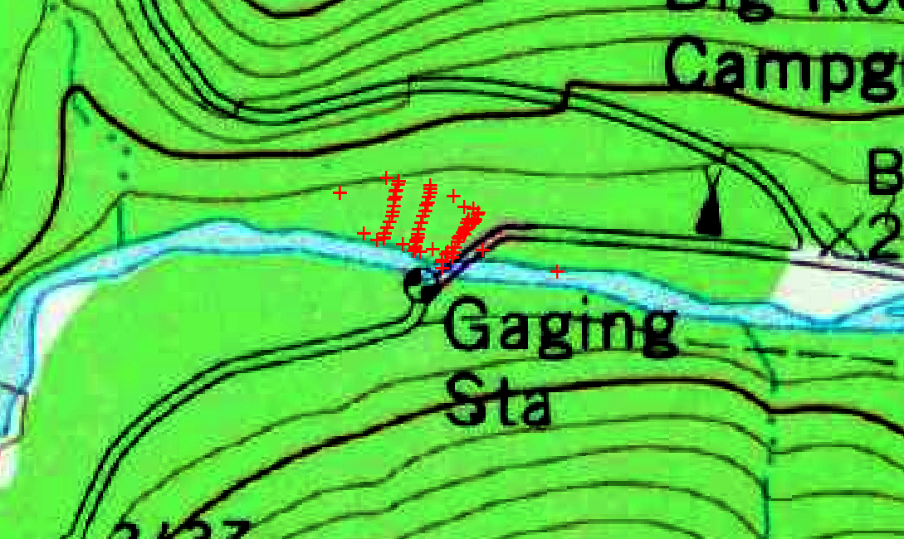

Figure 1. Overlay of survey data on topo map using ArcMap. Note, survey points are not exactly aligned due to inaccuracy of the handheld GPS location of HUB-1 and the approximate azimuth obtained by compass.

- For the CSV file to be pulled into SACGUI, the original ‘X1’ data (surveyed on day 1 of survey) was erased and the ‘X1-new’ data was renamed to ‘X1’. The original X1 data was surveyed at too much of a skew to the flow, so X1was redone on day 2 of survey to align the cross section more perpendicular to the flow line

DISCHARGE AND GAGE HEIGHT: 9,700 cfs; Outside stage from extrapolating HWM from indirect survey was 11.8 feet. Inside recorder peak was 11.72 feet. Crest gage was read on 6/28/2016 indicating a peak stage of 11.53 feet (intake and vent holes were noted as clear). Velocities were high during this flood and it is suspected there was considerable drawdown around the gage structure and CSG.

DRAINAGE AREA: (SQ MI): 80.4 square miles per USGS station description

UNIT DISCHARGE:(CFS per SQ MI): 121 cfs per square mile

NATURE OF FLOOD: On June 23, 2016, thunderstorms brought torrential rain to much of West Virginia and southwestern Virginia. A day earlier, flash flood warnings were issued by the National Weather Service (NWS) for several counties as a warm front located over Ohio and Pennsylvania was expected to produce an outflow boundary that would become the focus for storms as a strong upper level disturbance crossed the region. Heavy rain began to fall during the early morning hours of the 23rd and additional flash flood warnings were issued over the area as the rainfall continued throughout the day. Through the morning, forecasts from the NWS indicated diminishing rainfall in some areas, but then changed as convection renewed in those areas and then persisted throughout the afternoon.
Moderate flooding was widespread throughout south-central West Virginia. Extreme flooding was localized within three bands within this area where supercells trained in the Elk, Gauley, and Greenbrier River Basins in West Virginia, and the James River Basin in Virginia. Flood flows from the Greenbrier River also resulted in flooding on the New River in and downstream from Hinton, West Virginia.
In some of the hardest-hit areas of Roane, Kanawha, Clay, Fayette, Nicholas, and Greenbrier counties in West Virginia, the NWS estimated return periods exceeding 1,000 years (fig.1). Rainfall totals in excess of 7.0 inches (in.) were recorded in many areas of West Virginia, including Maxwelton, (9.37 in.), Rainelle, (7.53 in.), and White Sulphur Springs, (9.17 in.). The path of impressive rainfall totals extended from Charleston, WV, to Roanoke, VA, with the hardest hit areas in Virginia being Alleghany and Bath counties. The town of Covington, VA, received 5.03 in. of rainfall over the 24-hour period. Numerous water rescues, road closures, and cars and homes washed away were reported throughout the afternoon. Unfortunately, at least 23 people were killed and many communities were devastated as a result of this event.
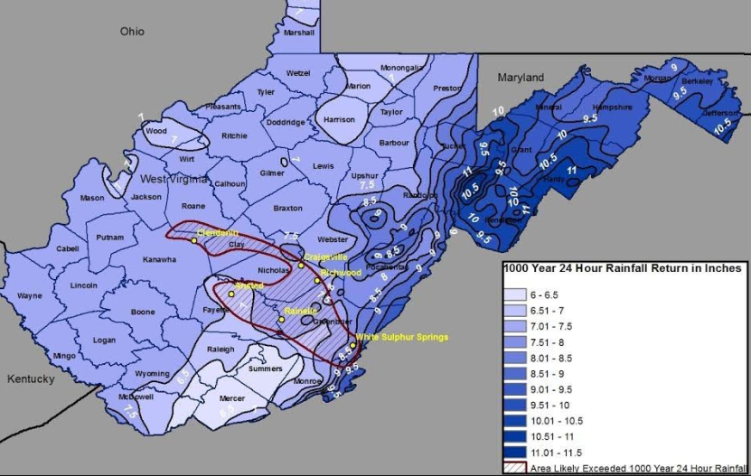
Figure 2. Map showing 24-hour 1,000 rainfall return period amounts for West Virginia and the area where the 1,000 year 24-hour rainfall on June 23, 2016 exceeded the 1,000 year 24-hour rainfall (source: National Weather Service)

FIELD CONDITIONS:
- The reach was fairly straight coming from the downstream side of the Forest Service Bridge (with X1 just being downstream of the bridge) to X2.
- The main channel composed of gravel, cobbles, and boulder sized material in the main channel and the banks composed of dirt, sand, and gravel with trees and rhododendron growing on both banks, except for a 25 feet reach length of the left bank at X1 where it is grass. This short reach length includes the gage house and much irregularity in the ground surface on the banks due to bank slumping and general disturbance . Figures figure 3-5 show the reach from various vantage points.
- All cross sections were compact shape with the water surface during the flood being contained in the banks of the channel for this part of the reach. As such, no subdivision was done on any cross section. Downstream of the X3, the flow expands as the natural levee on the right bank is lower allowing for spillover for the flow, thus the reach was terminated at X3 to avoid this expansion. Cross section geometry from X1 to X3 changes very little.
- There is no evidence of scour or fill in this reach during the flood.
- The HWM on both bank were generally wash lines, flagged in the aftermath of the flooding. Descriptions found on the flags indicated the hydrographer judged them to be of poor condition (see field notes for HWM descriptions and quality)
- In general, high water marks on left bank were slightly (approximately 0.02 to 0.2 ft) higher than the right bank. The combined water surface profile was drawn with preference given to those HWM that had good agreement with left and right banks (LH-1P/RH-5-P; LH-4-P/RH-3-P; and LH-5-P/RH-2-P), with a higher slope in the X1-X2 reach than the X2-X3 reach. Sensitivity analysis was performed with straight lines given from the maximum slope drawn on a RH-6-P to LH-5-P/RH-2-P path to a minimum slope drawn on a RH-6-P to LH-7-P path.
- Roughness Values: Manning’s “n” values were selected at the site at the time of the survey, with additional analysis done during office computations. A composite value of 0.049 was assigned to section X1 and composite value of 0.05 for X2 and X3. Engineering judgement was used in the field to make the initial selections of n and these were evaluated and adjusted based on photographic comparison with Barnes WSP 1849. Additionally, Cowan’s method was used to determine valuse of n as a comparison check. Channel consists of rocks and boulder in main channel, some boulders as large as 2 feet intermediate diameter. Edge of channels is dirt/sand/gravel with trees, some minor overhanging branches, and rhododendron. Reach is fairly uniform both in terms of geometry and roughness. X1 has grass on the left bank along with the gage house 30 feet downstream.
- From Barnes photographic comparison, felt minimum composite n for all sections was likely 0.045. Maximum composite n=0.052.
- Roughness for sections were computed using Cowan method as follows: n_{b}=0.028 (gravel);n₁=0.020 (severe); n₂=0 (gradual); n₃=0.02 (appreciable), n₄=0.005 ( low), and m=1.0. n=(0.028+0.020+0+0.020+0.005)*1.0=0.073 This value was judged to be too high and unreasonable, particularly given our mean hydraulic depth was approximately 8 feet, which is double the mean depths for channels with n values greater than 0.065 in Barnes.
- Sensitivity analysis ran with minimum composite n of 0.045 for all cross sections and maximum n of 0.052 using the water surface profile from a best fit of all high water marks on both banks. Additional sensitivity was done on the best fit water surface profiles determined for left bank only high water marks and right bank only high water marks.
- Photographs: Photos and video of the reach were taken during the survey. Those are all contained in a digital folder with a WORD document serving as an index description of all photos.

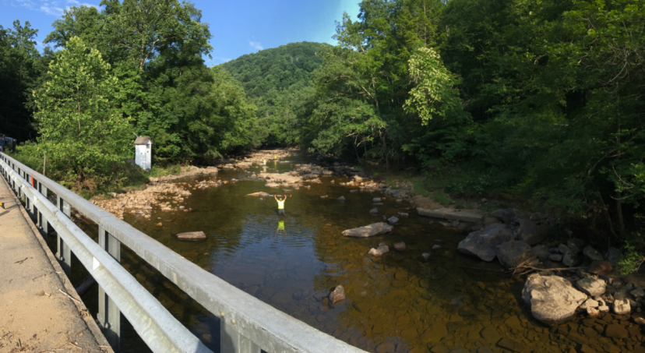

Figure 3. Photo taken from Forest Service bridge (note it is skew to channel) looking downstream through reach. Note that rodman standing on each of the three cross sections. Water surface during flood peak was 2 to 4 feet above the horizontal prism poles held by the rodmen.

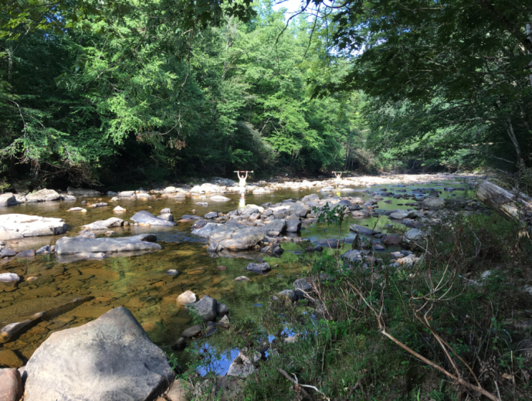

Figure 4. Photo taken from right bank looking diagagonal downstream at X2 and X3. Water surface during flood peak was 2 to 4 feet above the horizontal prism poles held by the rodmen.

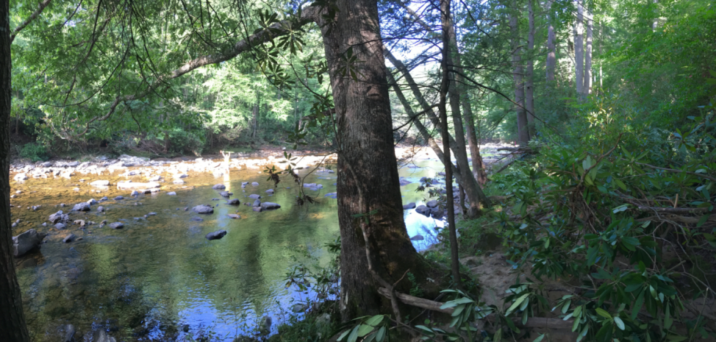

Figure 5.—Photo taken from right bank upstream of X3 looking downstream at X3. Note rodman standing on X3. High water was 2-4 feet above horizontal rod. This photo shows a bit more of the right bank vegetation which was trees and rhododendron.

COMPUTATIONS: The U.S Geological Survey computer software SACGUI was used to ingest the survey data, set up the baseline, define the cross sections, and populate the initial SAC input file. The USGS software program SAC was used to compute discharge. The final water surface profile used for the computation was based on a best fit line of all high water marks given, with no weighting for particular high water marks given they were all rated as poor quality wash lines. As part of the sensitivity analysis, best fit of left-bank only HWM and right-bank only HWM were determined, as well as a maximum water surface slope and minimum water surface slope. Figure 6 below contains the final water surface profile from best fit along with the RB and LB HWM profiles. See file ‘water surface slope analysis.xlsx’ for the data and graphics underlyiung figure 6.

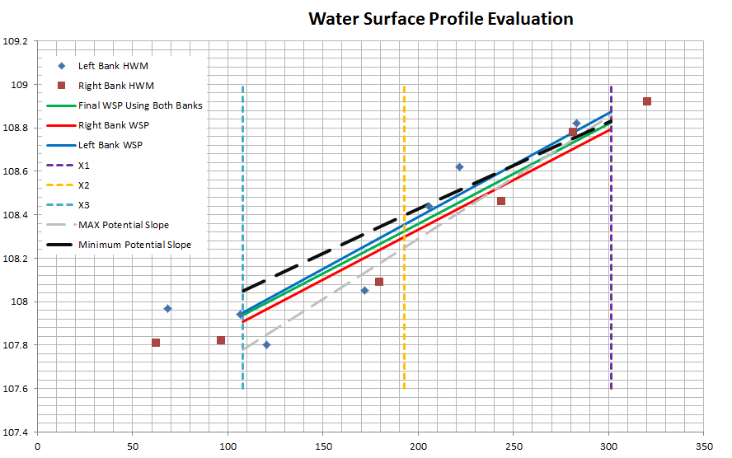

Figure 6. Final water surface profile computed form best-fit along with RB and LB profiles.

DISCHARGE DETERMINATION: 9,700 cfs using the slope area method.

EVALUATION OF RESULTS: The reach was shorter than desired in order to keep from having large expansions in the reach. The high water marks were flagged very soon after the flood, but because the marks were high velocity wash lines, they were considered poor. However, the scatter from left bank to right was only on the order of 0.2 feet. And the inside recorder peak agrees with the interpolation of the nearby high water marks to within 0.1 feet. As such, the high water marks may well have been judged to be fair (Koenig and others, 2016, T&M 3-A24, Page 28) A best fit of the high water marks from both banks was used to determine the water surface profile. Program diagnostics from SAC for the computation was as follows (Table 1):
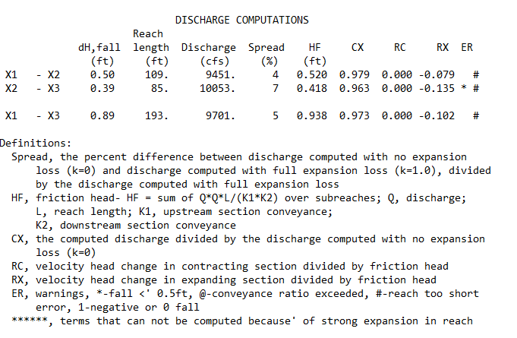

Table 1. Output from SAC for the accepted slope area computation for the final value of 9,700 ft³/s

As noted in table 1, there is some expansion in the reach as noted by the spreads and RX being non-zero values. The spread is relatively low, while the RX is acceptable. Expansion in X2-X3 is greater than X1-X2. Impact of expansion on computation is thought to be minimal. SAC has also flagged the reach as being too short as the reach length is less than 75 times the mean depth.

A sensitivity analysis of both the roughness values and water surface elevations was conducted and presented in table 2.

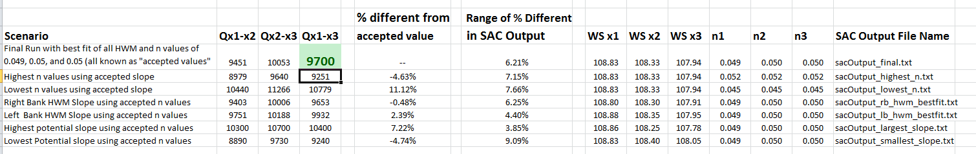
Table 2. Results from sensitivity analysis examining the sensitivity of the computed discharge by varying the roughness and water surface elevations through reasonable ranges of values.

The column “% different from accepted value” is the percentage difference between the value of Q computed for whatever change is listed under the “Scenario” column and the accepted value of 9,700 ft3/s. As is noted, all values stay within 11.1 percent of the accepted value. Roughness was varied through the reasonable ranges, based on engineering judgement, of 0.045 to 0.052 with variation of Q being between -4.63% and 11.12%. Water surface slope was varied between a maximum slope and minimum reasonable slopes (indicated in figure 6) with a variation of discharge being between -4.74 and 7.22 %. Roughness is the more influential parameter to the final value of Q.

Use 9,700 cfs and consider the results of fair (+/- 15% based on TWRI rating system) reliability based on sensitivity analysis, agreement of marks from left to right bank, and slight expansion of the reach.

FLOOD FLOW FREQUENCY: No Flood frequency was computed. Indirect was plotted on Crippen and Bue envelope curve for Region 4 and found to be well within the envelope (figure 7).

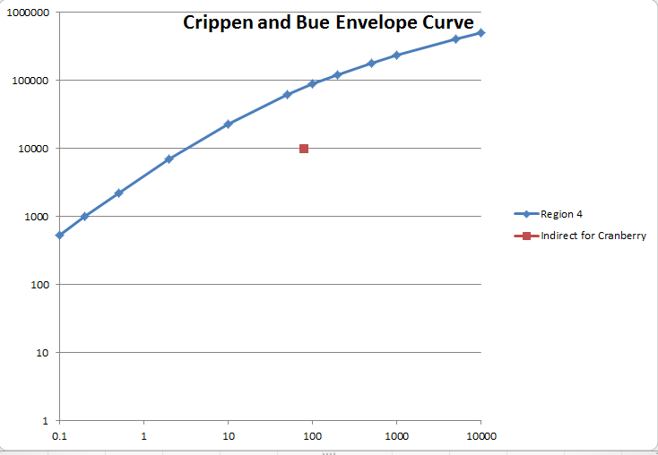
Figure 7. Crippen and Bue Envelope curve for Region 4 (includes West Virginia) and the Cranberry River near Richwood, WV indirect from peak flood of June 23, 2016

PREVIOUS COMPUTATIONS: A previous slope-area indirect was conducted at this site for the flood of August 31, 1984. For a stage of 11.0 feet the flow was estimated at 9,800 cfs.

ARCHIVAL INFORMATION: Measurement data and summary will be archived in the VA/WV WSC files.

REMARKS: Document any remarks from checkers/reviewer applicable to measurement or its use for other computations (gage record computation, etc.)

PREPARED BY: Robert Holmes August 18, 2016

CHECKED BY: Mathew F. Schellekens/ August 22, 2016

REVIEWED BY: Larry R. Bohman/ August 24, 2016
- SUMMARY EVALUATION: The number and quality of HWMs was indeed poor however a good number of sensitivity analyses were all done and resulted in much less than the 15% difference in discharge afforded to uncertainty for a FAIR indirect (Table 2 font was a bit small to read!). The very short reach also had a minimal number of cross sections. Still none of the other diagnostics discussed below were egregiously bad so the reviewer concurs with the resulting discharge and quality rating, though the GH is of concern (see item 2 below).
- Getting the best discharge/GH pair is the ultimate purpose of any measurement. The HWMs near the gage were fairly close to one another and the difference with the recording gage could be due to the peak occurring between recording intervals. But the CSG reading 0.3 ft below the other HWMs deserves some addition discussion in the DISCHARGE AND GAGE HEIGHT paragraph. Were either (or both) the CSG and recording gage affected by the “debris pile up” that was supposedly removed by the USFS before the indirect survey?
RRH Response: The debris pile on the bridge is well away from the gage and had no effect per the field personnel. Suspect drawdown on the CSG.
- I’d really like to see a rating curve plot for the gage which includes this computation. Because it never really goes overbank, I’d expect a logarithmic extension to work fairly well. If not, then I’d like to see a discussion of why this measurement plots off the log-extended rating and what explanations there might be for the unexpected plotting position.
RRH Response: rating was plotted but not included in summary. See embedded here. Note a linear extension of measurements on log rating would seem to line up nicely with this indirect. I think the rating was drawn to far to right to begin with.

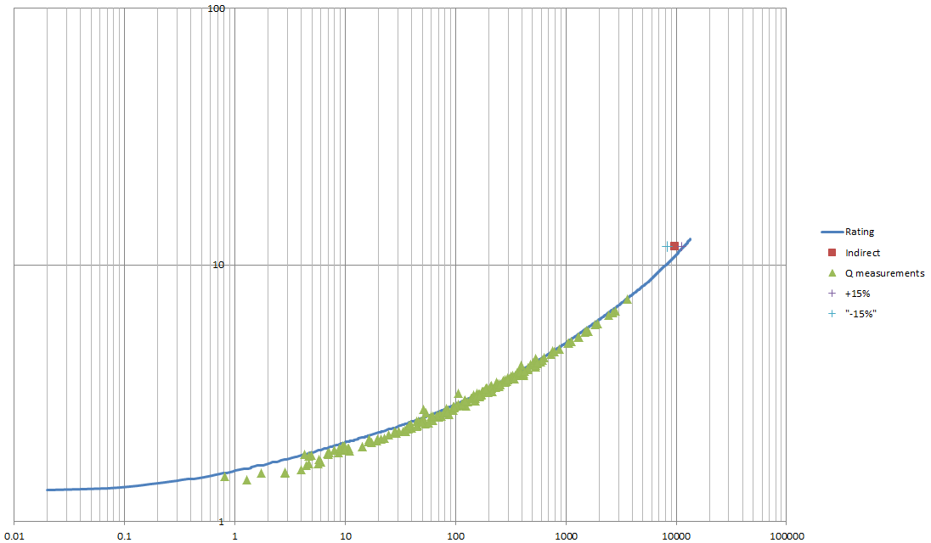

- The length of the reach is less than 200 ft! 75 times the hydraulic depth of 8 ft amounts to 600 feet. Because the reach was short and the channel uniform, there were no ineffective flow areas and no tributaries.
- Package contents were all present.
- Conveyance and channel shape were fairly uniform throughout the reach and no subdivision was needed. No scour or fill was discussed but not likely in view of the rock/boulder bottom.
- The use of regression to get bank profiles is a bit mechanical but my own manual attempt produced water surface elevations at the cross sections within a few hundredths of those actually used.
- The n-values used seemed a bit low but were in line with the 1984 indirect in the same reach.
- The fall (0.89 ft) was generally just a bit less than the typical velocity head (averaged about 0.95 ft for the reach) which is what we want.
- The friction loss (H_{f}= 0.94 ft) should be less than the fall (0.89 ft) and should comprise about 90% of the fall. In this case the friction head is about 105% of the fall… not alarming but not ideal either.
- The individual reach discharge computations did not vary by more than 5-7%. The stats indicate some expansion but the RX values are relatively small. The spread between 0% and 100% energy recovery is never more than 7% (good).
- The location map is a blown-up topo map of poor quality. Seems like you could get an aerial photo and superimpose the cross sections and add the gage location and roadway names to make a better plan view figure.
- The SAC OUTPUT files have no station name or number on them. While they’ll probably never get misplaced, it’s always a good idea to have this information included in the output file header info.
- There was no real discussion of the previous indirect or how it was used to make the current one (n-values, reach selection, etc.).
- There were SEVERAL duplicate photos in the archive…these should be cleaned up and labeled appropriately.

